MongoDB & NoSQL Learning Documentation

1. Introduction to NoSQL
NoSQL (Not Only SQL) refers to a category of databases that store and manage data in formats other than the traditional row-and-column structure used by relational databases. NoSQL databases are designed to handle large volumes of unstructured or semi-structured data, and they offer more flexibility when it comes to how data is organized. Instead of requiring a fixed structure ahead of time, NoSQL databases allow data to be stored in flexible formats such as documents, key-value pairs, wide-columns, or graphs.
This makes NoSQL databases well suited for applications that need to scale quickly, handle changing data requirements, or work with data that doesn't fit neatly into a table format.
2. Introduction to MongoDB
MongoDB is a popular NoSQL database that stores data as documents, using a format called BSON (Binary JSON). Each document is a set of key-value pairs, similar in structure to a JSON object, and documents are grouped together into collections. Because MongoDB does not enforce a fixed schema, documents within the same collection can have different fields, which makes it easy to adapt the data model as an application evolves.
MongoDB is commonly used in backend applications for tasks such as storing user data, managing application state, and performing fast queries and aggregations over large datasets.
3. RDBMS vs NoSQL (MongoDB)
The table below highlights the key differences between a traditional RDBMS and a NoSQL database like MongoDB.
Aspect | RDBMS | NoSQL (MongoDB)
Basic storage unit | Row | Document
Group of records | Table | Collection
Database concept | Same term used in both platforms | Same term used in both platforms
Schema | Fixed schema (must be defined in advance) | Flexible schema (no fixed structure required)

4. Index — Topics Covered in This Document
The following MongoDB concepts and commands are covered in this document:
1. use command 10. upsert
2. show database 11. delete method
3. create collection 12. comparison operation
4. delete the collection 13. logical operation
5. delete the database 14. array operation
6. datatypes 15. aggregate
7.insert the documents 16. validation
8. find method 17. lookup
9. update method 18. indexing

Creating and switch the database:
“use databasename” is use to create the database and if it already exist , it will switch from current to the mention database name.
Creating collection:
“db.createCollection(“collectionname”)” is use to create the collection in the database.
Delete the collection:
“db.collectionname.drop()” is use to delete the collection in the database.
Delete the database:
“db.dropDatabase()” is use to delete the database.
showing databases:
“show dbs” is use to show the databases.
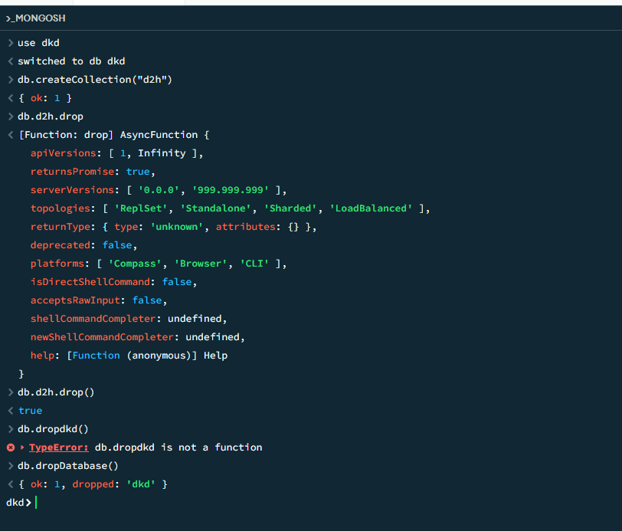

Data Types:
1.String - “harish”
2.Integer - 19
3.Float - 0.3
4.Boolean - true or false
5.Date - new Date(“yyyy-mm-dd”)
6.Array - [“navin” , ”harish” , ”shandhip”]
7.Nested document - related:{ name:”harish , age:21 , role:”devops”}
Insert method:
This method is use to insert the record or document which in bson format.
i)Insert one:
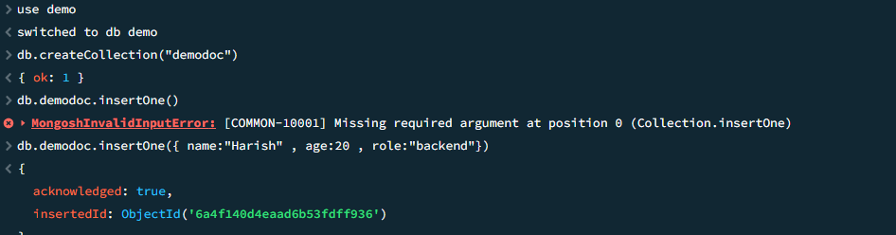
ii)Insert many:
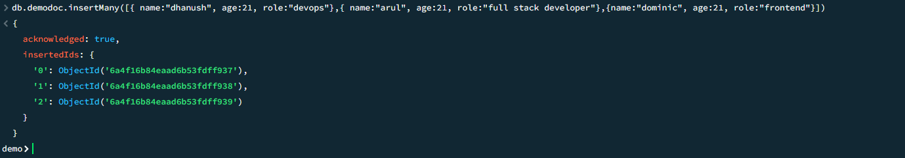
Find method:
The find method is use to return the document in the collection by giving the attributes , sorting , skiping or limiting.

i)Find method:
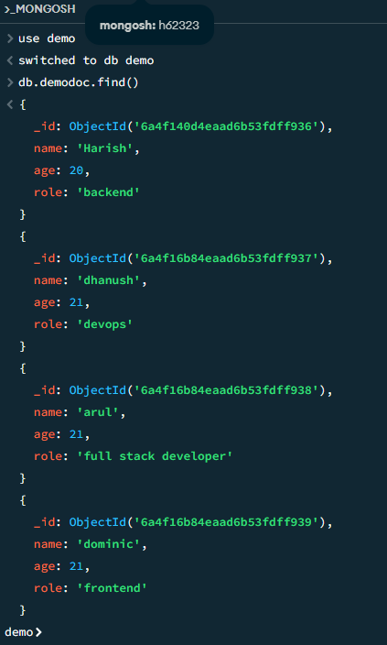
ii)Find the document by attributes and values:
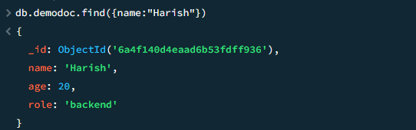

iii)Find method with projection:
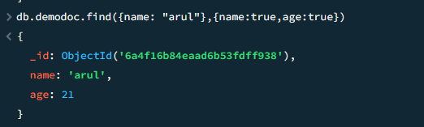
iv)Find method using sorting method:
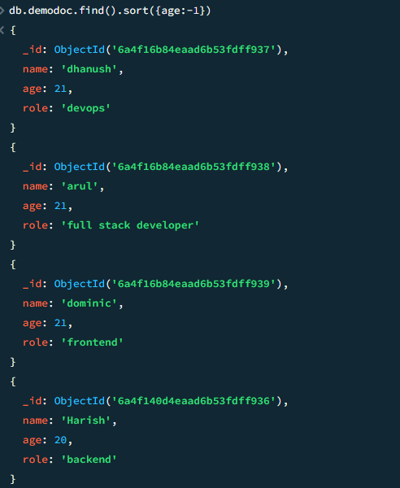
v)Find method using sorting and limit methods:
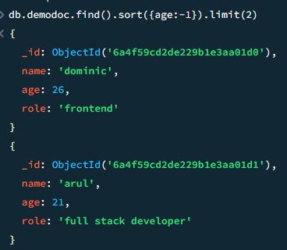

vi)Find method using skip method:
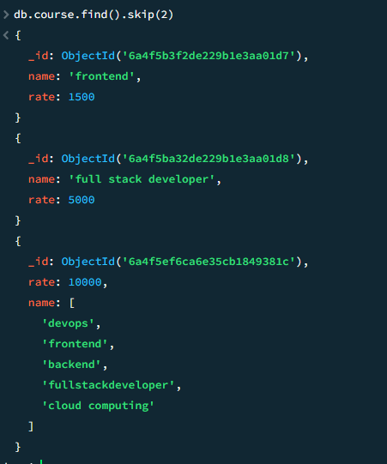
vii)Findone method:
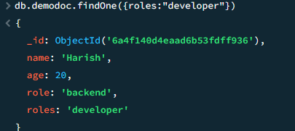

Update method:
This method is use to update the exists document’s data in collection.
i)Updateone method :
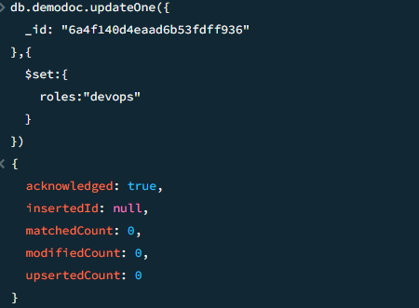
ii)UpdateMany method:
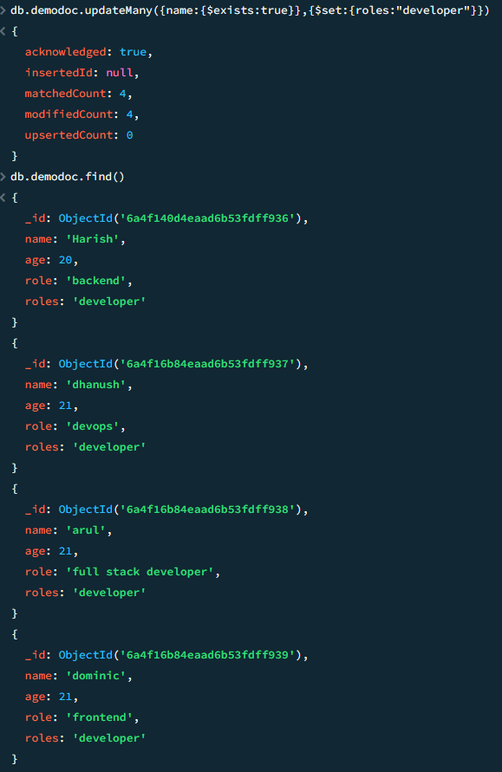

iii)Update method with upsert:
This is used to add it in collection if it doesn’t exists.
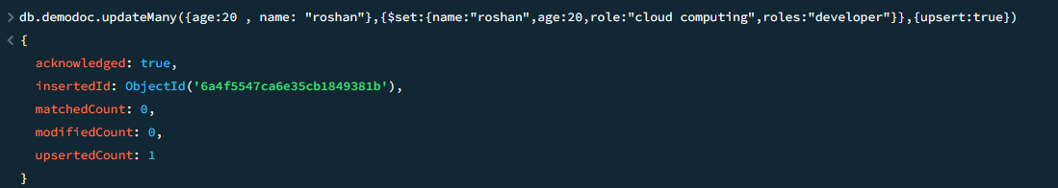
iv)update method with incrementing the values in document:
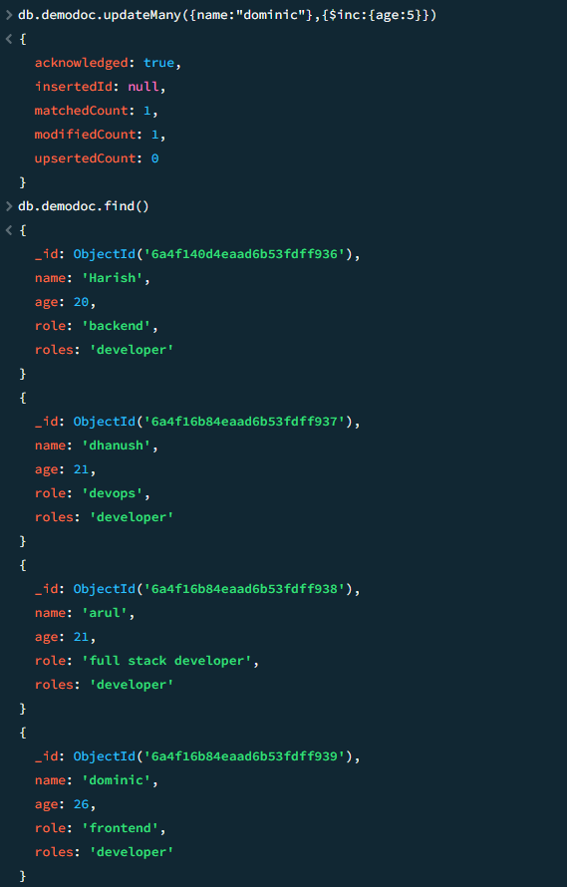

Delete method:
this is used to delete the document in the collection.
i)Delete one method:
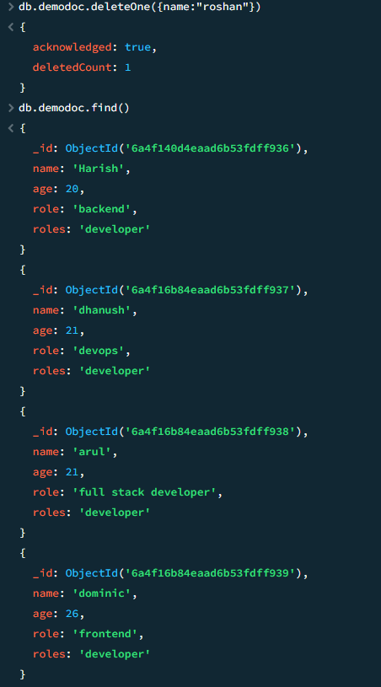
ii)Delete Many method:
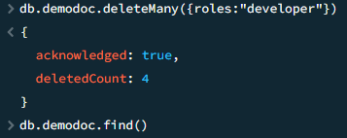

Comparison Operator:
Comparison operation is used to display the documents by compare the value in the collection like
$gt - ”Greater than”
$lt - ”Lesser than”
$eq - ”Equal to”
$gte -”Greater than and equal to”
$lte -”Lesser than and equal to”
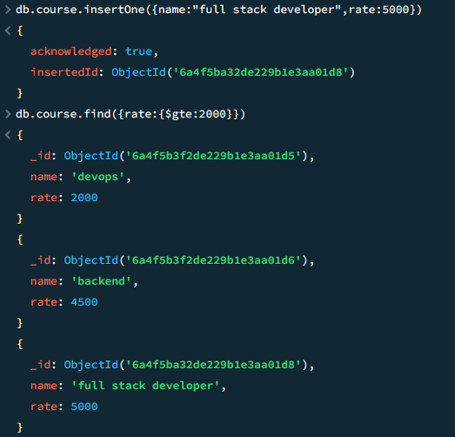

Logical Operator:
Logical operators are symbols or keywords used to combine or modify conditional statements in NOSQL query.
$and -Returns true only if all of the provided conditions are true. If any condition is false, the entire expression is false.
$or -Returns true if at least one of the conditions is true. It only returns false if all conditions are false.
$not - Reverses the logical state of a condition. If a condition is true, NOT makes it false; if it's false, NOT makes it true.
$nor -that outputs true only when all its inputs are false. If any input is true, the output is false.
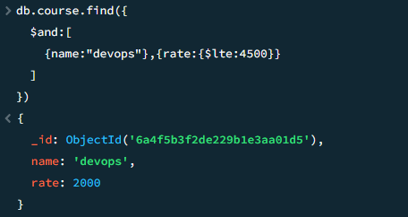

Array Operator:
The Array Operation a query modifier used to search, filter, update, or manipulate arrays stored inside document-based databases.
$addToSet - Add in array without duplicating.
$push - add in array with duplicating.
$pull - remove the value.
$pop - remove the value using index value.
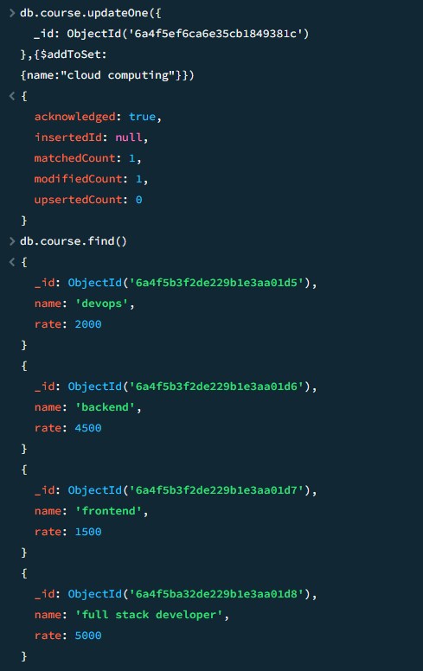

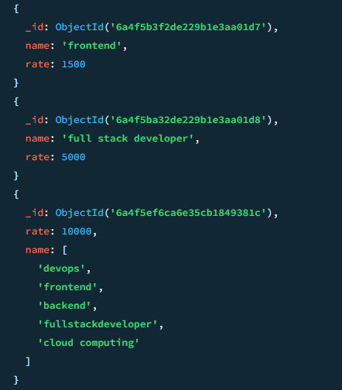
Aggregate:
Aggregation is the process of collecting, filtering, and combining multiple records to return a single summarized result (like calculating a total, average, or count).
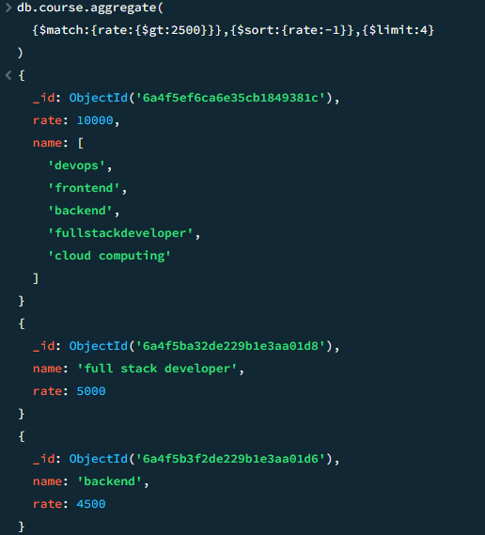

Group in Aggregate:
The group is use to group the duplicate and perform the operation like sum , max , min , avg.
$sum - sum the values of group.
$min - find the minimum number from the grouped document.
$max - find the maximum number from the grouped document.
$avg - find the average value from the group documents.
$out - create a separate collection to store the grouped document .
$count - count the document in the output of the group.
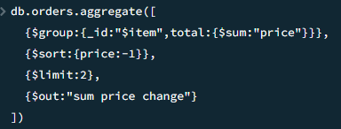
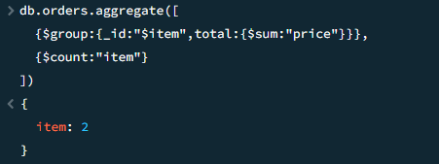

Validation:
Validation is ensures data integrity by enforcing required fields, data types, and value ranges before data is saved.
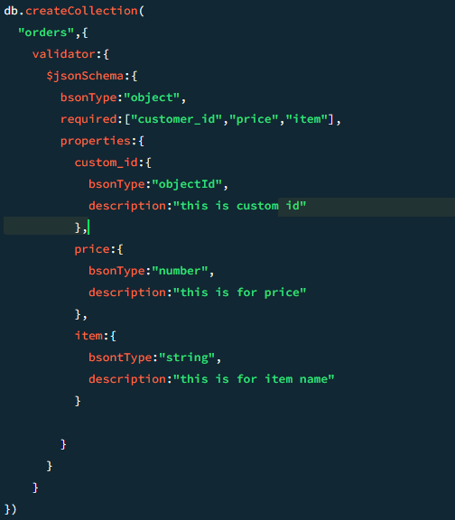
$lookup:
$lookup is an aggregation pipeline stage that performs a left outer join with another collection within the same database.
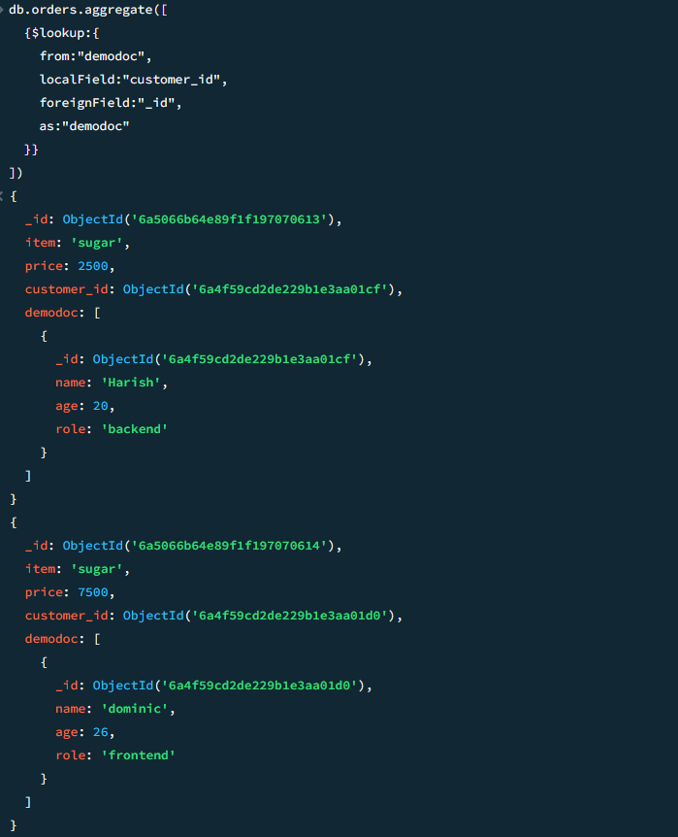

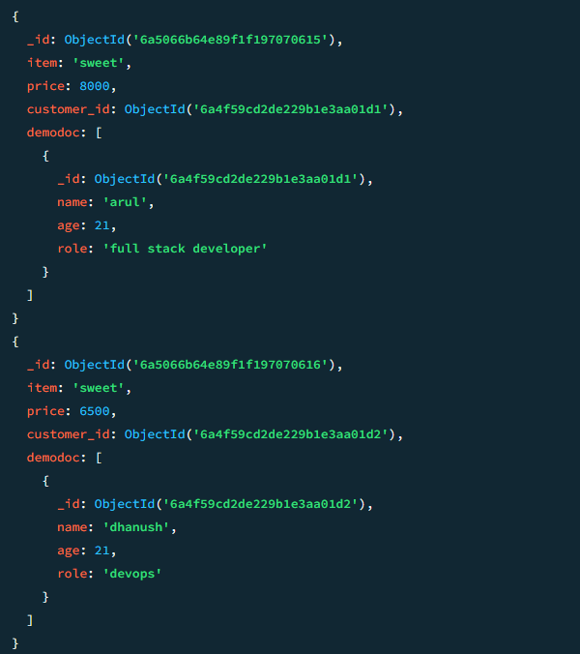
Indexing:
Indexes are special data structures that store a small, ordered portion of a collection’s data to drastically improve query speeds.
Creating the indexing:
db.users.createIndex({ email: 1 })
Get the indexing:
db.users.getIndexes()
Delete the indexing:
db.users.dropIndex({ email: 1 }) , db.users.dropIndex("email_1") (or) db.users.dropIndexes()

