WEEK 3 TASK REPORT
Advanced Data Analysis and Visualization in Logistics
YUVA Internship | Prepared by: Harish Babu

1. Introduction
This project demonstrates how data analysis can help a logistics operation understand delivery performance, transport costs, regional differences, and customer satisfaction. A hypothetical dataset of 300 shipments was created for learning purposes. The figures are illustrative and are not real company records.

2. Objectives
- Analyze shipment delivery time and delay patterns.
- Compare average shipping costs across transport modes.
- Evaluate on-time delivery performance by region.
- Explore the relationship between delivery delays and customer satisfaction.
- Provide practical, data-driven recommendations.

3. Tools and Methodology
Python was used with Pandas for data preparation and aggregation, NumPy for generating a reproducible hypothetical dataset, and Matplotlib for visualizations. The dataset contains shipment ID, region, transport mode, distance, delivery days, delay days, shipping cost, on-time status, and customer satisfaction.
The analysis calculated average delivery time, average shipping cost, on-time delivery percentage, average delay, customer satisfaction, and comparisons by transport mode and region.

4. Key Performance Indicators
Metric | Result
Total shipments analyzed | 300
On-time delivery rate | 88.7%
Average delivery time | 5.80 days
Average delay | 1.36 days
Average shipping cost | ₹6,569.61
Average customer satisfaction | 4.28 / 5

5. Visual Analysis

Figure 1. Average delivery time by transport mode
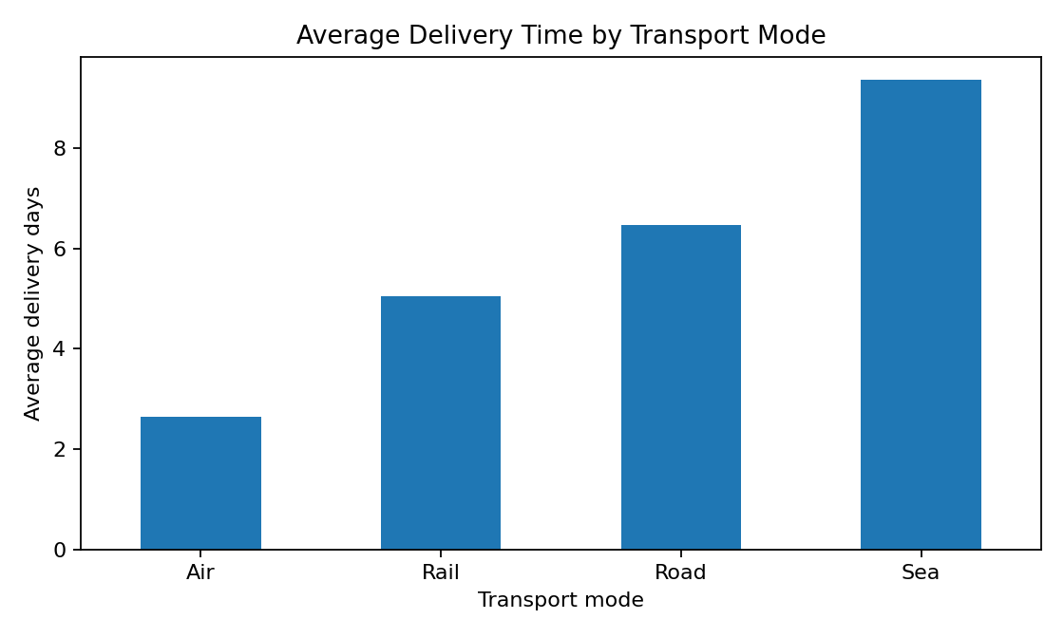
This chart compares average delivery duration across road, rail, air, and sea shipments. Transport modes differ in speed and route characteristics; the best choice depends on urgency, distance, and budget.

Figure 2. Average shipping cost by transport mode
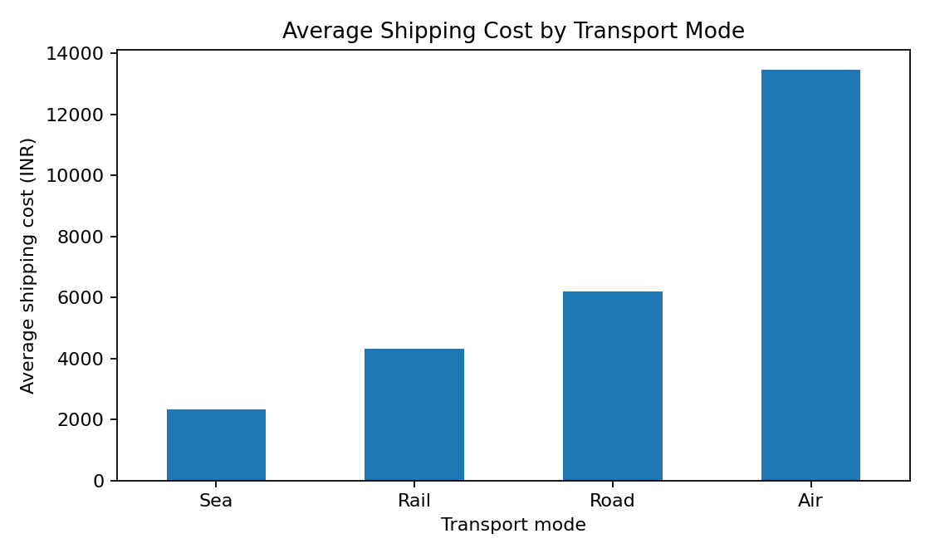
The cost comparison helps identify the trade-off between speed and expense. Air transport is generally more expensive, while sea and rail can be economical for suitable shipments.

Figure 3. On-time delivery rate by region
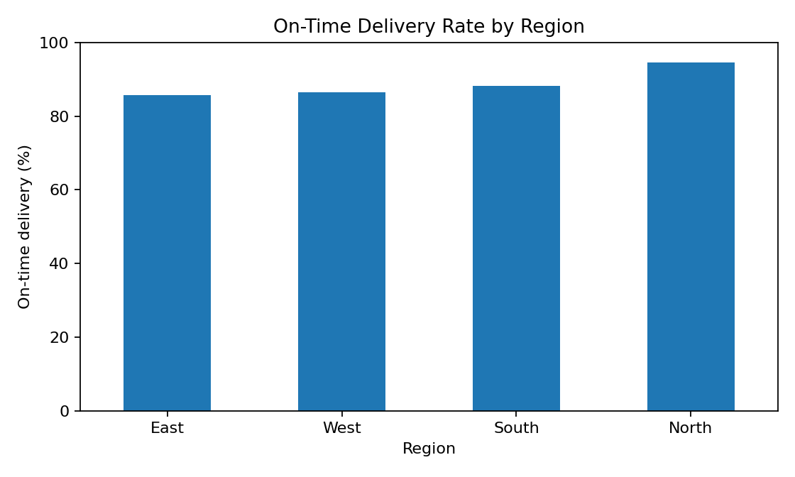
Regional differences may indicate route congestion, weather, handling constraints, or differences in dispatch planning. Regions with lower on-time performance should be investigated.

Figure 4. Delivery delay and customer satisfaction
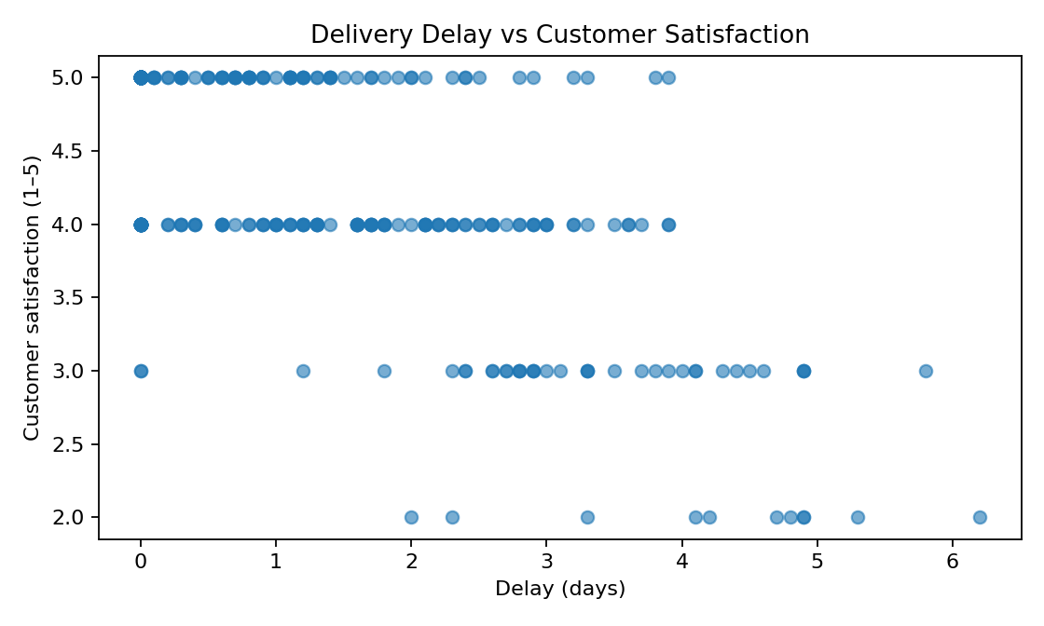
The scatter plot helps assess whether greater delays tend to coincide with lower customer satisfaction. This is an exploratory relationship and does not prove that delay alone causes dissatisfaction.

6. Transport Mode Summary
Mode | Shipments | Avg delivery (days) | Avg cost (₹) | On-time (%)
Air | 55 | 2.64 | 13,445 | 89.1%
Rail | 72 | 5.04 | 4,311 | 87.5%
Road | 134 | 6.47 | 6,198 | 89.5%
Sea | 39 | 9.35 | 2,321 | 87.2%

7. Regional Summary
Region | Shipments | On-time (%) | Avg delay (days)
East | 77 | 85.7% | 1.20
North | 74 | 94.6% | 1.21
South | 68 | 88.2% | 1.63
West | 81 | 86.4% | 1.44

8. Findings and Recommendations
- Monitor on-time delivery rate weekly and investigate regions that repeatedly underperform.
- Choose transport mode based on shipment urgency, distance, and total landed cost rather than cost alone.
- Use early-warning alerts for shipments at risk of delay and notify customers proactively.
- Review carrier performance, dispatch timing, route congestion, and hand-off delays for late shipments.
- Track customer satisfaction alongside delivery performance to understand service quality.
- Validate these findings against real operational data before making business decisions.

9. Limitations
This is a hypothetical dataset created for an internship learning task. Results are illustrative and should not be presented as actual company performance. Real-world analysis should check missing values, outliers, data definitions, sample representativeness, and relevant operational context.

10. Conclusion
The project demonstrates a basic end-to-end logistics analytics workflow: structure shipment data, calculate performance indicators, visualize patterns, interpret results, and suggest operational improvements. Data-driven monitoring can help logistics teams improve reliability, manage cost, and protect customer satisfaction.

Appendix: Python Code
import pandas as pd
import matplotlib.pyplot as plt

df = pd.read_csv("week3_logistics_dataset.csv")

print("Total shipments:", len(df))
print("On-time delivery rate (%):", (df["On_Time"].eq("Yes").mean() * 100).round(2))
print("Average delivery days:", df["Delivery_Days"].mean().round(2))
print("Average shipping cost:", df["Shipping_Cost_INR"].mean().round(2))

# Compare delivery time by transport mode
df.groupby("Transport_Mode")["Delivery_Days"].mean().sort_values().plot(kind="bar")
plt.title("Average Delivery Time by Transport Mode")
plt.xlabel("Transport Mode")
plt.ylabel("Average Delivery Days")
plt.tight_layout()
plt.show()

# Compare cost by transport mode
df.groupby("Transport_Mode")["Shipping_Cost_INR"].mean().sort_values().plot(kind="bar")
plt.title("Average Shipping Cost by Transport Mode")
plt.xlabel("Transport Mode")
plt.ylabel("Average Shipping Cost (INR)")
plt.tight_layout()
plt.show()

# On-time performance by region
(df.groupby("Region")["On_Time"].apply(lambda x: x.eq("Yes").mean() * 100)
.sort_values().plot(kind="bar"))
plt.title("On-Time Delivery Rate by Region")
plt.xlabel("Region")
plt.ylabel("On-Time Delivery (%)")
plt.tight_layout()
plt.show()

# Delay versus customer satisfaction
plt.scatter(df["Delay_Days"], df["Customer_Satisfaction_1_to_5"], alpha=0.6)
plt.title("Delivery Delay vs Customer Satisfaction")
plt.xlabel("Delay (days)")
plt.ylabel("Customer Satisfaction (1-5)")
plt.tight_layout()
plt.show()

