1. GITHUB URL: <https://github.com/harishbabua/capstone-html>

CIRCLE CI URL: <https://app.circleci.com/pipelines/github/harishbabua/capstone-html/11/workflows/d8579e4a-f036-481c-9623-70b33d7bc567>

1. Use image repository to store Docker images

* docker pull harishbabua/udablueimage

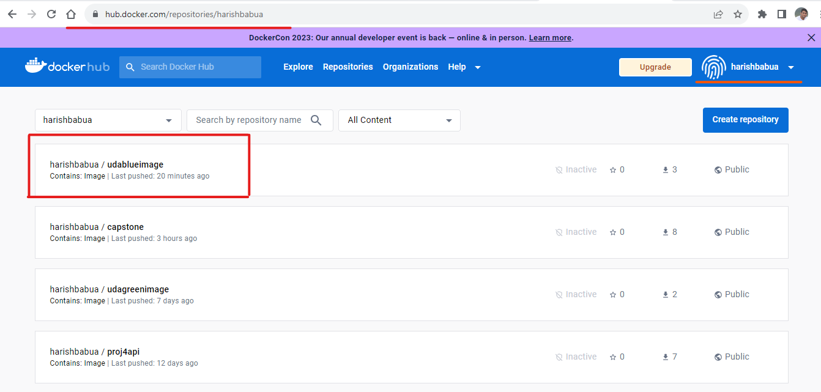

### **EKS Cluster :**

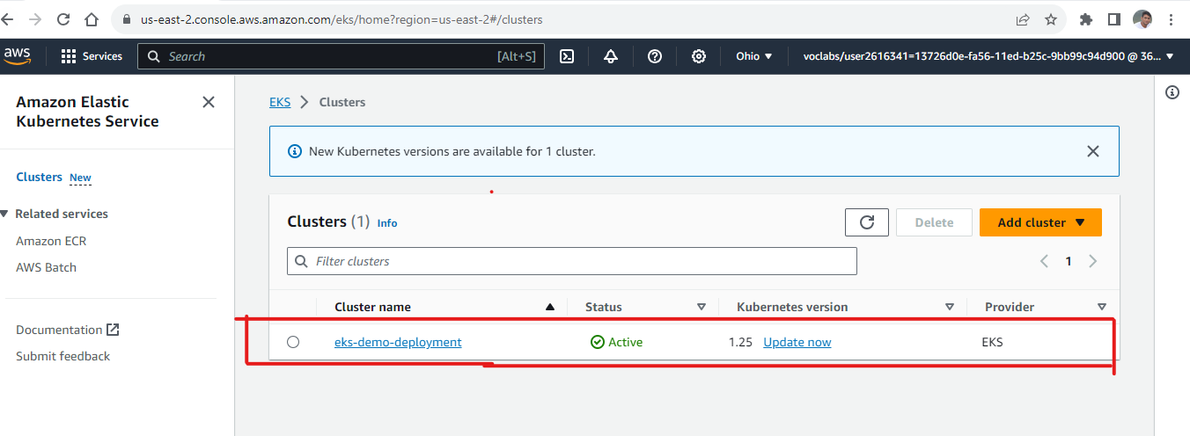

### **VERIFYING EKS CLUSTER**

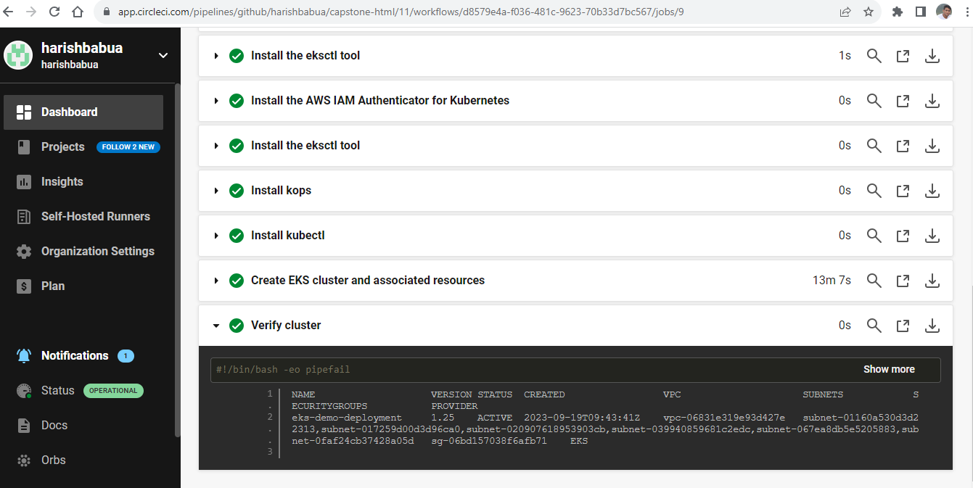

### **SERVICE**

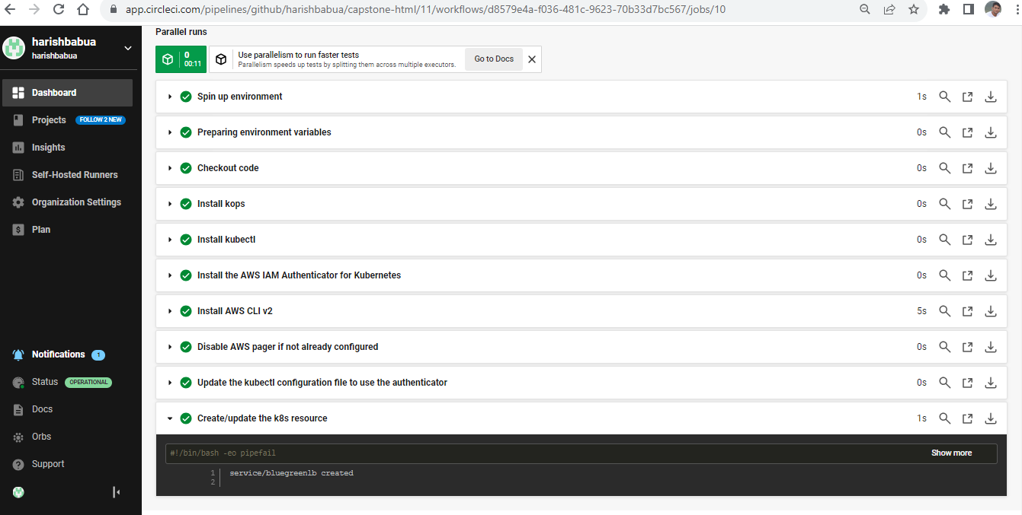

### **CREATE DEPLOYMENT**

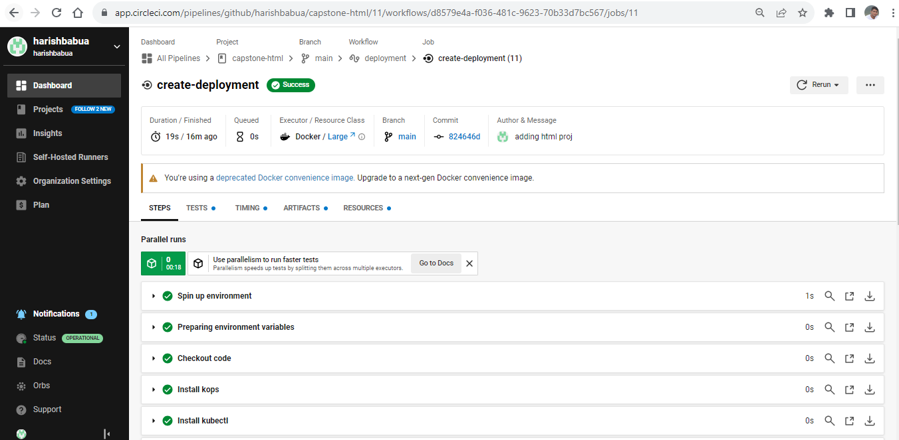

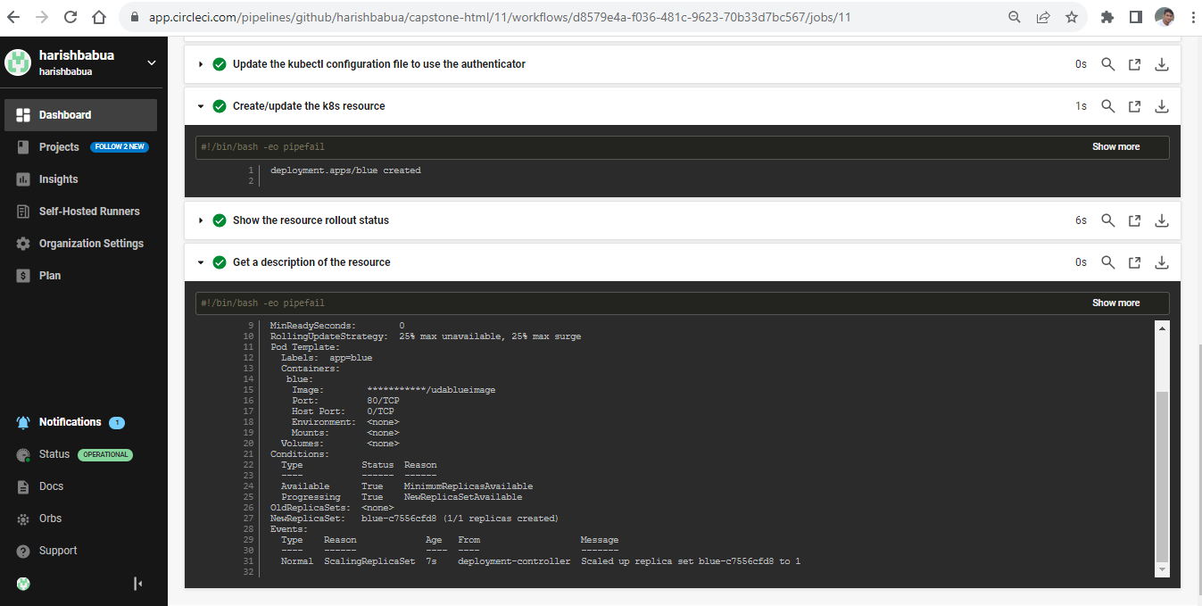

### **aws-eks/update-container-image**

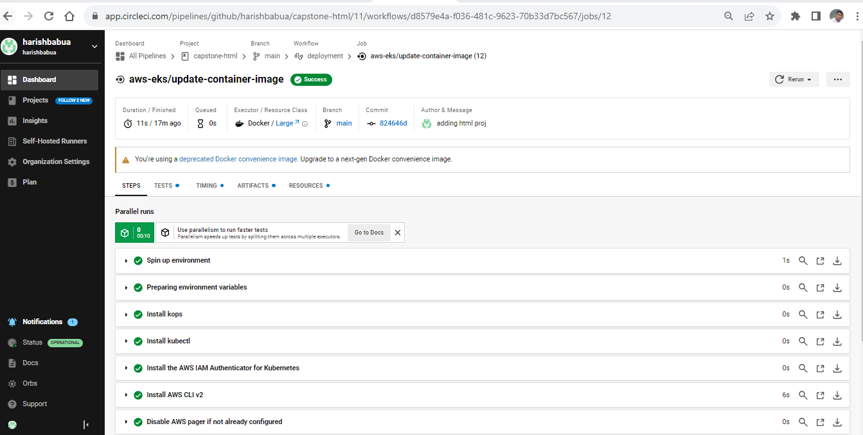

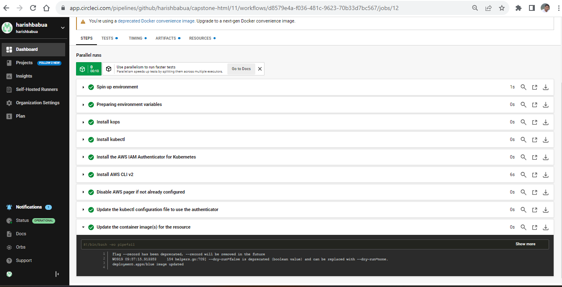

### LOAD BALANCER

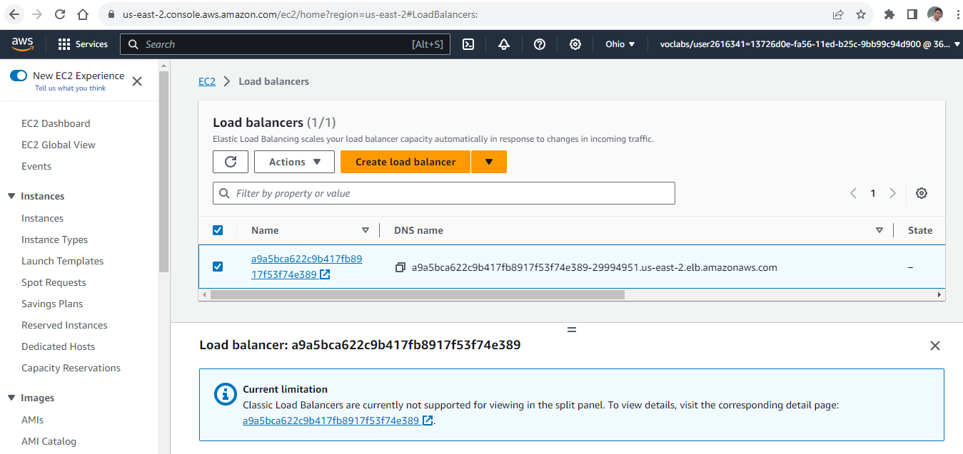

### **EC2:**

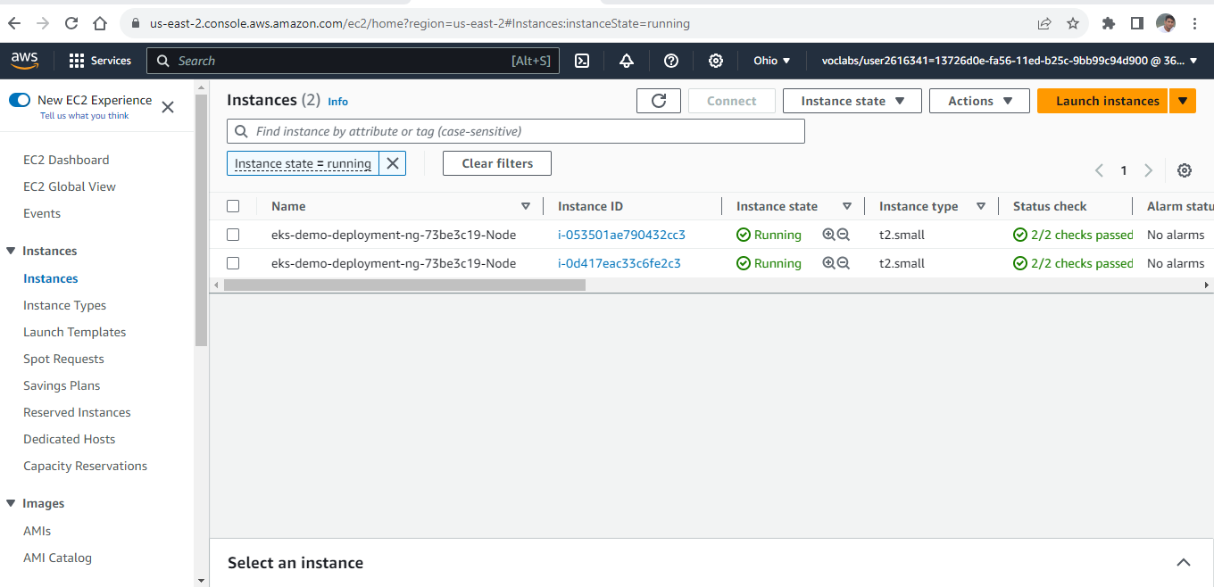

**LOAD BALANCER URL** : <http://a9a5bca622c9b417fb8917f53f74e389-29994951.us-east-2.elb.amazonaws.com:8000>

### **WORKING APPLICATION**

