jQuery_Day – 1_Week3_Hands_On -- Kaveri Harish Babu
Problem 1
Problem Statement:
Problem 1 (Level-1): Student Feedback Form Interaction
Scenario:
A training institute wants to collect feedback from students through a simple web form. They want to enhance user experience using jQuery to validate inputs and display messages dynamically without reloading the page.
Requirements
• Create a feedback form with fields: Name, Email, Course Rating (dropdown), and Comments.
• Use jQuery selectors to capture form inputs.
• On clicking the Submit button, validate that Name and Email are not empty.
• Display a success message dynamically below the form using jQuery DOM manipulation.
• Clear the form fields after successful submission.

️ Technical Constraints
• Use jQuery CDN for integration.
• Use basic jQuery syntax: $(selector).action().
• Do not use plain JavaScript for validation (only jQuery methods).
• No backend integration required.

Expectations:
• Proper use of jQuery selectors and event handling.
• Clean and readable code structure.
• Validation messages should be user-friendly.

Learning Outcome:
• Understand jQuery syntax and selectors.
• Learn basic DOM manipulation using jQuery.

Source Code:
File Name: Index.html
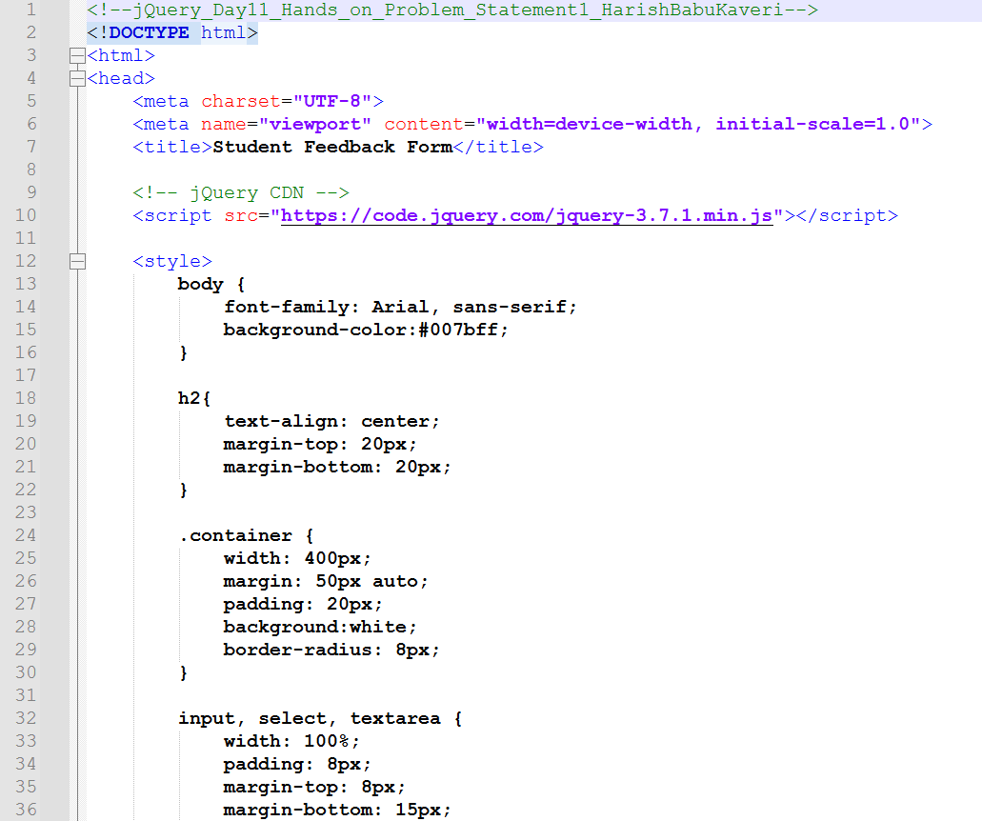
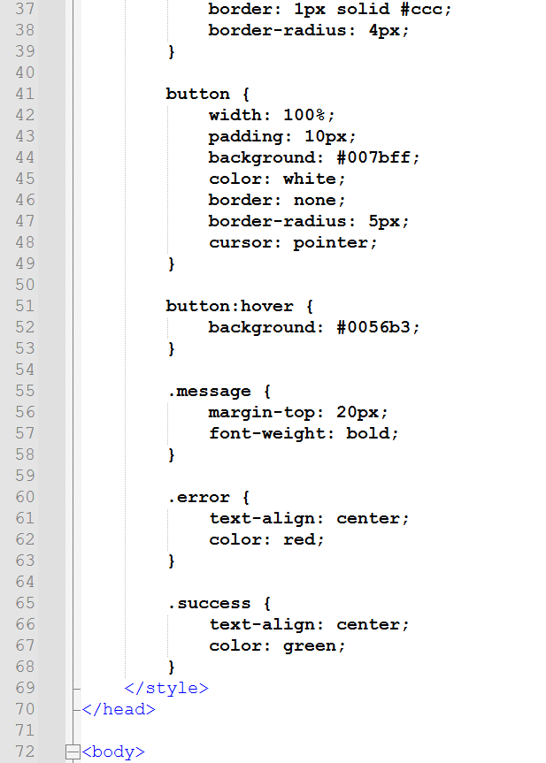
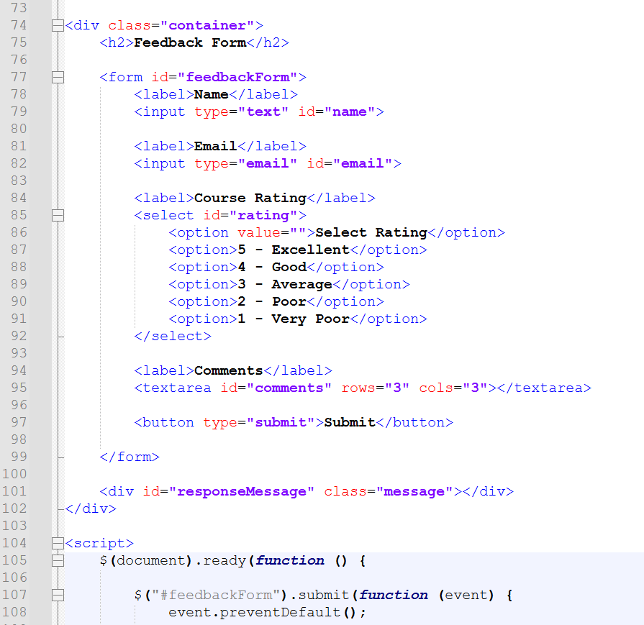
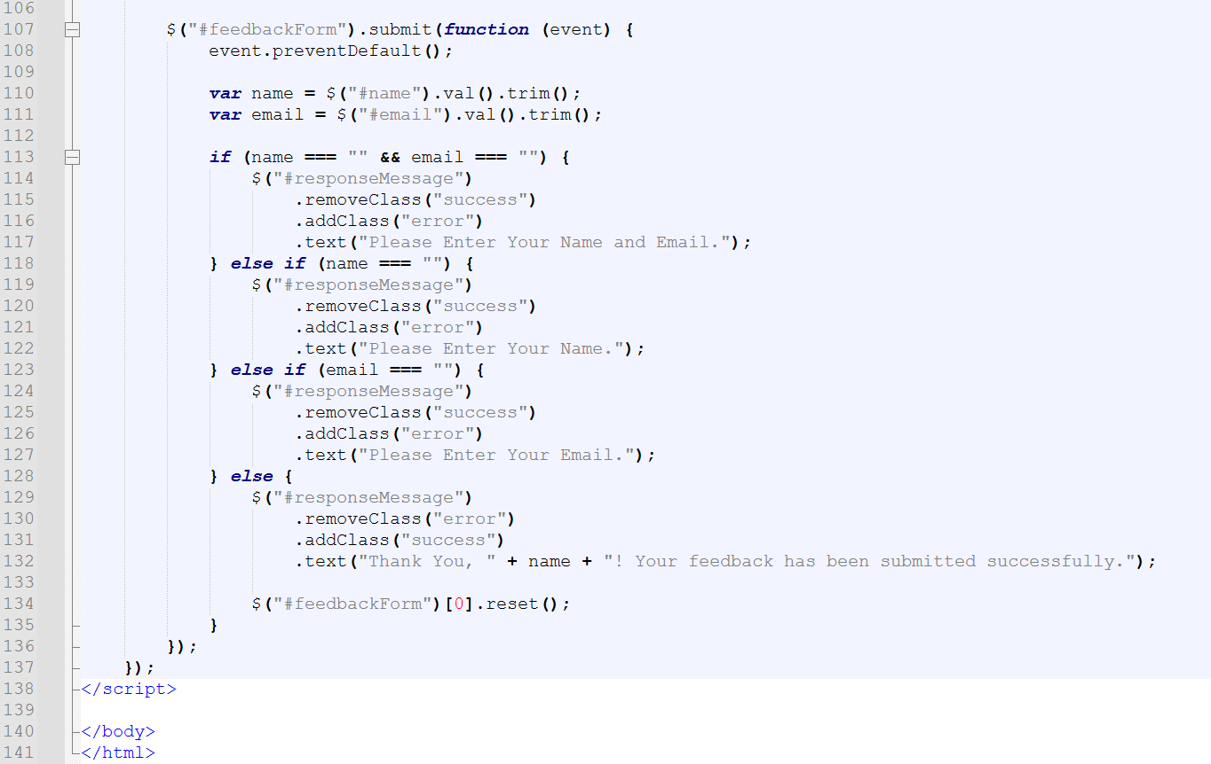

Output:
Output File: index.html
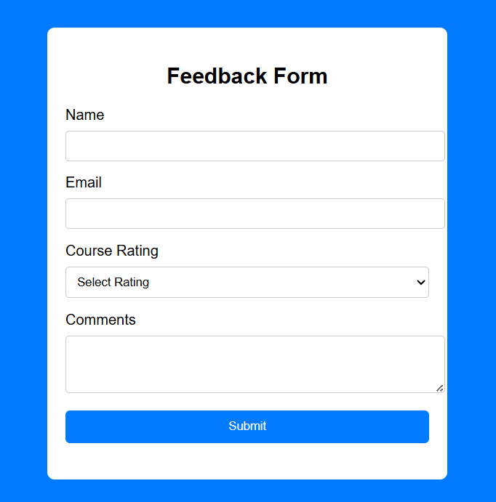
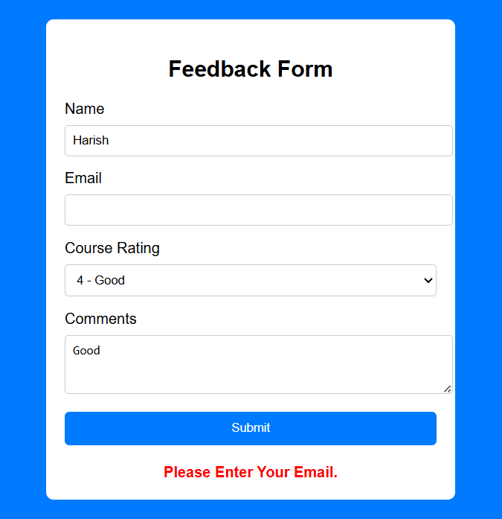
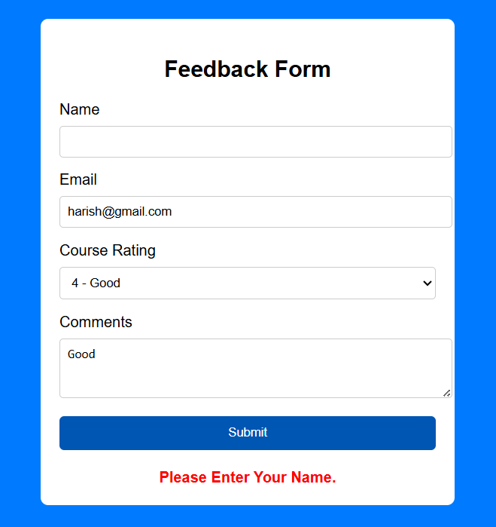
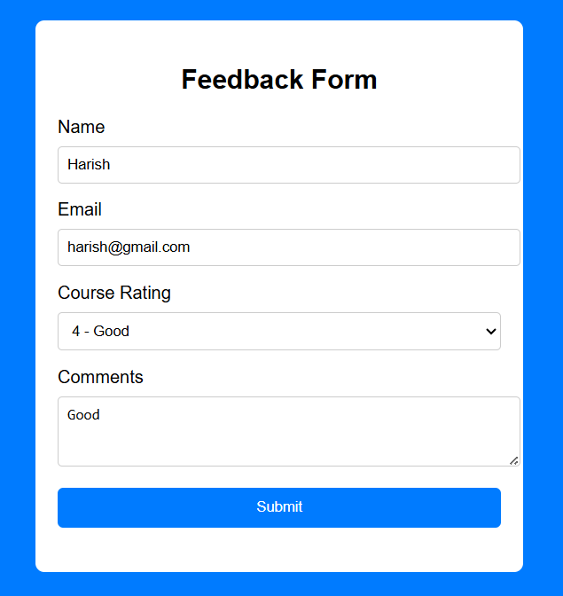

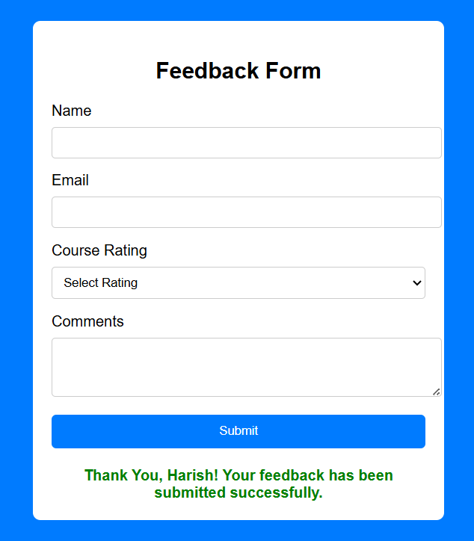
Explanation:
This code creates a Feedback Form using HTML, CSS, and jQuery. When you click Submit, jQuery checks if the Name and Email fields are filled and shows error messages if they’re empty. If everything is filled correctly, it shows a green success message like “Thank You, Your_Name! Your feedback has been submitted successfully.” and then clears the form.
Problem 2
Problem Statement: (Level-1): Dynamic FAQ Toggle Section
Scenario:
A website contains a Frequently Asked Questions (FAQ) section. The company wants answers to appear and disappear when users click on the questions.
Requirements
• Create at least 5 FAQ questions with hidden answers.
• Use jQuery click() event to toggle answers.
• Apply slideToggle() or show()/hide() methods.
• Highlight the selected question using CSS class manipulation.

️ Technical Constraints
• Use only jQuery methods for DOM manipulation.
• Use class selectors and ID selectors appropriately.
• Avoid inline JavaScript.

Expectations:
• Smooth UI interaction.
• Proper use of jQuery effects.
• Organized HTML structure.

Learning Outcome
• Implement event handling using jQuery.
• Use basic jQuery effects.
• Practice DOM traversal and manipulation.
Source Code:
File Name: index.html
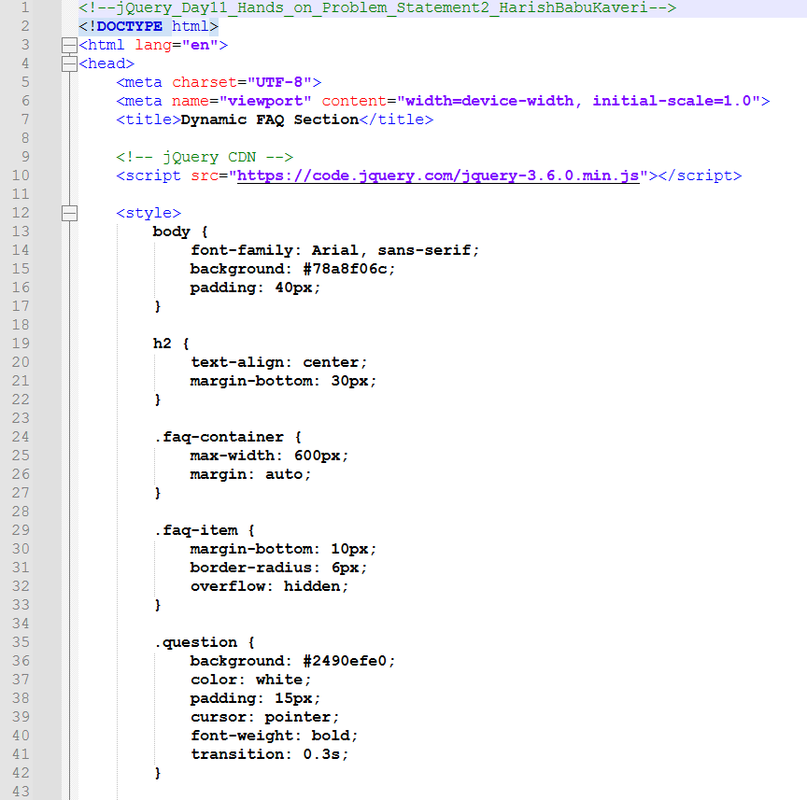
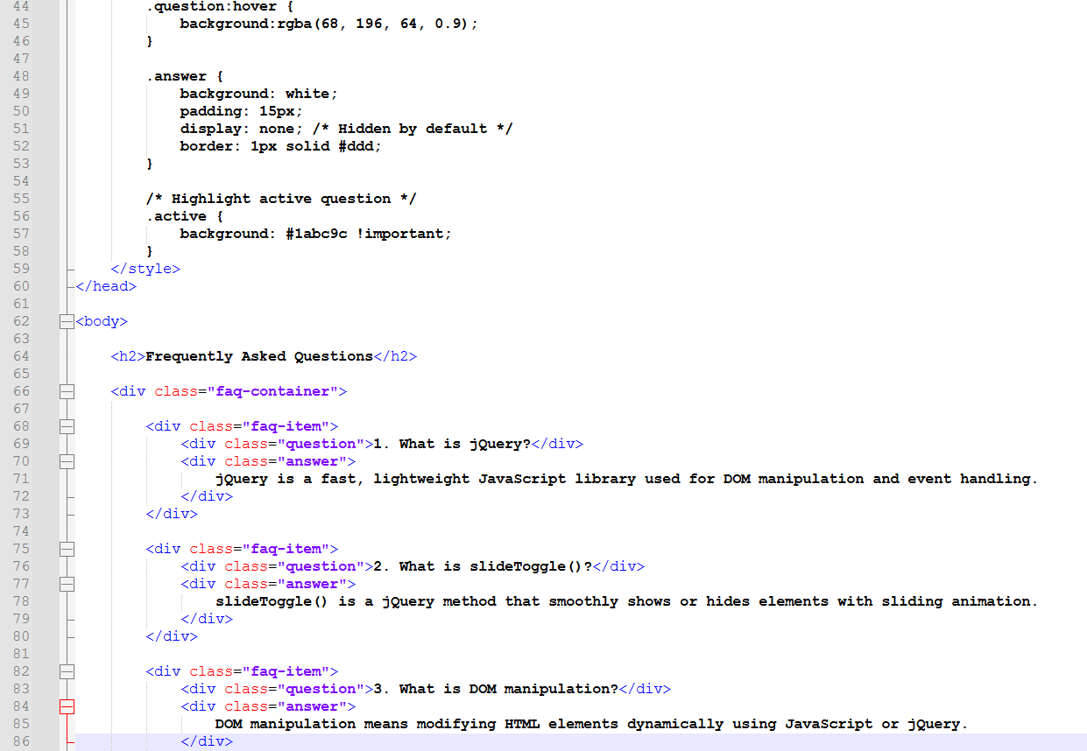
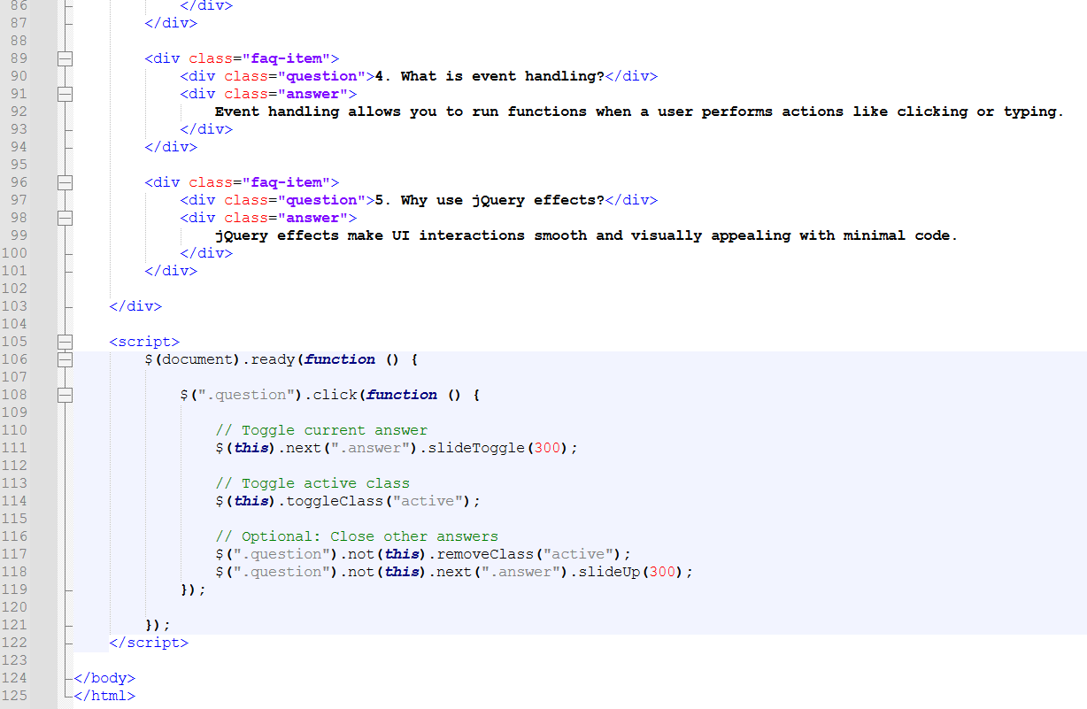
Output:
Output File: index.html
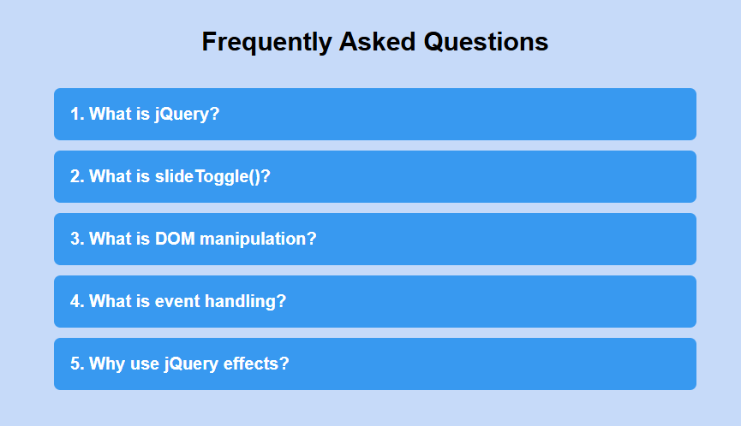
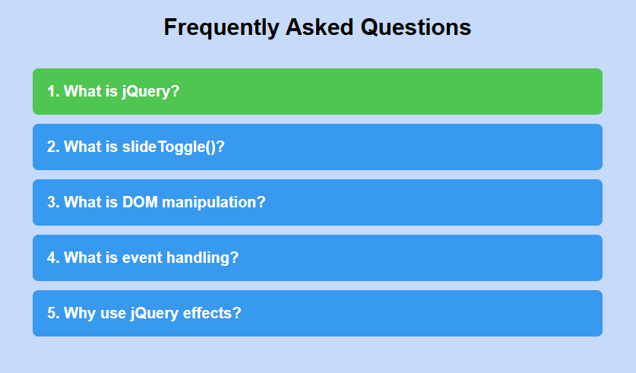
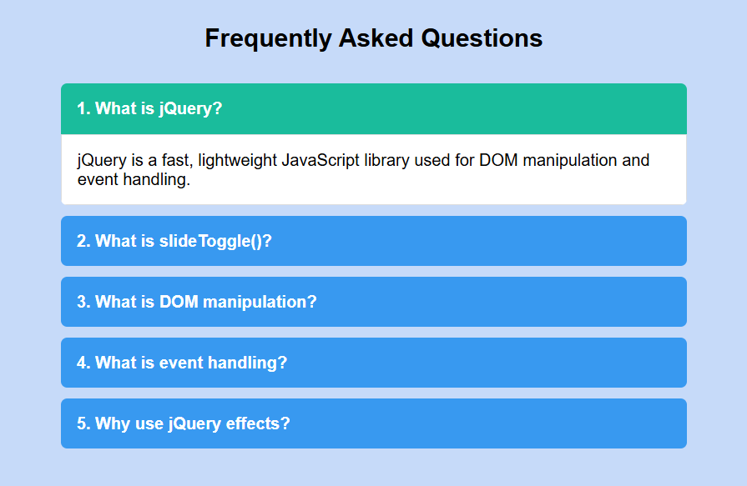

Explanation:
This code creates a FAQ section where answers are hidden by default. When you click on a question, jQuery uses slideToggle() to smoothly show or hide the answer and highlights the selected question. If you click another question, the previous one closes automatically, making it look clean and interactive.

Problem 3
Problem Statement: (Level-2): Product List with Add to Cart Counter
Scenario:
An e-commerce website wants to display a list of products. When users click 'Add to Cart', the cart counter at the top should increase dynamically.
Requirements
• Display at least 4 products with 'Add to Cart' buttons.
• Use jQuery to handle button click events.
• Increase the cart counter dynamically without page refresh.
• Disable the button once the product is added.
• Display a small confirmation message beside the product.

️ Technical Constraints
• Use jQuery event delegation if needed.
• Use .text(), .attr(), and .prop() methods.
• No backend or database integration.
Expectations:
• Efficient event handling.
• Proper use of jQuery methods for attribute manipulation.
• Clean UI updates.

Learning Outcome
• Understand advanced DOM manipulation.
• Use jQuery methods for dynamic content updates.
• Apply event delegation concepts.
Source Code:
File Name: index.html

Output:
Output File: index.html

Explanation:

Problem 4
Problem Statement: (Level-2): Interactive To-Do List Application
Scenario:
A productivity web app requires a dynamic To-Do List where users can add, mark as complete, and remove tasks using jQuery.

Requirements
• Provide an input field and Add button to insert tasks.
• Display tasks dynamically in a list.
• Allow users to mark tasks as completed (strike-through effect).
• Provide a delete button for each task.
• Display total task count and completed task count dynamically.

️ Technical Constraints
• Use jQuery for all DOM manipulation and event handling.
• Use append(), remove(), toggleClass(), and on() methods.
• No external libraries except jQuery.

Expectations:
• Proper dynamic element handling.
• Efficient event binding for dynamically created elements.
• Responsive and interactive UI behavior.

Learning Outcome
• Master jQuery DOM manipulation.
• Implement dynamic event handling.
• Build a small interactive application using jQuery.

Source Code:
File Name: index.html

Output:
Output File: index.html

Explanation:

