BootStrap_Day – 4_Week2_Hands_On -- Kaveri Harish Babu
Problem 1
Problem Statement: Responsive Personal Portfolio Homepage(Level-1)
Scenario:
You are designing a responsive personal portfolio homepage for a fresher web developer who wants to showcase profile information, skills, and contact details.

📌 Requirements
- Integrate Bootstrap 5 using CDN.
- Create a responsive layout using container, rows, and columns.
- Use Bootstrap grid system with appropriate breakpoints.
- Include components such as navbar, cards (for skills), and buttons.
- Use utility classes for spacing, alignment, and colors.
🛠️ Technical Constraints
- Must use Bootstrap 5 CDN (no local files).
- No custom CSS except minimal styling if required.
- Use grid system (row and col classes) properly.
- Ensure responsiveness across mobile, tablet, and desktop.
🎯 Learning Outcome
- Understand Bootstrap setup using CDN.
- Learn responsive grid system and breakpoints.
- Implement basic Bootstrap components.
- Apply utility classes effectively.

Source Code:
File Name: index.html

Output:
Output File: index.html

Explanation:
This code creates a simple Feedback Form where the user can type feedback and click Submit Feedback. JavaScript checks if the textarea is empty before submitting. If no feedback is entered, it shows a red error message asking the user to enter feedback. If feedback is provided, it displays a green success message and clears the textbox.

Problem 2
Problem Statement: Product Listing Page Using Bootstrap(Level-1)
Scenario:
Create a responsive product listing page for an online electronics store displaying multiple products in card format.

📌 Requirements
- Use Bootstrap grid to display products in 1 column (mobile), 2 columns (tablet), and 4 columns (desktop).
- Each product should be displayed using Bootstrap Card component.
- Include buttons such as “Add to Cart” and “View Details”.
- Use spacing utilities and background color utilities.

🛠️ Technical Constraints
- Must use Bootstrap CDN.
- Use built-in Bootstrap classes only.
- Proper use of container, row, and col classes.

Expectations:
- Fully responsive layout.
- Equal card height alignment.
- Proper spacing using margin and padding utilities.

🎯 Learning Outcome
- Master grid layouts with multiple breakpoints.
- Use Bootstrap cards and buttons.
- Apply spacing and color utility classes.

Source Code:
File Name: index.html
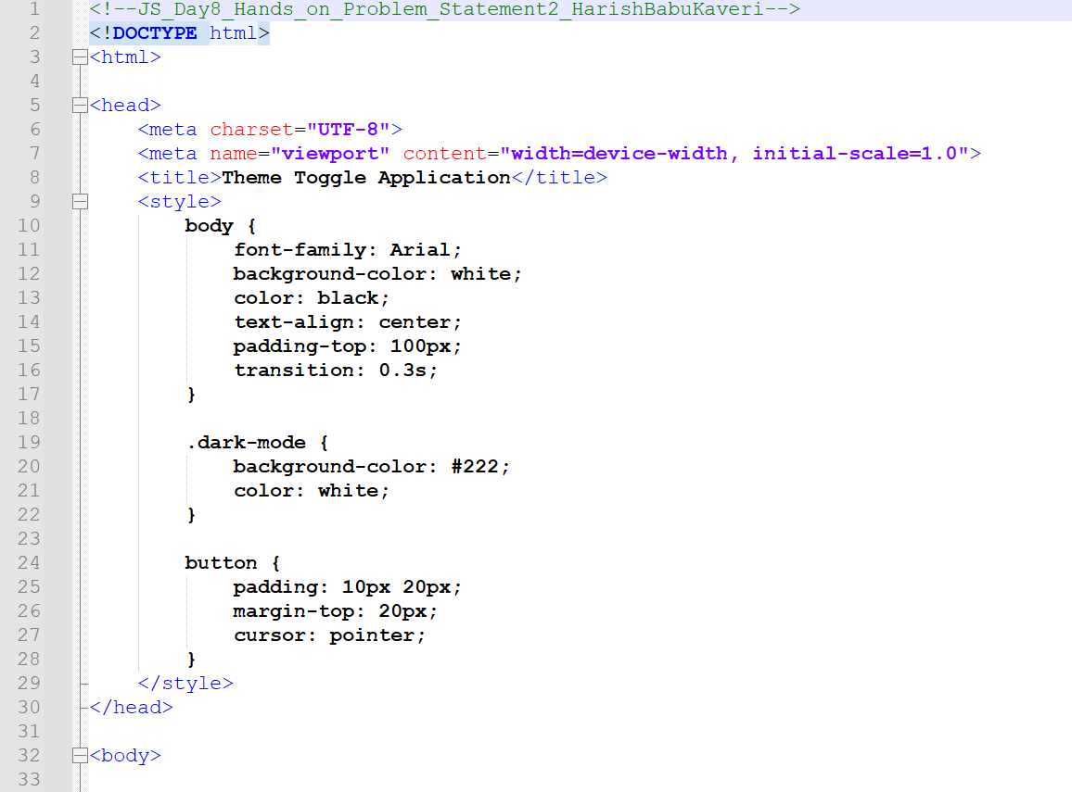
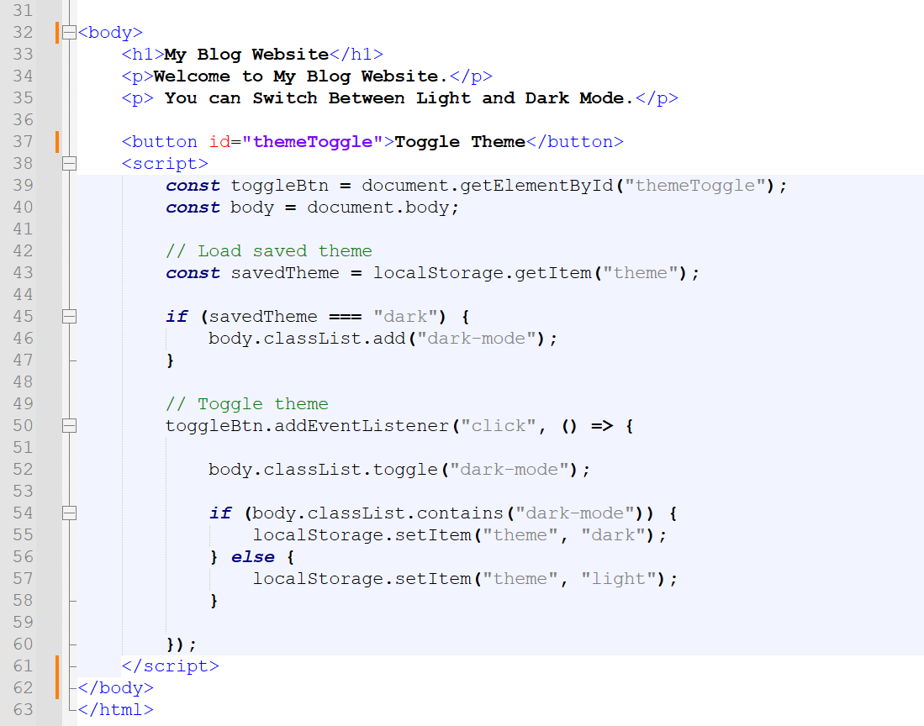
Output:
Output File: index.html
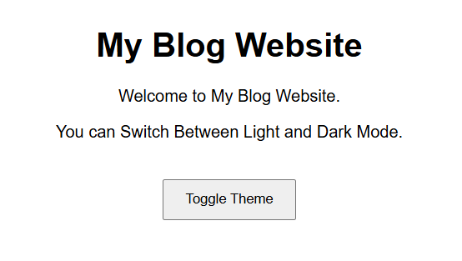
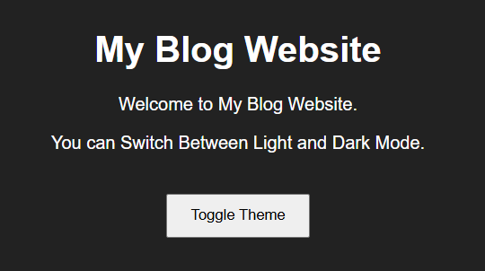
Explanation:
This code creates a simple Theme Toggle webpage where the user can switch between Light mode and Dark mode by clicking the Toggle Theme button. JavaScript adds or removes the dark-mode class to change the background and text color, and it also saves the selected theme in localStorage so the same theme stays when the page is refreshed.

Problem 3
Problem Statement: Dynamic To-Do List (Level-2)
Scenario:
A productivity application requires an interactive To-Do list where users can add, delete, and mark tasks as complete without refreshing the page.
📌 Requirements
• Add new tasks dynamically.
• Delete tasks on button click.
• Mark tasks as completed.
• Use event delegation for better performance.

🛠️ Technical Constraints
• Must use DOM manipulation.
• Event delegation required.
• Code should follow modular structure.

Expectations:
• Fully functional interactive UI.
• Organized and reusable functions.

🎯 Learning Outcome
• Advanced DOM event handling.
• Event delegation concept.
• Understanding role of libraries in speeding up development.
Source Code:
File Name: index.html
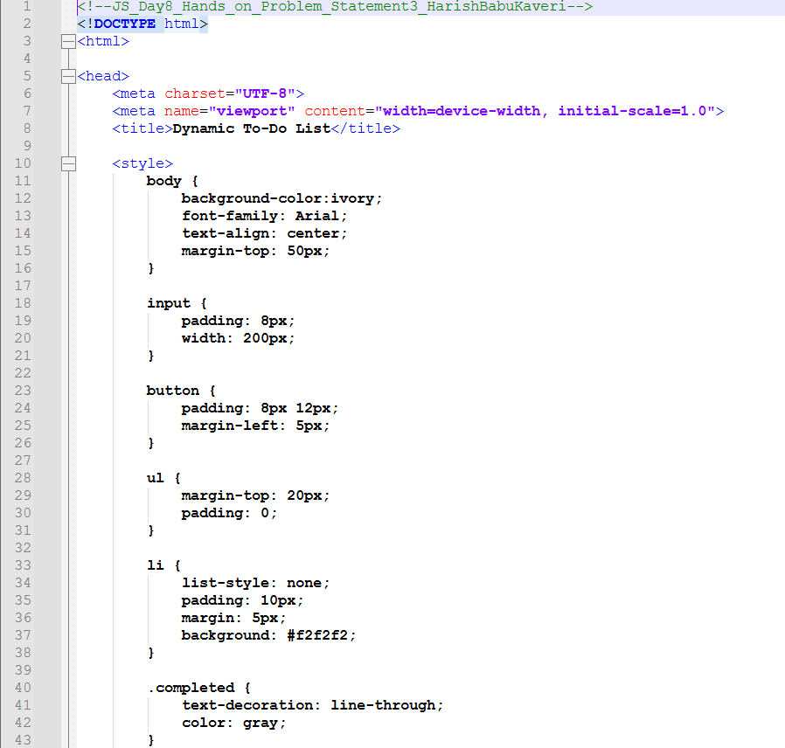
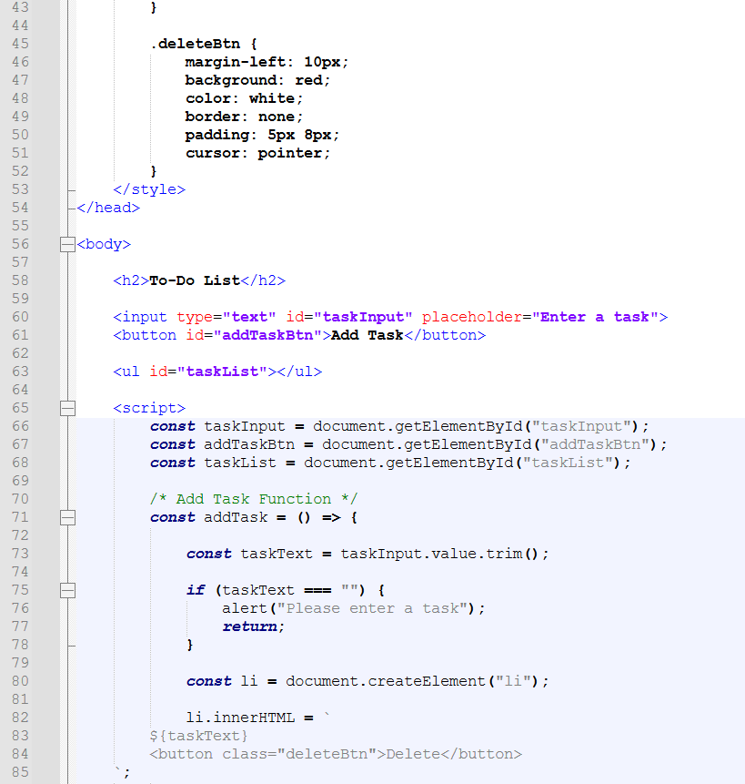
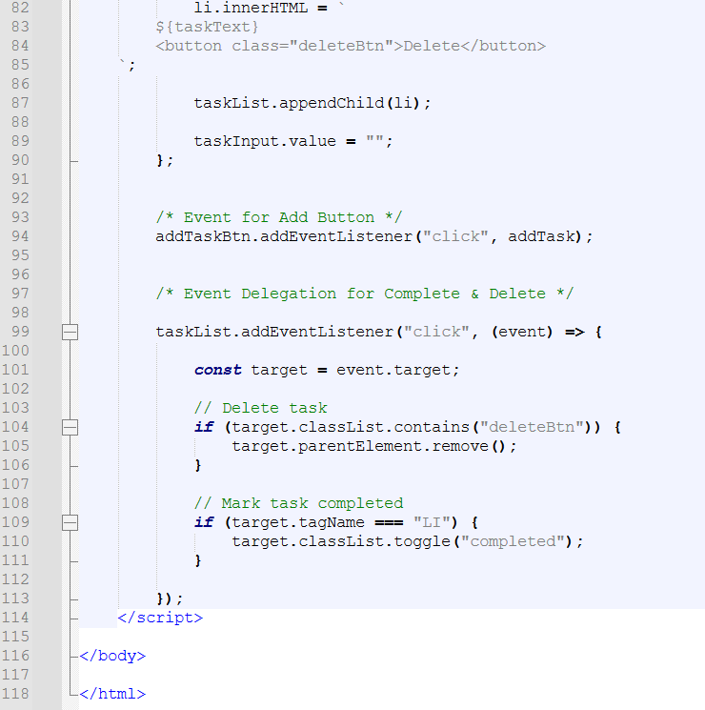

Output:
Output File: index.html
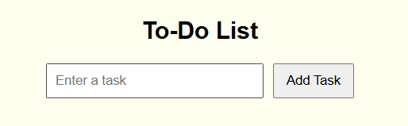
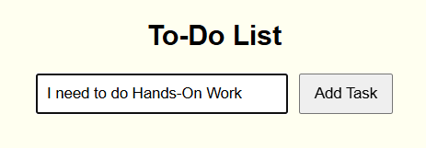
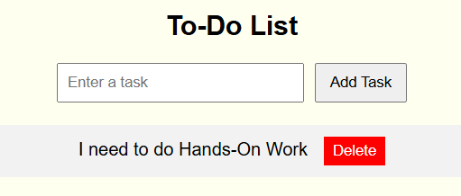
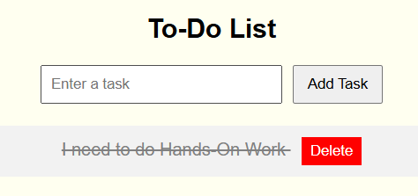
Explanation:
This code creates a simple To-Do List web app where users can type a task and click Add Task to display it in the list. When a task is added, it appears with a Delete button, and clicking the task marks it as completed (line-through). Users can also remove tasks by clicking the delete button.

Problem 4
Problem Statement: Mini Product Search App (Level-2)
Scenario:
An e-commerce company needs a mini product search application that filters products dynamically as users type in the search box.

📌 Requirements
• Display product list from a predefined array.
• Filter products dynamically using input event.
• Display “No Results Found” when applicable.

🛠️ Technical Constraints
• Must use DOM manipulation.
• Event delegation required.
• Code should follow modular structure.

Expectations:
• Real-time filtering.
• Proper state management.

🎯 Learning Outcome
• State management basics.

Source Code:
File Name: index.html
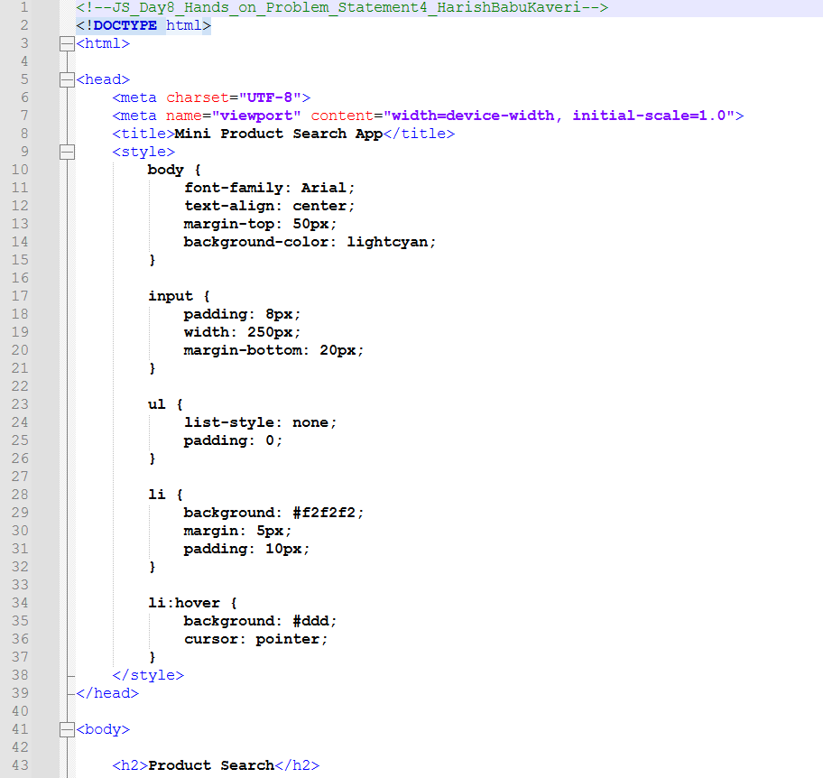
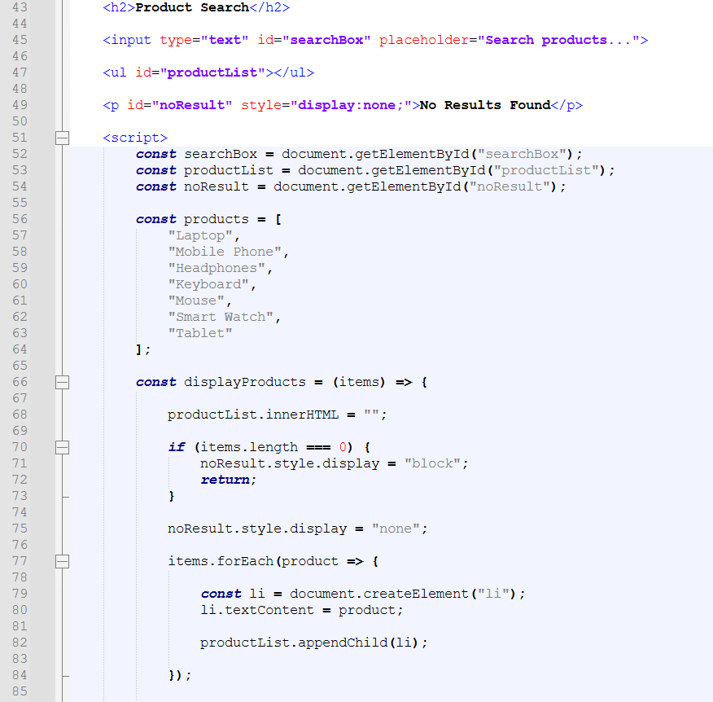
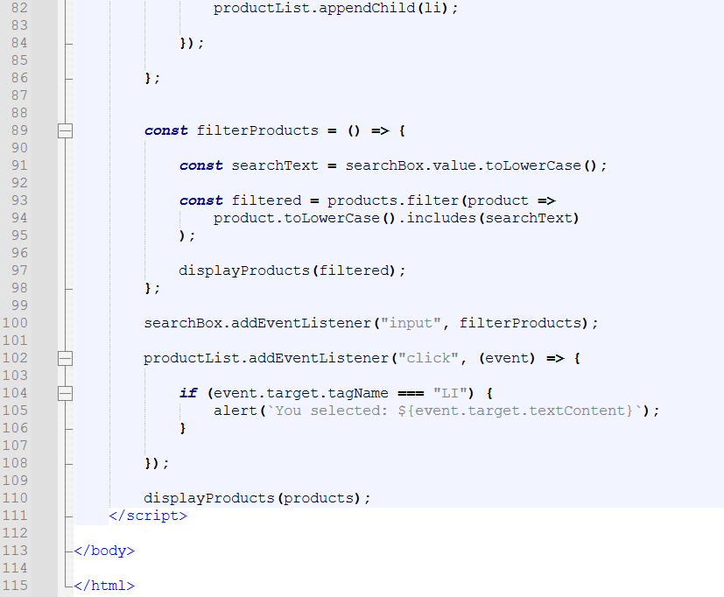
Output:
Output File: index.html


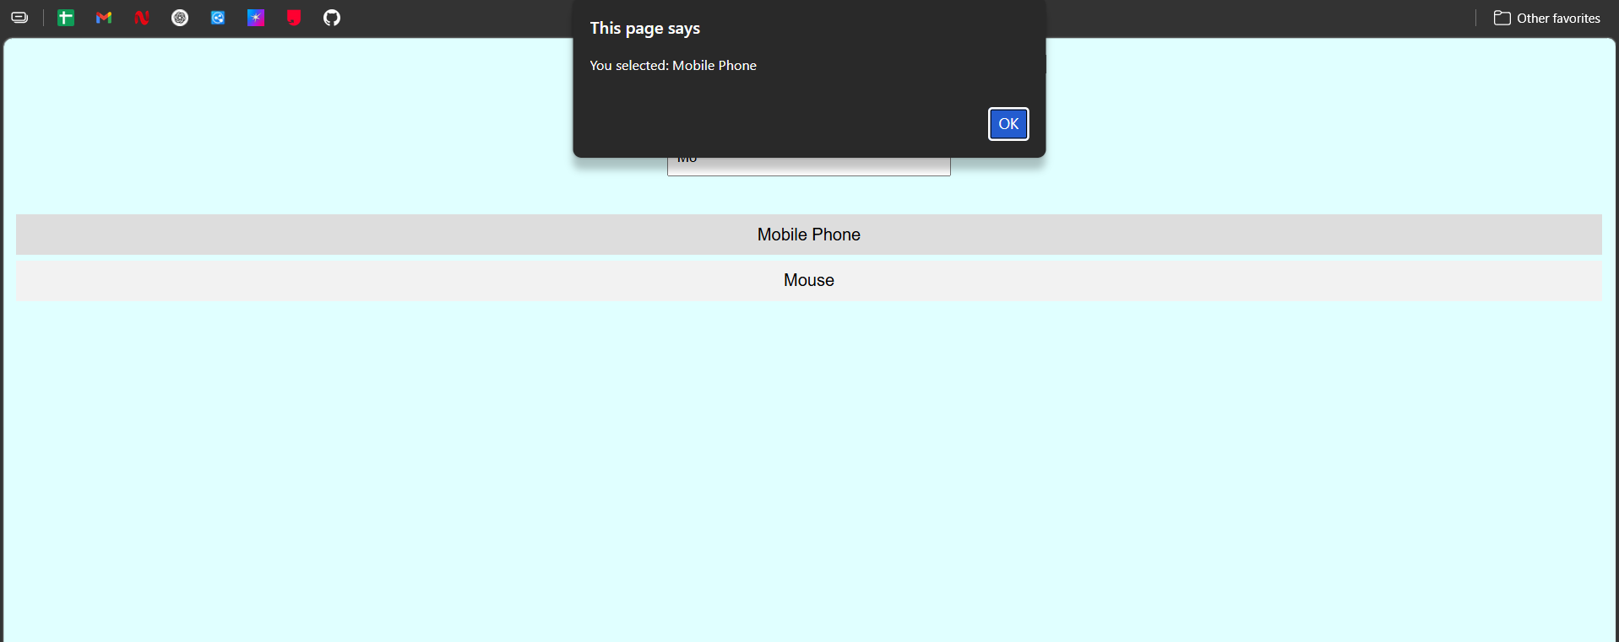

Explanation:
This code creates a simple Product Search app where a list of products is shown on the page. When the user types something in the search box, JavaScript filters the products in real time and only matching items are displayed. If a user clicks on any product, an alert message shows the selected product name, and if nothing matches the search, it displays “No Results Found.”

