HTML5 – Day – 1 Hands On – Kaveri Harish Babu
Problem 1
Problem Statement:
1. Create a basic HTML page with proper structure (DOCTYPE, head, body)
2. Add a heading and a paragraph introducing yourself
3. Create an unordered list showing your hobbies
4. Create an ordered list showing daily routine steps
5. Create a simple table showing:
o Student Name
o Subject
o Marks
Source Code:
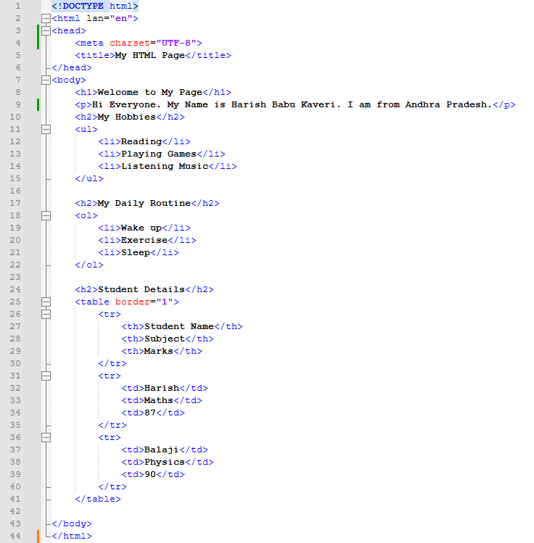
Output:
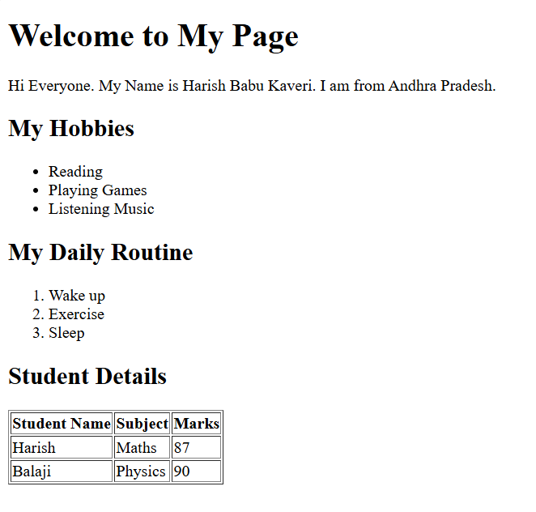
Explanation:
This code creates a simple personal webpage. It shows a welcome heading, a short introduction about me, My hobbies in bullet points, My daily routine in numbered form, and a table with student details like Name, Subject, and Marks.

Problem 2
Problem Statement:
A small restaurant wants a basic menu webpage to display their offerings online before moving to a full website.
📌 Requirements
Create an HTML page that displays:
1. Restaurant Name (Heading)
2. About the Restaurant (Paragraph)
3. Menu Categories (Unordered List)
4. Price List (Table)
🛠️ Technical Constraints
- Use proper HTML boilerplate
- Use at least 5 HTML elements
- Use HTML attributes such as border, title, align
- Use:
  - <table>, <tr>, <th>, <td>
  - <ul> and <li>
🎯 Learning Outcome
You should be able to:
- Build a complete HTML page structure
- Use tables for structured data
- Use lists for grouped information

Source Code:
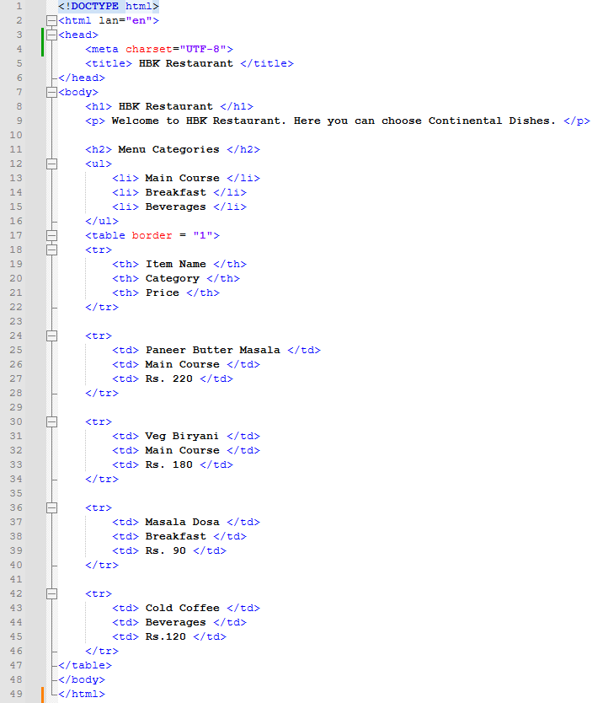
Output:
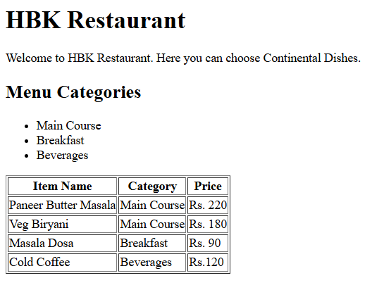
Explanation:
This code creates a simple restaurant webpage for HBK Restaurant. It shows the restaurant name, a short welcome message, menu categories in bullet points, and a table with item names, categories, and prices.
Problem 3
Problem Statement:
You are building a simple webpage for personal use to plan your weekly grocery shopping. The page should clearly show priority items and optional items, so it’s easy to decide what to buy first.
📌 Requirements
Create an HTML webpage that includes:
- A page title:
Weekly Grocery Checklist
- A main heading displaying the same title.
- An Ordered List showing high-priority grocery items, such as:
  - Rice
  - Milk
  - Vegetables
  - Cooking Oil
- An Unordered List showing optional or non-essential items, such as:
  - Snacks
  - Ice cream
  - Soft drinks

🛠️ Technical Constraints
- Use proper HTML boilerplate:
  - <!DOCTYPE html>
  - <html>, <head>, <body>

- Use:
  - <ol> and <ul> correctly
  - <li> for each item
- Add at least one HTML attribute (example: title)
- Ensure proper indentation and readability
🎯 Learning Outcome
You will be able to:
- Create structured content using HTML lists
- Choose the correct list type based on real-world requirements
- Understand how HTML represents logical order and grouping
- Build confidence in writing basic but meaningful HTML pages
Source Code:
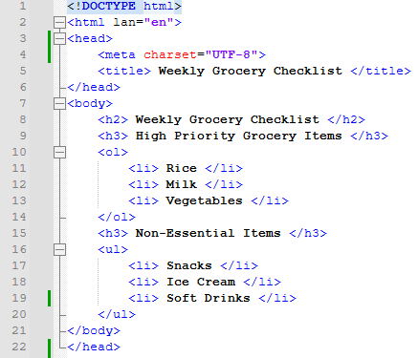

Output:
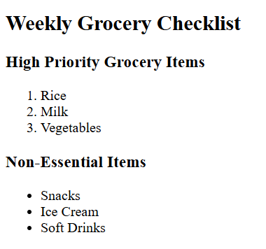
Explanation:
This code creates a simple webpage for a Weekly Grocery Checklist. It shows a main heading, then high-priority items in a numbered list, and non-essential items in bullet points.

Problem 4
Problem Statement:
A company wants a basic onboarding page for new employees that HR can later style using CSS.
📌 Requirements
Use Semantic HTML:
- <header> → Company name & welcome message
- <section> → Employee details
- <article> → Company policies
- <footer> → Contact information
Content Structure
- Employee Information (Table)
  - Employee ID
  - Name
  - Department
  - Joining Date
- Company Policies (Ordered List)
  - Working hours
  - Leave policy
  - Code of conduct
- Facilities Provided (Unordered List)
  - Laptop
  - Internet access
  - Training materials

🛠️ Technical Constraints
- Use semantic tags only (no <div> for layout)
- Add meaningful attributes (title, lang, etc.)
- Proper indentation & readability
🎯 Learning Outcome
Learners should be able to:
- Explain why semantic HTML matters
- Differentiate between structural and non-structural tags
- Build readable, SEO-friendly HTML
Source Code:
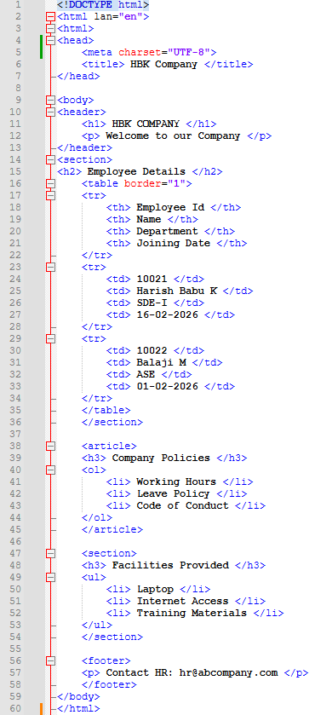
Output:
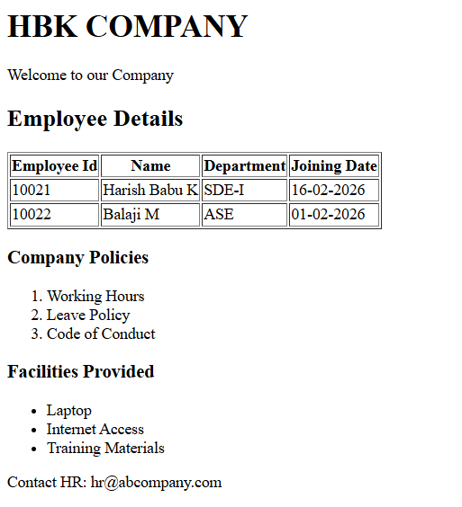
Explanation:
This code creates a simple company webpage for HBK Company. It shows a header with the company name, a table displaying employee details, company policies in a numbered list, facilities in bullet points, and a contact email in the footer.

Problem 5
Problem Statement:
A college wants to create a basic informational webpage for one of its departments (e.g., Computer Science, Information Technology).
The page will be used by students and parents to understand faculty details, subjects offered, and the weekly timetable before the site is enhanced with CSS and backend features.
📌 Requirements
Create an HTML webpage that includes the following sections:
- Header
  - Department Name
  - College Name
- Section 1: Faculty Details
  - Display faculty information in a table with columns:
    - Faculty Name
    - Designation
    - Subject Handled
- Section 2: Subjects Offered
  - Display the list of subjects using an unordered list
- Section 3: Weekly Timetable
  - Display timetable details in a table with columns:
    - Day
    - Subject
    - Time Slot

- Footer
  - College address
  - Contact information

🛠️ Technical Constraints
- Use proper HTML document structure:
  - <!DOCTYPE html>
  - <html>, <head>, <body>
- Use semantic HTML elements:
  - <header>, <section>, <footer>
- Use:
  - <table>, <tr>, <th>, <td>
  - <ul> and <li>
- Add meaningful HTML attributes such as lang or title
- Avoid CSS and JavaScript (HTML only)
🎯 Learning Outcome
You will be able to:
- Build real-world HTML pages with structured content
- Understand how semantic HTML improves readability and maintenance
- Organize information logically using tables and lists
- Prepare HTML content that is ready for CSS styling and backend integration

Source Code:
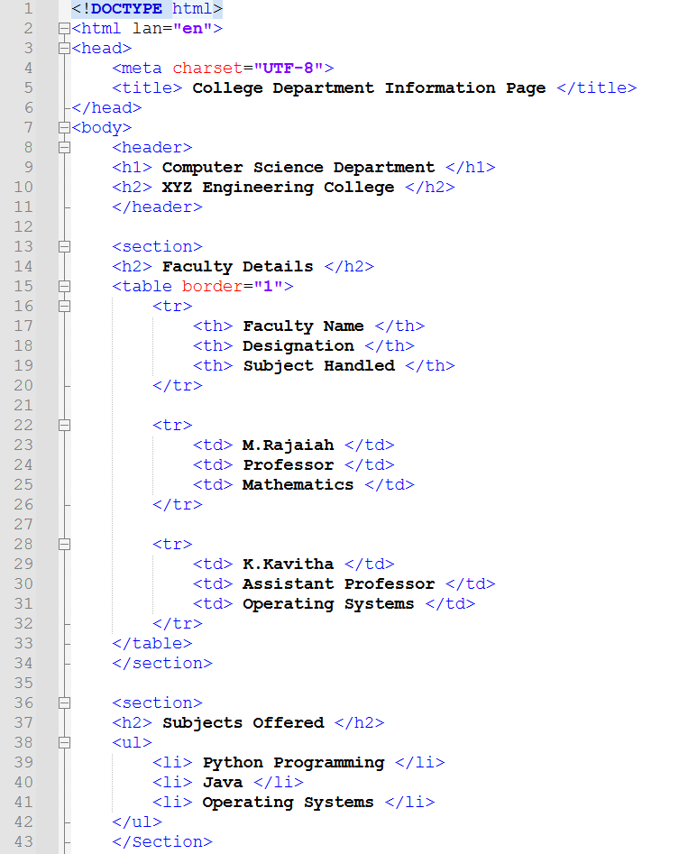

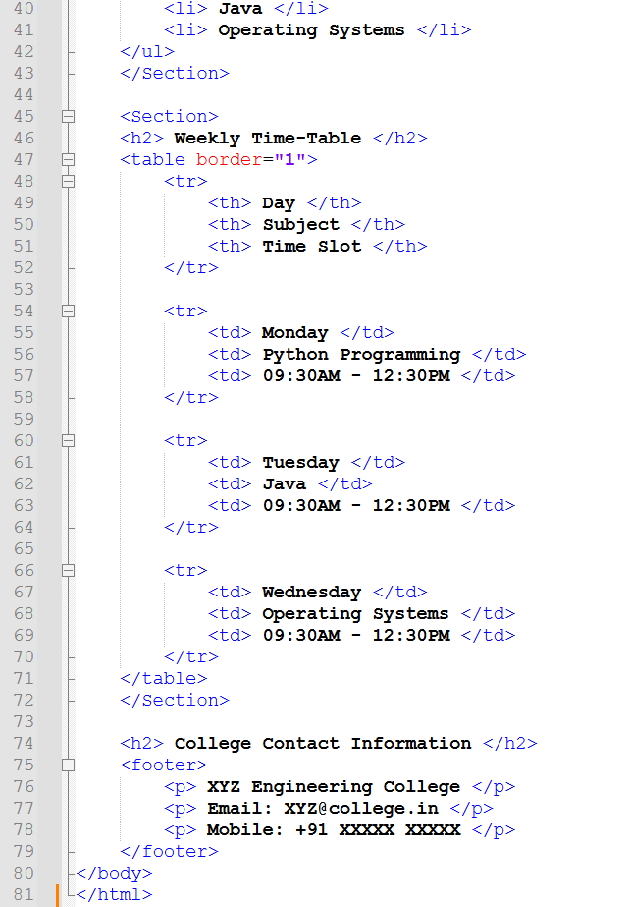

Output:
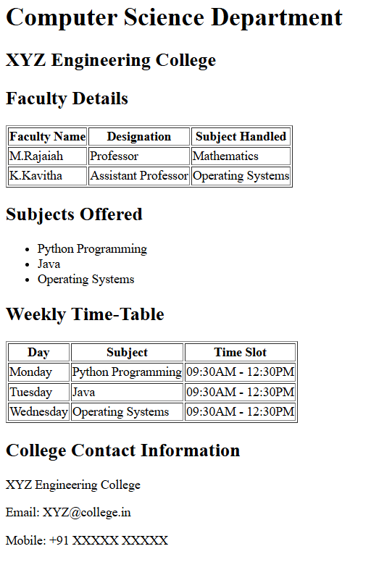
Explanation:
This code creates a simple webpage for a Computer Science Department. It shows the college name, faculty details in a table, subjects offered in a bullet list, a weekly timetable in another table, and contact information at the bottom.

