HTML5_Day – 2_Hands_On -- Kaveri Harish Babu
Problem 1
Problem Statement:
Assessment Goal: Validate understanding of links and form elements.
Hands-on Tasks:
- Create two HTML pages and link them using navigation links
- Add a navigation bar with Home and Contact links
- Create a registration form with:
  - Name
  - Email
  - Password
  - Gender (radio buttons)
  - Course selection (dropdown)
- Use required and placeholder attributes
Expected Outcome:
A multi-page website with working navigation and a basic form.

Source Code:
File Name: Index.html
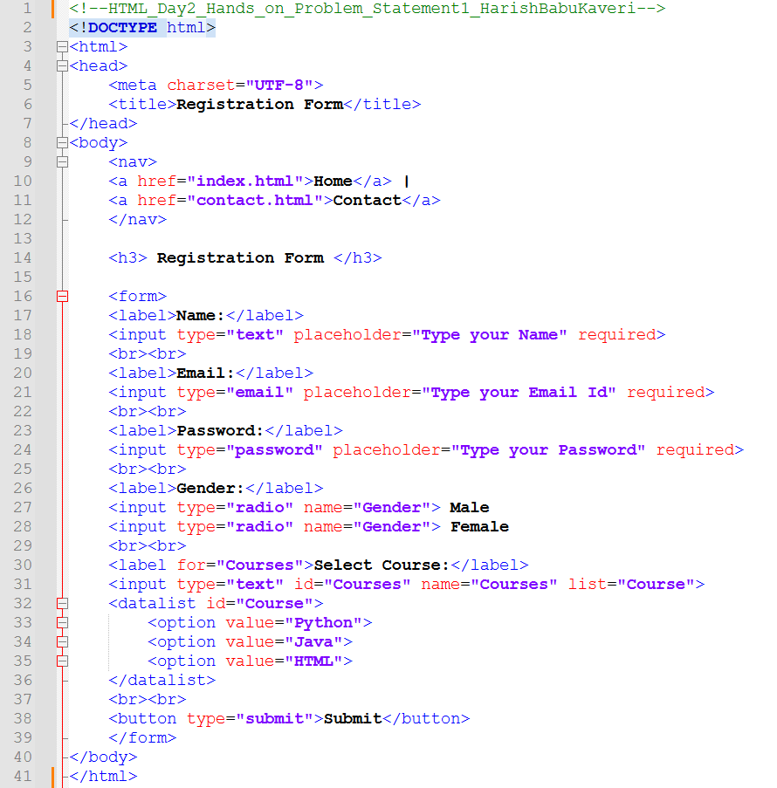

File Name: contact.html
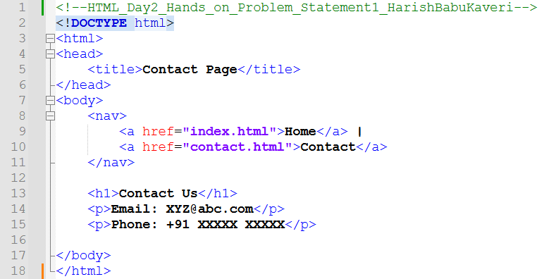
Output:
Output File: index.html
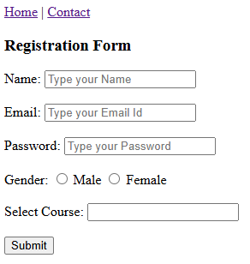

Output File: contact.html
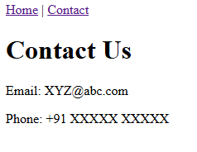
Explanation:
This code creates two simple webpages: one is a Registration Form and the other is a Contact Page, connected using navigation links (Home | Contact). The registration page collects name, email, password, gender, and course details, while the contact page shows email and phone information.

Problem 2
Problem Statement:
Simple Website Navigation System (Level-1)
Scenario
A small coaching institute wants a basic static website with multiple pages so students can easily navigate between sections like Home, Courses, and Contact.
📌 Requirements
- Create 3 HTML pages:
  - index.html (Home)
  - courses.html
  - contact.html
- Use:
  - <nav> element to create a navigation menu
  - <a> anchor tags for navigation
- Navigation menu should appear on all pages
- Use relative paths to link pages
- Include at least:
  - One internal anchor link (#section)
  - One external link (e.g., institute’s social media)

🛠️ Technical Constraints
- Only HTML5
- No CSS or JavaScript
- Navigation must be semantic (<nav>)

🎯 Learning Outcome
You should be able to:
- Use <nav> and <a> elements
- Understand relative paths
- Build a simple multi-page navigation structure
- Users should move seamlessly between pages
- Code should be readable and well-indented
- Navigation links should work correctly
Source Code:
File Name: index.html
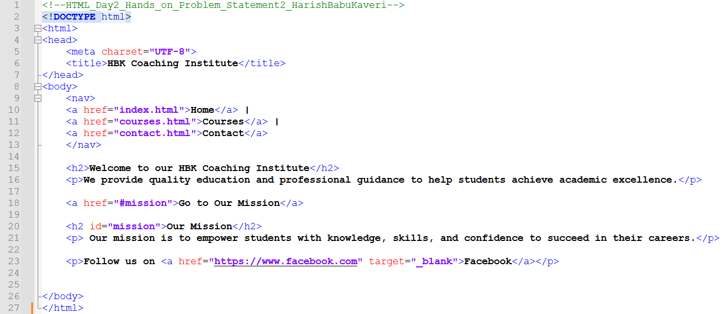
File Name: courses.html
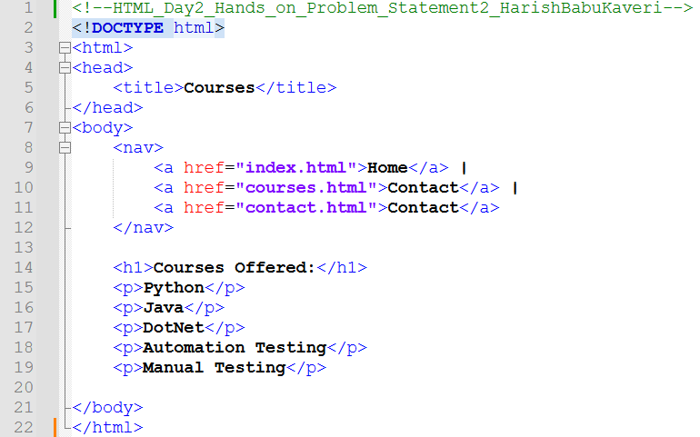
File Name: contact.html
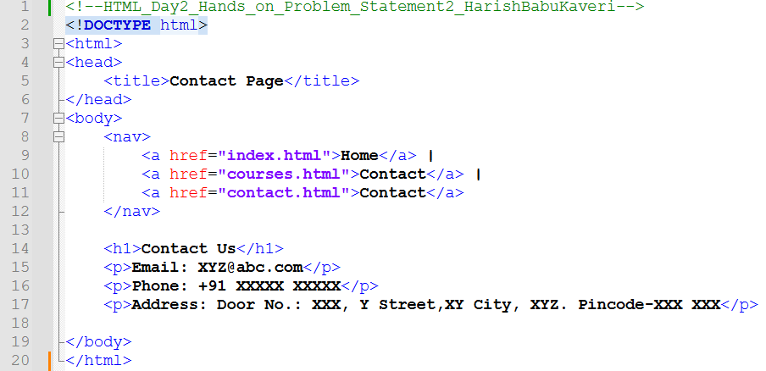
Output:
Output File: index.html


Output File: courses.html
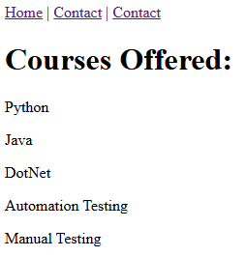
Output File: contact.html
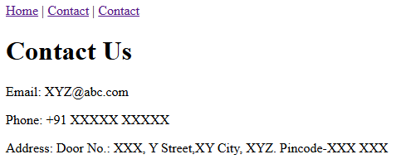
Explanation:
This code creates a small website for Coaching Institute with three pages: Home, Courses, and Contact, all connected using navigation links. The Home page shows a welcome message and mission, the Courses page lists available courses, and the Contact page displays email, phone, and address details.

Problem 3
Problem Statement:
Student Registration Form with Input Types (Level-1)
Scenario
An institute wants a basic student registration form with built-in validation to reduce incorrect submissions.
📌 Requirements
Create an HTML webpage that includes:
Create a form with following input types:
- text (Name)
- email
- tel
- number (Age)
- date
Use HTML5 built-in validation:
- required
- min, max
- pattern (for phone number)
Add submit button

🛠️ Technical Constraints
- HTML5 only
- No JavaScript validation
- Use proper <label> tags

🎯 Learning Outcome
You will be able to:
- Use advanced input types
- Apply built-in HTML5 validation
- Improve form usability without JavaScript
- Browser should show validation errors automatically
- Inputs should restrict invalid values
- Form should be user-friendly

Source Code:
File Name: index.html
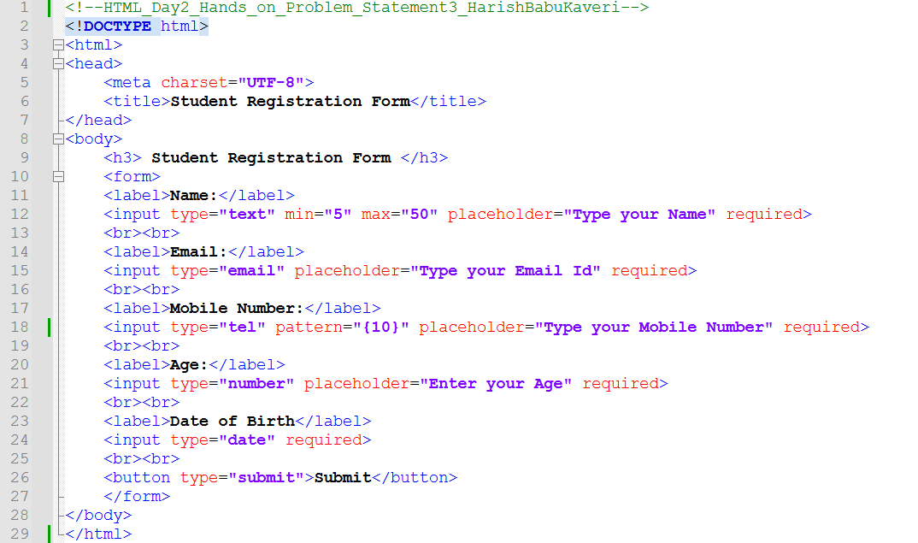

Output:
Output File: index.html
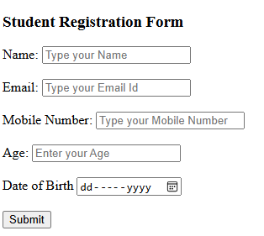
Explanation:
This code creates a simple Student Registration Form where students can enter their name, email, mobile number, age, and date of birth. It uses different input types like email, number, date, and also includes validation with required fields.

Problem 4
Problem Statement:
Multi-Page Website with Breadcrumb Navigation (Level-2)
Scenario
A training portal website has multiple levels of pages and users often get confused about where they are. The company wants breadcrumbs for better navigation.
📌 Requirements
Pages:
- Home
- Courses
- Web Development
- HTML Course
Implement:
- <nav> for main menu
- Breadcrumb navigation using anchor tags
Example:
Home > Courses > Web Development > HTML
Use:
- Hierarchical linking
- Relative paths
Breadcrumb should update based on page hierarchy

🛠️ Technical Constraints
- HTML5 only
- No CSS frameworks
- Semantic elements preferred

🎯 Learning Outcome
Learners should be able to:
- Breadcrumbs must reflect correct page structure
- Navigation must work without broken links
- Clear hierarchy in folder structure
- Design hierarchical navigation
- Implement breadcrumbs
- Understand real-world website structure

Source Code:
File Name: index.html
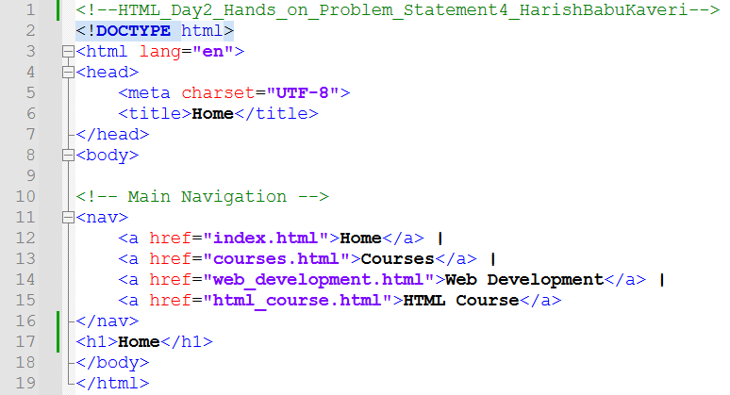

File Name: courses.html
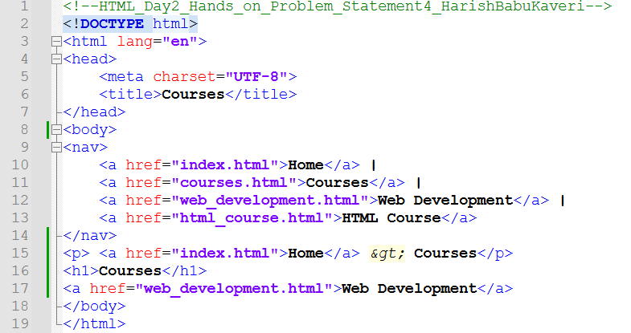
File Name: web_development.html
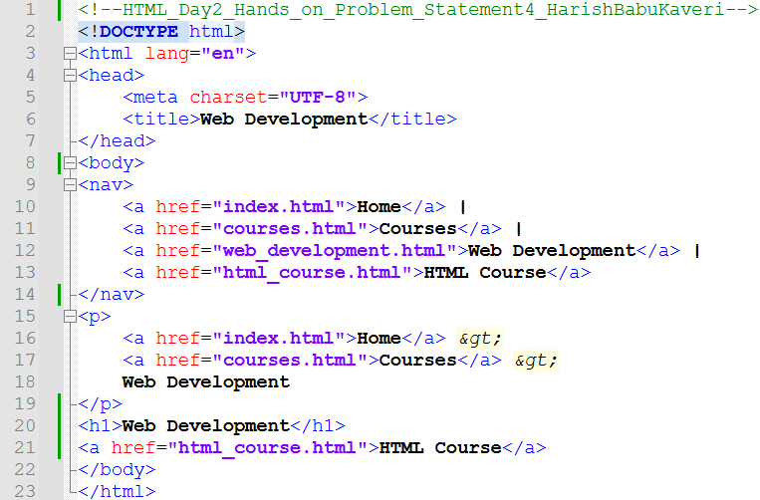
File Name: html_course.html
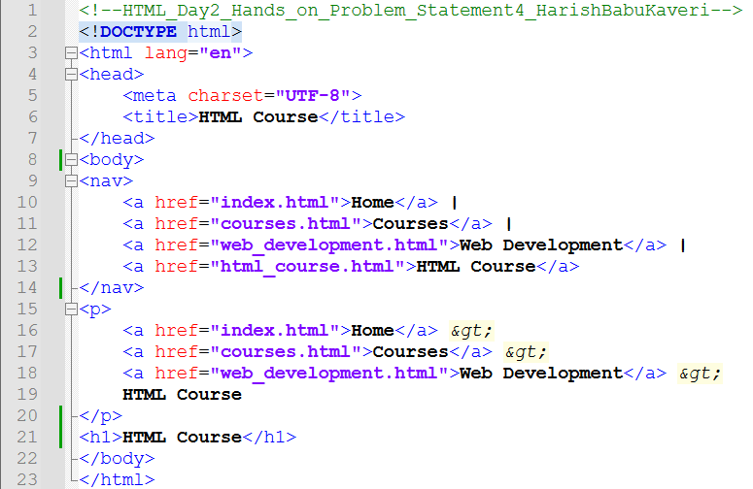

Output:
Output File: index.html
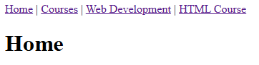
Output File: courses.html
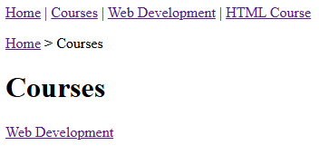
Output File: web_development.html
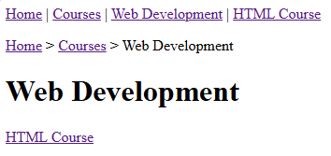
Output File: html_course.html
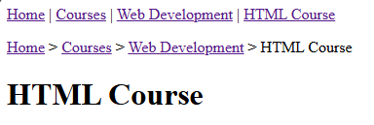
Explanation:
This code creates a small multi-page website with Home, Courses, Web Development, and HTML Course pages, all connected using navigation links. It also uses breadcrumb links (Home > Courses > Web Development > HTML Course) to show the user’s current page location.

Problem 5
Problem Statement:
Course Enrollment Form with Advanced HTML Elements
Scenario
An online learning platform wants to enhance user experience by showing course progress, skill levels, and suggested inputs while filling the form.
📌 Requirements
Create an enrollment form using:
- <datalist> for course suggestions
- <progress> to show enrollment completion
- <meter> to indicate skill level (Beginner–Advanced)
Include modern input types:
- email
- range
- number
Use built-in validation

🛠️ Technical Constraints
- HTML5 only
- No JavaScript or CSS
- Must use semantic elements

🎯 Learning Outcome
You will be able to:
- Use advanced HTML5 elements
- Enhance form UX without JavaScript
- Understand real-time data representation in HTML
Browser should display:
- Dropdown suggestions via <datalist>
- Progress bar updates (static value)
- Meter shows skill level visually
Clean and structured form layout

Source Code:
File Name: index.html
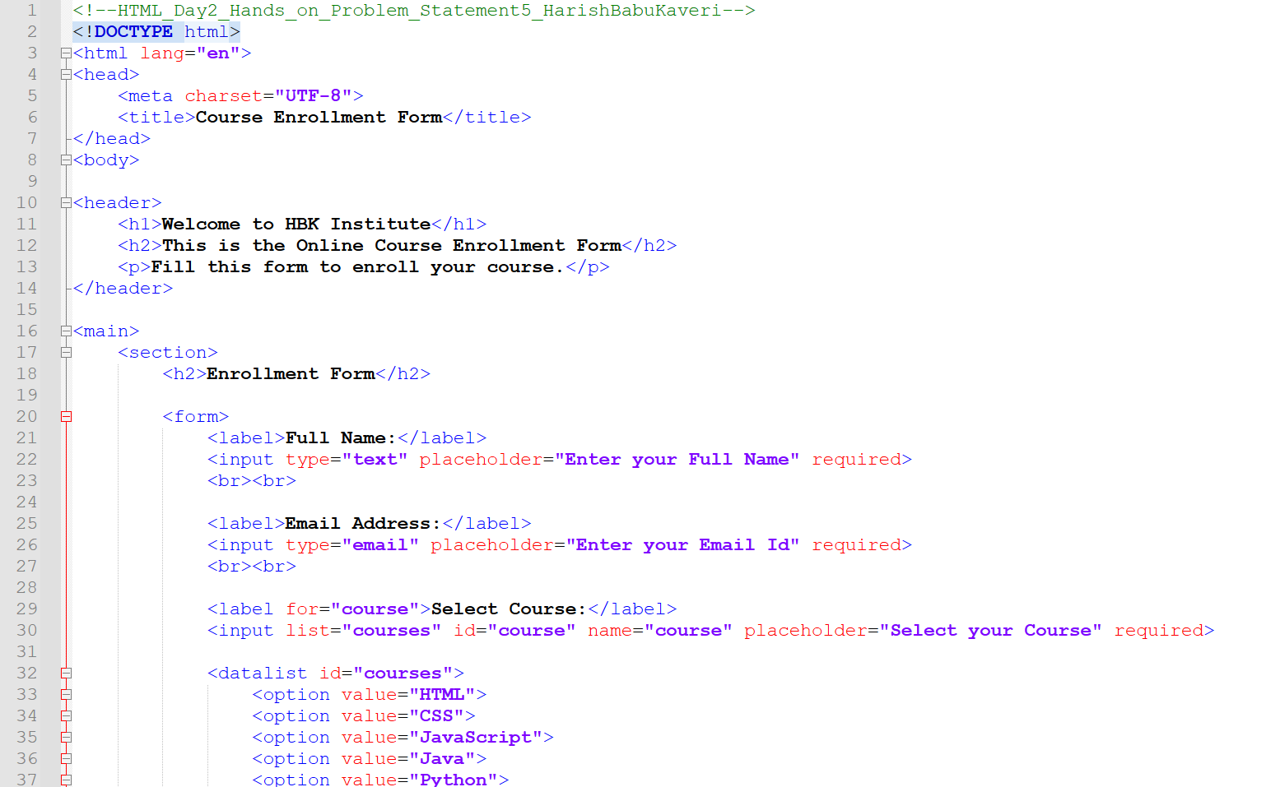

Continuation…
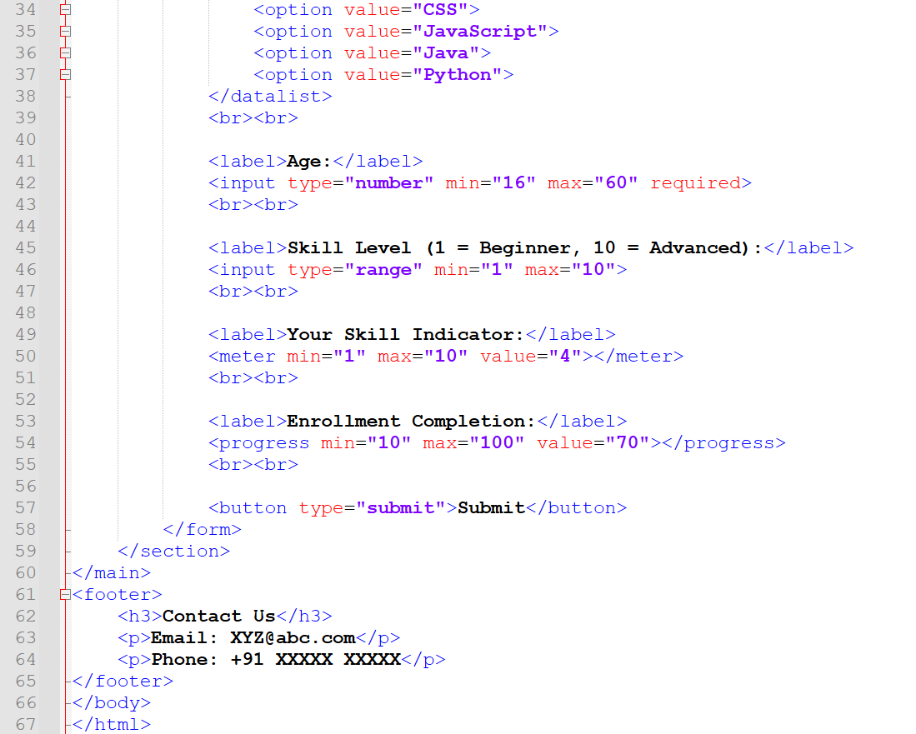

Output:
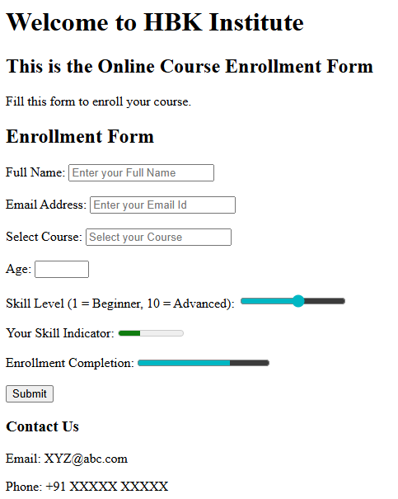
Explanation:
This code creates an Online Course Enrollment Form for Institute. It collects details like name, email, course selection (with suggestions), age, and skill level, and also shows a skill meter and enrollment progress bar.

