CSS_Day – 3_Hands_On -- Kaveri Harish Babu
Problem 1
Problem Statement:
Assessment Goal: Check ability to apply styling and understand selectors and box model.
Hands-on Tasks:
- Create an external CSS file and link it to HTML
- Apply different text styles to headings and paragraphs
- Add background colour and borders to a section
- Demonstrate margin and padding on a div
- Style the form created on Day 2
Expected Outcome:
A visually styled webpage using external CSS and proper selectors.

Source Code:
File Name: Index.html
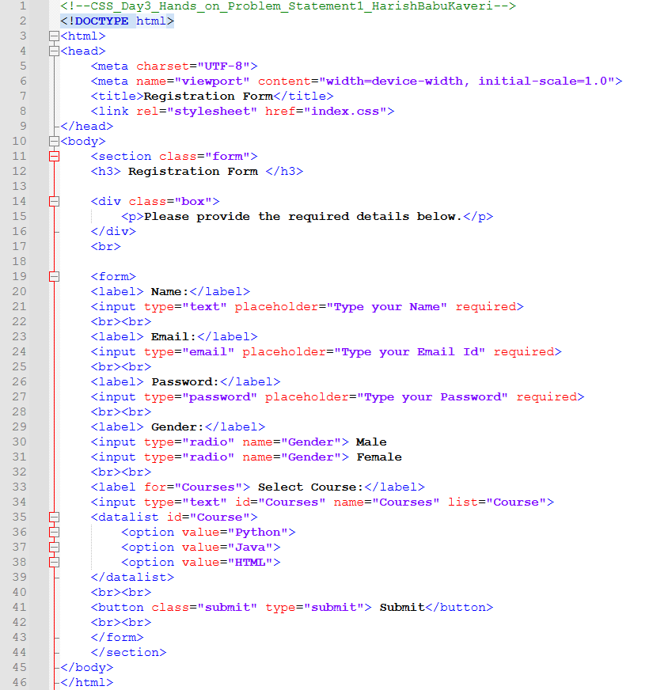

File Name: index.css
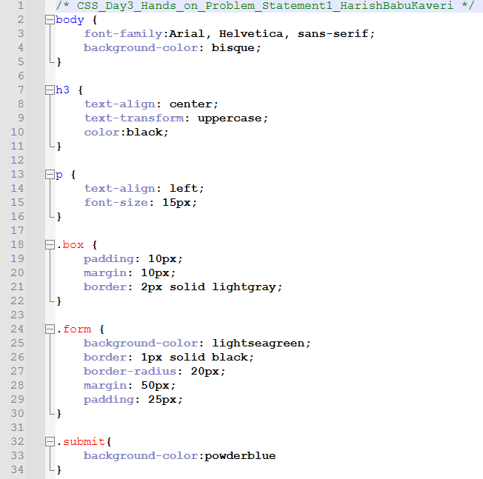

Output:
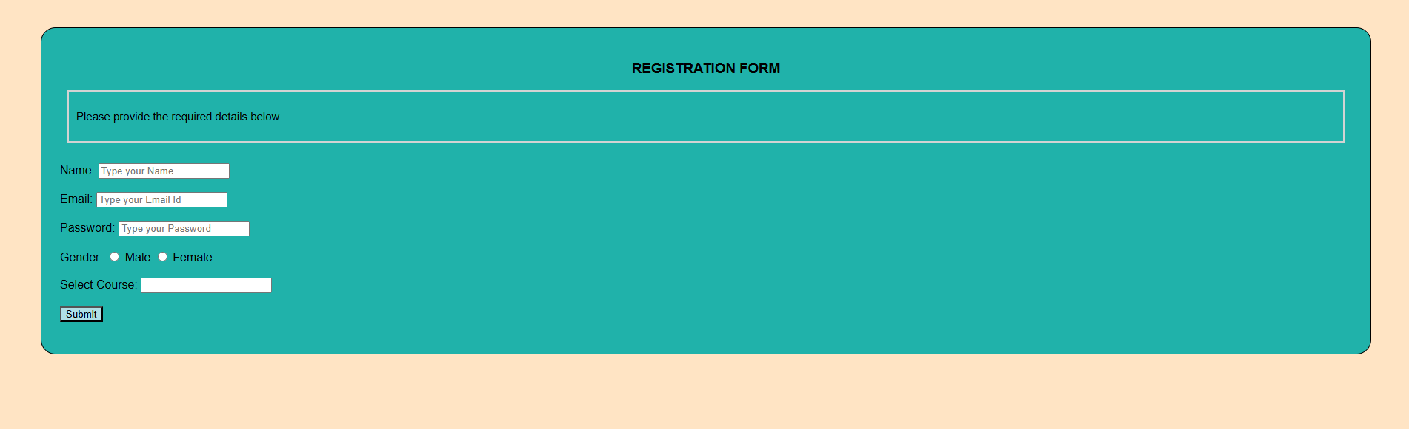
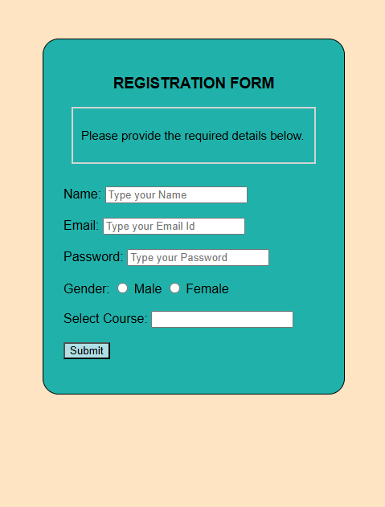
Explanation:
This code creates a Registration Form using HTML and styles it with an external CSS file. The CSS adds background colors, spacing, borders, rounded corners, and styles the submit button to make the form look neat and attractive.
Problem 2
Problem Statement:
Personal Profile Card (Level-1)
Scenario
You are building a simple personal profile card for a portfolio website.
The card will display a user’s name, role, short bio, and contact button, styled purely using CSS.
📌 Requirements
Create a profile card layout containing:
- Name (heading)
- Role/title
- Short description paragraph
- Contact button
Apply:
- Text formatting (alignment, decoration)
- Font styles (font-family, size, weight)
- Typography enhancements (line-height, letter-spacing)
Use the CSS Box Model:
- Padding for spacing inside the card
- Border to define the card boundary
- Margin to separate the card from the page edges
Add:
- Background color
- Border radius
- Hover effect on the button

🛠️ Technical Constraints
- Use only HTML + CSS
- No images or icons
- No frameworks (Bootstrap, Tailwind, etc.)
- Inline CSS not allowed (use <style> or external CSS)

🎯 Learning Outcome
You should be able to:
- Understand how CSS styles text and fonts
- Apply box model concepts effectively
- Style elements using colours, borders, and spacing
- Improve visual hierarchy using typography

Source Code:
File Name: index.html
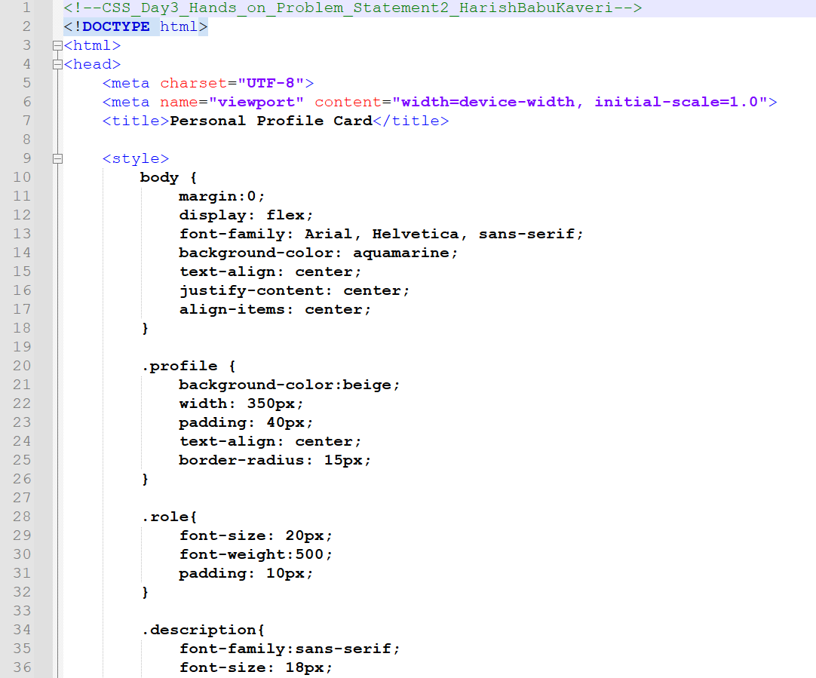
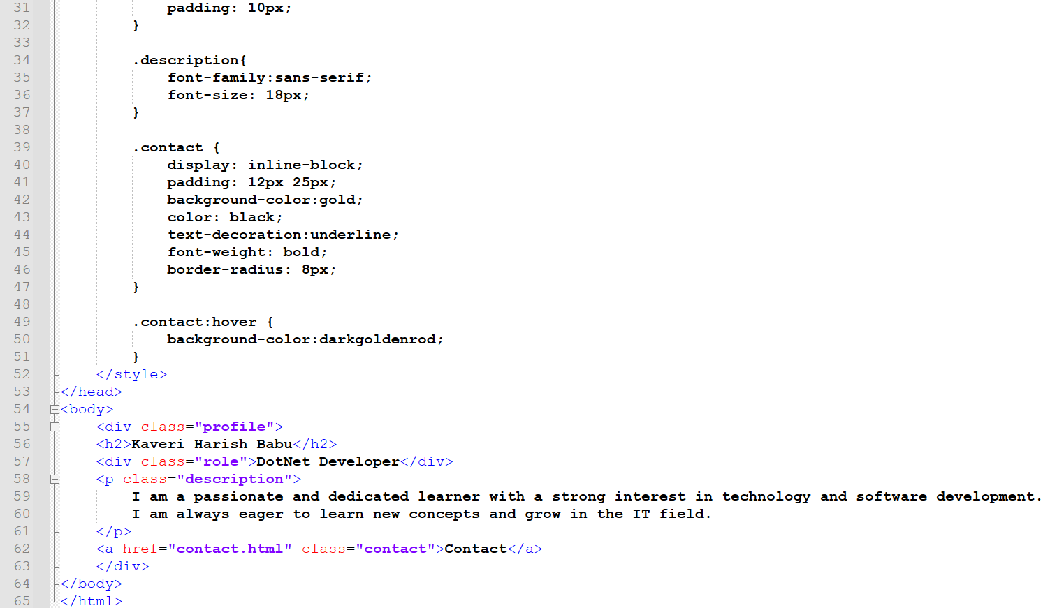
File Name: contact.html
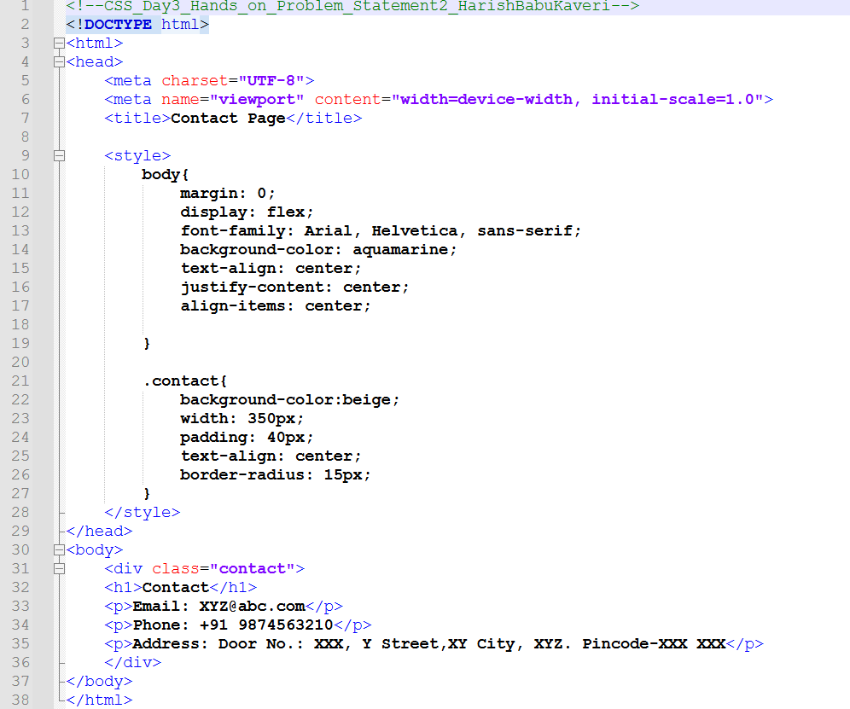
Output:
Output File: index.html
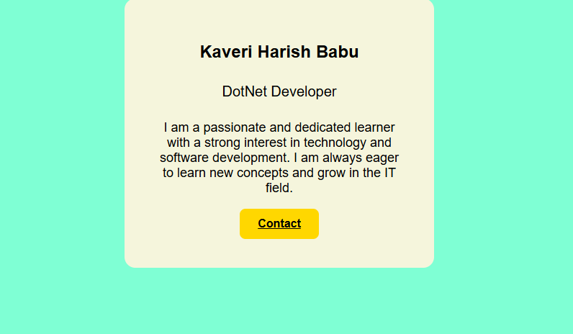

Output File: contact.html
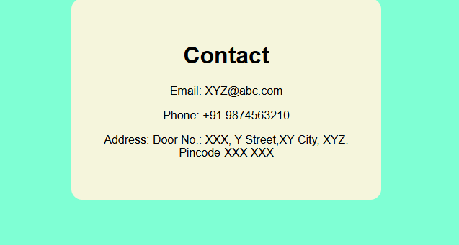
Explanation:
This code creates a Personal Profile Card using HTML and CSS, and a separate Contact page linked with a button. The CSS centers the card on the screen, adds background colors, spacing, rounded corners, and a hover effect on the Contact button.

Problem 3
Problem Statement:
Product Feature List Section (Level-1)
Scenario
You are designing a feature highlight section for a product landing page that lists key features in a visually appealing way.
📌 Requirements
Create a section with:
- Section heading
- List of 4–5 features
Style the list using:
- Custom fonts
- Text color and background color
- Border and padding for each feature item
Use:
- CSS selectors (element, class, descendant)
Apply hover effects on feature items

🛠️ Technical Constraints
- Use unordered list (<ul>)
- No JavaScript
- No layout frameworks
- Only basic HTML structure

🎯 Learning Outcome
You will be able to:
- Practice CSS selectors
- Style lists professionally
- Improve UI consistency
Source Code:
File Name: index.html
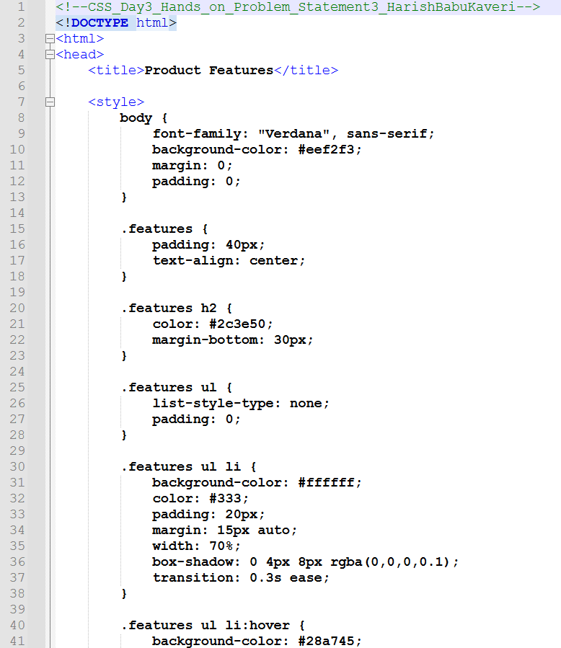
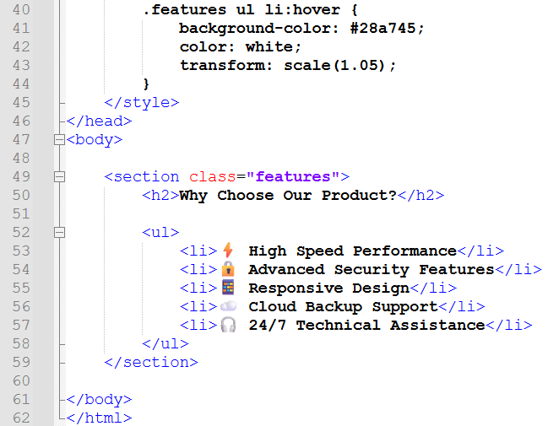
Output:
Output File: index.html
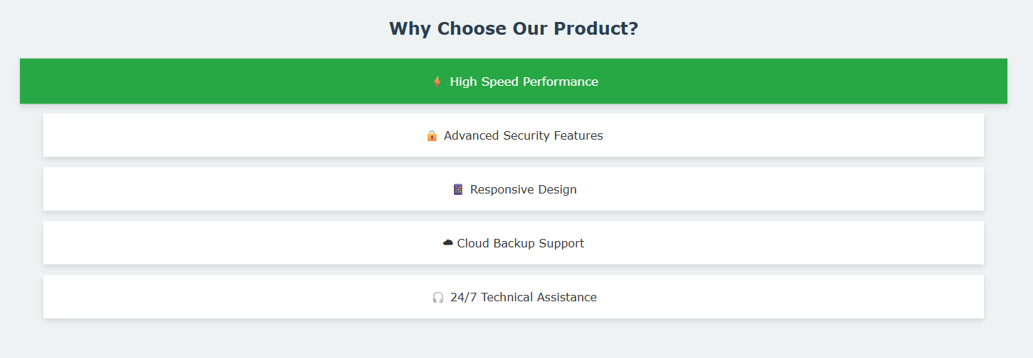
Explanation:
This code creates a Product Features section using HTML and CSS. It displays a heading and a list of features, styled with background colors, spacing, shadows, and a hover effect that changes color and slightly enlarges each item.
Problem 4
Problem Statement:
Responsive Blog Layout (Level-2)
Scenario
You are creating a blog homepage that displays articles in a modern responsive layout suitable for desktop, tablet, and mobile screens.
📌 Requirements
Create a page layout with:
- Header
- Main content area with multiple blog cards
Use:
- Flexbox or CSS Grid for layout
- Box model for spacing
Each blog card should contain:
- Title
- Short description
- Read More button

Apply:
- Background colors
- Borders
- Typography enhancements
Use media queries to:
- Display multiple columns on desktop
- Switch to single column on mobile
🛠️ Technical Constraints
- Only HTML + CSS
- No CSS frameworks
- No fixed widths (use percentages or flexible units)
🎯 Learning Outcome
Learners should be able to:
- Understand Flexbox/Grid layouts
- Apply responsive design principles
- Write effective media queries
- Build real-world page layouts

Source Code:
File Name: index.html
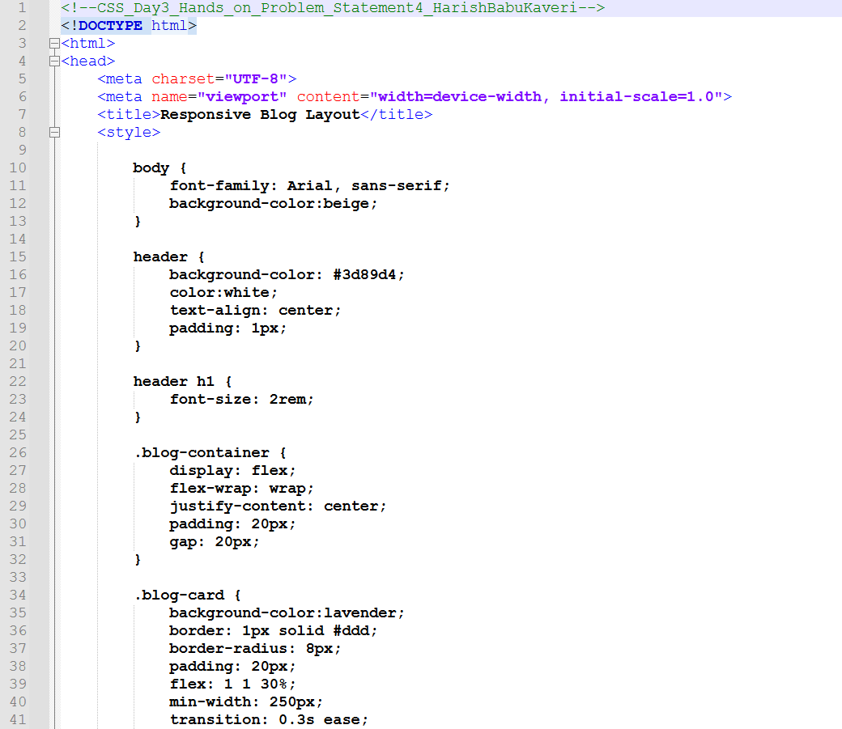
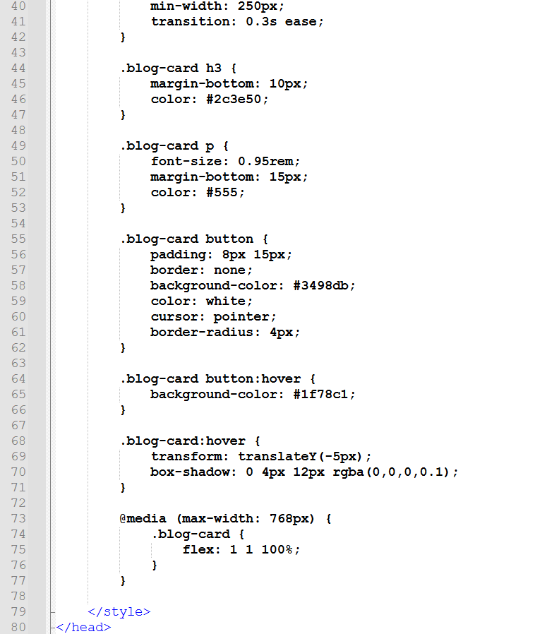
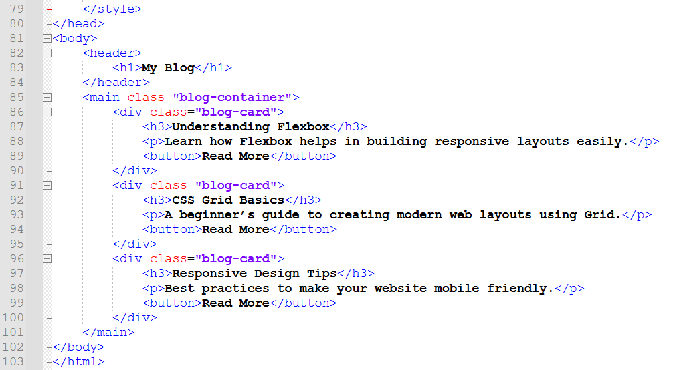

Output:
Output File: index.html
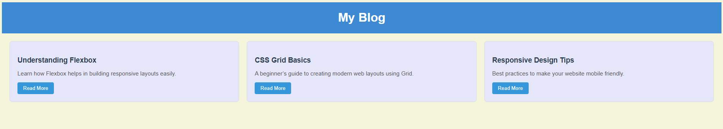

Explanation:
This code creates a responsive blog layout using HTML and CSS Flexbox. It displays blog posts as cards with titles, descriptions, and “Read More” buttons, styled with colors, shadows, and hover effects.

Problem 5
Problem Statement:
Responsive Dashboard Layout (Level-2)
Scenario
You are designing a simple admin dashboard layout for a web application.
📌 Requirements
Create a layout with:
- Sidebar navigation
- Main content area
- Info cards inside the main section
Use:
- display properties
- Flexbox or Grid for page structure
Style:
- Sidebar with background color
- Cards with borders, padding, and margins
Apply media queries to:
- Convert sidebar into top navigation on mobile
- Stack cards vertically on small screens

🛠️ Technical Constraints
- HTML + CSS only
- No JavaScript
- No external UI libraries

🎯 Learning Outcome
You will be able to:
- Master page layouts using Flexbox/Grid
- Apply modern responsive web design techniques
- Understand how layout adapts across devices
- Build industry-relevant UI structures

Source Code:
File Name: index.html
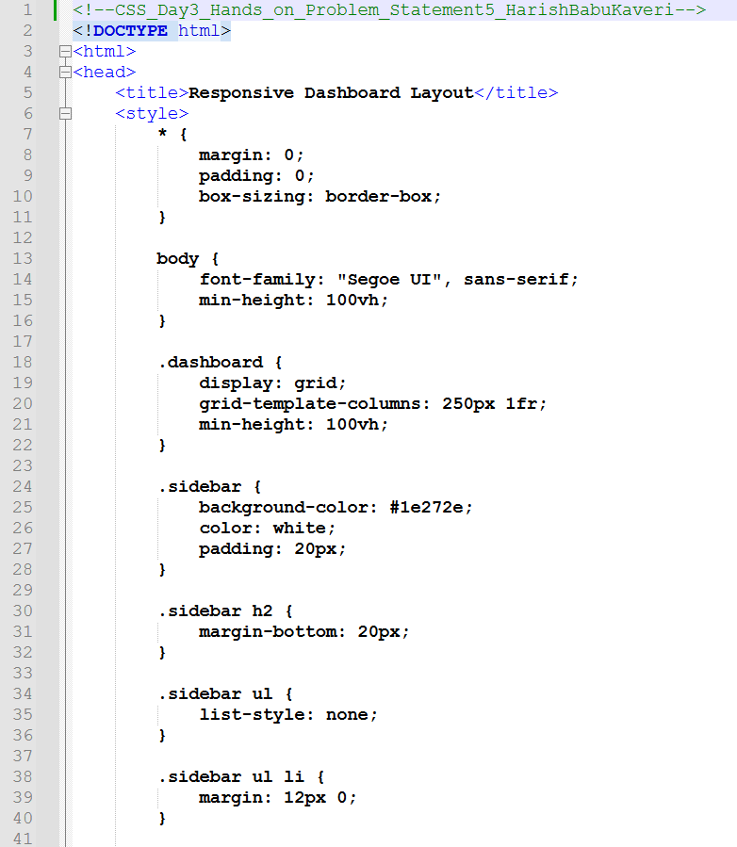

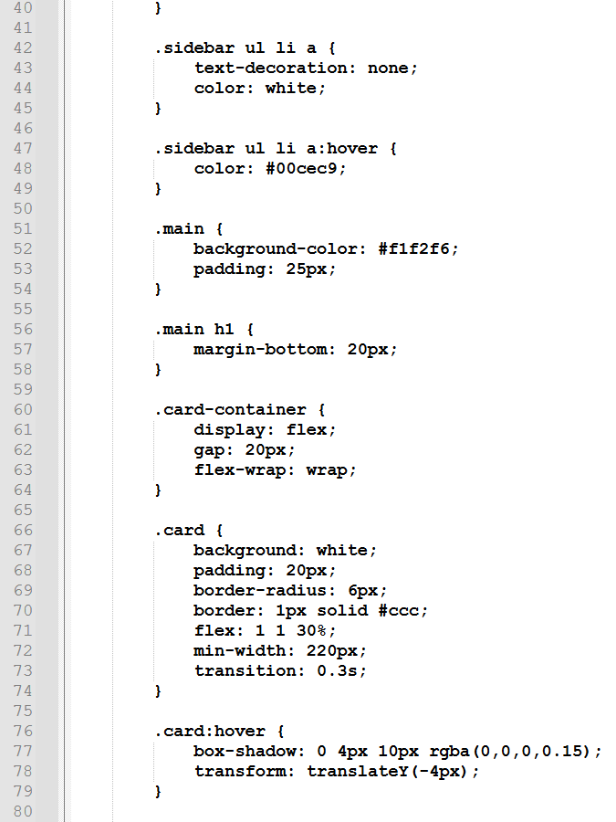
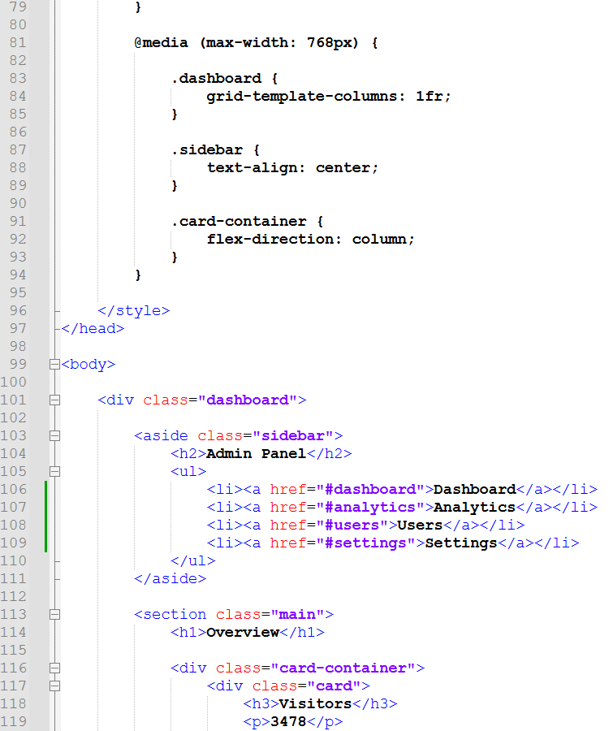

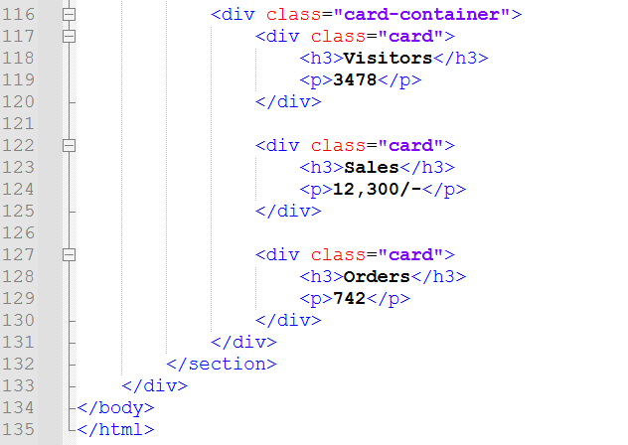

Output:
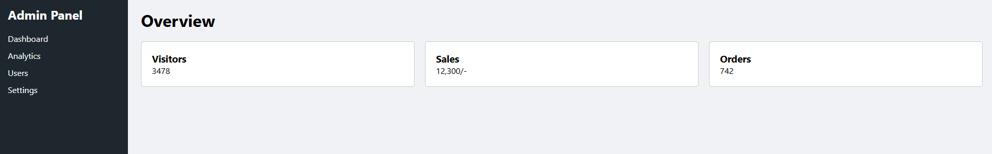
Explanation:
This code creates a responsive admin dashboard using CSS Grid and Flexbox. It has a sidebar (Admin Panel with links) on the left and a main section showing cards like Visitors, Sales, and Orders.

