JavaScript_Day – 4_Hands_On -- Kaveri Harish Babu
Problem 1
Problem Statement:
Assessment Goal: Ensure learners understand responsiveness and screen adaptability.
Hands-on Tasks:
- Add viewport meta tag to the HTML page
- Use media queries to:
  - Change background color on mobile screen
  - Adjust font size for smaller screens
- Convert navigation into vertical layout on mobile
- Test the page using browser responsive mode
Expected Outcome:
A webpage that looks different and readable on mobile and desktop screens.

Source Code:
File Name: Index.html
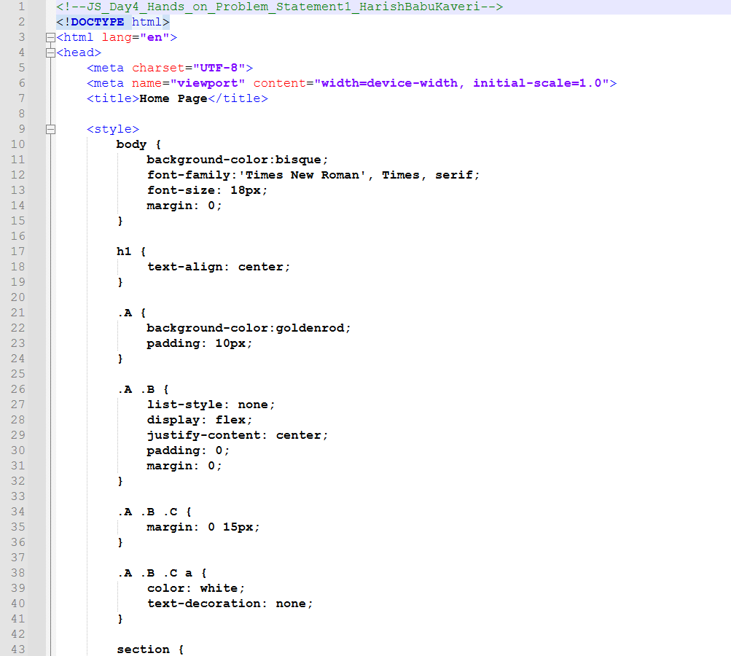
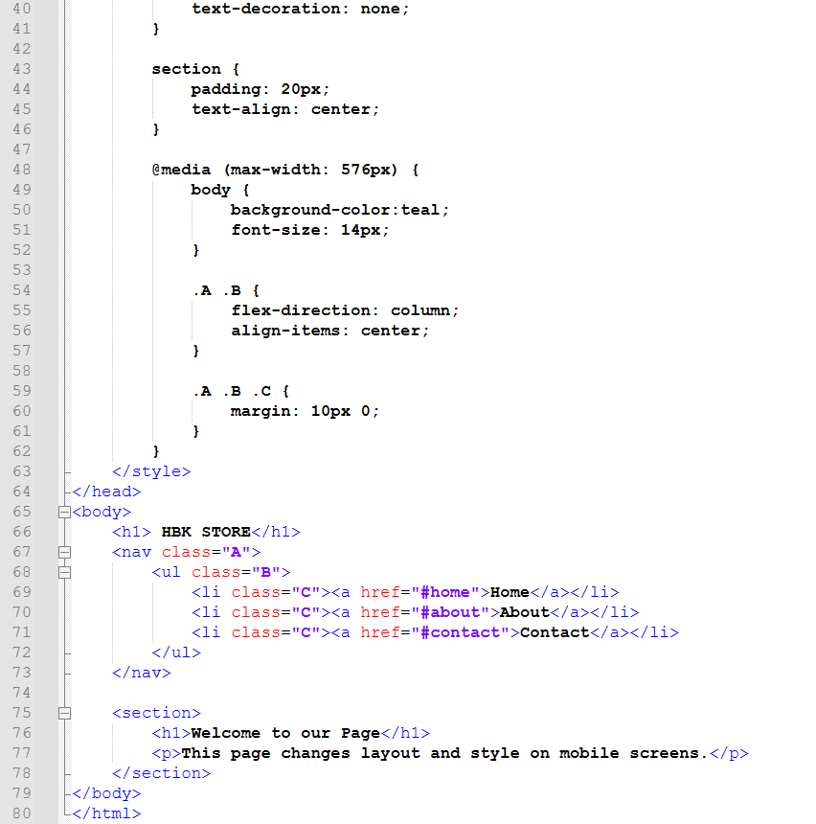

Output:
Output File: index.html
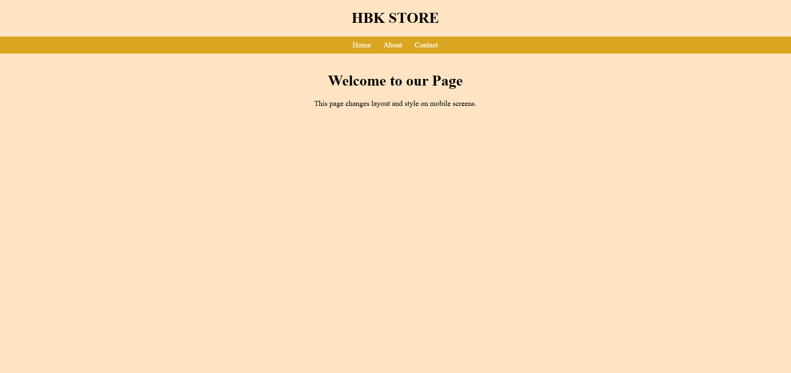

Explanation:
This code creates a simple webpage for Store with a navigation bar and some basic styling using CSS. It also uses a media query to change the layout and background color when the screen size is small (like on a mobile). On a desktop, the menu appears in a horizontal line with a light background, but on mobile, the menu becomes vertical and the background color changes, making the page responsive and mobile-friendly.
Problem 2
Problem Statement:
Student Grade Evaluator (Level-1)
Scenario
A school wants a simple JavaScript program to evaluate a student’s performance based on marks obtained in a subject.
📌 Requirements
- Accept the student’s marks as a variable
- Use if–else statements to assign grades:
- Marks ≥ 75 → Grade A
- Marks ≥ 60 → Grade B
- Marks ≥ 40 → Grade C
- Marks < 40 → Fail
Display the grade on the web page or console
🛠️ Technical Constraints
- Use JavaScript variables (let or const)
- Use numeric data types
- Use comparison and logical operators
- No functions or arrays allowed
- Output using console.log() or document.write()
🎯 Learning Outcome
You should be able to:
- Declare and use variables
- Apply comparison operators
- Implement conditional logic using if–else
- Understand decision-making in JavaScript

Source Code:
File Name: index.html
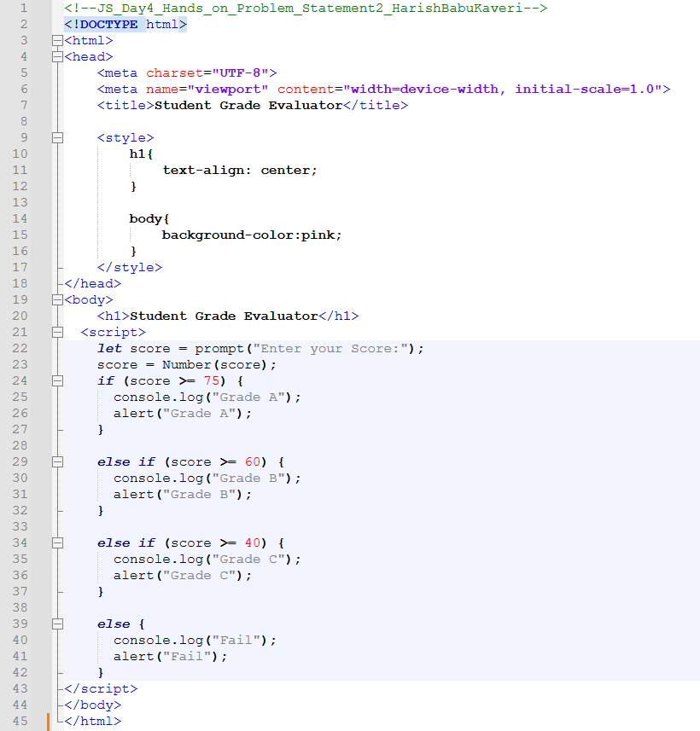

Output:
Output File: index.html
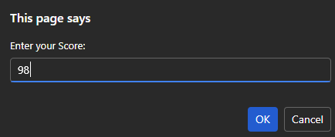

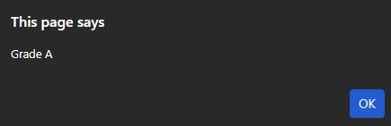

Explanation:
This code creates a simple Student Grade Evaluator page using JavaScript. It asks the user to enter their score through a prompt, checks the marks using if-else conditions, and then shows the grade (A, B, C, or Fail) in an alert box.

Problem 3
Problem Statement:
Simple Discount Calculator (Level-1)
Scenario
An online store wants to apply a discount based on the total purchase amount.
📌 Requirements
- Store purchase amount in a variable
- Apply discount rules:
  - Amount ≥ 5000 → 20% discount
  - Amount ≥ 3000 → 10% discount
  - Amount < 3000 → No discount
- Calculate and display:
  - Discount amount
  - Final payable amount

🛠️ Technical Constraints
- Use arithmetic operators
- Use if–else statements
- Use only primitive data types
No user input (hardcoded values allowed)

🎯 Learning Outcome
You will be able to:
- Perform calculations using operators
- Work with expressions
- Apply conditional statements
- Build real-world logic using JavaScript basics

Source Code:
File Name: index.html
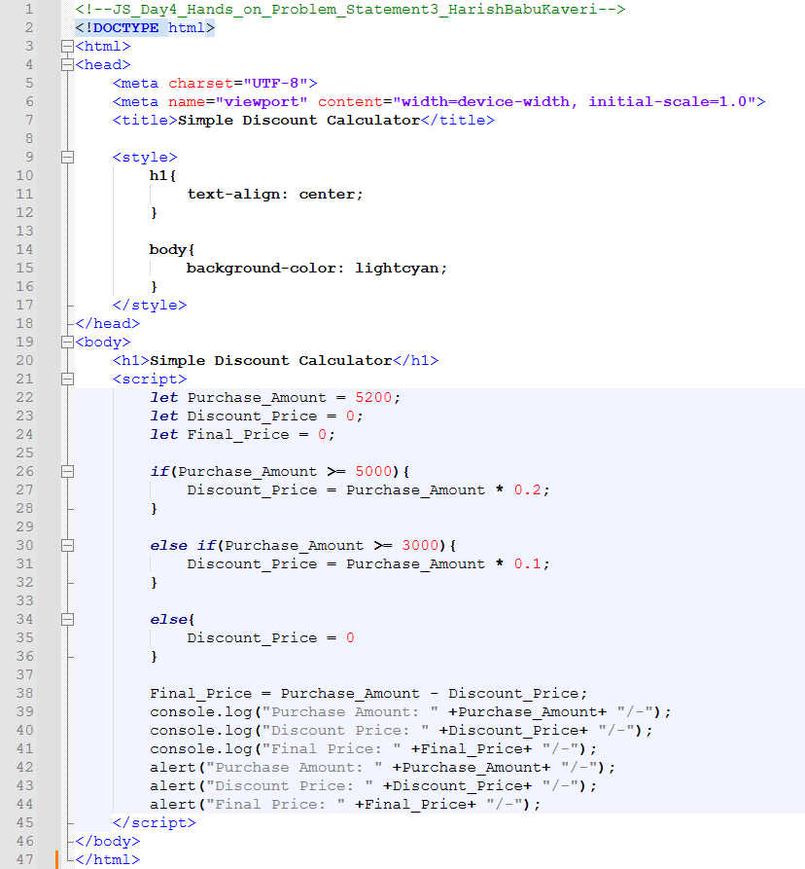
Output:
Output File: index.html
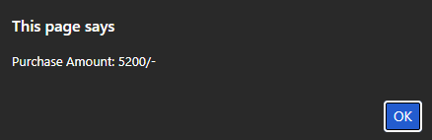

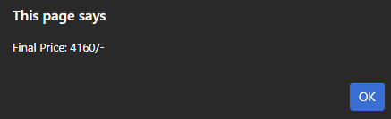
Explanation:
This code creates a Simple Discount Calculator using JavaScript. It checks the purchase amount (₹5200) and applies a 20% discount if it’s ₹5000 or more, then calculates the final price. It shows the purchase amount, the discount (₹1040), and the final price (₹4160) using alert messages.

Problem 4
Problem Statement:
Traffic Signal Simulator (Level-2)
Scenario
A traffic control system needs a JavaScript program that displays instructions based on traffic signal color.
📌 Requirements
- Store signal color in a variable ("red", "yellow", "green")
- Use a switch statement to display:
- Red → Stop
- Yellow → Get Ready
- Green → Go
Handle invalid signal input gracefully
🛠️ Technical Constraints
- Must use switch–case
- Use string data types
- Use console.log() for output
- No if–else allowed
🎯 Learning Outcome
Learners should be able to:
- Use switch statements effectively
- Compare string values
- Handle multiple conditions cleanly
- Understand control flow alternatives

Source Code:
File Name: index.html
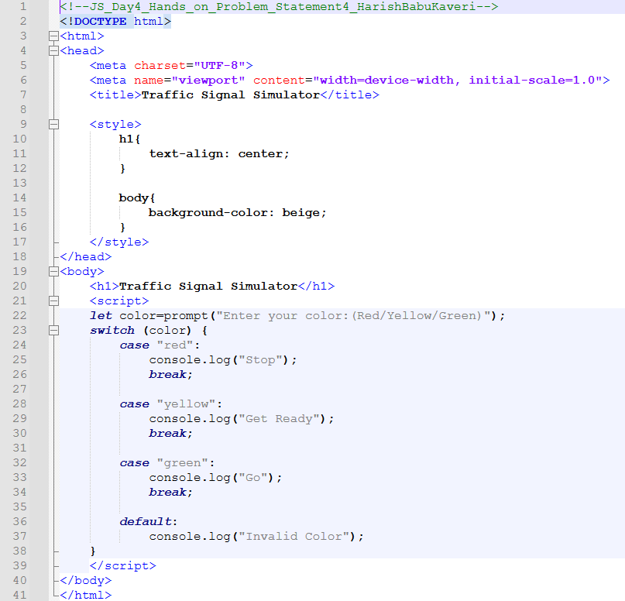
Output:
Output File: index.html
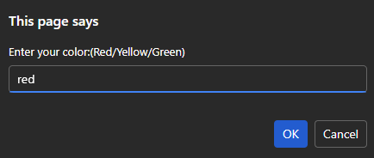
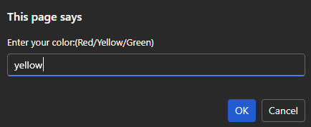
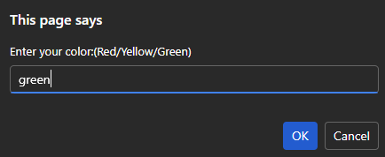
Explanation:
This code creates a simple Traffic Signal Simulator using JavaScript. It asks the user to enter a color (red, yellow, or green) and uses a switch statement to display the corresponding action like Stop, Get Ready, or Go in the console.

Problem 5
Problem Statement:
Number Analysis Tool (Level-2)
Scenario
A utility program is required to analyze numbers and provide insights such as positivity, parity, and range.
📌 Requirements
- Store a number in a variable
- Use conditional (ternary) operator to check:
- Positive or Negative
- Use if–else to check:
- Even or Odd
- Use a loop to print all numbers from 1 to the given number

🛠️ Technical Constraints
- Store a number in a variable
- Use conditional (ternary) operator to check:
- Positive or Negative
- Use if–else to check:
- Even or Odd
- Use a loop to print all numbers from 1 to the given number

🎯 Learning Outcome
You will be able to:
- Combine multiple control flow techniques
- Use loops for iteration
- Apply conditional operators
- Build multi-step logical programs

Source Code:
File Name: index.html
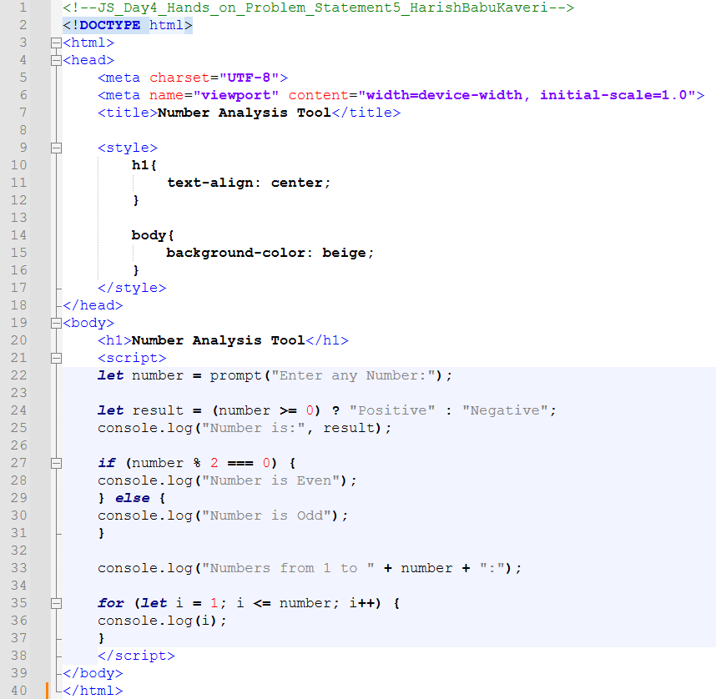

Output:

Explanation:
This code creates an Online Course Enrollment Form for Institute. It collects details like name, email, course selection (with suggestions), age, and skill level, and also shows a skill meter and enrollment progress bar.

