JavaScript_Day – 5_Hands_On -- Kaveri Harish Babu
Problem 1
Problem Statement:
Greeting Generator (Level-1)
Scenario
A simple webpage should greet users based on the name they enter. This helps beginners understand how JavaScript functions accept parameters and how variables behave inside functions.
📌 Requirements
- Create an input box to enter a user’s name.
- Create a button labeled “Generate Greeting”.
- When the button is clicked:
- A JavaScript function should accept the name as a parameter.
- Display a greeting message like:
“Hello, Rahul! Welcome to our website.”
- Display the greeting inside a <p> element.

🛠️ Technical Constraints
- Use only vanilla JavaScript (no libraries).
- Use function keyword (not arrow functions for this task).
- Use document.getElementById() for DOM manipulation.
- Variable for the greeting message must be declared inside the function.

🎯 Learning Outcome
You should be able to:
- Understand how functions receive input using parameters.
- Learn local variable scope.
- Manipulate webpage elements using the DOM.

Source Code:
File Name: Index.html
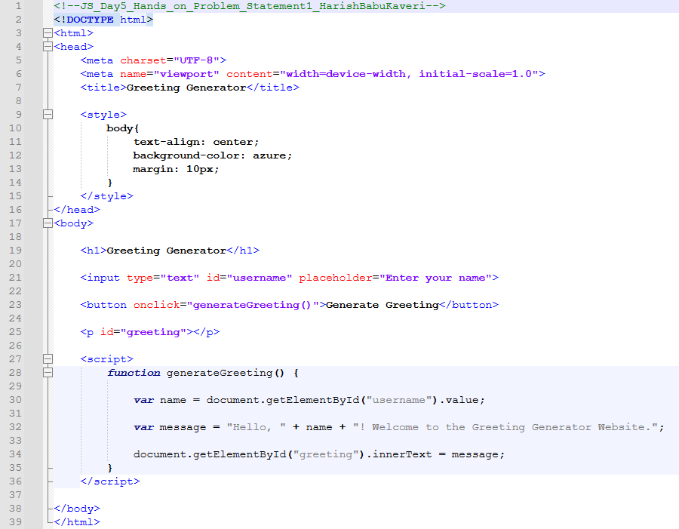

Output:
Output File: index.html
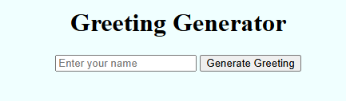
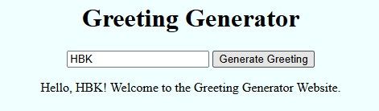

Explanation:
This code creates a simple Greeting Generator. When you enter your name and click the button, JavaScript takes the name from the input box and creates a personalized welcome message.

Problem 2
Problem Statement:
Simple Object-Based User Info Display (Level-1)
Scenario
A webpage needs to display basic user information stored inside a JavaScript object.
📌 Requirements
Create a JavaScript object user with properties:
- name
- age
- city
Create a function displayUserInfo(userObj):
- Accepts the object as a parameter.
- Displays user details in separate <p> elements.
A button click should trigger the function.

🛠️ Technical Constraints
- Object properties must be accessed using dot notation.
- Function should not use global variables.
- DOM elements should be updated dynamically.
🎯 Learning Outcome
You will be able to:
- Understand JavaScript objects.
- Pass objects to functions.
- Display object data dynamically on a webpage.

Source Code:
File Name: index.html
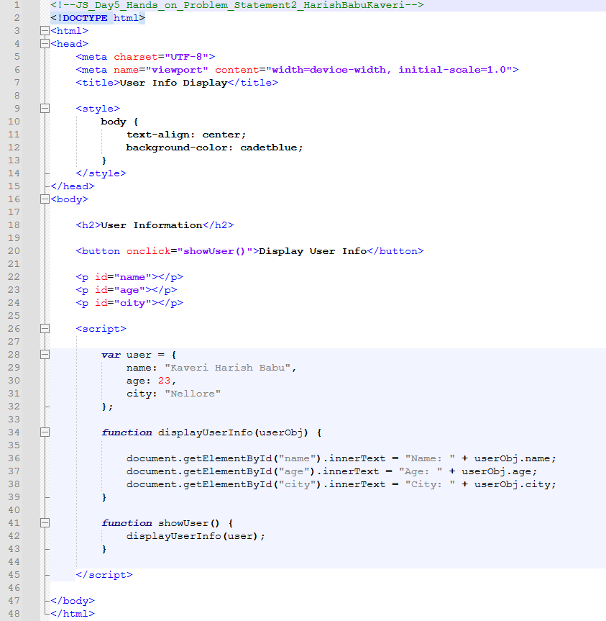

Output:
Output File: index.html
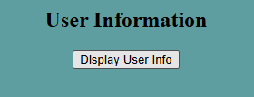
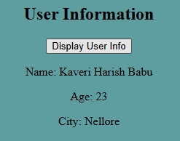

Explanation:
This code creates a simple User Information display using a JavaScript object. When you click the “Display User Info” button, it reads the user object (name, age, city) and shows the details on the screen.
The output displays the user’s name, age, and city dynamically below the button.

Problem 3
Problem Statement:
Counter App with Scope Control (Level-2)
Scenario
Build a counter application where users can increment and reset a value. This problem focuses on variable scope and DOM manipulation.
📌 Requirements
Display a counter value starting from 0.
Create two buttons:
- Increment
- Reset
Use:
- A global variable to store counter value.
- A function incrementCounter(step) that:
  - Accepts step value as a parameter.
  - Updates the counter.
Reset button should reset the counter to 0.

🛠️ Technical Constraints
- Counter value must be maintained outside the function (global scope).
- DOM updates must happen inside functions only.
- No inline JavaScript in HTML.

🎯 Learning Outcome
Learners should be able to:
- Understand variable scope (global vs local).
- Apply function parameters in real scenarios.
- Control UI behavior using JavaScript functions.
Source Code:
File Name: index.html
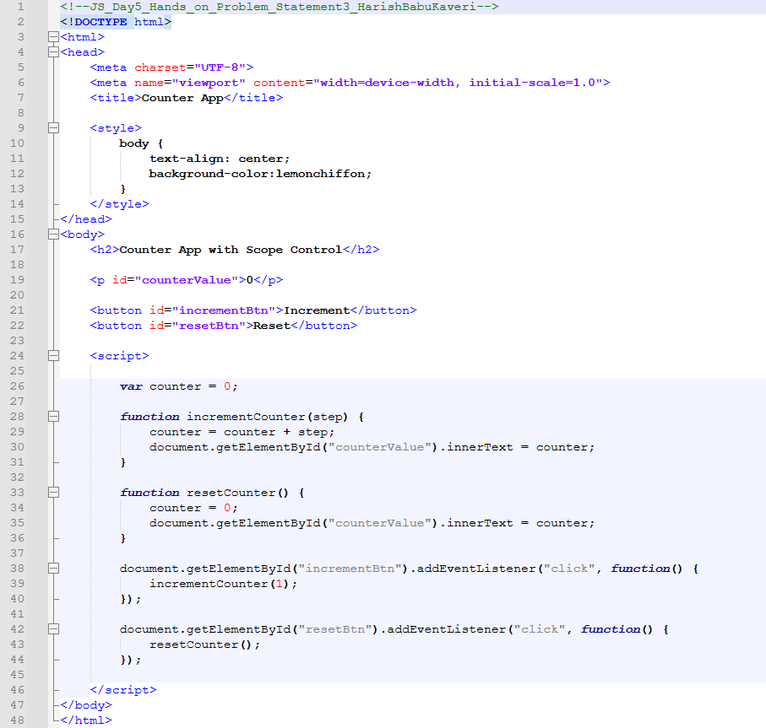

Output:
Output File: index.html
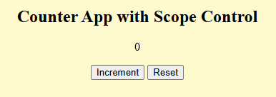
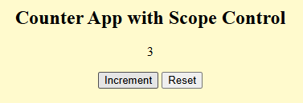
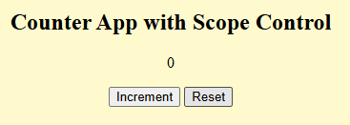
Explanation:
This code creates a simple Counter App using a global variable called counter. When you click Increment, the value increases by 1, and when you click Reset, it goes back to 0. The number shown on the screen updates instantly based on the button you press.

Problem 4
Problem Statement:
Dynamic Student Profile Manager (Level-2)
Scenario
Create a mini student profile system where details are stored in an object and displayed dynamically using DOM manipulation.
📌 Requirements
Create a student object with:
- name
- rollNo
- marks
Create a function updateStudentProfile(studentObj):
- Accepts the object as a parameter.
- Displays details in a styled <div>.
Add another function updateMarks(newMarks):
- Updates marks and refreshes the display.

🛠️ Technical Constraints
- Student object must be declared in global scope.
- Functions should update object values using parameters.
- DOM should update without page refresh.

🎯 Learning Outcome
You will be able to:
- Deep understanding of object manipulation.
- Function interaction with shared data.
- Real-world use of DOM updates and scope handling.

Source Code:
File Name: index.html
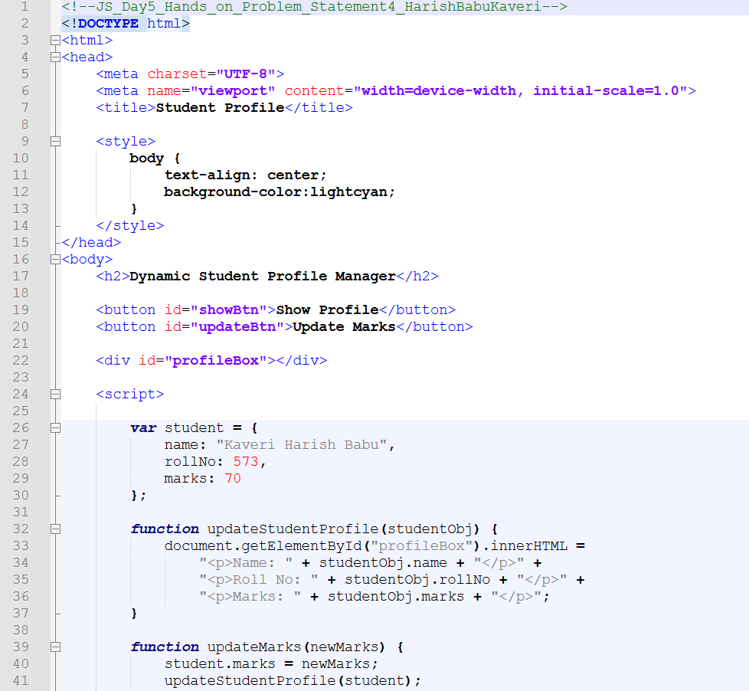
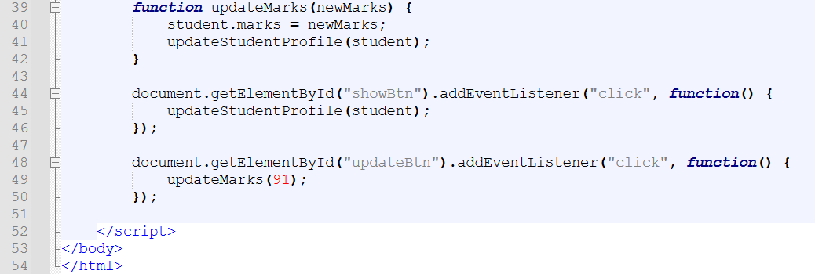
Output:
Output File: index.html
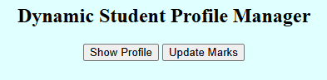
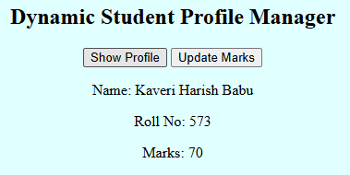
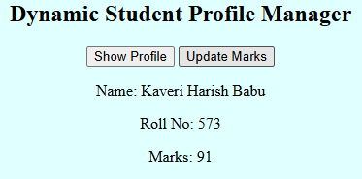

Explanation:
This code creates a Dynamic Student Profile Manager using a JavaScript object to store student details (name, roll number, marks). When you click Show Profile, it displays the student info, and when you click Update Marks, it changes the marks value and updates it on the screen. The output first shows marks as 70, and after clicking Update Marks, it changes to 91 instantly.

