JavaScript_Day – 1_Week2_Hands_On -- Kaveri Harish Babu
Problem 1
Problem Statement:
Personal Notes Saver using LocalStorage (Level-1)
Scenario
You are building a simple web page where users can write daily notes and save them in their browser without using a server.
📌 Requirements
- A textarea for writing notes.
- A Save button (using onclick).
- A Clear button.
- Notes must:
Be stored in localStorage
Automatically load when the page refreshes
- Display stored note on page load.

🛠️ Technical Constraints
- Must use:
  - onclick inline event
  - localStorage.setItem()
  - localStorage.getItem()
  - localStorage.removeItem()
- No backend/database.
- Pure HTML + JavaScript only.
- Data stored as key-value pair.

🎯 Learning Outcome
You should be able to:
- Inline event handling (onclick)
- Browser Storage APIs
- Storing & retrieving key-value data
- Page load event handling
- Basic DOM manipulation

Source Code:
File Name: Index.html
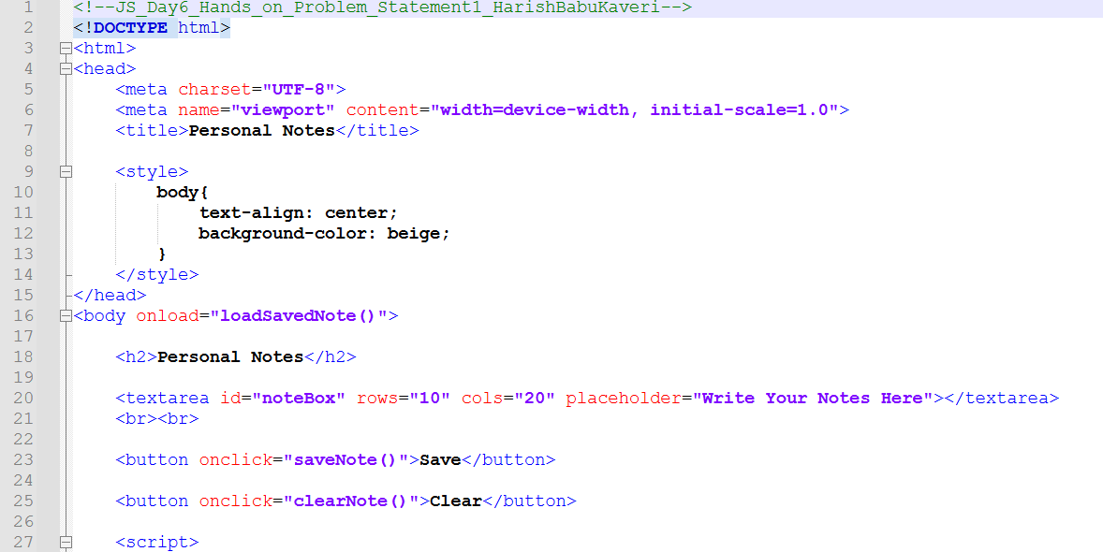

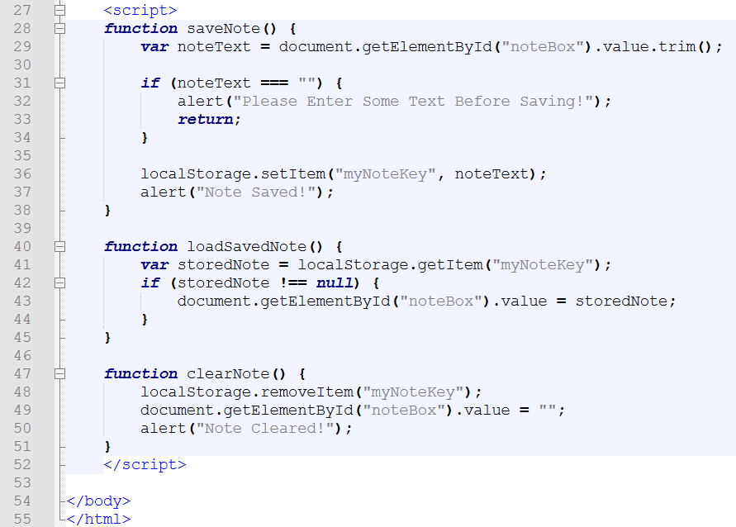

Output:
Output File: index.html
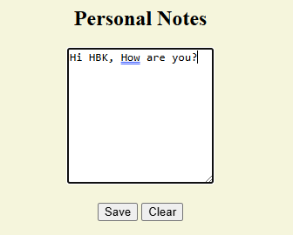
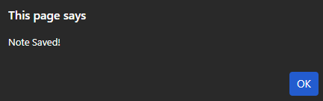
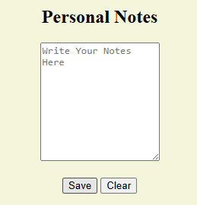
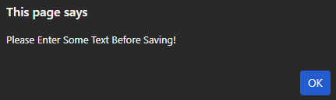

Explanation:
This code creates a simple Personal Notes app using a textarea and buttons. When you click Save, it stores your note in the browser’s localStorage, so it stays even after refreshing the page. When the page loads, it automatically shows the saved note, and if you click Clear, it deletes the note. It also shows an alert if you try to save an empty note.

Problem 2
Problem Statement:
Live Form Validation with Events (Level-1)
Scenario
Create a simple registration form that validates user input when fields change.
📌 Requirements
- Fields:
Name
Email
Age
- Use:
onchange
onclick
- Validate:
Name cannot be empty
Email must contain "@"
Age must be greater than 18
- Display validation message dynamically.
- Store valid user data in sessionStorage.
🛠️ Technical Constraints
- Must use inline onchange events.
- Store valid data using:
sessionStorage.setItem()
- No external libraries.
- Use basic JavaScript only.
🎯 Learning Outcome
You will be able to:
- onchange event usage
- Form validation logic
- Difference between localStorage and sessionStorage
- Dynamic DOM updates

Source Code:
File Name: index.html
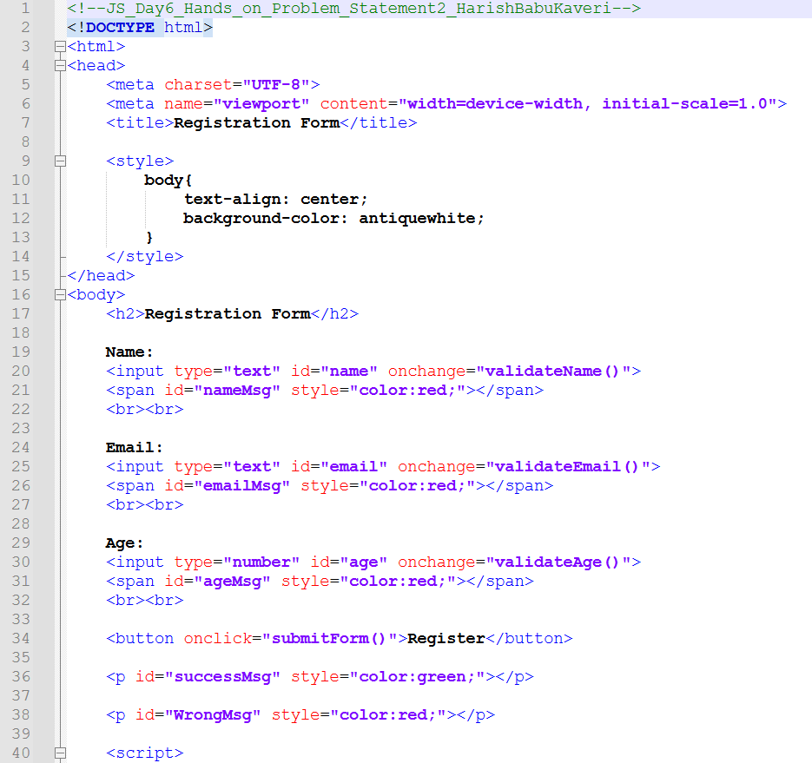
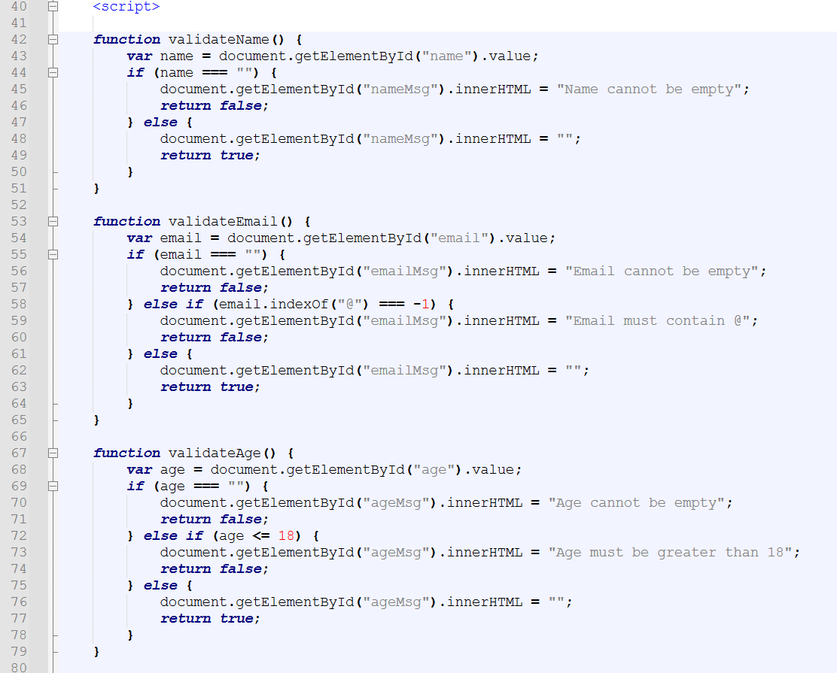
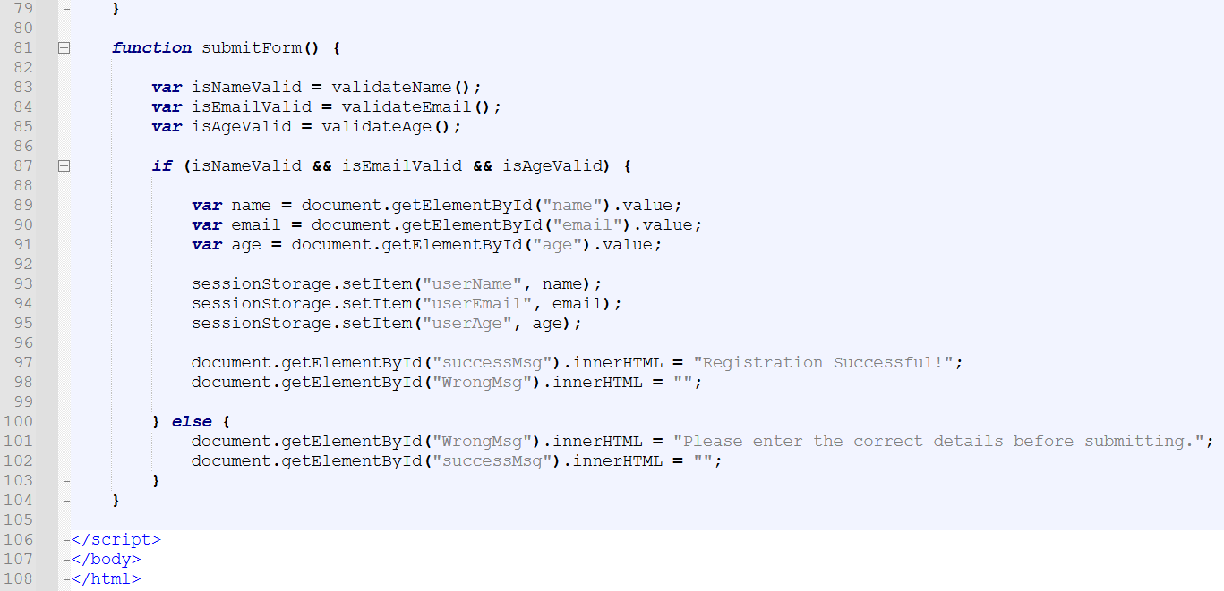

Output:
Output File: index.html
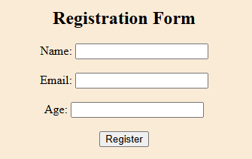
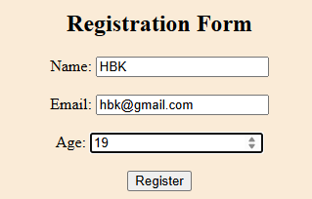
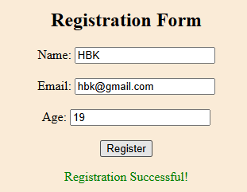
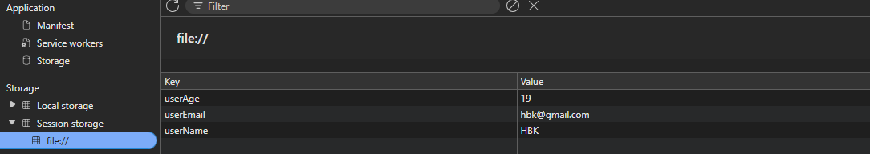
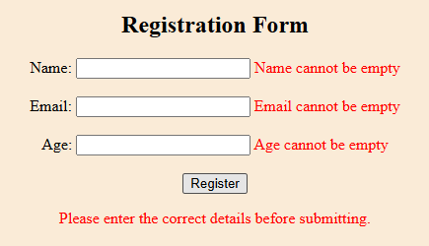

Explanation:
This code creates a Registration Form with validation using JavaScript. It checks if the name, email, and age are filled correctly (email must contain “@” and age must be above 18). If everything is correct, it shows “Registration Successful!” and stores the details in sessionStorage. If not, it displays error messages in red and asks the user to enter valid details.

Problem 3
Problem Statement:
Location-Based Weather Logger (Level-2)
Scenario
Create a web application that fetches the user's geographic location and stores location history in localStorage.
📌 Requirements
- Button: Get My Location
- Use:
navigator.geolocation.getCurrentPosition()
- Display:
Latitude
Longitude
- Handle:
Permission denied
Timeout
Location unavailable
- Save last 5 location entries in localStorage.
- Display location history on page load.

🛠️ Technical Constraints
- Must handle:
Success callback
Error callback
- Use browser permission handling.
- Store data as JSON using:
JSON.stringify()
JSON.parse()
- Use inline event (onclick).
🎯 Learning Outcome
Learners should be able to:
- Geolocation API
- Handling browser permissions
- Error handling in APIs
- Managing structured data in localStorage
- JSON parsing and stringifying

Source Code:
File Name: index.html
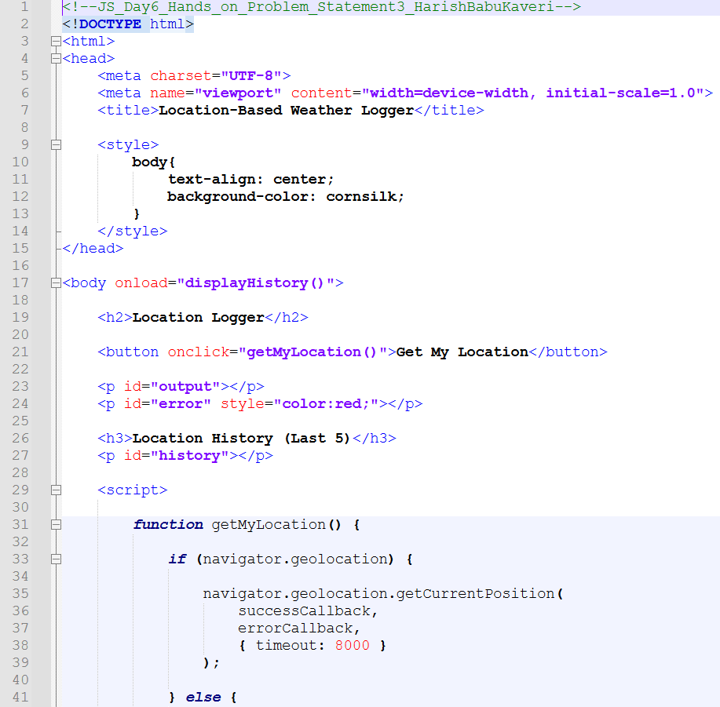
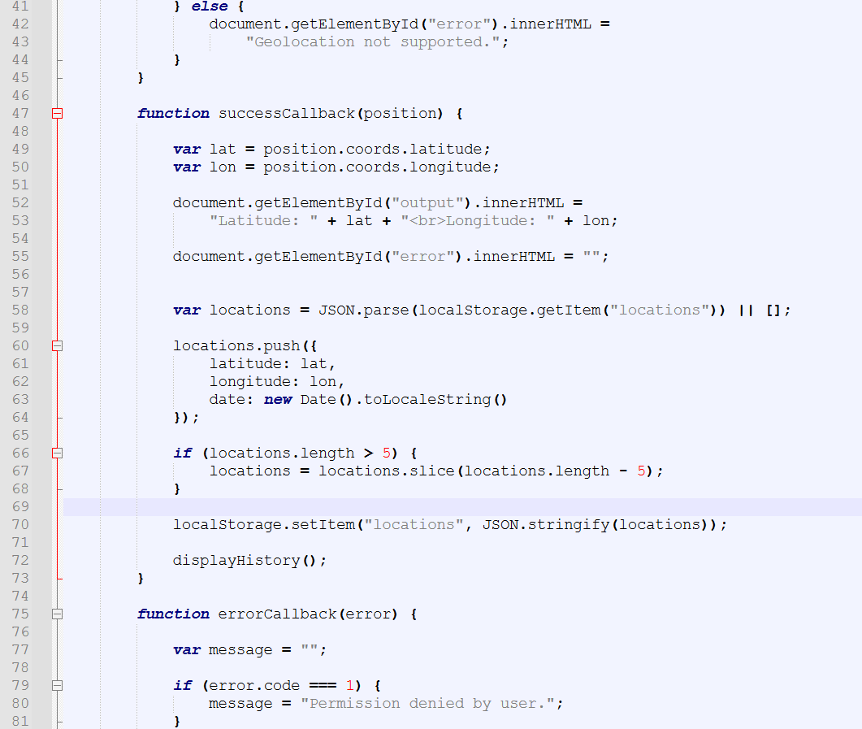
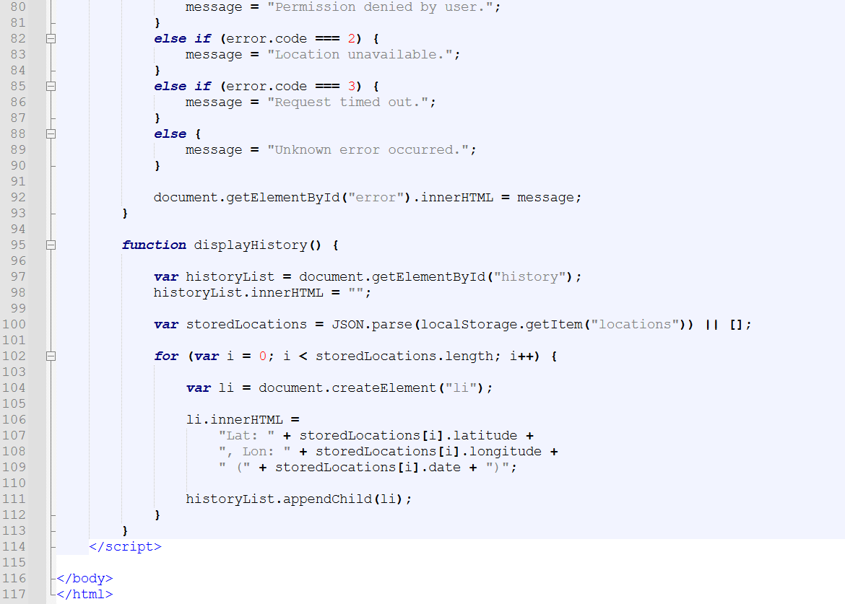
Output:
Output File: index.html
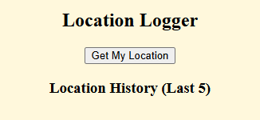
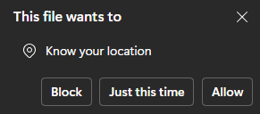
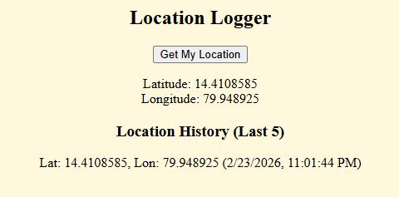
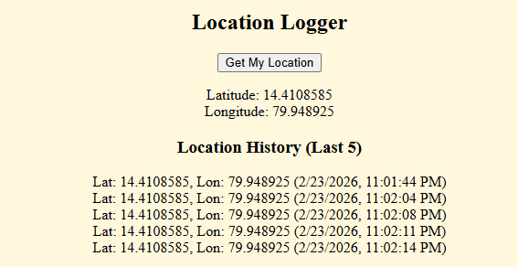
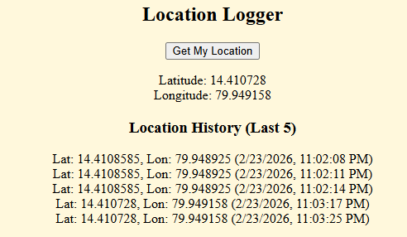
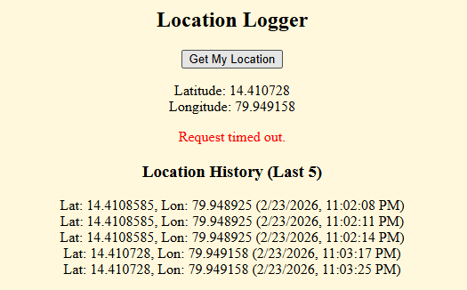
Explanation:
This code creates a Location Logger that uses the browser’s geolocation feature to get your current latitude and longitude when you click “Get My Location.” It asks for permission, shows your location on the screen, and handles errors like timeout or permission denied. It also saves the last 5 locations in localStorage and displays them as history, so you can see your recent location logs even after refreshing the page.

Problem 4
Problem Statement:
Mini Expense Tracker using Client-Side Database (Level-2)
Scenario
Develop a client-side expense tracker where users can add, view, and delete expenses using a browser-supported database.
📌 Requirements
- Fields:
  - Expense Title
  - Amount
  - Date
- Buttons:
  - Add Expense
  - View Expenses
  - Delete Expense
- Use:
  - Client-side database (Web SQL or IndexedDB)
- Execute SQL-like queries:
  - CREATE TABLE
  - INSERT
  - SELECT
  - DELETE
- Maintain transaction handling.
- Display expense list dynamically.

🛠️ Technical Constraints
- Must use:
  - Client-side DB transactions
  - SQL execution methods
- Must handle:
  - Transaction errors
  - Query errors
- No server/database allowed.
- Pure JavaScript + HTML.

🎯 Learning Outcome
You will be able to:
- Client-side database concepts
- Executing SQL queries in browser
- Managing transactions
- Advanced DOM rendering
- Persistent structured storage

Source Code:
File Name: index.html
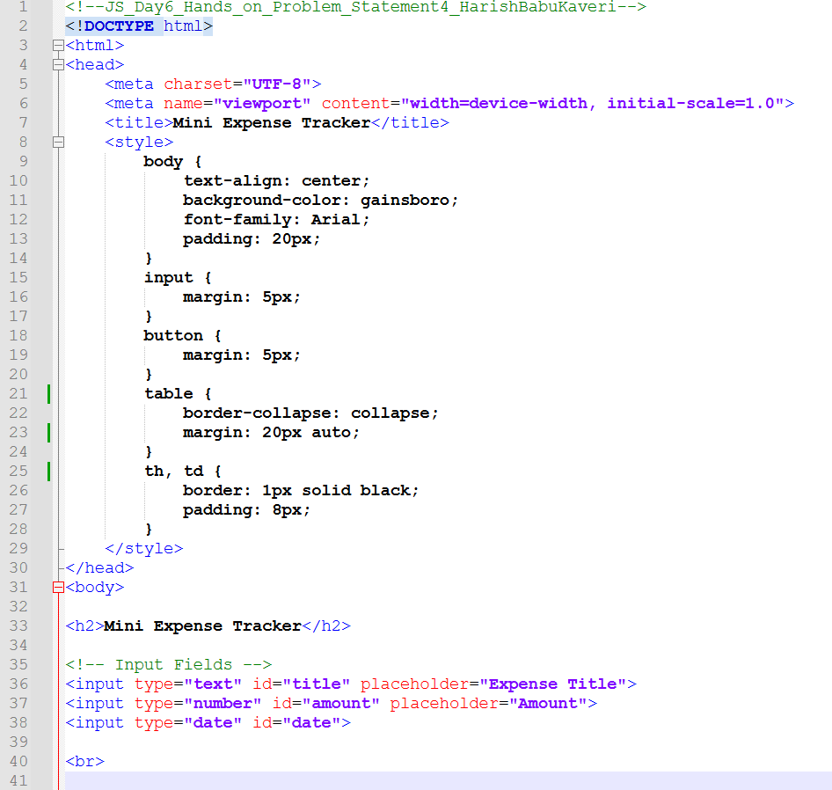
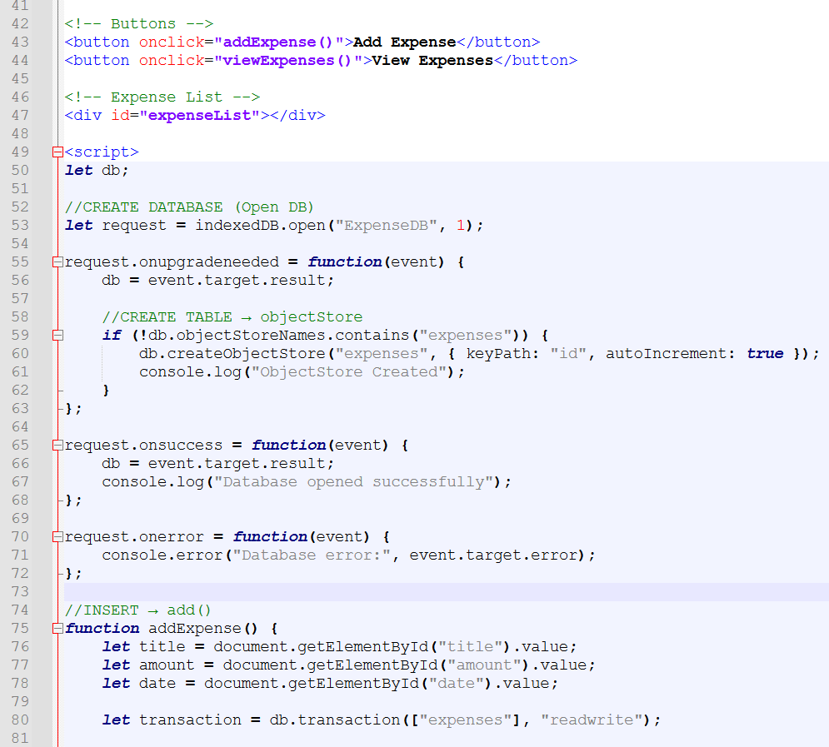
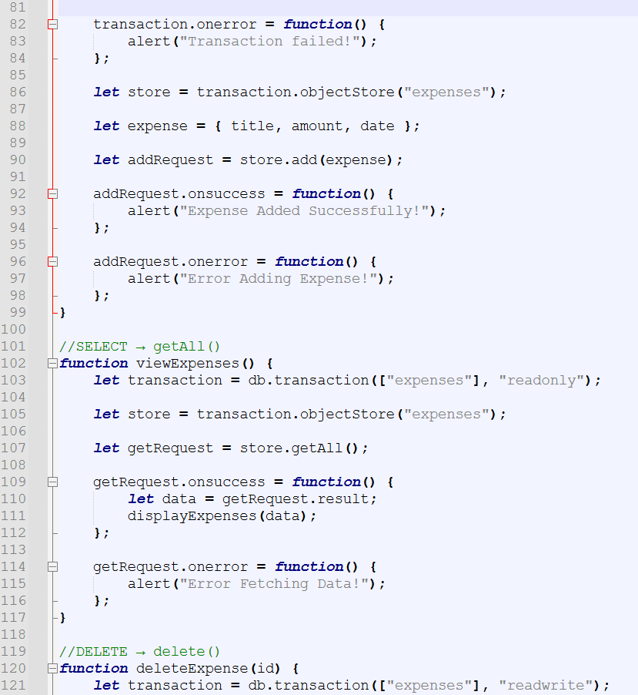
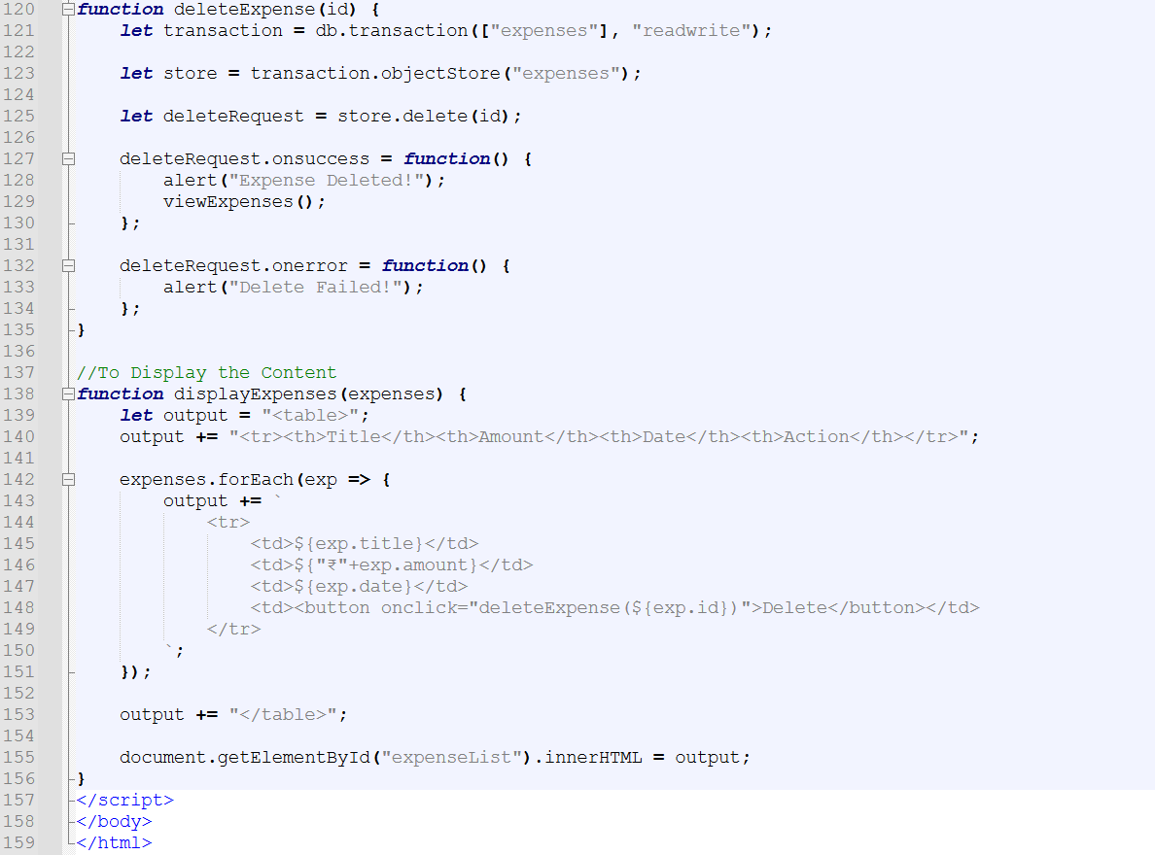
Output:
Output File: index.html
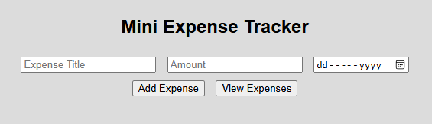
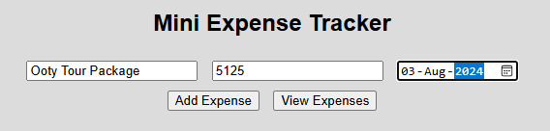
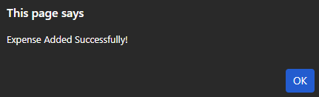
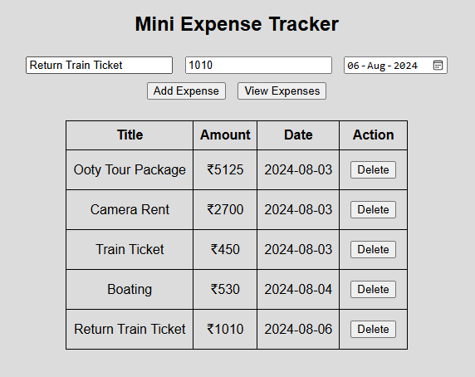
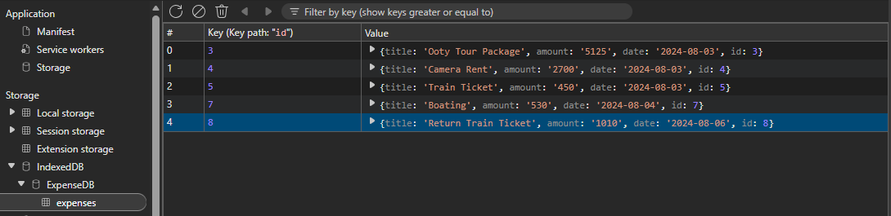

Explanation:
This code creates a Mini Expense Tracker using IndexedDB in the browser. You can add an expense (title, amount, date), store it in a database, view all expenses in a table, and delete any record. The output shows your entered expenses neatly in a table, and the data is saved in the browser’s IndexedDB, so it stays even after refreshing the page.

