Session6 assignment
1.Create a Python dictionary called insta_followers that stores the number of followers for 5 Instagram influencers (use their usernames as keys and follower counts as values). Print the dictionary.
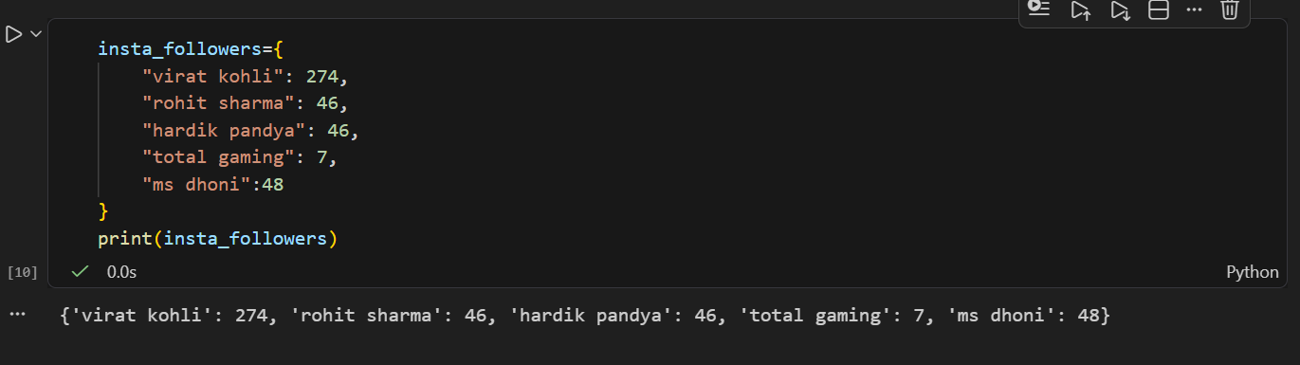

2.Add a new influencer to your insta_followers dictionary and update the follower count for one existing influencer. Then, delete one influencer from the dictionary and print the updated dictionary.
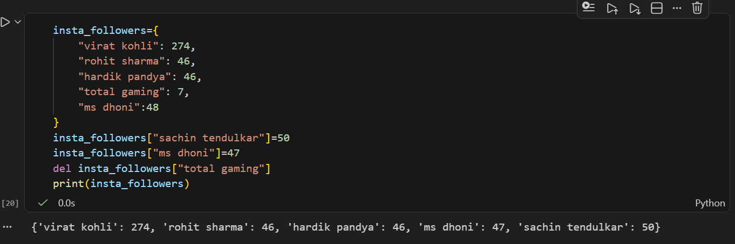

3.Given a dictionary called food_prices with 5 Zomato food items as keys and their prices as values, write code to display all items that cost more than ₹200.
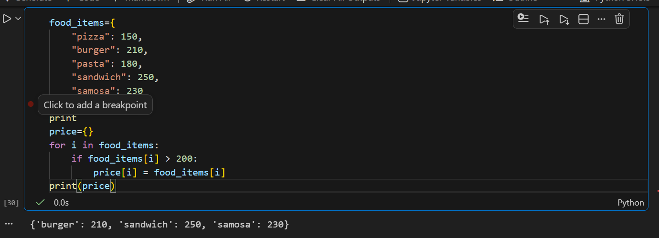

4.Create two sets: flipkart_users and myntra_users, each containing 5 unique usernames. Find and print the set of users who have accounts on both platforms using set intersection.
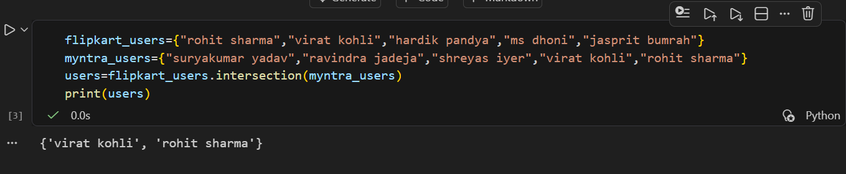

5.Write a function get_unique_artists(spotify_playlist1, spotify_playlist2) that takes two sets of artist names and returns a set of all unique artists across both playlists (set union).<br><br><em><strong>Hint:</strong> Use the union() method or the | operator for sets.</em>
