Session7 assignment
1.Write a Python script that takes your current Spotify listening time in minutes and checks if it is above 120 minutes; if yes, print 'You are a true music fan!', otherwise print 'Keep listening!'.
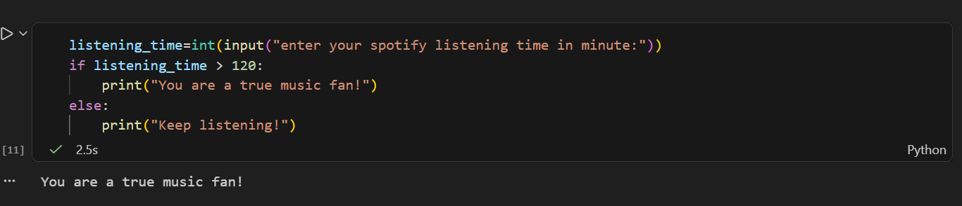

2.Create a Python program that asks the user to enter their Zomato order amount and checks if it is above 300; if yes, print 'Eligible for free delivery', else print 'Delivery charges apply'.
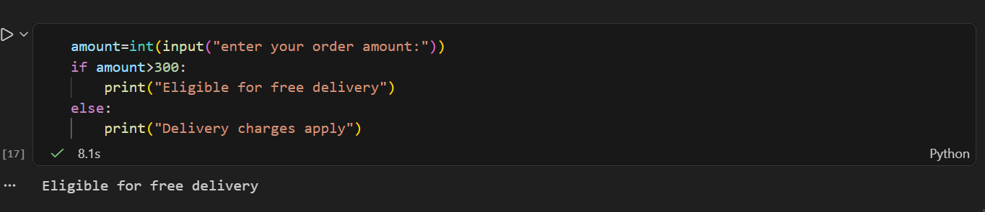

3.Build a Python script that takes your Flipkart cart total and applies the following logic: if total > 2000, print 'You get a 10% discount'; elif total > 1000, print 'You get a 5% discount'; else print 'No discount available'.
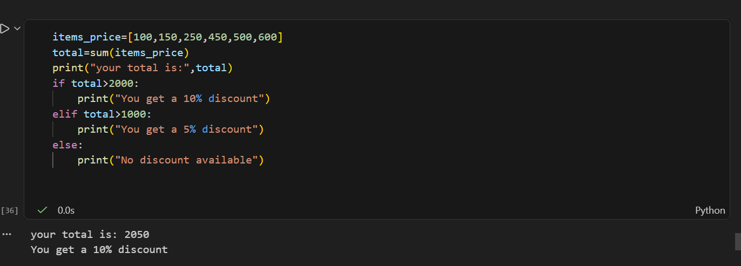

4.Write a Python program that asks the user to enter their IPL fantasy team points and uses nested if-else statements to print: 'Champion' if points > 800, 'Top Performer' if points between 500 and 800, 'Keep Trying' otherwise.<br><br><em><strong>Hint:</strong> Use nested if-else blocks to check the ranges.</em>



