Session21 assignment
1.Create a Python class called Product with attributes name and price, and a method get_discounted_price() that returns the price after applying a 10% discount.
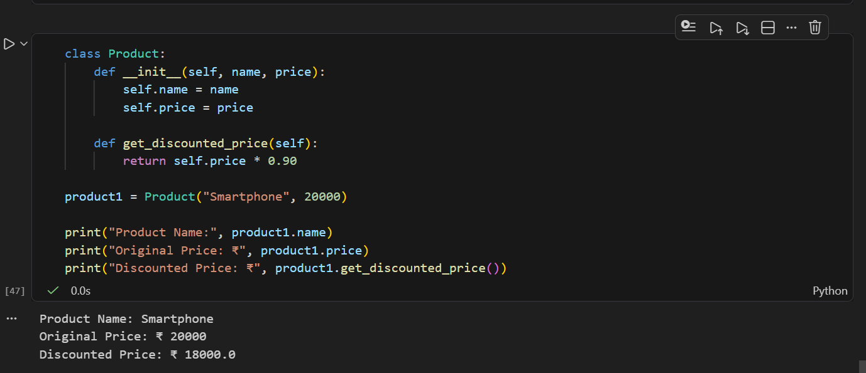

2.Now create a subclass called Electronics that inherits from Product and overrides the get_discounted_price() method to apply a 20% discount instead of 10%.
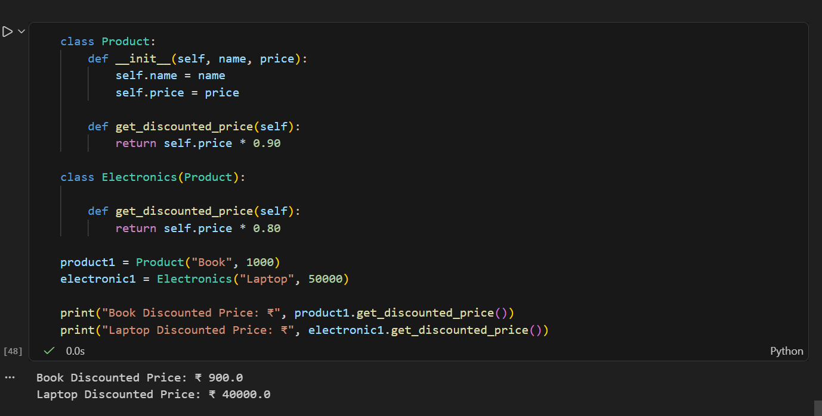

3.Write a function show_final_price(item) that takes any Product or Electronics object and prints its name and the discounted price by calling get_discounted_price(). Demonstrate polymorphism by passing both a Product and an Electronics object to this function.
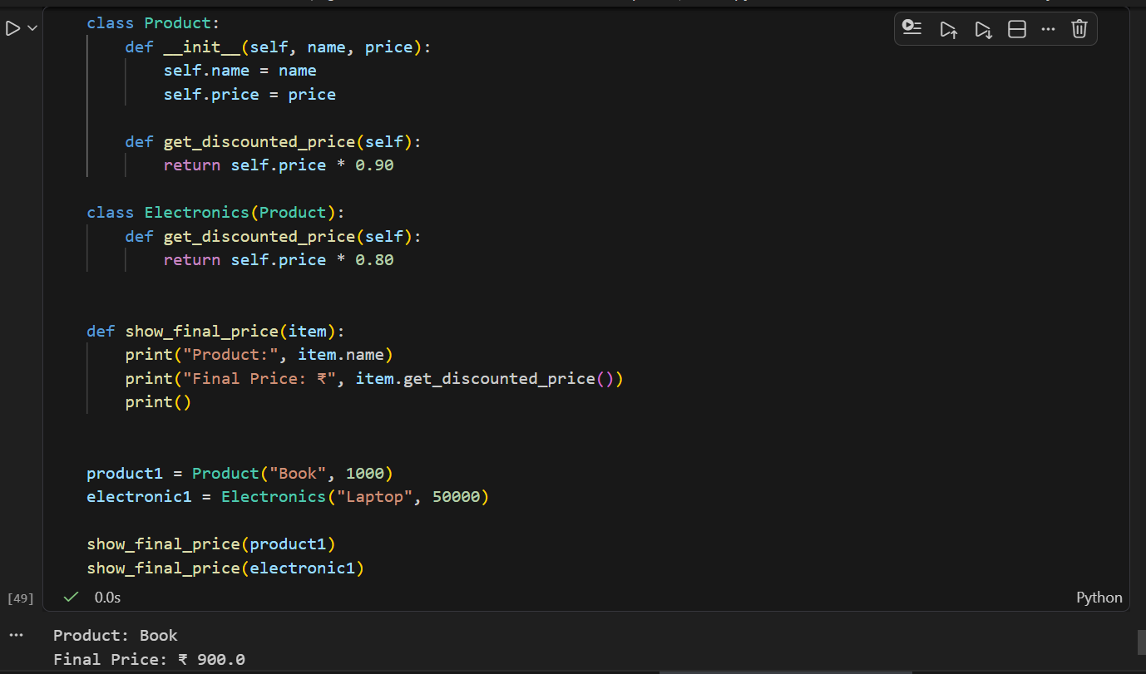

4.Build a simple Ticket class for a movie booking app with a method get_final_price(). Then, create a subclass PremiumTicket that overrides get_final_price() to add a 50 rupee convenience fee. Show both in action by creating objects and printing their final prices.<br><br><em><strong>Hint:</strong> Use super() in PremiumTicket to reuse the parent method and add the extra fee.</em>
