Session8 assignment
1.Create a Python script that uses a for loop to print the names of 5 favorite food delivery apps (e.g., Zomato, Swiggy, etc.), one per line.
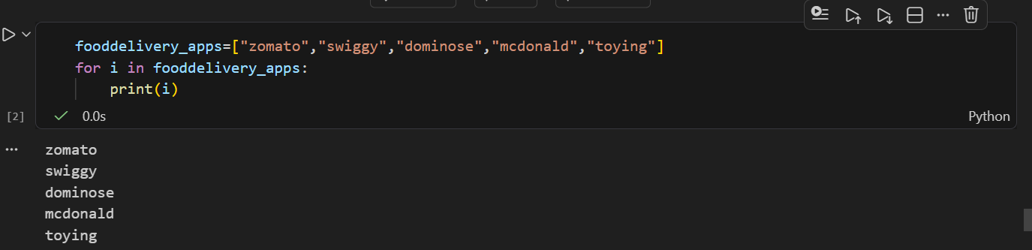

2.Given a list of daily step counts for a week, use a while loop to find and print the first day when you crossed 10,000 steps.<br><br><em><strong>Hint:</strong> Loop through the list and stop as soon as you find a value greater than 10,000.</em>
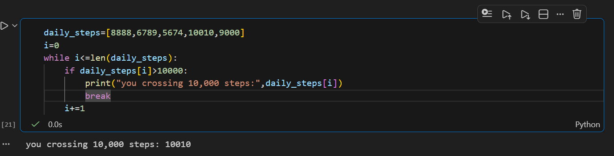

3.Write a Python function that takes a list of IPL team names and prints only those teams whose names are longer than 6 characters, skipping the rest using the continue statement.
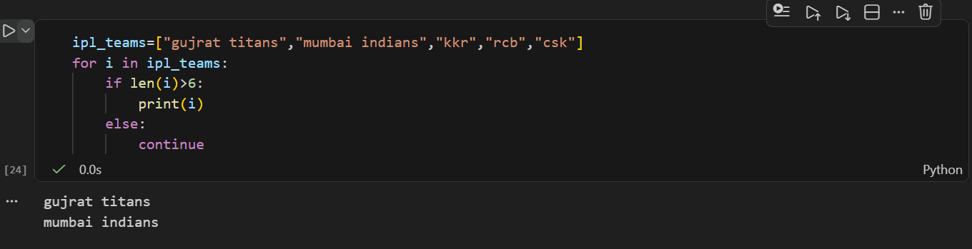

4.You have a list of song durations (in seconds) from your Spotify playlist. Use a for loop with enumerate to print each song's position (starting from 1) and its duration in the format: 'Song 1: 210 seconds'.
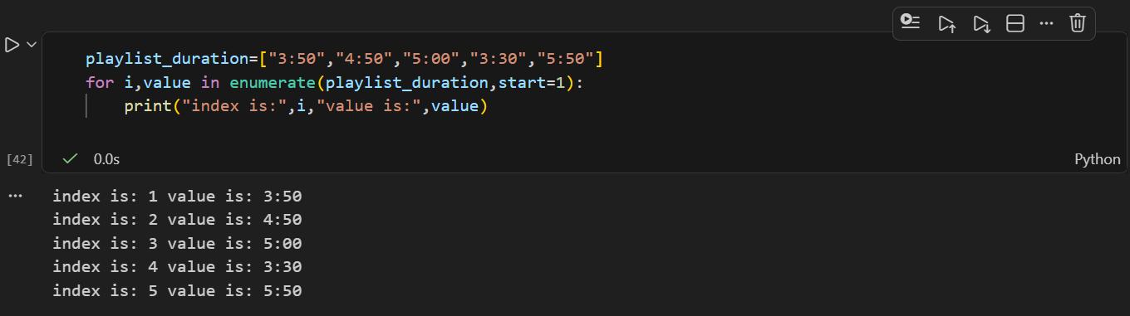

5.Build a simple shopping cart total calculator: Given a list of item prices from a Flipkart cart, use a loop to sum the prices. If an item price is 0 (out of stock), skip it. Stop adding items if the running total crosses ₹2000 using break, and print the final total.<br><br><em><strong>Constraint:</strong> Use both break and continue in your solution.</em>
