Session3 assignment
1.Declare four variables in Python: your age as an int, your height in centimeters as a float, your name as a str, and whether you have a Spotify account as a bool. Print each variable and use the type() function to display its data type.
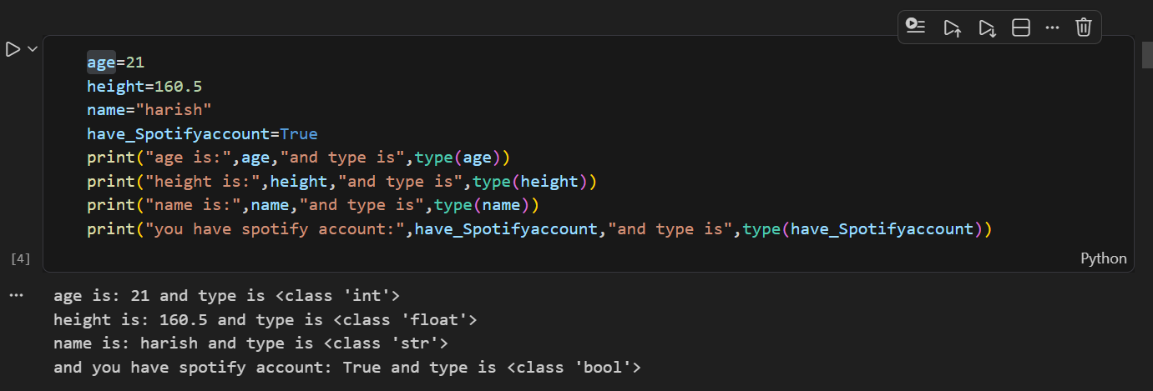

2.Write a function total_cart_amount(prices) that takes a list of product prices as strings (like ['199.99', '49', '350.75']) and returns the total as a float. Print the result for a sample Flipkart-style cart.<br><br><em><strong>Hint:</strong> Use float() to convert each string before summing.</em>
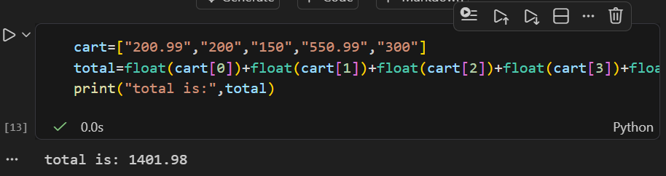

3.Create a script that asks the user to input their cricket score as a string, converts it to an int, and prints 'Half-century!' if the score is 50 or more, otherwise prints 'Keep going!'.<br><br><em><strong>Constraint:</strong> Use input(), int(), and if-else.</em>
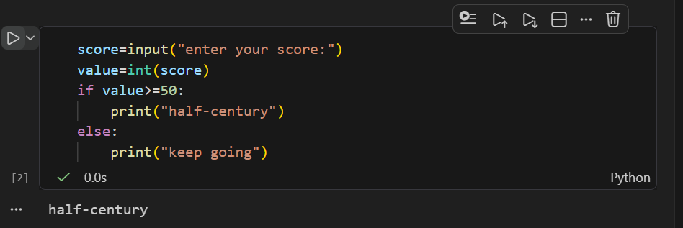

4.Given the variable is_premium = 'True' (as a string), write code to correctly convert it to a boolean value and print its type.<br><br><em><strong>Hint:</strong> The bool() function alone won’t work as expected. Think about string comparison.</em>
