Session9 assignment
1.Define a function called calculate_final_price(price, discount_rate) that returns the final price after applying the discount rate to the given price.

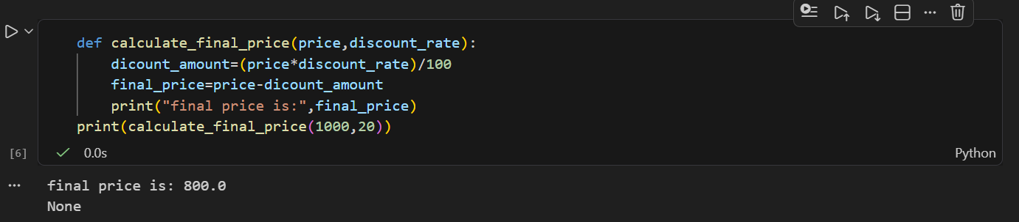

2.Create a function called get_delivery_charge(amount, city='Ahmedabad') that returns 0 if city is 'Ahmedabad', otherwise returns 50 as a delivery charge.<br><br><em><strong>Hint:</strong> Use a default argument for the city parameter.</em>

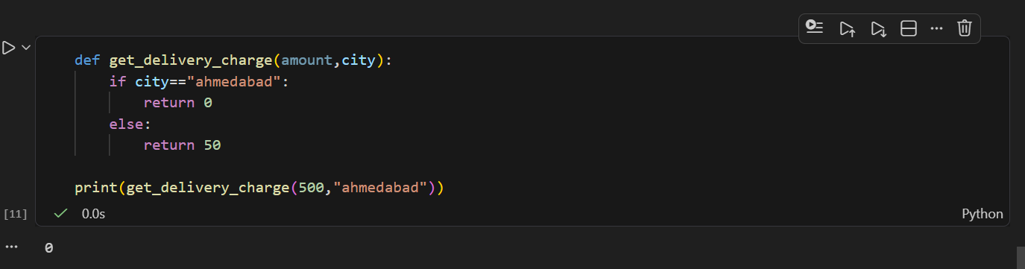

3.Write a function called format_price(price, currency='INR') that returns a string like '₹500' if currency is 'INR', or '$500' if currency is 'USD'.

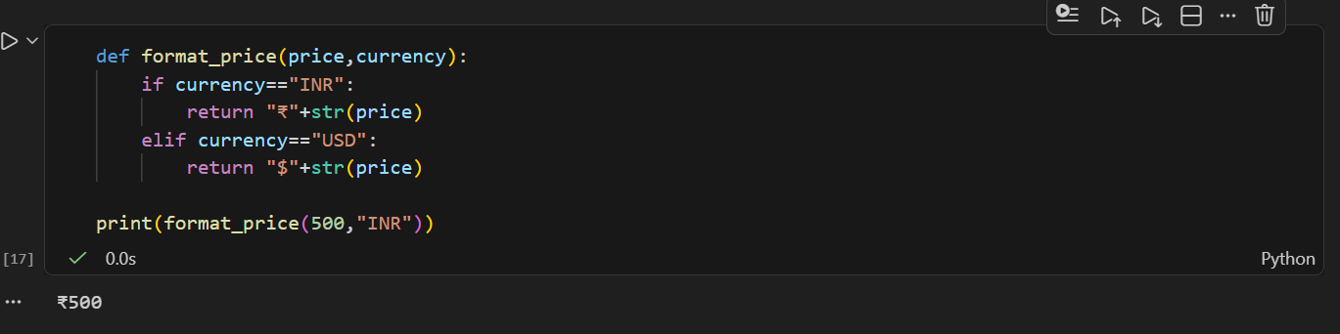

4.Build a function called apply_coupon(price, coupon_code=None) that returns the price after a 10% discount if coupon_code is 'ZOMATO10', otherwise returns the original price.<br><br><em><strong>Constraint:</strong> Use a default argument for coupon_code.</em>

