Session1 assignment
1.Install MySQL or PostgreSQL on your system and create a new database named 'music_streaming_app' using the command line or GUI tool of your choice.
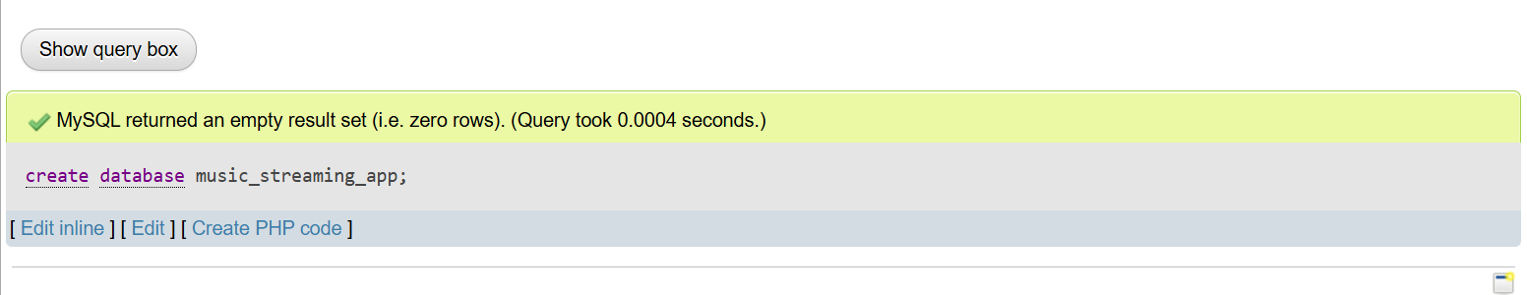

2.Inside the 'music_streaming_app' database, create a table called 'playlists' with columns: playlist_id (integer, primary key), name (varchar), and created_by (varchar).
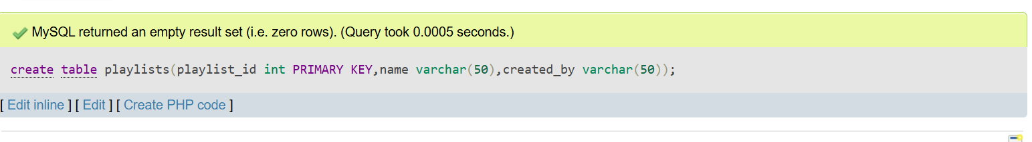

3.Insert three sample rows into the 'playlists' table representing playlists like 'Bollywood Hits', 'Chill Vibes', and 'Workout Mix', each created by a different user.
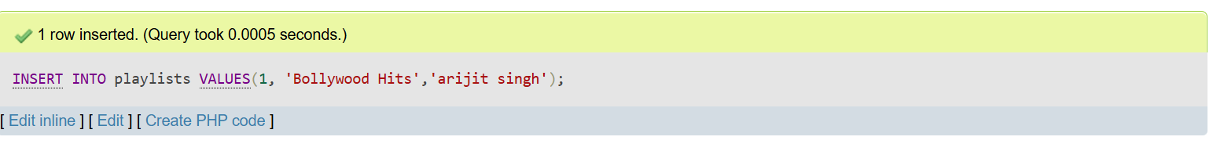
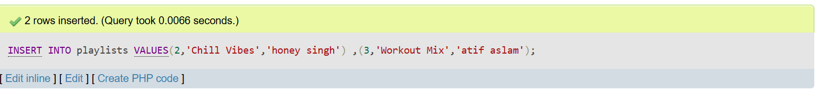

4.Write an SQL SELECT query to display all playlists created by the user 'Amit' from the 'playlists' table.<br><br><em><strong>Hint:</strong> Use the WHERE clause to filter by the 'created_by' column.</em>
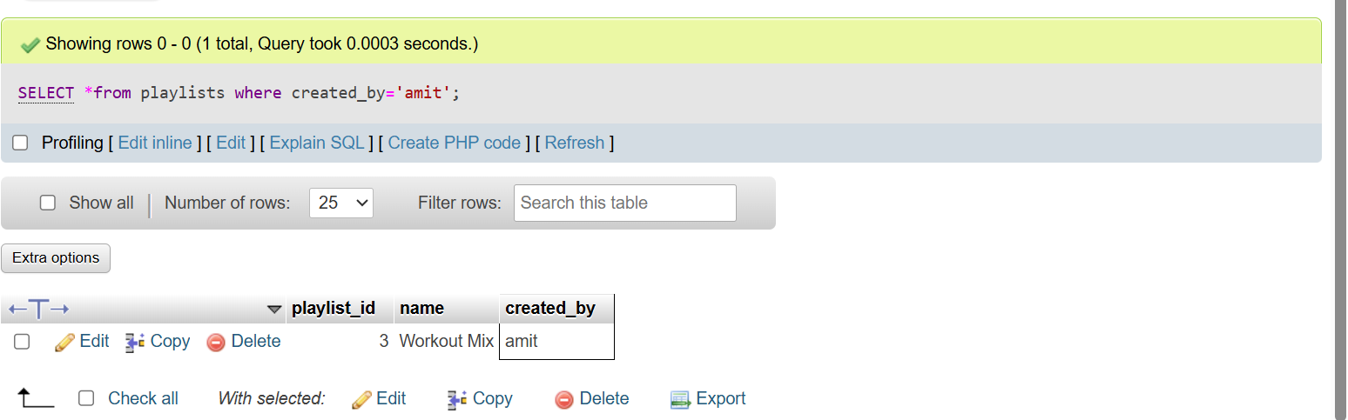

5.Open ChatGPT or Copilot and ask it to explain the difference between a table, a row, and a column in SQL using an example from a food delivery app like Zomato. Paste the explanation you receive into your assignment.
Ans:
In SQL, a table is used to store related data. For example, a food delivery app like Zomato may have a table called Orders that stores information about customer orders.
A row represents one complete record in the table. For example, if a customer orders a pizza, that order's details are stored in one row.
A column represents a specific type of information about all records in the table. For example, the Orders table may have columns such as Order_ID, Customer_Name, Restaurant_Name, Food_Item, and Price.

