Session8 assignment
1.Create a table called Orders with columns: order_id, user_id, payment_method, and amount. Insert at least 8 sample records representing different users and payment methods (like UPI, Card, Wallet, COD).
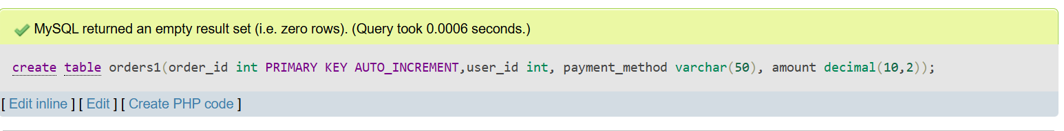
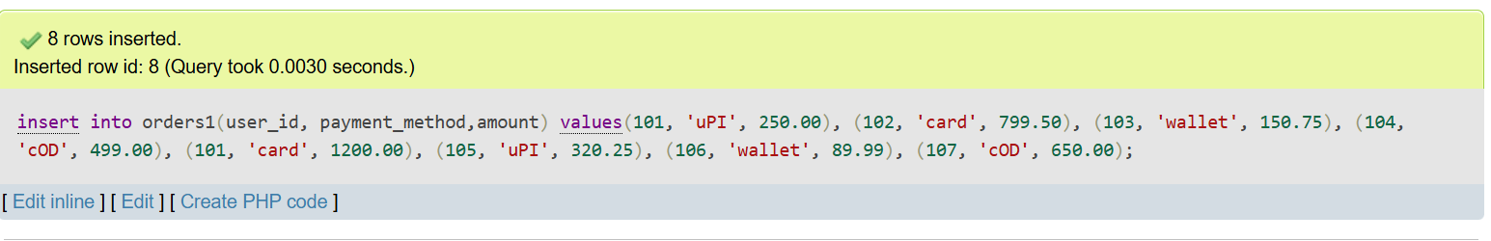

2.Write an SQL query to count how many orders were placed using each payment_method in the Orders table, similar to how Zomato shows payment breakdown in analytics.
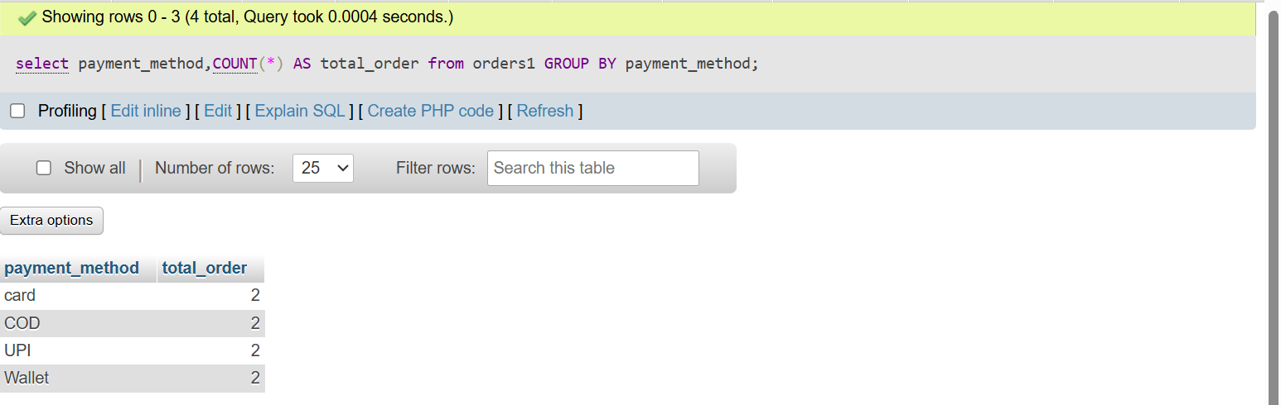

3.Write an SQL query to find the total amount spent by each user_id in the Orders table. Display user_id and their total spend.
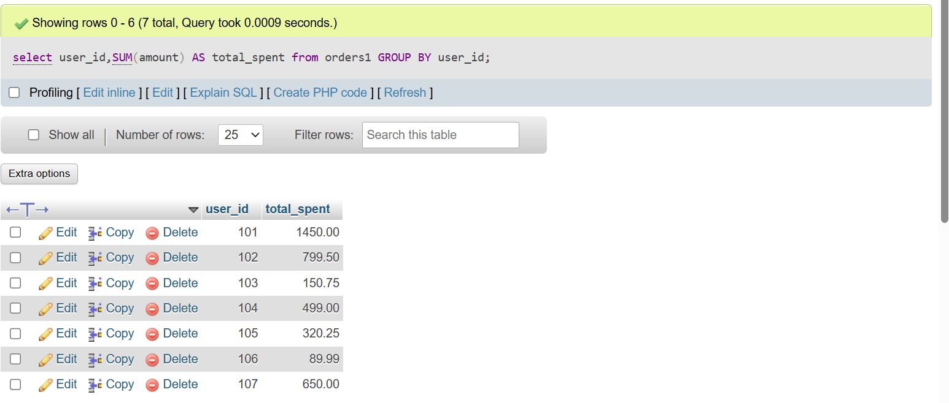

4.Write an SQL query to show only those payment methods where the average order amount is greater than 300, using GROUP BY and HAVING.<br><br><em><strong>Hint:</strong> Use AVG(amount) in your HAVING clause.</em>
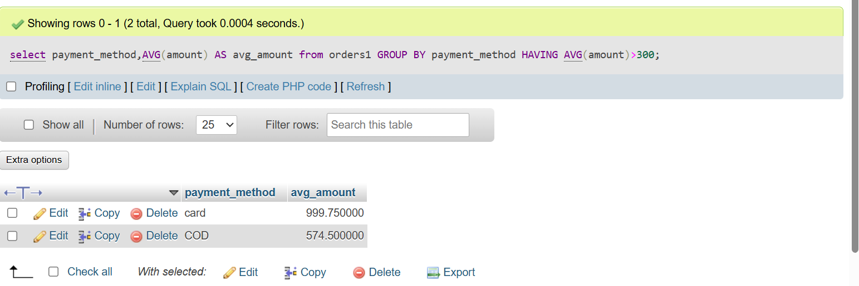

5.Explain the difference between WHERE and HAVING by giving one example query for each, using the Orders table. Your examples should show a scenario where WHERE and HAVING filter different things.
1) WHERE
- WHERE is used to filter rows before grouping
- It works on original table data

2) HAVING
- HAVING is used to filter groups after GROUP BY
- It works on grouped/aggregated data like SUM(), AVG(), COUNT()

