Session10 assignment
1.Create two tables: Influencers (id, name) and Collaborations (id, influencer1_id, influencer2_id, collab_date). Write a SQL FULL JOIN query to list all influencers and show their collaboration partner names if any, including influencers with no collaborations.
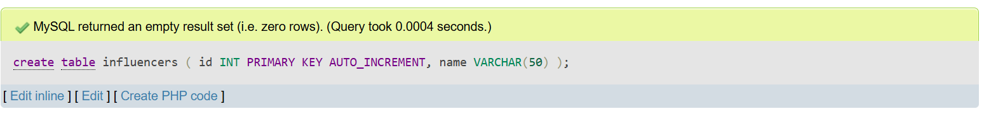
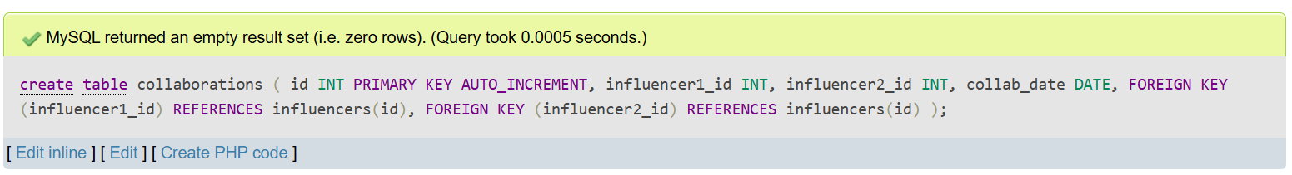

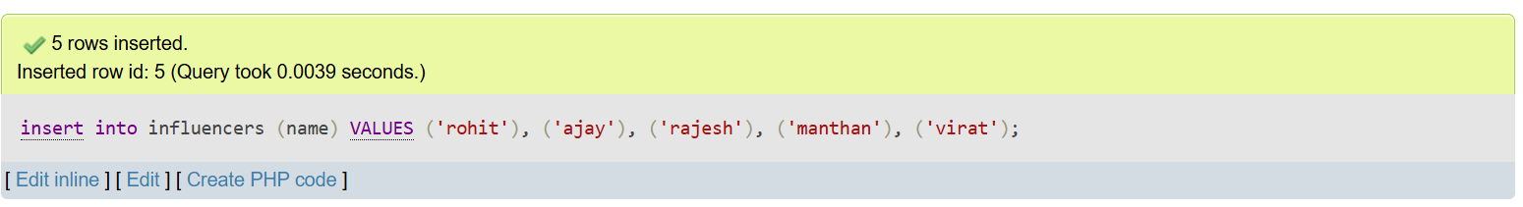
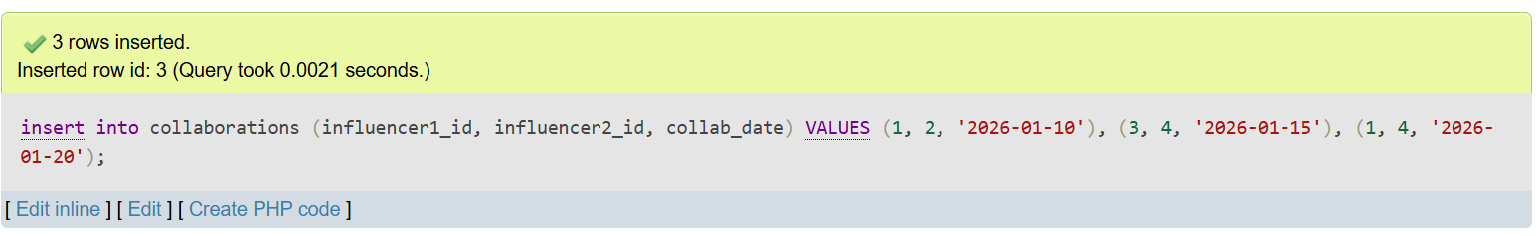

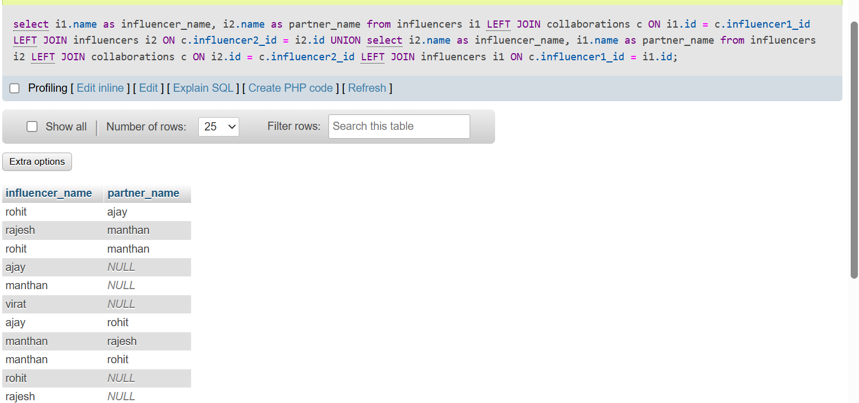

2.Using a SELF JOIN, write a query on a table called Playlists (id, user_id, playlist_name, parent_playlist_id) to display each playlist alongside its parent playlist name, similar to how Spotify shows nested playlists.<br><br><em><strong>Hint:</strong> Join Playlists with itself on parent_playlist_id = id.</em>
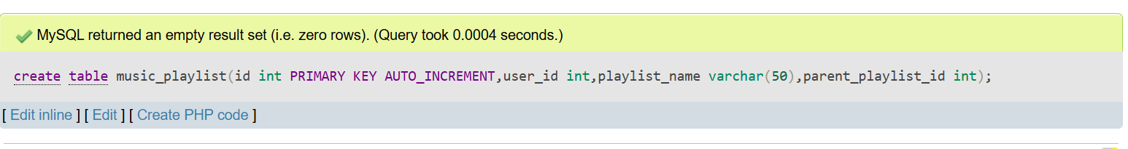
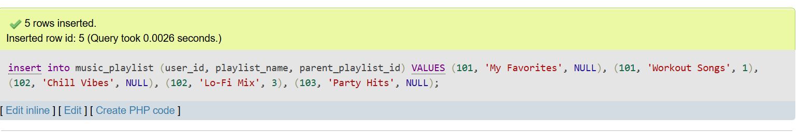
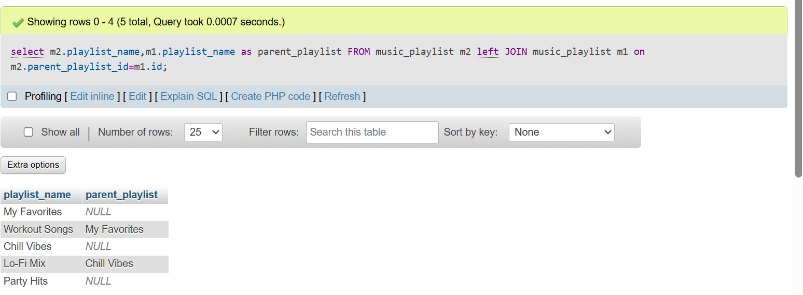

3.Given three tables: Users (id, username), Orders (id, user_id, order_date), and Payments (id, order_id, amount), write a SQL query using multiple JOINs to display each username, their order date, and payment amount, showing all users even if they have no orders or payments.
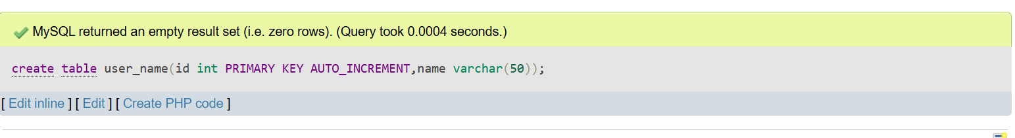

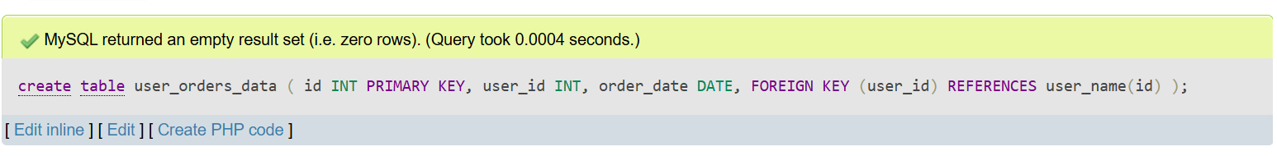
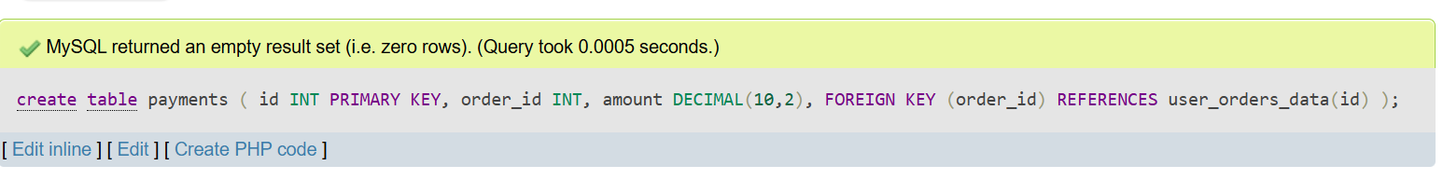

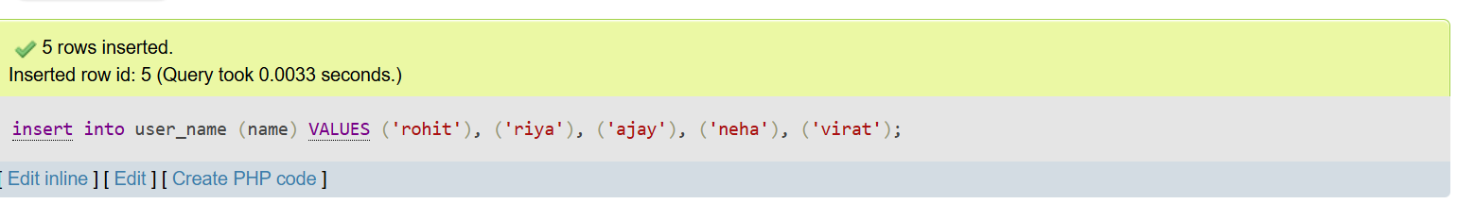
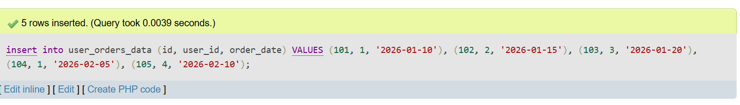
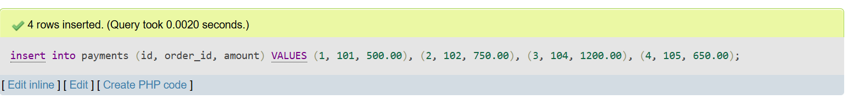

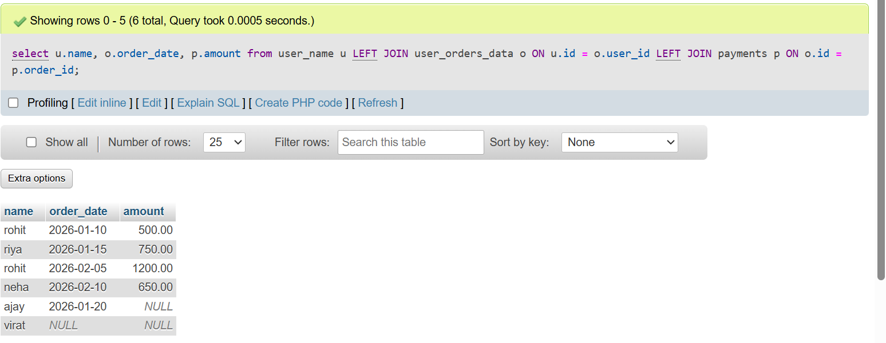

4.You notice that your JOIN query between Zomato's Restaurants and Reviews tables is returning duplicate rows for some restaurants. Modify your query to eliminate duplicates and explain in one line why the duplicates were happening.<br><br><em><strong>Hint:</strong> Use DISTINCT or GROUP BY and consider the relationship between restaurants and reviews.</em>
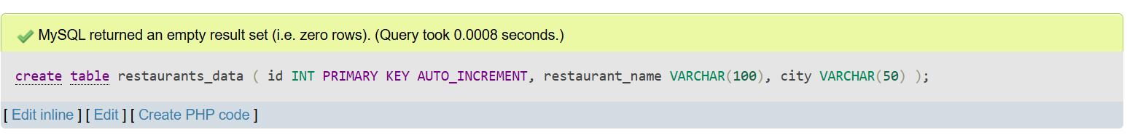
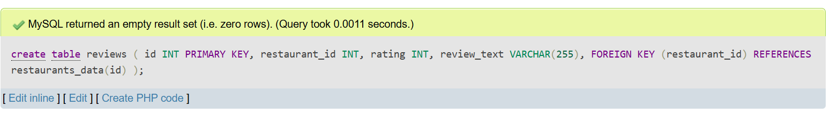

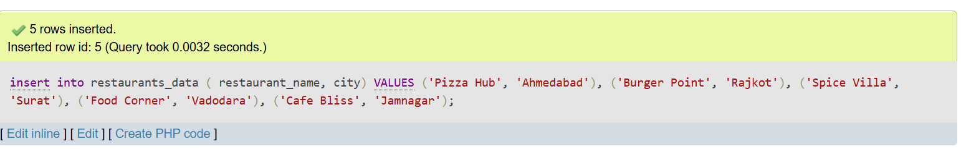
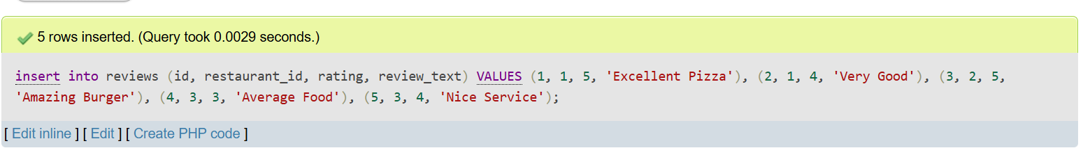

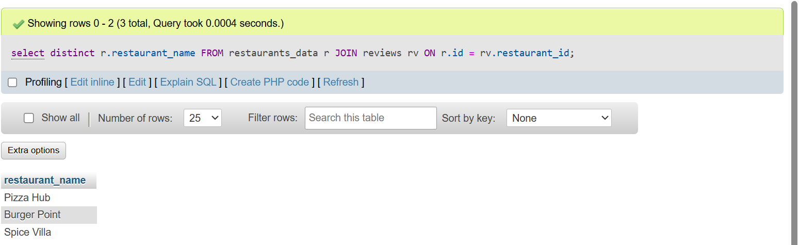
Reason: Duplicates were happening because one restaurant can have multiple reviews (one-to-many relationship), so the JOIN returned one row for each review.

5.Write two different JOIN queries on a Products and Categories table (like Flipkart) to list all products with their category names, but use different join conditions in each. Briefly explain which join condition is more efficient and why.
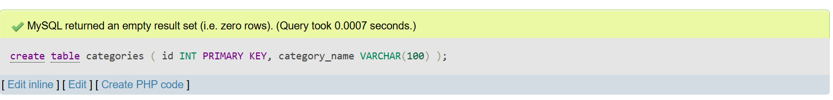
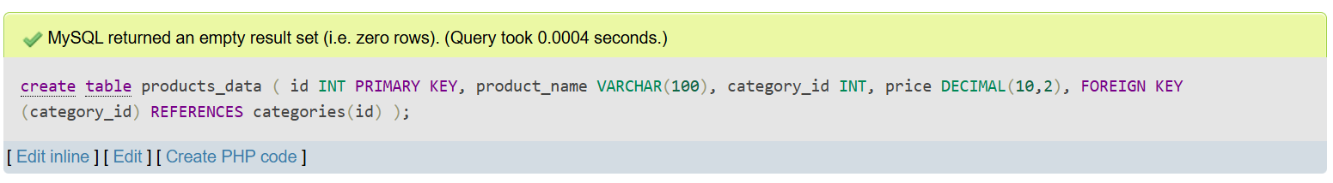

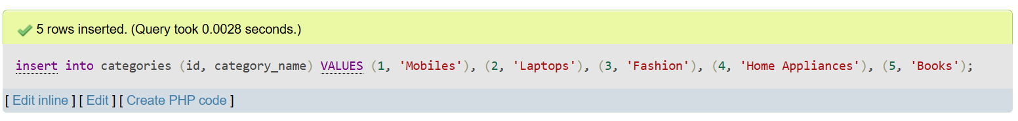
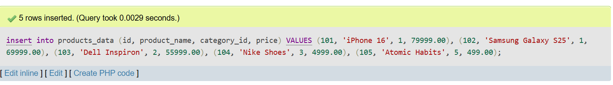

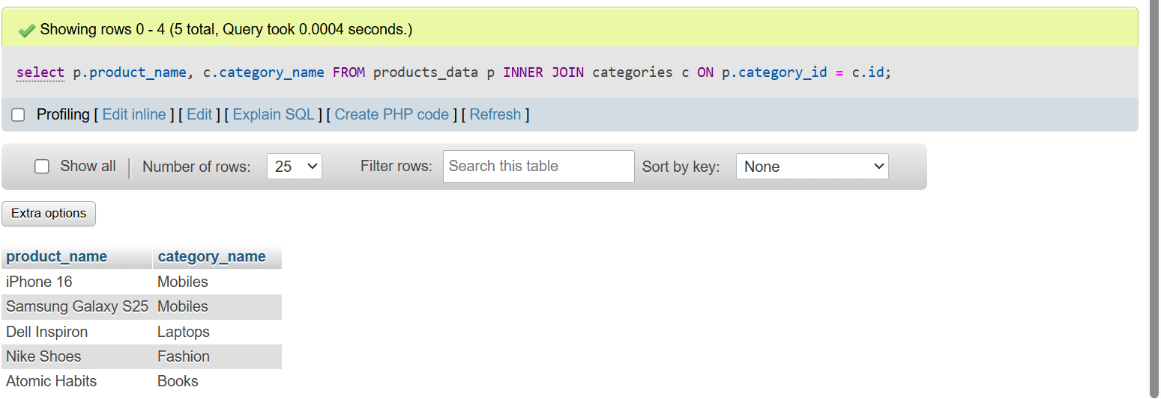
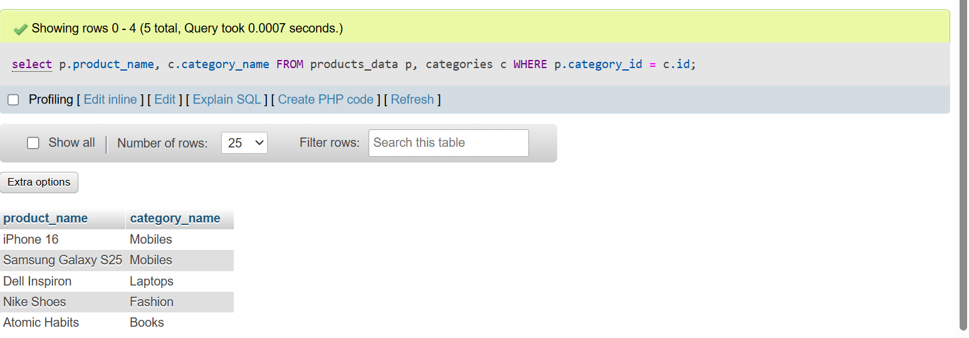

More efficient: Query 1 (INNER JOIN) is more efficient because it uses the modern ANSI JOIN syntax, which is clearer, easier to maintain, and allows the database optimizer to process joins more effectively.

