**B6 Session-2 Assignment-1**

**Problem Statement**:

1. What are the different methods to call a function in R?

When calling a function you can specify arguments by position, by complete name, or by partial name. Arguments are matched first by exact name (perfect matching), then by prefix matching, and finally by position.

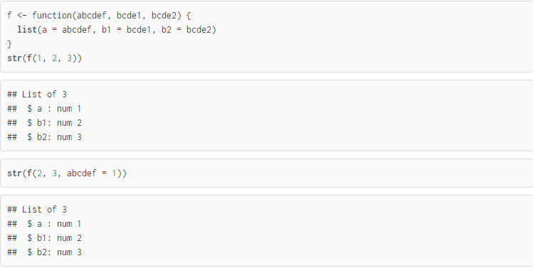

Calling a function given a list of arguments

Suppose you had a list of function arguments:

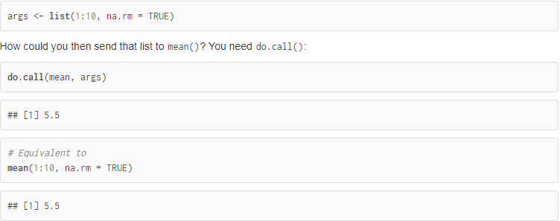

Default and missing arguments

### 

1. The lazy evaluation of a function means, the argument is evaluated only if it is evaluated only if it is usedinside the body of the function. Say True or False.

Ans: True

1. State TRUE OR FALSE
2. Insights driven from descriptive analytics is not meaningful.

Ans: False

1. The number of values in each Elements of a list, should be equal.

Ans: False

1. The datasets are not stored in memory of the computer using R.

Ans: False

1. Data frames and matrices are two dimensional however the array is multidimensional.

Ans: True