**B6 Session-7 Assignment-1**

1. Histogram for all variables in a dataset mtcars. Write a program to create histograms for all columns.

2. Check the probability distribution of all variables in mtcars

3. Write a program to create boxplot for all variables.

1. Histogram for all variables in a dataset mtcars. Write a program to create histograms for all columns.

library(tidyr)  
library(ggplot2)  
ggplot(gather(mtcars), aes(value)) +geom_histogram(bins =10) +  
facet_wrap(~key, scales ='free_x')

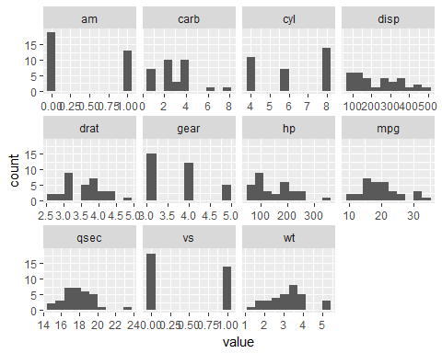

2. Check the probability distribution of all variables in mtcars.

```{r}

library(readr)

mtcars<- read_csv("C:/Users/Seshan/Desktop/mtcars.csv")

cars<- mtcars

print(head(cars))

column_means<- colMeans(cars) # Get the means of each column

print(column_means) # Check means

center_matrix<- matrix( rep(column_means, nrow(cars)), # Repeat the column means

nrow=nrow(cars),

ncol=ncol(cars),

byrow = TRUE)

# Construct row by row

centered<- cars - center_matrix # Subtract column means

print( head( centered )) # Check the new data set

print(colMeans(centered)) # Check the new column means to confirm they are 0

sd(centered$mpg)

column_sds<- apply(centered, # A matrix or data frame

MARGIN = 2, # Operate on rows(1) or columns(2)

FUN = sd) # Function to apply

print(column_sds) # Check standard deviations

scale_matrix<- matrix( rep(column_sds, nrow(cars)), # Repeat the column sds

nrow=nrow(cars),

ncol=ncol(cars),

byrow = TRUE)

centered_scaled<- centered/scale_matrix # Divide by column sds to scale the data

summary(centered_scaled) # Confirm that variables are on similar scales

auto_scaled<- scale(cars, # Numeric data object

center=TRUE, # Center the data?

scale=TRUE) # Scale the data?

summary(auto_scaled) # Check the auto scaled data

normally_distributed<- rnorm(10000) # Generate normally distributed data

hist(normally_distributed, breaks=30) # Create a histogram of the distribution

skewed_right<- rexp(10000, 0.5) # Generate skewed data

hist(skewed_right, breaks=50) # Create a histogram of the distribution

log_transformed<- log(skewed_right+1)

hist(log_transformed, breaks=50)

cor(cars[,1:6]) # Check the pairwise correlations of 6 variables

pairs(cars[,1:6])

Max. : 1.1899 Max. : 1.7789 Max. : 3.2117

mpgcyldisphp

Min. :-1.6079 Min. :-1.225 Min. :-1.2879 Min. :-1.3810

1st Qu.:-0.7741 1st Qu.:-1.225 1st Qu.:-0.8867 1st Qu.:-0.7320

Median :-0.1478 Median :-0.105 Median :-0.2777 Median :-0.3455

Mean : 0.0000 Mean : 0.000 Mean : 0.0000 Mean : 0.0000

3rd Qu.: 0.4495 3rd Qu.: 1.015 3rd Qu.: 0.7688 3rd Qu.: 0.4859

Max. : 2.2913 Max. : 1.015 Max. : 1.9468 Max. : 2.7466

dratwtqsecvs

Min. :-1.5646 Min. :-1.7418 Min. :-1.87401 Min. :-0.868

1st Qu.:-0.9661 1st Qu.:-0.6500 1st Qu.:-0.53513 1st Qu.:-0.868

Median : 0.1841 Median : 0.1101 Median :-0.07765 Median :-0.868

Mean : 0.0000 Mean : 0.0000 Mean : 0.00000 Mean : 0.000

3rd Qu.: 0.6049 3rd Qu.: 0.4014 3rd Qu.: 0.58830 3rd Qu.: 1.116

Max. : 2.4939 Max. : 2.2553 Max. : 2.82675 Max. : 1.116

am gear carb

Min. :-0.8141 Min. :-0.9318 Min. :-1.1222

1st Qu.:-0.8141 1st Qu.:-0.9318 1st Qu.:-0.5030

Median :-0.8141 Median : 0.4236 Median :-0.5030

Mean : 0.0000 Mean : 0.0000 Mean : 0.0000

3rd Qu.: 1.1899 3rd Qu.: 0.4236 3rd Qu.: 0.7352

Max. : 1.1899 Max. : 1.7789 Max. : 3.2117

mpgcyldisphp drat wt

mpg 1.0000000 -0.8521620 -0.8475514 -0.7761684 0.6811719 -0.8676594

cyl -0.8521620 1.0000000 0.9020329 0.8324475 -0.6999381 0.7824958

disp -0.8475514 0.9020329 1.0000000 0.7909486 -0.7102139 0.8879799

hp -0.7761684 0.8324475 0.7909486 1.0000000 -0.4487591 0.6587479

drat 0.6811719 -0.6999381 -0.7102139 -0.4487591 1.0000000 -0.7124406

wt -0.8676594 0.7824958 0.8879799 0.6587479 -0.7124406 1.000000

| **mpg**  <dbl> | **cyl**  <int> | **disp**  <dbl> | **hp**  <int> | **drat**  <dbl> | **wt**  <dbl> | **qsec**  <dbl> | **vs**  <int> | **am**  <int> | **gear**  <int> |  |
| --- | --- | --- | --- | --- | --- | --- | --- | --- | --- | --- |
| 21.0 | 6 | 160 | 110 | 3.90 | 2.620 | 16.46 | 0 | 1 | 4 |  |
| 21.0 | 6 | 160 | 110 | 3.90 | 2.875 | 17.02 | 0 | 1 | 4 |  |
| 22.8 | 4 | 108 | 93 | 3.85 | 2.320 | 18.61 | 1 | 1 | 4 |  |
| 21.4 | 6 | 258 | 110 | 3.08 | 3.215 | 19.44 | 1 | 0 | 3 |  |
| 18.7 | 8 | 360 | 175 | 3.15 | 3.440 | 17.02 | 0 | 0 | 3 |  |
| 18.1 | 6 | 225 | 105 | 2.76 | 3.460 | 20.22 | 1 | 0 | 3 |  |

6 rows | 1-10 of 11 columns

| **mpg**  <dbl> | **cyl**  <dbl> | **disp**  <dbl> | **hp**  <dbl> | **drat**  <dbl> | **wt**  <dbl> | **qsec**  <dbl> |  |
| --- | --- | --- | --- | --- | --- | --- | --- |
| 1 | 0.909375 | -0.1875 | -70.721875 | -36.6875 | 0.3034375 | -0.59725 | -1.38875 |  |
| 2 | 0.909375 | -0.1875 | -70.721875 | -36.6875 | 0.3034375 | -0.34225 | -0.82875 |  |
| 3 | 2.709375 | -2.1875 | -122.721875 | -53.6875 | 0.2534375 | -0.89725 | 0.76125 |  |
| 4 | 1.309375 | -0.1875 | 27.278125 | -36.6875 | -0.5165625 | -0.00225 | 1.59125 |  |
| 5 | -1.390625 | 1.8125 | 129.278125 | 28.3125 | -0.4465625 | 0.22275 | -0.82875 |  |
| 6 | -1.990625 | -0.1875 | -5.721875 | -41.6875 | -0.8365625 | 0.24275 | 2.37125 |  |

6 rows | 1-8 of 11 columns

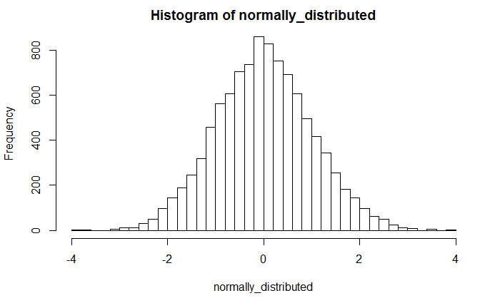

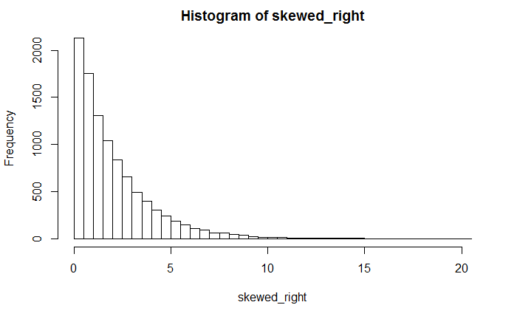

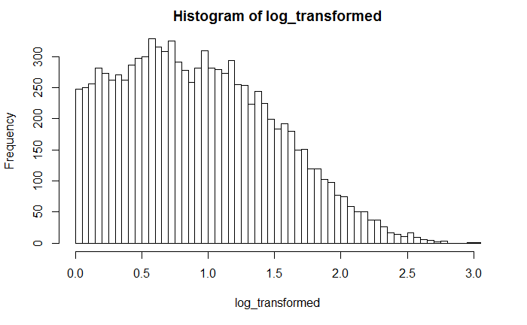

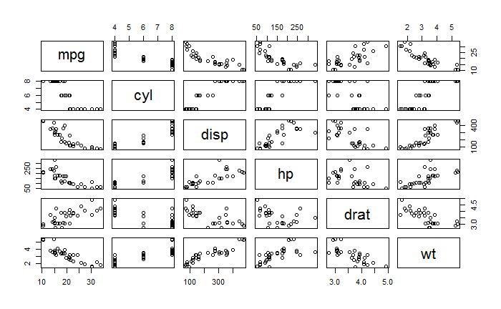

require(graphics)

pairs(mtcars, main = "mtcars data", gap = 1/4)

coplot(mpg ~ disp | as.factor(cyl), data = mtcars,

panel = panel.smooth, rows = 1)

## possibly more meaningful, e.g., for summary() or bivariate plots:

mtcars2 <- within(mtcars, {

vs<- factor(vs, labels = c("V", "S"))

am<- factor(am, labels = c("automatic", "manual"))

cyl<- ordered(cyl)

gear<- ordered(gear)

carb<- ordered(carb)

})

summary(mtcars2)

#### generate subset: automatic and manual cars ####

cars_auto = subset(mtcars, am == 0)

cars_manu = subset(mtcars, am == 1)

# dimensions

dim(mtcars)

dim(cars_auto); dim(cars_manu)

mean(cars_auto$mpg); mean(cars_manu$mpg)

sd(cars_auto$mpg); sd(cars_manu$mpg)

(mean(cars_manu$mpg) - mean(cars_auto$mpg))/mean(cars_auto$mpg)

#### mpg plots ####

par(mfrow = c(2, 1))

hist(cars_auto$mpg, main = "Distribution mpg - automatic transmission", xlab = "mpg")

abline(v = mean(cars_auto$mpg), col = "red")

hist(cars_manu$mpg, main = "Distribution mpg - manual transmission", xlab = "mpg")

abline(v = mean(cars_manu$mpg), col = "red")

t.test(cars_manu$mpg, cars_auto$mpg, paired = F, var.equal = F)

#### Permutation test ####

# what if I shuffle the am groups and calculate the mean?

# get target variable and group vectors

y = mtcars$mpg

group = mtcars$am

y; group

# baseline group means and difference

baselineMeans = tapply(mtcars$mpg, mtcars$am, mean)

baselineMeansDiff = baselineMeans[2] - baselineMeans[1]

tStat = function(w, g) mean(w[g == 1]) - mean(w[g == 0])

observedDiff = tStat(y, group)

# check if function works - should be 0:

baselineMeansDiff - observedDiff

# execute shuffle:

permutations = sapply(1:100000, function(i) tStat(y, sample(group)))

# shuffle experiment results plots:

par(mfrow = c(2, 1), mar = c(4, 4, 2, 2))

hist(permutations, main = "Distribution of shuffled group mean differences") # distribution of difference of averages of permuted groups

plot(permutations, type = "b", main = "Shuffled group mean trials", xlab = "trial", ylab = "shuffled group mean differences", ylim = c(-14, 14))

abline(h = observedDiff, col = "red", lwd = 3)

mean(permutations >observedDiff)

#### generate subset: automatic and manual cars ####

cars_auto = subset(mtcars, am == 0)

cars_manu = subset(mtcars, am == 1)

#### Visual inspection of all covariates ####

pairs(mtcars)

#### 4 bivariate analysis: hp / wt / drat / disp ####

par(mfrow = c(2, 2), mar = c(2, 3, 2, 3))

# plot1

with(mtcars, plot(hp, mpg, type = "n", main = "mpg vs. hp - by transmission type")) # no data

with(cars_auto, points(hp, mpg, col = "red", pch = 20))

with(cars_manu, points(hp, mpg, col = "blue", pch = 20))

legend("topright", pch = 20, col = c("red", "blue"), legend = c("auto", "manu")) # add legend

model1_auto = lm(mpg ~ hp, data = cars_auto)

model1_manu = lm(mpg ~ hp, data = cars_manu)

abline(model1_auto, col = "red", lwd = 2)

abline(model1_manu, col = "blue", lwd = 2)

abline(v = 175, lty = 2)

# plot2

with(mtcars, plot(wt, mpg, type = "n", main = "mpg vs. weight - by transmission type")) # no data

with(cars_auto, points(wt, mpg, col = "red", pch = 20))

with(cars_manu, points(wt, mpg, col = "blue", pch = 20))

legend("topright", pch = 20, col = c("red", "blue"), legend = c("auto", "manu")) # add legend

abline(v = 3.2, lty = 2)

# plot 3

with(mtcars, plot(drat, mpg, type = "n", main = "mpg vs. drat - by transmission type")) # no data

with(cars_auto, points(drat, mpg, col = "red", pch = 20))

with(cars_manu, points(drat, mpg, col = "blue", pch = 20))

legend("topright", pch = 20, col = c("red", "blue"), legend = c("auto", "manu")) # add legend

model2_auto = lm(mpg ~ drat, data = cars_auto)

model2_manu = lm(mpg ~ drat, data = cars_manu)

abline(model2_auto, col = "red", lwd = 2)

abline(model2_manu, col = "blue", lwd = 2)

abline(v = 175, lty = 2)

# plot 4

with(mtcars, plot(disp, mpg, type = "n", main = "mpg vs. disp - by transmission type")) # no data

with(cars_auto, points(disp, mpg, col = "red", pch = 20))

with(cars_manu, points(disp, mpg, col = "blue", pch = 20))

legend("topright", pch = 20, col = c("red", "blue"), legend = c("auto", "manu")) # add legend

labels = with(mtcars, paste(as.character(disp), as.character(mpg), sep = ",")) # generate point labels

with(mtcars, text(disp, mpg, labels = labels, cex = 0.7, pos = 2))

abline(v = 167.6, lty = 2)

### analyse covariance matrix for regressor selection:

z <- cor(mtcars)

require(lattice)

# only am

data = mtcars

data$am = as.factor(data$am)

model2 = lm(mpg ~ am, data = data)

# get results

summary(model2)

#### model selection using leaps ####

library(leaps)

data = mtcars

data$log_mpg = log(data$mpg) # add log of y

#### method 1. best fit ####

regfit.full = regsubsets(log_mpg ~. , data = data, nvmax = 10)

reg.summary = summary(regfit.full)

reg.summary

# how I select the optimal number of variables?

plot(reg.summary$cp, xlab = "Number of variables", ylab = "cp", type = "b")

regfit.fwd = regsubsets(log_mpg ~ ., data = data, nvmax = 10, method = "forward")

summary(regfit.fwd)

plot(regfit.fwd, scale = "Cp")

#### lm with all variables / no split ####

# prepare data

data = mtcars

data$am = as.factor(data$am)

model1 = lm(mpg ~ ., data = data)

# get results

summary(model1)

# plot residual analysis

par(mfrow = c(2, 2))

plot(model1)

# plot hist

par(mfrow = c(1, 1))

hist(model1$residuals)# normality test on residuals

shapiro.test(model1$residuals)

Min 1Q Median 3Q Max

-3.4506 -1.6044 -0.1196 1.2193 4.6271

Coefficients:

Estimate Std. Error t value Pr(>|t|)

(Intercept) 12.30337 18.71788 0.657 0.5181

cyl -0.11144 1.04502 -0.107 0.9161

disp 0.01334 0.01786 0.747 0.4635

hp -0.02148 0.02177 -0.987 0.3350

drat 0.78711 1.63537 0.481 0.6353

wt -3.71530 1.89441 -1.961 0.0633 .

qsec 0.82104 0.73084 1.123 0.2739

vs 0.31776 2.10451 0.151 0.8814

am1 2.52023 2.05665 1.225 0.2340

gear 0.65541 1.49326 0.439 0.6652

carb -0.19942 0.82875 -0.241 0.8122

---

Signif.codes: 0 ‘***’ 0.001 ‘**’ 0.01 ‘*’ 0.05 ‘.’ 0.1 ‘ ’ 1

Residual standard error: 2.65 on 21 degrees of freedom

Multiple R-squared: 0.869, Adjusted R-squared: 0.8066

F-statistic: 13.93 on 10 and 21 DF, p-value: 3.793e-07

Shapiro-Wilk normality test

data: model1$residuals

W = 0.95694, p-value = 0.2261

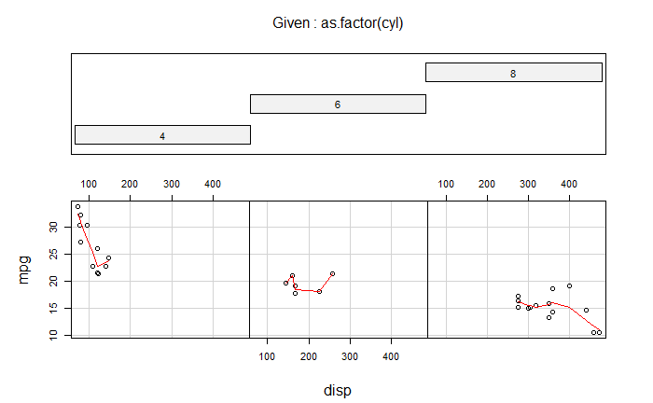

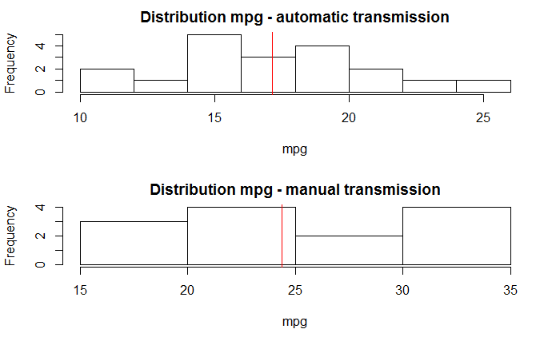

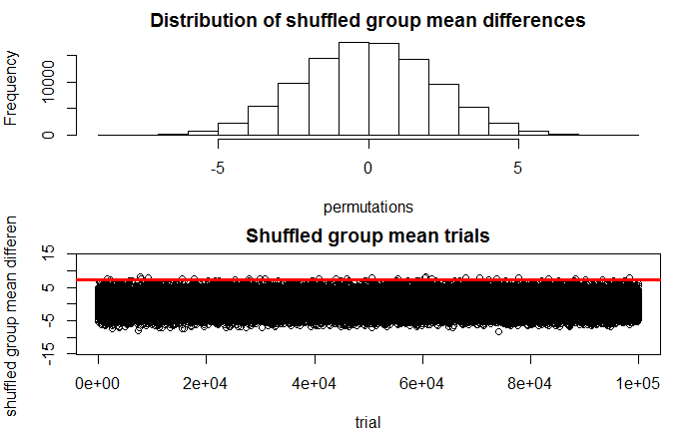

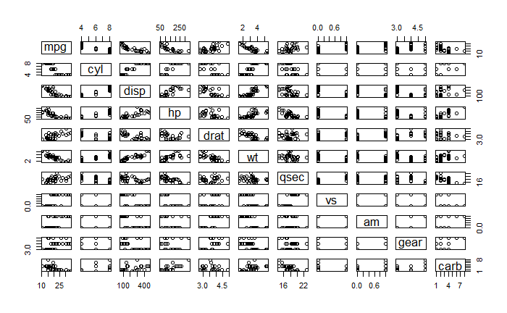

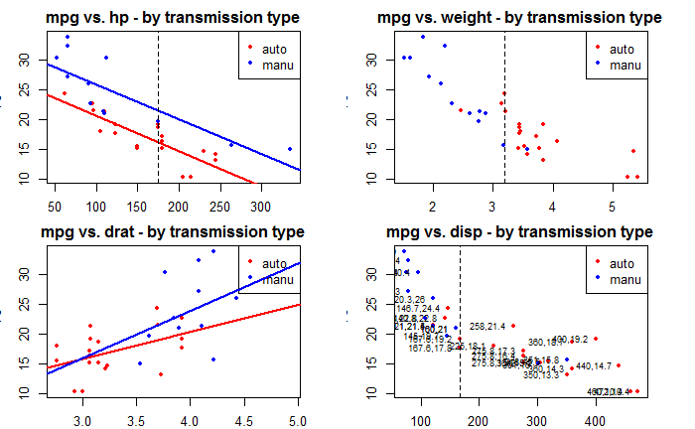

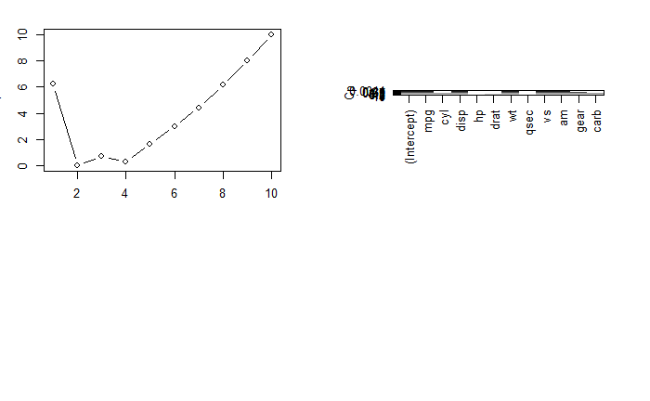

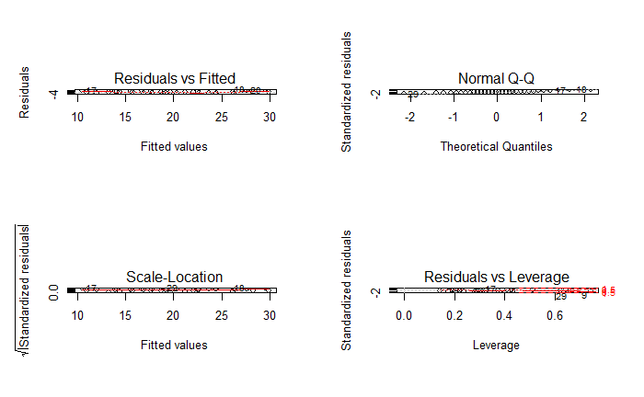

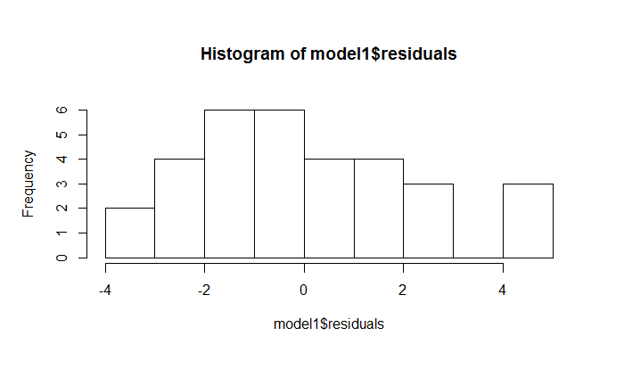

## 3. Write a program to create boxplot for all variables

library(psych)  
describe(mtcars)  
boxplot(mtcars$mpg,mtcars$cyl,mtcars$disp,mtcars$hp,mtcars$drat,mtcars$wt,mtcars$qsec,mtcars$vs,mtcars$am,mtcars$gear,mtcars$carb,col = "red")  
library(ggplot2)  
library(car)  
library(corrgram)  
data=mtcars  
name=mtcars  
mtcars$am<- as.factor(mtcars$am)  
levels(mtcars$am) <- c("Automatic", "Manual")  
head(mtcars)  
summary(mtcars)

describe(mtcars)

boxplot(mtcars$mpg,mtcars$cyl,mtcars$disp,mtcars$hp,mtcars$drat,mtcars$wt,mtcars$qsec,mtcars$vs,mtcars$am,mtcars$gear,mtcars$carb,col = "red")

plot1 <- ggplot(mtcars, aes(x=factor(am),y=mpg,fill=factor(am)))+  
geom_boxplot(notch=F)+facet_grid(.~cyl)+scale_x_discrete("Transmission")+  
scale_y_continuous("Miles per Gallon")+ggtitle("MPG by Transmission Type & Cylinder")  
plot1 <- ggplot(mtcars, aes(x=factor(am),y=mpg,fill=factor(am)))+  
geom_boxplot(notch=F)+facet_grid(.~cyl)+scale_x_discrete("Transmission")+  
scale_y_continuous("Miles per Gallon")+ggtitle("MPG by Transmission Type & Cylinder")  
plot2 <- ggplot(mtcars, aes(x=factor(am),y=mpg,fill=factor(am)))+  
geom_boxplot(notch=F)+facet_grid(.~vs)+scale_x_discrete("Transmission")+  
scale_y_continuous("Miles per Gallon")+ggtitle("MPG by Transmission Type & VS")  
plot3 <- ggplot(mtcars, aes(x=factor(am),y=mpg,fill=factor(am)))+  
geom_boxplot(notch=F)+facet_grid(.~gear)+scale_x_discrete("Transmission")+  
scale_y_continuous("Miles per Gallon")+ggtitle("MPG by Transmission Type & Gears")  
plot4 <- ggplot(mtcars, aes(x=factor(am),y=mpg,fill=factor(am)))+  
geom_boxplot(notch=F)+facet_grid(.~carb)+scale_x_discrete("Transmission")+  
scale_y_continuous("Miles per Gallon")+ggtitle("MPG by Transmission Type &Carburetors")  
grid.arrange(plot1, plot2, plot3, plot3, nrow=2, ncol=2)

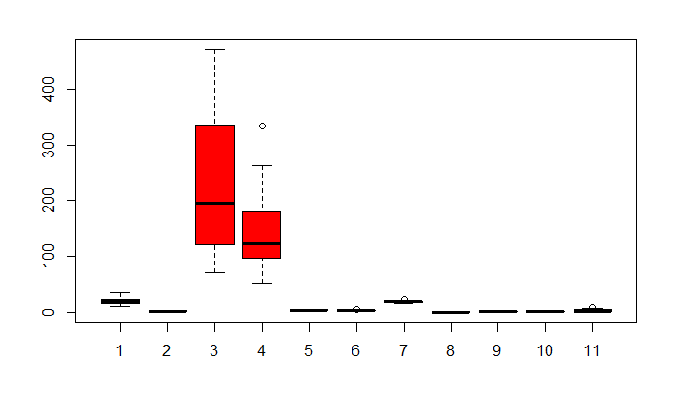

## 

## R Markdown

This is an R Markdown document. Markdown is a simple formatting syntax for authoring HTML, PDF, and MS Word documents. For more details on using R Markdown see <http://rmarkdown.rstudio.com>.

When you click the **Knit** button a document will be generated that includes both content as well as the output of any embedded R code chunks within the document. You can embed an R code chunk like this:

library(psych)

describe(mtcars)

boxplot(mtcars$mpg,mtcars$cyl,mtcars$disp,mtcars$hp,mtcars$drat,mtcars$wt,mtcars$qsec,mtcars$vs,mtcars$am,mtcars$gear,mtcars$carb,col = "red")

library(ggplot2)

library(car)

library(corrgram)

library(reshape)

library(dplyr)

library(gridExtra)

data=mtcars

name=mtcars

mtcars$am<- as.factor(mtcars$am)

levels(mtcars$am) <- c("Automatic", "Manual")

head(mtcars)

summary(mtcars)

plot1 <- ggplot(mtcars, aes(x=factor(am),y=mpg,fill=factor(am)))+

geom_boxplot(notch=F)+facet_grid(.~cyl)+scale_x_discrete("Transmission")+

scale_y_continuous("Miles per Gallon")+ggtitle("MPG by Transmission Type & Cylinder")

plot1 <- ggplot(mtcars, aes(x=factor(am),y=mpg,fill=factor(am)))+

geom_boxplot(notch=F)+facet_grid(.~cyl)+scale_x_discrete("Transmission")+

scale_y_continuous("Miles per Gallon")+ggtitle("MPG by Transmission Type & Cylinder")

plot2 <- ggplot(mtcars, aes(x=factor(am),y=mpg,fill=factor(am)))+

geom_boxplot(notch=F)+facet_grid(.~vs)+scale_x_discrete("Transmission")+

scale_y_continuous("Miles per Gallon")+ggtitle("MPG by Transmission Type & VS")

plot3 <- ggplot(mtcars, aes(x=factor(am),y=mpg,fill=factor(am)))+

geom_boxplot(notch=F)+facet_grid(.~gear)+scale_x_discrete("Transmission")+

scale_y_continuous("Miles per Gallon")+ggtitle("MPG by Transmission Type & Gears")

plot4 <- ggplot(mtcars, aes(x=factor(am),y=mpg,fill=factor(am)))+

geom_boxplot(notch=F)+facet_grid(.~carb)+scale_x_discrete("Transmission")+

scale_y_continuous("Miles per Gallon")+ggtitle("MPG by Transmission Type & Carburetors")

grid.arrange(plot1, plot2, plot3, plot3, nrow=2, ncol=2)

summary(cars)

| dbl> | **n**  <dbl> | **mean**  <dbl> | **sd**  <dbl> | **median**  <dbl> | **trimmed**  <dbl> | **mad**  <dbl> | **min**  <dbl> | **max**  <dbl> |  |
| --- | --- | --- | --- | --- | --- | --- | --- | --- | --- |
| mpg | 1 | 32 | 20.09 | 6.03 | 19.20 | 19.70 | 5.41 | 10.40 | 33.90 |  |
| cyl* | 2 | 32 | 2.09 | 0.89 | 2.00 | 2.12 | 1.48 | 1.00 | 3.00 |  |
| disp | 3 | 32 | 230.72 | 123.94 | 196.30 | 222.52 | 140.48 | 71.10 | 472.00 |  |
| hp | 4 | 32 | 146.69 | 68.56 | 123.00 | 141.19 | 77.10 | 52.00 | 335.00 |  |
| drat | 5 | 32 | 3.60 | 0.53 | 3.70 | 3.58 | 0.70 | 2.76 | 4.93 |  |
| wt | 6 | 32 | 3.22 | 0.98 | 3.33 | 3.15 | 0.77 | 1.51 | 5.42 |  |
| qsec | 7 | 32 | 17.85 | 1.79 | 17.71 | 17.83 | 1.42 | 14.50 | 22.90 |  |
| vs | 8 | 32 | 0.44 | 0.50 | 0.00 | 0.42 | 0.00 | 0.00 | 1.00 |  |
| am* | 9 | 32 | 1.41 | 0.50 | 1.00 | 1.38 | 0.00 | 1.00 | 2.00 |  |
| gear* | 10 | 32 | 1.69 | 0.74 | 2.00 | 1.62 | 1.48 | 1.00 | 3.00 |  |

Next

12

Previous

1-10 of 11 rows | 1-10 of 13 columns

## speed dist   
## Min. : 4.0 Min. : 2.00   
## 1st Qu.:12.0 1st Qu.: 26.00   
## Median :15.0 Median : 36.00   
## Mean :15.4 Mean : 42.98   
## 3rd Qu.:19.0 3rd Qu.: 56.00   
## Max. :25.0 Max. :120.00

## Including Plots

You can also embed plots, for example:

Note that the echo = FALSE parameter was added to the code chunk to prevent printing of the R code that generated the plot.