**B6 Session-7 Assignment-2**

Problem Statement

1. Write a program to create barplots for all the categorical columns in mtcars.

2. Create a scatterplot matrix by gear types in mtcars dataset.

3. Write a program to create a plot density by class variable

library(psych)  
describe(mtcars)

## vars n mean sd median trimmed mad min max range skew  
## mpg 1 32 20.09 6.03 19.20 19.70 5.41 10.40 33.90 23.50 0.61  
## cyl 2 32 6.19 1.79 6.00 6.23 2.97 4.00 8.00 4.00 -0.17  
## disp 3 32 230.72 123.94 196.30 222.52 140.48 71.10 472.00 400.90 0.38  
## hp 4 32 146.69 68.56 123.00 141.19 77.10 52.00 335.00 283.00 0.73  
## drat 5 32 3.60 0.53 3.70 3.58 0.70 2.76 4.93 2.17 0.27  
## wt 6 32 3.22 0.98 3.33 3.15 0.77 1.51 5.42 3.91 0.42  
## qsec 7 32 17.85 1.79 17.71 17.83 1.42 14.50 22.90 8.40 0.37  
## vs 8 32 0.44 0.50 0.00 0.42 0.00 0.00 1.00 1.00 0.24  
## am 9 32 0.41 0.50 0.00 0.38 0.00 0.00 1.00 1.00 0.36  
## gear 10 32 3.69 0.74 4.00 3.62 1.48 3.00 5.00 2.00 0.53  
## carb 11 32 2.81 1.62 2.00 2.65 1.48 1.00 8.00 7.00 1.05  
## kurtosis se  
## mpg -0.37 1.07  
## cyl -1.76 0.32  
## disp -1.21 21.91  
## hp -0.14 12.12  
## drat -0.71 0.09  
## wt -0.02 0.17  
## qsec 0.34 0.32  
## vs -2.00 0.09  
## am -1.92 0.09  
## gear -1.07 0.13  
## carb 1.26 0.29

library(ggplot2)

##   
## Attaching package: 'ggplot2'

## The following objects are masked from 'package:psych':  
##   
## %+%, alpha

library(car)

## Loading required package: carData

##   
## Attaching package: 'car'

## The following object is masked from 'package:psych':  
##   
## logit

library(corrgram)  
library(reshape)  
library(dplyr)

##   
## Attaching package: 'dplyr'

## The following object is masked from 'package:reshape':  
##   
## rename

## The following object is masked from 'package:car':  
##   
## recode

## The following objects are masked from 'package:stats':  
##   
## filter, lag

## The following objects are masked from 'package:base':  
##   
## intersect, setdiff, setequal, union

library(gridExtra)

##   
## Attaching package: 'gridExtra'

## The following object is masked from 'package:dplyr':  
##   
## combine

data=mtcars  
name=mtcars  
mtcars$am <-as.factor(mtcars$am)  
levels(mtcars$am) <-c("Automatic", "Manual")  
head(mtcars)

## mpg cyl disp hp drat wt qsec vs am gear  
## Mazda RX4 21.0 6 160 110 3.90 2.620 16.46 0 Manual 4  
## Mazda RX4 Wag 21.0 6 160 110 3.90 2.875 17.02 0 Manual 4  
## Datsun 710 22.8 4 108 93 3.85 2.320 18.61 1 Manual 4  
## Hornet 4 Drive 21.4 6 258 110 3.08 3.215 19.44 1 Automatic 3  
## Hornet Sportabout 18.7 8 360 175 3.15 3.440 17.02 0 Automatic 3  
## Valiant 18.1 6 225 105 2.76 3.460 20.22 1 Automatic 3  
## carb  
## Mazda RX4 4  
## Mazda RX4 Wag 4  
## Datsun 710 1  
## Hornet 4 Drive 1  
## Hornet Sportabout 2  
## Valiant 1

summary(mtcars)

## mpg cyl disp hp   
## Min. :10.40 Min. :4.000 Min. : 71.1 Min. : 52.0   
## 1st Qu.:15.43 1st Qu.:4.000 1st Qu.:120.8 1st Qu.: 96.5   
## Median :19.20 Median :6.000 Median :196.3 Median :123.0   
## Mean :20.09 Mean :6.188 Mean :230.7 Mean :146.7   
## 3rd Qu.:22.80 3rd Qu.:8.000 3rd Qu.:326.0 3rd Qu.:180.0   
## Max. :33.90 Max. :8.000 Max. :472.0 Max. :335.0   
## drat wt qsec vs   
## Min. :2.760 Min. :1.513 Min. :14.50 Min. :0.0000   
## 1st Qu.:3.080 1st Qu.:2.581 1st Qu.:16.89 1st Qu.:0.0000   
## Median :3.695 Median :3.325 Median :17.71 Median :0.0000   
## Mean :3.597 Mean :3.217 Mean :17.85 Mean :0.4375   
## 3rd Qu.:3.920 3rd Qu.:3.610 3rd Qu.:18.90 3rd Qu.:1.0000   
## Max. :4.930 Max. :5.424 Max. :22.90 Max. :1.0000   
## am gear carb   
## Automatic:19 Min. :3.000 Min. :1.000   
## Manual :13 1st Qu.:3.000 1st Qu.:2.000   
## Median :4.000 Median :2.000   
## Mean :3.688 Mean :2.812   
## 3rd Qu.:4.000 3rd Qu.:4.000   
## Max. :5.000 Max. :8.000

1. Write a program to create barplots for all the categorical columns in mtcars.

table1 <- table(mtcars$cyl, mtcars$gear, dnn=c("Cylinders", "Gears")) # Creates a contingency table  
addmargins(table1) #Displays the table (Not necessary  
barplot(table1, ylab="Frequency", xlab="Gears", main="Side-By-Side Bar Chart", col=c("turquoise4", "turquoise2", "turquoise" ), beside=TRUE, width=.3)  
legend("right", title="Cylinders", legend= sort(unique(mtcars$cyl)), fill =c("turquoise4", "turquoise2", "turquoise" ), box.lty=0)  
legend("right", title="Cylinders", legend= sort(unique(mtcars$cyl)), fill =c("turquoise4", "turquoise2", "turquoise" ), box.lty=0)

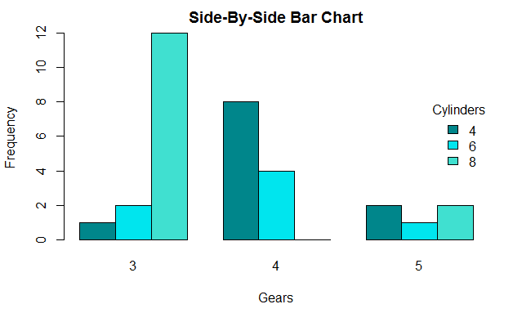

># Histogram on a Categorical variable

>g <- ggplot(mpg, aes(manufacturer))

>g + geom_bar(aes(fill=class), width = 0.5) +

+ theme(axis.text.x = element_text(angle=65, vjust=0.6)) +

+ labs(title="Histogram on Categorical Variable",

+ subtitle="Manufacturer across Vehicle Classes")

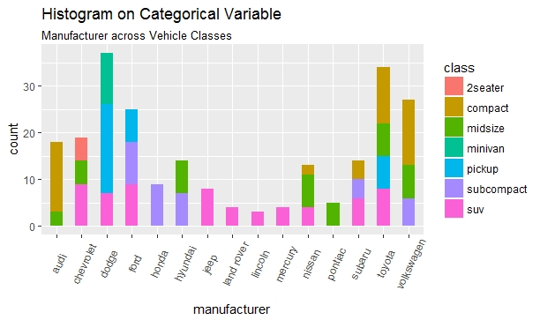

library(Matrix)

##   
## Attaching package: 'Matrix'

## The following object is masked from 'package:reshape':  
##   
## expand

scatterplotMatrix(~mpg+disp+drat+wt+gear|cyl,data=mtcars, main="gear type")

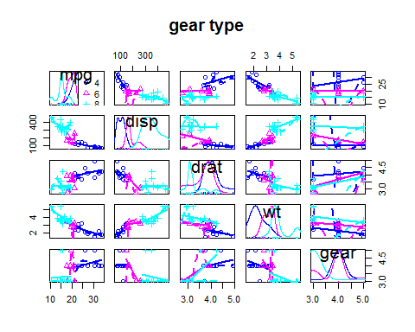

library(dplyr)  
data(mtcars)  
mtcars$gear <-factor(mtcars$gear,levels=c(3,4,5),  
labels=c("3gears","4gears","5gears"))   
mtcars$am <-factor(mtcars$am,levels=c(0,1),  
labels=c("Automatic","Manual"))   
mtcars$cyl <-factor(mtcars$cyl,levels=c(4,6,8),  
labels=c("4cyl","6cyl","8cyl"))  
g <-ggplot()  
g <-g +theme_bw()  
g <-g +geom_point(data=mtcars, aes(x=mpg, y=disp,colour=gear)) +theme(legend.title=element_blank())   
g

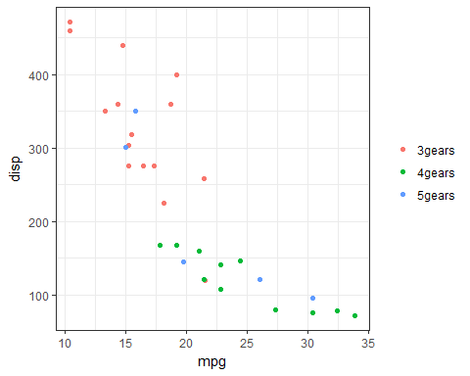

g <-ggplot()  
g <-g +theme_bw()  
g <-g +geom_point(data=mtcars, aes(x=mpg, y=disp,colour=gear),size =4.0) +theme(legend.title=element_blank())+  
guides(colour =guide_legend(override.aes =list(size=4)))+  
ggtitle('Mpg')+theme(plot.title =element_text(size=20, face="bold", margin =margin(10, 0, 10, 0)))  
g

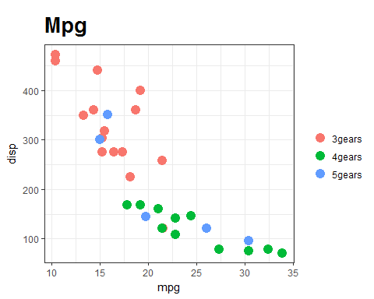

g <-ggplot()  
g <-g +theme_bw()  
g <-g +geom_point(data=mtcars, aes(x=mpg, y=disp,colour=gear),size =4.0) +theme(legend.title=element_blank())+  
guides(colour =guide_legend(override.aes =list(size=4)))+  
ggtitle('Mpg')+theme(plot.title =element_text(size=20, face="bold", margin =margin(10, 0, 10, 0)))   
g<-g +labs(x ="mpg", y="disp") +theme(text =element_text(size=20))   
g

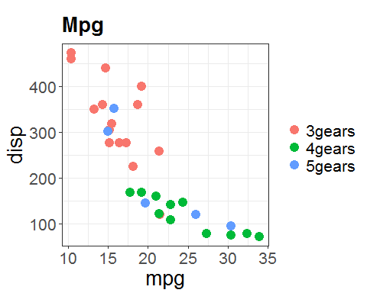

g <-ggplot()  
g <-g +theme_bw()  
g <-g +geom_point(data=mtcars, aes(x=mpg, y=disp,colour=gear),size =4.0) +theme(legend.title=element_blank())+  
guides(colour =guide_legend(override.aes =list(size=4)))+  
ggtitle('Mpg')+theme(plot.title =element_text(size=20, face="bold", margin =margin(10, 0, 10, 0)))   
g<-g +labs(x ="mpg", y="disp") +theme(text =element_text(size=20))   
g



g <-ggplot()  
g <-g +theme_bw()  
g <-g +geom_point(data=mtcars, aes(x=mpg, y=disp,colour=gear),size =4.0) +theme(legend.title=element_blank())+  
guides(colour =guide_legend(override.aes =list(size=4)))+  
ggtitle("Mpg")+theme(plot.title =element_text(size=20, face="bold", margin =margin(10, 0, 10, 0)))   
g<-g +labs(x ="mpg", y="disp") +theme(text =element_text(size=20))+scale_colour_brewer("Diamond\nclarity")   
g

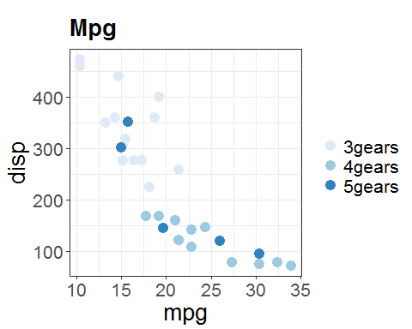

Write a program to create a plot density by class variable

qplot(mpg, data=mtcars, geom="density", fill=gear, alpha=I(.5),   
main="Distribution of Gas Milage", xlab="Miles Per Gallon",   
ylab="Density")

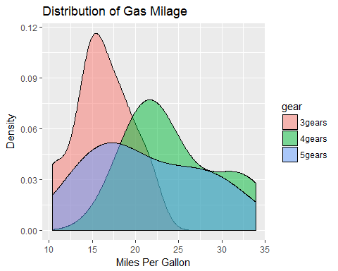

## R Markdown

This is an R Markdown document. Markdown is a simple formatting syntax for authoring HTML, PDF, and MS Word documents. For more details on using R Markdown see <http://rmarkdown.rstudio.com>.

When you click the**Knit** button a document will be generated that includes both content as well as the output of any embedded R code chunks within the document. You can embed an R code chunk like this:

summary(cars)

## speed dist   
## Min. : 4.0 Min. : 2.00   
## 1st Qu.:12.0 1st Qu.: 26.00   
## Median :15.0 Median : 36.00   
## Mean :15.4 Mean : 42.98   
## 3rd Qu.:19.0 3rd Qu.: 56.00   
## Max. :25.0 Max. :120.00

## Including Plots

You can also embed plots, for example:



Note that the echo = FALSE parameter was added to the code chunk to prevent printing of the R code that generated the plot.