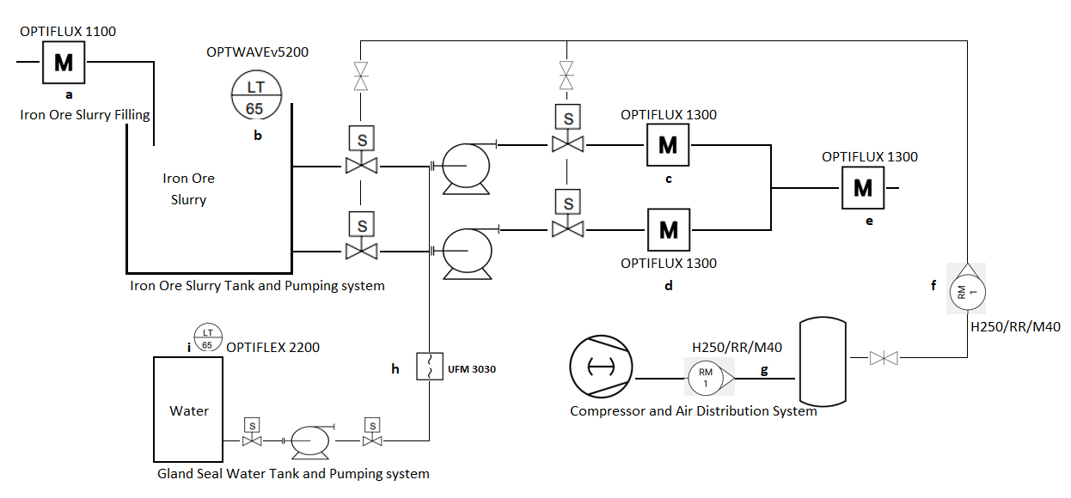

|  |  |  |  |  |
| --- | --- | --- | --- | --- |
| Process: Iron Ore Slurry processed from Thickener unit is pumped to and stored in storage tank. The slurry is then pumped to Filtration unit for  Water separation. Two Slurry Feed pumps (1 working+1 standby) are used to pump slurry pump from slurry tank to the filtration unit. | |  |  |  |
|  | Each Slurry Pump is having Valves at both Suction and Discharge which are operated by Pneumatic cylinders and Pneumatic air is supplied  by Compressor & Compressed Air Storage Tanks. Slurry Pumps have gland cooling system for which water is supplied from Gland Water  cooling Pumping System with water tank and pump | | | |

**Instrument Purpose:**

1. Iron Ore slurry Feed rate from Thickener to Slurry Storage Tank
2. Iron Ore Slurry Storage Tank Level
3. Iron Ore slurry Feed rate of Slurry Feed Pump1
4. Iron Ore slurry Feed rate of Slurry Feed Pump2
5. Iron Ore slurry Feed rate to Filtration Unit
6. Pneumatic Air flow to the Slurry Feed Pump Valve operation
7. Pneumatic Air flow from Compressor to Compressed air storage tank/ Receiver
8. Gland seal water flow rate from Gland seal pump
9. Gland seal water storage tank level

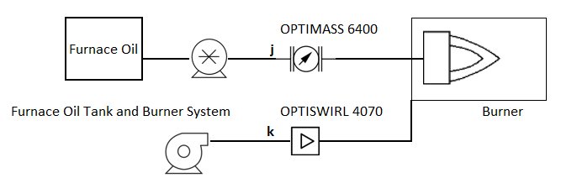

**Process:** Hot Air Generator is having a Furnace Oil Burner having FO Pump and Air Blower to supply Hot Air to the Process.

**Instrument Purpose:**

1. Furnace Oil flow rate from Pump to Burner
2. Combustion air flow rate from Blower to Burner