**-:** DBMS PROJECT **:-**

**Matrimonial Management System**



**Department of Computer Science & Engineering**

**NATIONAL INSTITUTE OF TECHNOLOGY PATNA**

**University Campus, Bihar - 800005**

**Submitted By :-** HARISH KUMAR ( 2006209)

**----------TEAM MEMBERS----------**

|  |  |
| --- | --- |
| **NAME** | **ROLL NO.** |
| KISHAN KUMAR | 2006166 |
| ANKIT RAJ | 2006207 |
| DEEPANSHU TIBREWAL | 2006208 |
| HARISH KUMAR | 2006209 |
| KUNDAN KUMAR | 2006211 |

**01. Document the requirement collection properly (point by point)**

* Every person wants to find personal happiness. While for some, it may come in the form of a booming career, for others it is finding the perfect life partner. Indian parents are extremely attached to their children and are actively involved in the child’s life. Finding a suitable match for their child is a big deal for Indian parents.
* Online matrimonial services too are available 24 x 7. This provides consumers who are forever busy to log in and create a profile as well as look for a suitable match whenever they want.
* The joint system of living is no longer applicable these days. With people not interacting with their relatives, nobody can assure the other party of the boy/girl’s nature, qualities, salary etc.

* These days, relatives do not wish to get involved in the process of matchmaking and shirk from their responsibilities. They would merely suggest prospective brides and grooms if asked but would not like to get involved in the details.

* Contrary to this, marriage bureaus take full responsibility, from hosting the profile to setting up communication and meeting between interested parties and making pre-wedding, wedding arrangements.
* The online matrimonial system provides a search utility which helps those users who have a certain criteria of qualities in mind to make online matrimonial easier.

**02. Describe your analysis on the requirements in short**

* One can visit site without being our client. So there is two different tables are required to manage.
* One client( customer) can upload multiple images so to reduce data redundancy we have used a separate table to

to store images.

* The online matrimonial system provides a search utility which helps those users who have a certain criteria of qualities in mind to make online matrimonial easier.
* Matrimonial System is an online web portal that enables a user to find their partners by choice from all over the world.It is a project on PHP in which a user needs to first register by entering some details and then he will have access to choose his/her life partner based on their preferences.
* This matrimonial project is developed to let individual find their potential matches for marriage as per their priorities.
* This application allows browsing profiles of other registered users on the site. An individual needs to give their information such as Name, Gender, Religion, Caste, Marital status, Current salary, Occupation etc. along with an option to upload photo of the individual registering and their kundali.
* In the user module, user can register with mandatory details. After that registration user can login and create their complete profile to become a valid customer and can see the profile, can send a request thorough Email to the favorite profile. In the admin part, admin can view registered user, add cast with edit and delete option.
* **FUTURE ASPECTS :**

• Linking with AADHAR CARD for the full verification of

the user.

• Video calling feature can be incorporated .

• Email alert features can be included so that when an

user is matching the requirement then he/she would get

an email alert of the matching person.

• An additional features of messaging and chatting with

the bride/grooms.

* **Back end:** PHP, MySQL

1. PHP: Hypertext Preprocessor (PHP) is a technology that

allows software developers to create dynamically generated web pages, in HTML, XML, or other document types, as per client request. PHP is open source software.

2. MySQL: MySql is a database, widely used for

accessingquerying, updating, and managing data in

databases.

* **Software used :** Xampp Server

**03. List down all the entity with their attributes you identified in the case study.**

|  |  |
| --- | --- |
| **ENTITY** | **ATTRIBUTES** |
| USER | gender, dob, email, id, userlevel  username, password |
| CUSTOMER | age, id, dob, country, state, caste  Height, religion, cust_id, sex, age  , email |
| PHOTOS | id, cust_id, pic |
| PARTERNER_PREF | id, education, occupation, diet,  country, education, descr, cust_id,  agemin, agemax, maritalstatus,  height, caste, subcaste |
| LOGIN | Id, username, password,  username |
| ADMIN | Id, username, password |

**04. Give a schema diagram for the case study.**

**USER**

|  |  |  |  |
| --- | --- | --- | --- |
| ID | USERNAME | PASSWORD | GENDER |

|  |  |  |
| --- | --- | --- |
| DOB | EMAIL | USERLEVEL |

**CUSTOMER**

|  |  |  |  |
| --- | --- | --- | --- |
| ID | CUST_ID | DOB | SEX |

|  |  |  |  |
| --- | --- | --- | --- |
| RELIGION | AGE | HEIGHT | EMAIL |

|  |  |  |
| --- | --- | --- |
| COUNTRY | STATE | CASTE |

**PHOTOS**

|  |  |  |
| --- | --- | --- |
| ID | CUST_ID | PIC |

**PARTNER_PREF**

|  |  |  |  |
| --- | --- | --- | --- |
| ID | CUST_ID | EDUCATION | OCCUPATION |

|  |  |  |  |
| --- | --- | --- | --- |
| COUNTRY | DESCR | AGEMIN | AGEMAX |

|  |  |  |  |  |
| --- | --- | --- | --- | --- |
| DIET | CASTE | HEIGHT | MARITAL_STATUS | SUBCASTE |

**LOGIN**

|  |  |  |  |
| --- | --- | --- | --- |
| ID | USERNAME | PASSWORD | EMAIL |

**ADMIN**

|  |  |  |
| --- | --- | --- |
| ID | USERNAME | PASSWORD |

**05. Classify each attribute and identify data type of each of the attributes in tabular form for every entity. Also mention possible constraints on each of the attributes in tabular form.**

**USER**

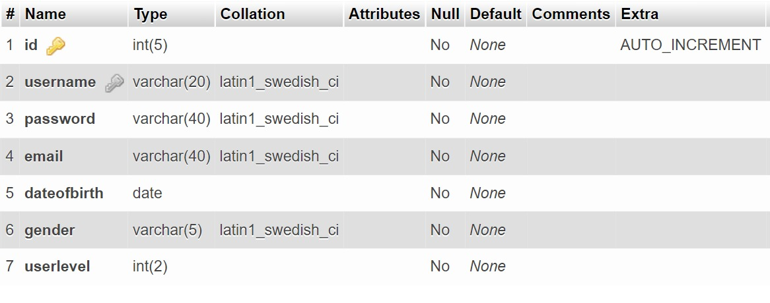

**CUSTOMER**

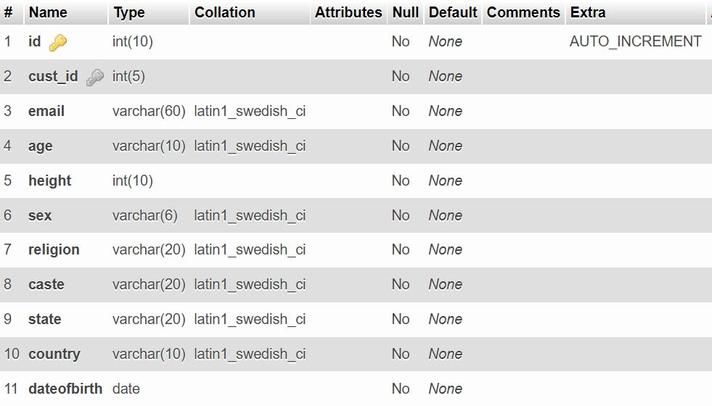

**PARTNER_PREF**

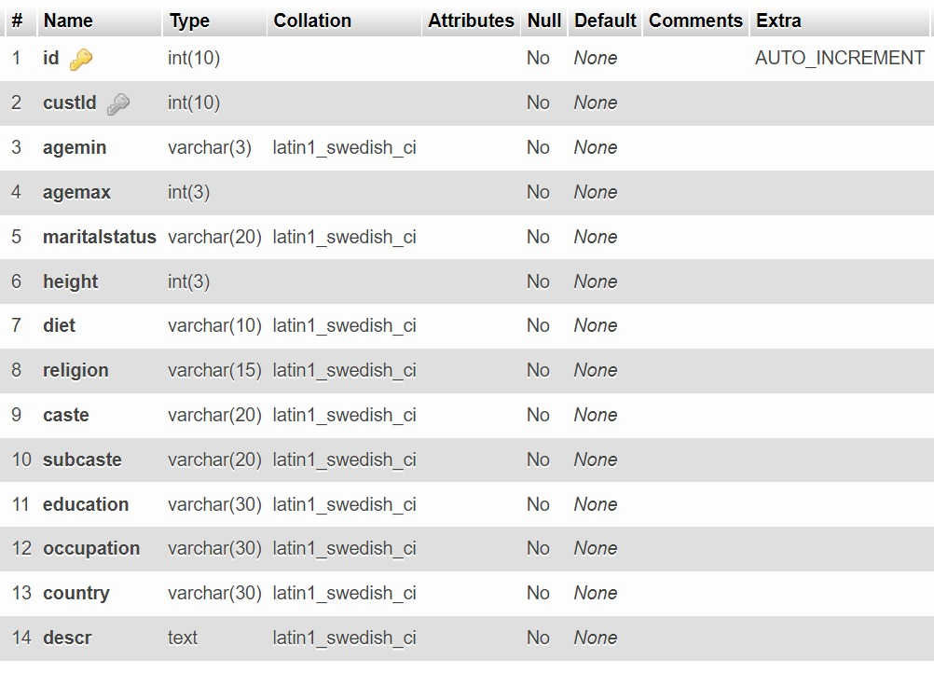

**ADMIN**

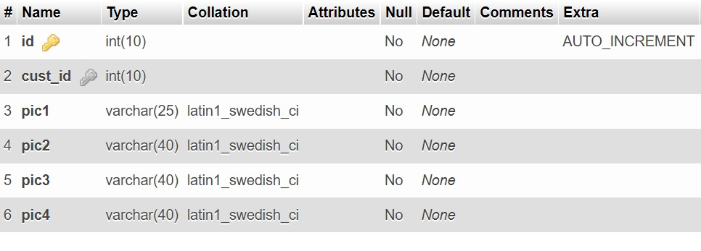

**PHOTOS**

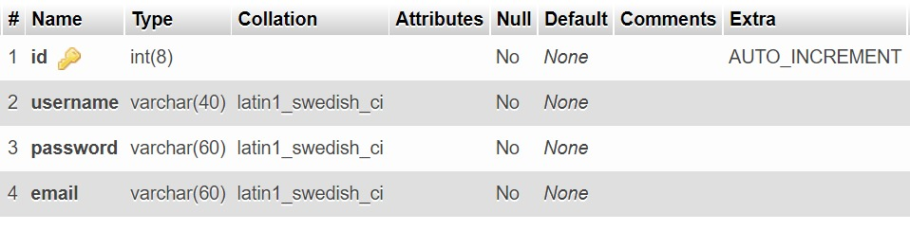

**06. Draw an ER Diagram for the case study.**

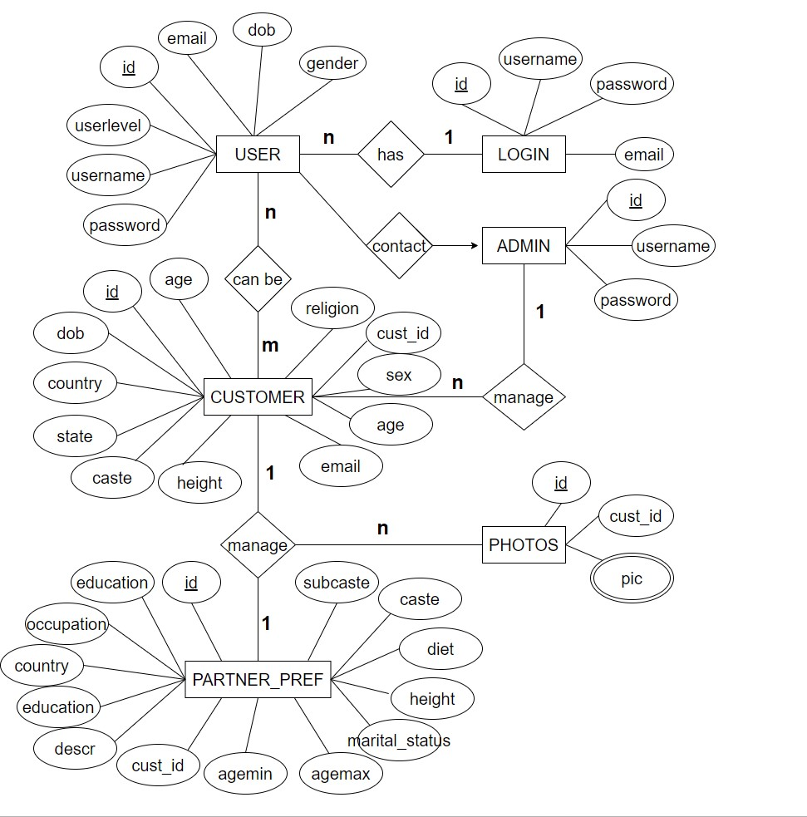

pic

**07. Identify all the relationship type in the ER diagram and mention cardinality ration and degree of each relation, and possible constraints about all the relationship types in tabular form.**

|  |  |
| --- | --- |
| USER---LOGIN | N:1 |
| USER---CUSTOMER | N:M |
| USER---ADMIN | 1:1 |
| CUSTOMER---PHOTOS | 1:N |
| CUSTOMER---PARTNER_PREF | 1:1 |



pic

**08. Indicate the primary keys and foreign keys.**

**USER :**

* PRIMARY KEY:- ID
* FOREIGN KEY:- NA

**CUSTOMER**

* PRIMARY KEY:- ID
* FOREIGN KEY:- CUST_ID

**PHOTOS**

* PRIMARY KEY:- ID
* FOREIGN KEY:- CUST_ID

**PARTNER_PREF**

* PRIMARY KEY:- ID
* FOREIGN KEY:- CUST_ID

**LOGIN**

* PRIMARY KEY:- ID
* FOREIGN KEY:- NA

**ADMIN**

* PRIMARY KEY:- ID
* FOREIGN KEY:- NA

**09. List down all the functional dependency identified by you in each of the relation in the ER Diagram.**

* In customer table, id is Primary key so it can identify all the rest of the attributes present in the table, So we can conclude that all non-prime attributes are functionally dependent on the id.
* In User table, id is Primary key so it can identify all the rest of the attributes present in the table, So we can conclude that all non-prime attributes are functionally dependent on the id.
* In Admin table, id is Primary key so it can identify all the rest of the attributes present in the table, So we can conclude that all non-prime attributes are functionally dependent on the id.
* In partner_pref table, id is Primary key so it can identify all the rest of the attributes present in the table, So we can conclude that all non-prime attributes are functionally dependent on the id.
* In Photos table, id is Primary key so it can identify all the rest of the attributes present in the table, So we can conclude that all non-prime attributes are functionally dependent on the id.

1. **Identify the Normal form (NF) for each of the relation and convert them to highest possible NF.**

* In all the tables, any attribute does not contain multiple values. So, all tables are in 1st Normal Form.
* As we Know, all tables attribute are fully dependent on candidate key and not dependent on subset of candidate key. This represents there is no any partial dependency. So, that all tables are in 2nd Normal Form.
* In every table, all attribute can be obtained by the table’s Primary Key that is Prime Attribute. In all the tables non prime attributes are not transitively dependent on prime attributes. So, all tables are in 3rd Normal Form.
* In every table, all attributes can only be obtained by the table’s Primary Key. So, all the table’s are in BCNF Form.

1. **Write down Relational algebra and Relational calculus expression for retrieving data based on each of the relationship.**

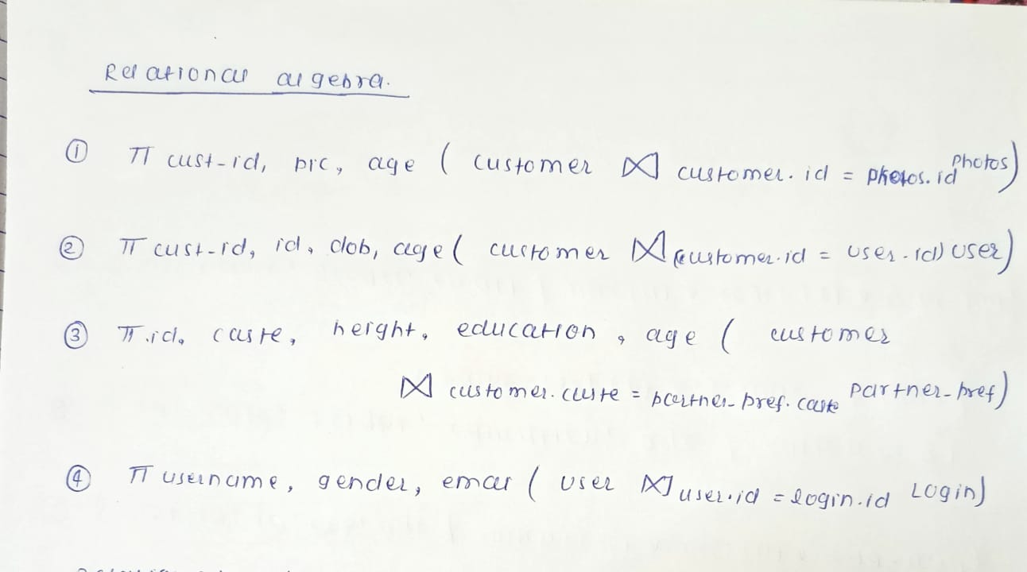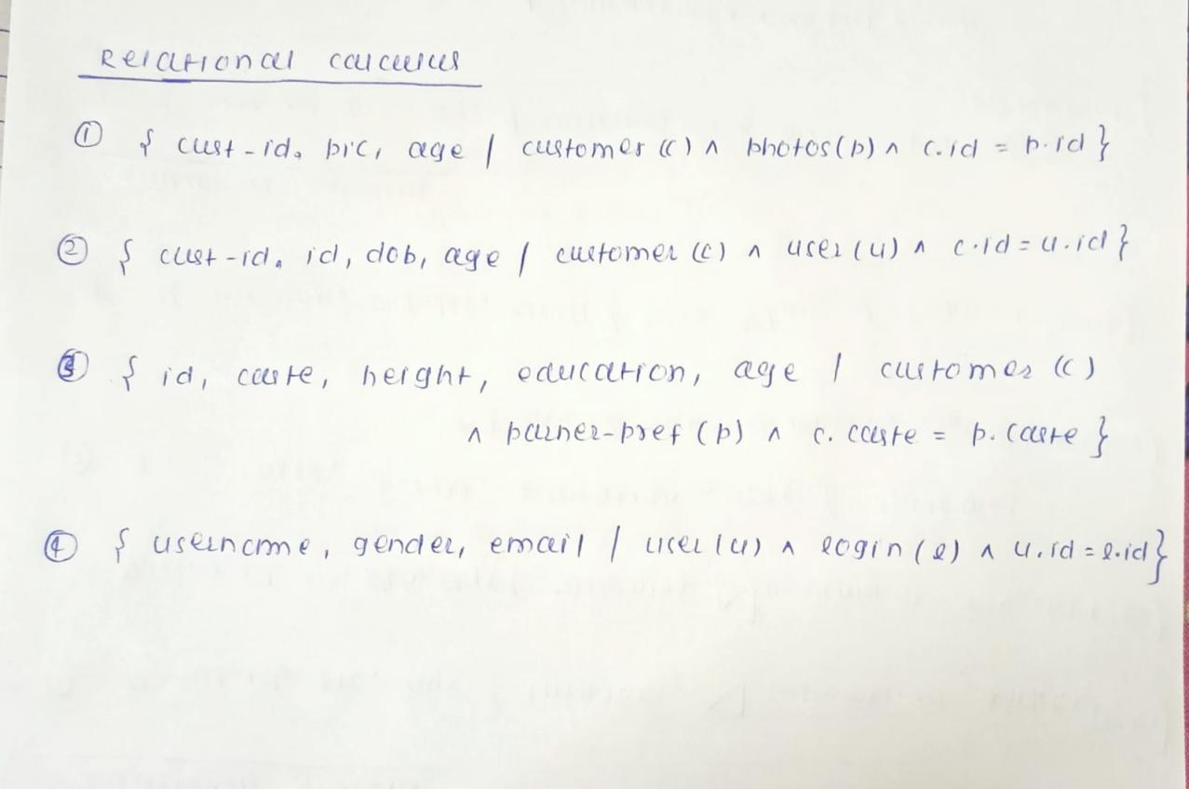

**-: THE END :-**