

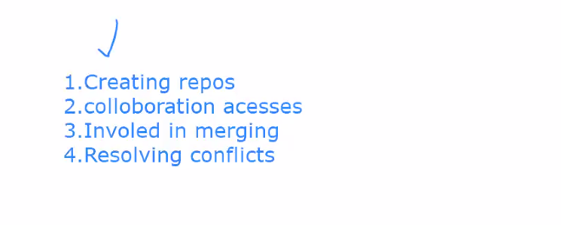

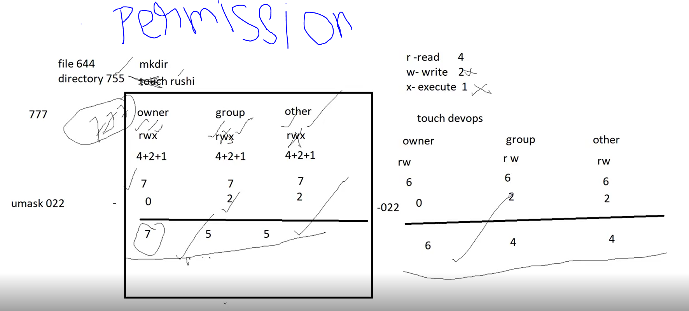

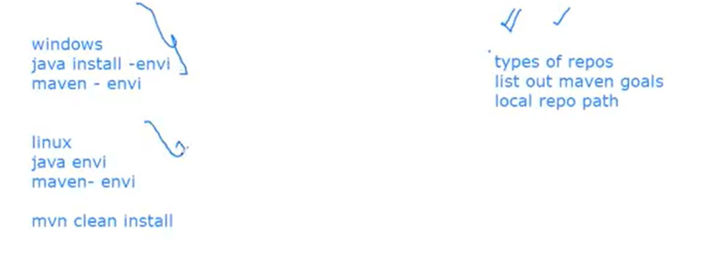

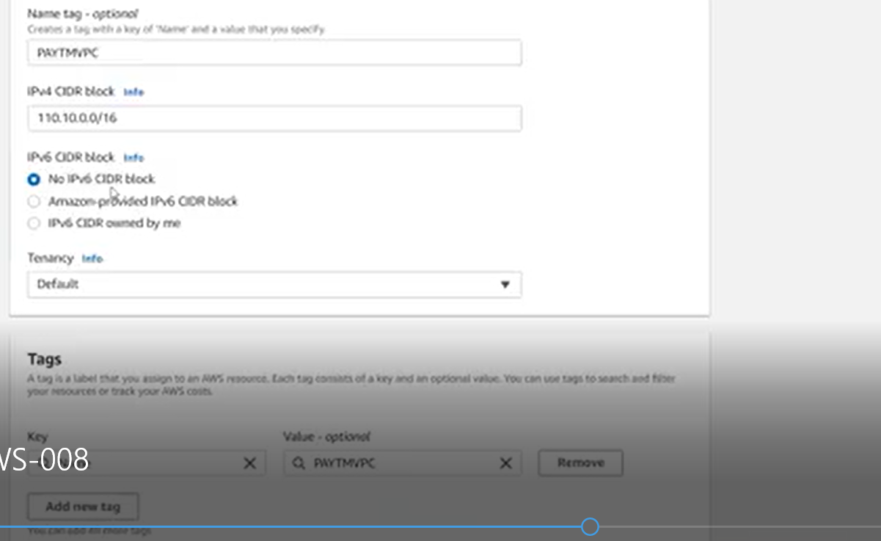

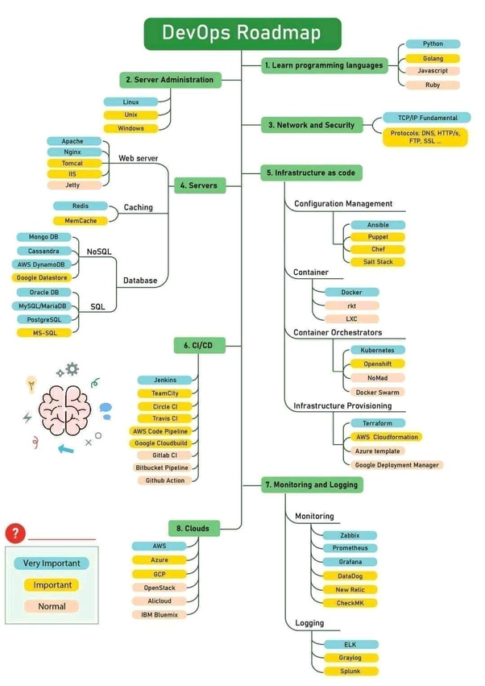

Devops Tips

* Learning theory is different from having practical experience. If you have just learned the tools and have not worked on it, it is difficult to face an interview. My suggestion would be.. pick some practical scenarios and start building pipelines using the tools you know. It may seem difficult in the beginning, but this is how you learn. If you are struck somewhere, don’t panic.Troubleshooting teaches you much and boosts your confidence.
* Prepare your own document for everything you learn. This may seem silly. But, you can’t remember everything for lifetime. So, documentation is a must.
* Prepare for the Devops interview questions online. You can find interview questions on each individual tool as well.
* Coming to AWS part, having certifications on AWS would add good value to your profile. If you haven’t done any, start now.
* Learn python or shell scripting(this is an added advantage to your profile).