Using the Windows Desktop Single Sign-On Authentication Module with Kerberos

* The OpenSSO Enterprise Windows Desktop SSO Authentication module is a Kerberos-based plug_in.

* The plug-in enables a Windows client user, who has already authenticated to a Kerberos Distribution Center (KDC), to authenticate to OpenSSO Enterprise without re-submiting user credentials.

About Kerberos Authentication Protocol:
* Kerberos is an authentication protocol. The Key Distribution Center (KDC) is the component of Kerberos that is responsible for issuing credentials.

* A credential is a packet of information that includes a ticket-granting ticket (TGT) and a matching session key.
* A ticket is an information packet that is used to securely pass the identity of a user to a server or service. After a ticket has been issued, it can be reused until the ticket expires.

About the OpenSSO Windows Desktop SSO Authentication Module
* The Windows Desktop SSO Authentication Module enables OpenSSO Enterprise to work with Kerberos tokens.

* The user presents the Kerberos token, previously issued by a Kerberos Distribution Center, to OpenSSO Enterprise using the SPNEGO protocol. The client browser sends back a SPNEGO token embedded with a Kerberos token.

* The OpenSSO Windows Desktop SSO Authentication module retrieves the Kerberos token and authenticates the user using the Java GSS API. If authentication is successful, the OpenSSO Windows Desktop SSO Authentication module returns an SSOToken to the client.

Deployment Architecture

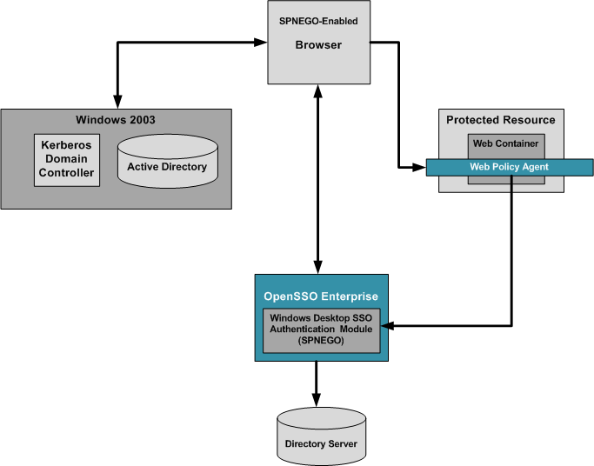
OpenSSO Windows Desktop SSO Authentication Module

* The OpenSSO Windows Desktop SSO Authentication module is a server-side SPNEGO implementation that uses the Java GSS-API to process a Kerberos token sent by a SPNEGO-supported browser.

* The following figure illustrates a typical process flow for Kerberos authentication using the Windows Desktop SSO Authentication module.

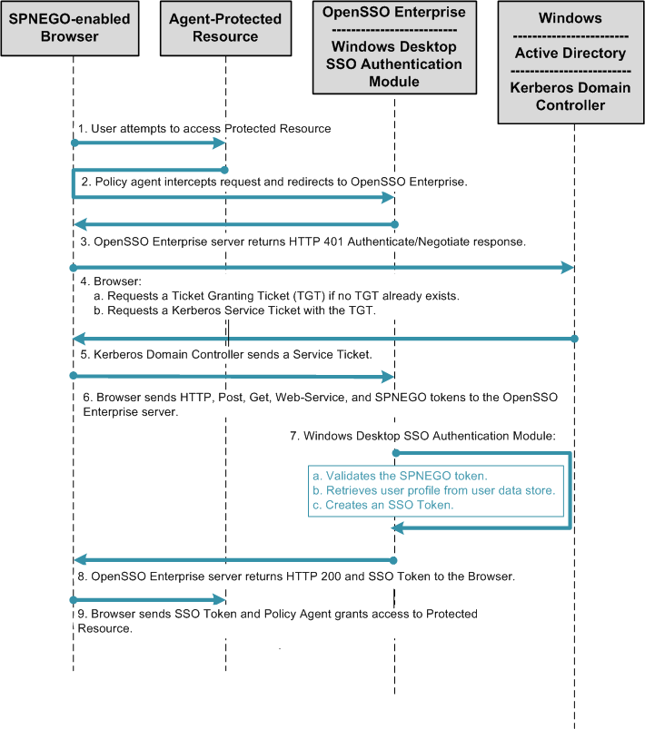
To Configure Windows Active Directory and Domain Controller
- Log in as an administrator to the Windows 2000 or 2003 server host.

- From the Start menu, go to Administrative Tools > Manage Your Server.

  - On the Manage Your Server wizard, choose Adding Roles to Your Sever.

  - In the Server Role window, choose Domain Controller (Active Directory).

  - Accept the default values by clicking Next.

  - Continue to accept the default values and clicking Next until the Report DNS Issue window is displayed.

  - This window is displayed when no properly configured DNS exists for Active Directory. Choose “Install and Configure DNS” to proceed to the next window.

  - Continue to accept the default values and clicking Next until the Summary window is displayed, then click Next.

The Active Directory Installation wizard is invoked.

- Install the Active Directory Domain Controller.

For detailed instructions, see Install Active Directory Domain Services on the Windows Server 2008-Based Member Server

- Install Windows Support Tools.

Windows Support Tools contains the ktpass Kerberos tool you need to map a service principal with an Active Directory account. For information about ktpass, see the Ktpass Overview. For detailed instructions on installing Windows Support Tools, see How to install the Windows 2000 Support Tools to a Windows 2000 Server-based computer.

- Create a new user account.

  - From the Start menu, go to Programs > Administration Tools.

  - Choose “Active Directory Users and Computers.”

  - Enter a user name and password for the new user, and create the user.

  - Verify that the Kerberos ticket is returned by the Kerberos Authentication Server properly.

Log into the new domain account from any Windows XP workstation belonging to the domain. You can use the Windows Support Tools to verify that the Kerberos ticket is returned by the Kerberos Authentication Server and cached into the ticket cache. For information about Windows Support Tools, see Windows Support Tools.
- Create a user account to map to the Kerberos service.

  - From the Start menu, go to Programs > Administration Tools.

  - Choose “Active Directory Users and Computers.”

  - Crete a new user with a name that is meaningful to you.

In this example, the name is openSSOhost.
  - Use the ktpass command to associate this user account with a service principal.

Example:
C:\Documents and Settings\Administrator>ktpass /pass password /mapuser openSSOhost
/princ HTTP/openSSOhost.identity.com@OPENSSOHOST.EXAMPLE.COM +DesOnly /ptype
KRB5_NT _PRINCIPAL /Target OPENSSOHOST.EXAMPLE.COM
Using legacy password setting method
Successfully mapped HTTP/openSSOhost.example.com to openSSOhost.
Key created.
Account openSSOhost has been set for DES-only encryption.

If OpenSSO Enterprise is configured with Java version 1.5_ 08 or higher, you don't need to specify the +DesOnly parameter here.

  - Export the keytab file and copy it to the system where OpenSSO Enterprise is installed.

Example:

C:\Documents and Settings\Administrator>ktpass /out demo1.HTTP.keytab /princ
HTTP/demo1.identity.com@DEMO.IDENTITY.COM /ptype KRB5_NT_PRINCIPAL /crypto
DES-CBC-CRC /Target DEMO.IDENTITY.COM
NOTE: creating a keytab but not mapping principal to any user.
For the account to work within a Windows domain, the
principal must be mapped to an account, either at the
domain level (with /mapuser) or locally (using ksetup)
If you intend to map HTTP/demo1.identity.com@DEMO.IDENTITY.COM
to an account through other means or don't need to map the user,
this message can safely be ignored.
Key created.
Output keytab to demo1.HTTP.keytab:
Keytab version: 0x502
keysize 70 HTTP/demo1.identity.com@DEMO.IDENTITY.COM ptype 1
(KRB5_NT_PRINCIPAL) vno 1 etype 0x1 (DES-CBC-CRC) keylength 8
(0xa1c4e6203e3b0d34)

If OpenSSO Enterprise is configured with Java version 1.5 or higher, you don't need to specify the /crypto DES-CBC-CRC parameter here.

You can test if this keytab file will work for OpenSSO Enterprise by using the Windows Support Tools, and specifying the /crypto DES-CBC-CRC parameter.

Configuring the Domain Controller
Depending upon the domain controller you are using, do one of the following:
- Configure DNS Mapping on the Windows Domain Controller
- Configure a Windows XP Workstation to Join the Kerberos Domain Controller Realm

Configuring DNS Mapping on the Windows Domain Controller
- Configure valid forward and reverse DNS mapping for the computer systems in your domain.
For example OpenSSO Enterprise and the Kerberos Domain Controller must have proper A (IP-Name lookup) and PTR (Reverse IP-Address lookup) records in the DNS database.

- If you use the /etc/hosts file instead of using DNS, all host names point to real, network-accessible IP addresses.

For example, if the IP address for host1.example.org is 15.168.120.15, then the /etc/hosts file should contain the following entries:

127.0.0.1 localhost openSSOhost
15.168.120.15 openSSOhost.example.com openSSOhost

Configuring a Windows XP Workstation to Join the Kerberos Domain Controller Realm
A Window XP workstation must be configured to work with a UNIX Kerberos Domain Controller or Windows 2003 Domain Controller. You can add the workstation to the Kerberos or Windows Domain Controller when installing Windows XP, or when modifying the network configuration that already exists on the Window XP workstation.
- To Configure an Windows XP Workstation to Join an Active Directory Domain Controller During Installation
- To Configure an Existing Window XP Workstation to Join a UNIX Kerberos Domain

To Configure an Windows XP Workstation to Join an Active Directory Domain Controller During Installation
- Follow the instructions in How to install or upgrade to Windows XP to start the Windows XP Setup wizard.
- Follow the onscreen instructions in the Windows XP Setup wizard until you get to the “Workgroup or Computer Domain” window.
  - Enter the Active Directory domain you want the Windows XP workstation to join, then click Next.
  - If the Windows XP Setup wizard cannot find the domain controller for this domain, enter the IP address of the domain controller in the Internet Protocol (TCP/IP) Properties window.
    - From the Start menu, choose Control Panel. Go to Network and Internet Connections > Network Connections.
    - Right-click the local area connection that you want to modify, and then click Properties.
    - On the General tab, in the “This connection uses the following items list,” click Internet Protocol (TCP/IP), and then click Properties.
For more information, see How to troubleshoot TCP/IP connectivity with Windows XP.
- Continue to follow the onscreen instructions in the Windows XP Setup wizard until all steps are completed.

