**Harish Parasuraman  
Michael Gildein  
Web Technologies  
MSIS_517L  
April 18, 2017**

**Assignment 8**

**Q1.**

**Step 1**

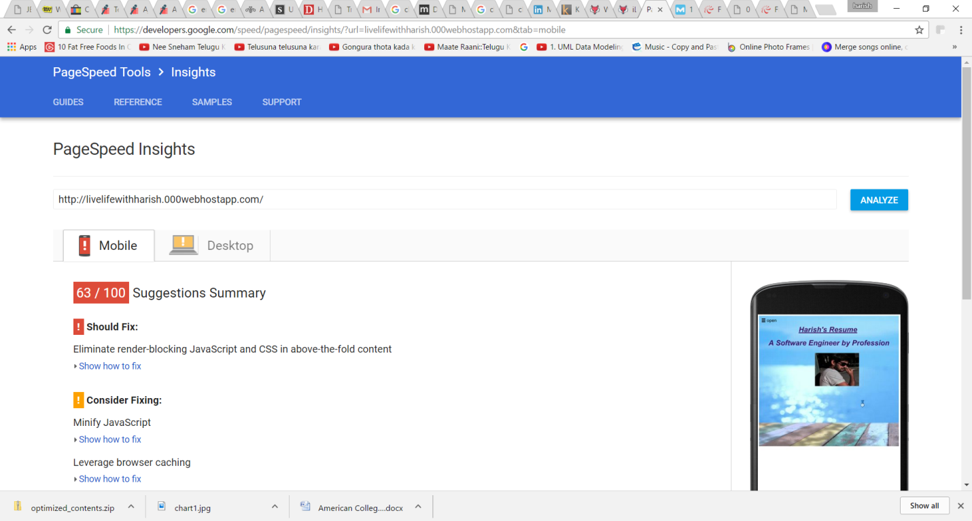

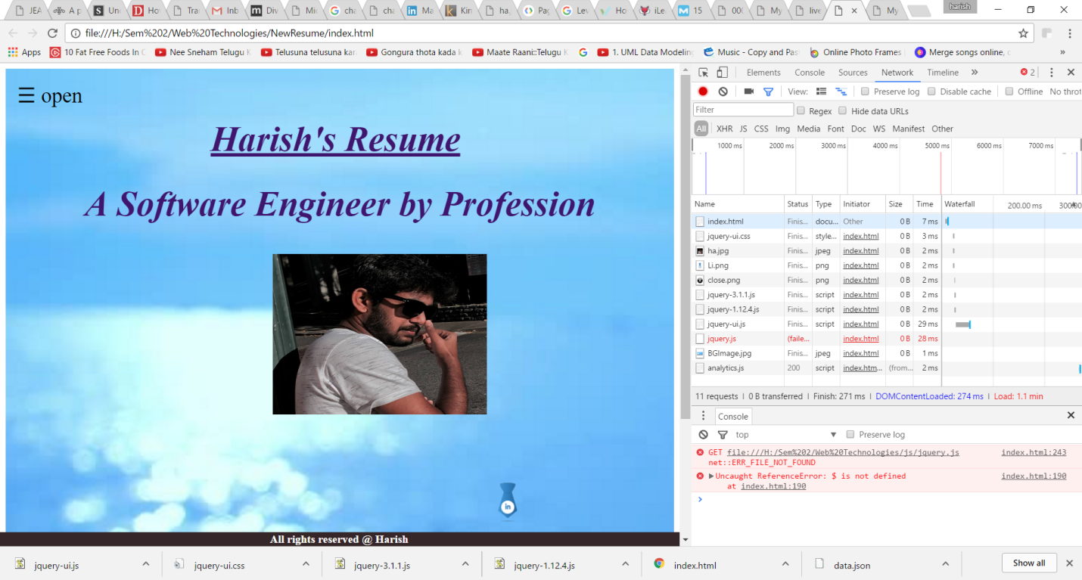

**Step 2: Before Minification**

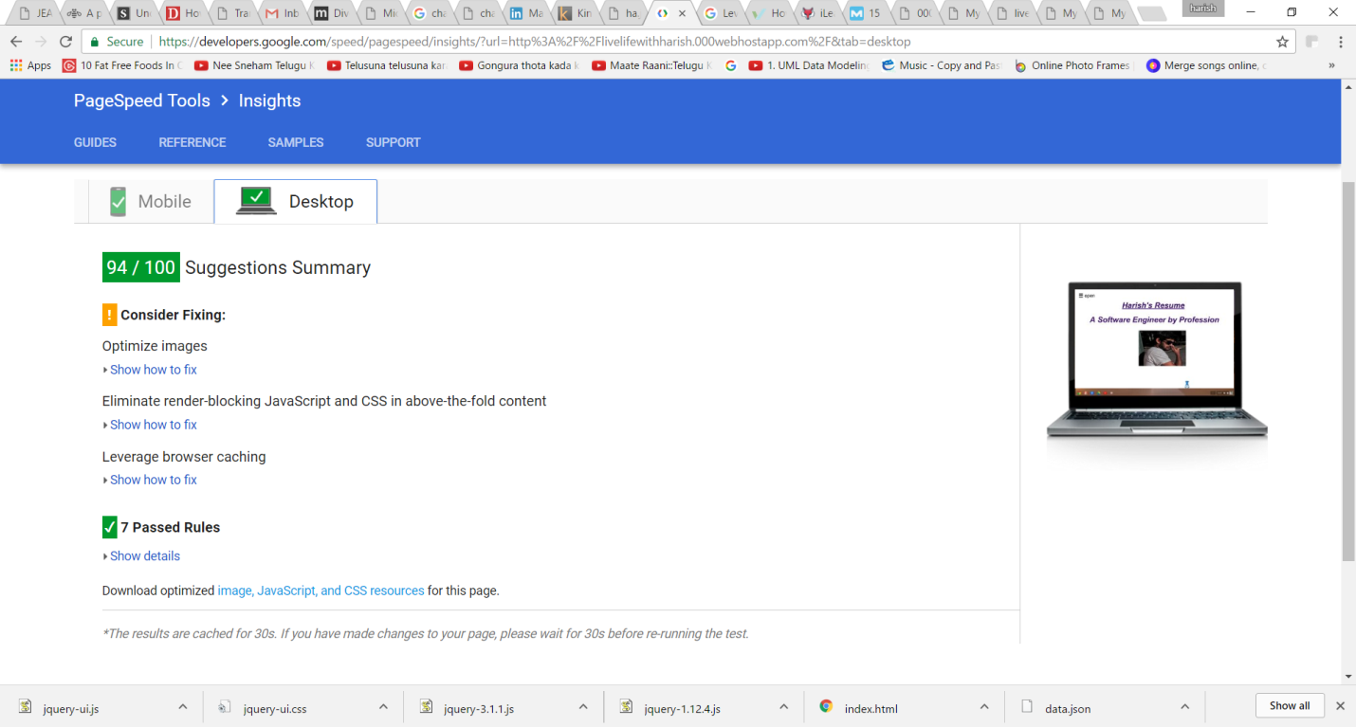

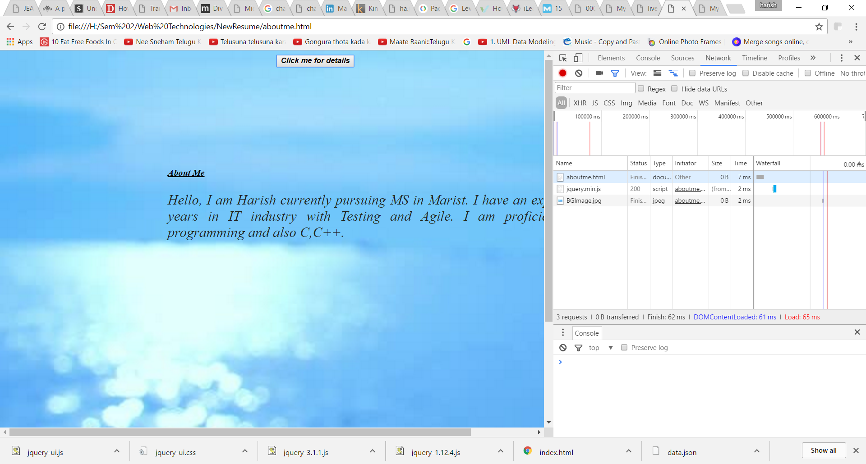

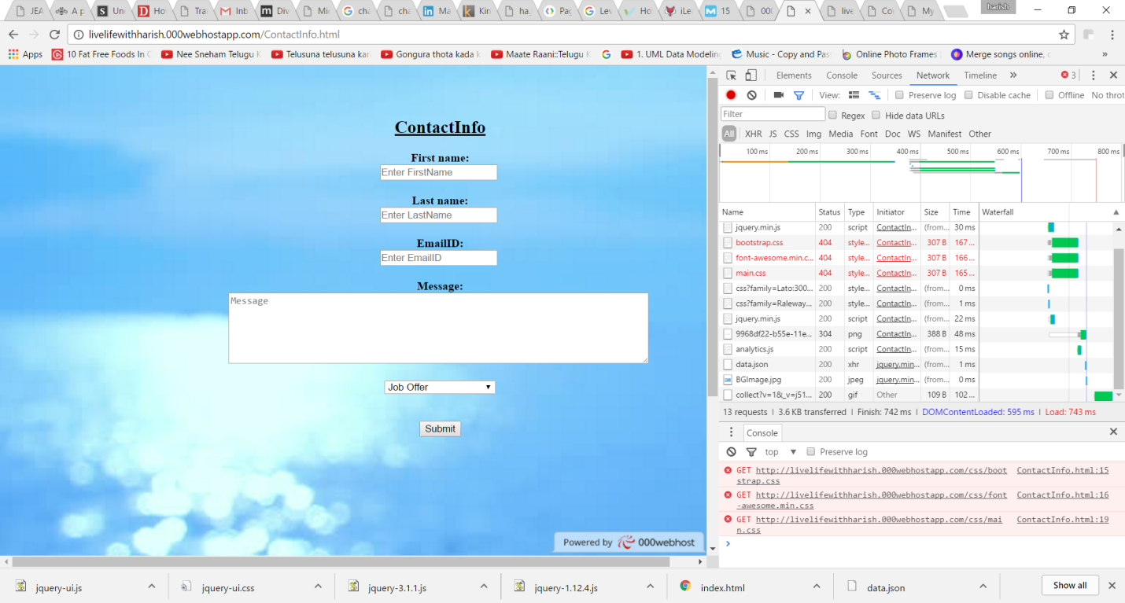

**Step 3: After Minification**

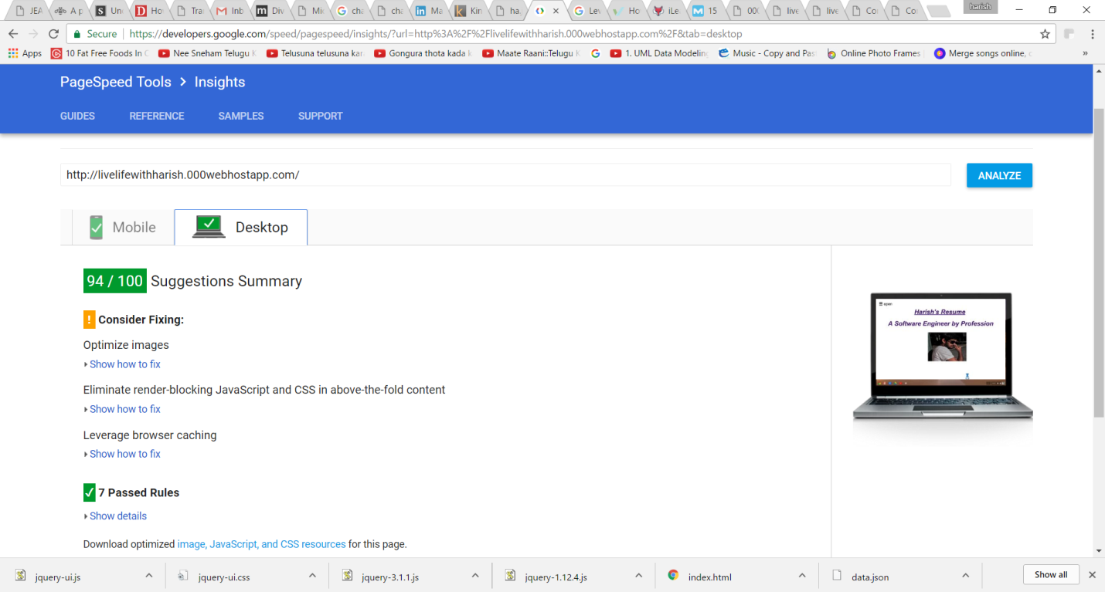

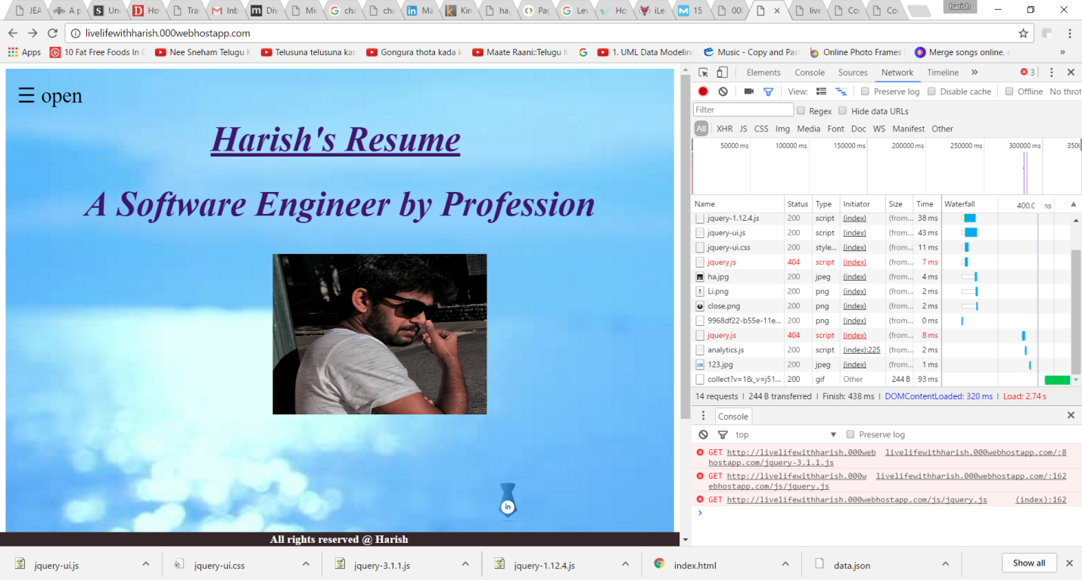

**Q2. How much of a performance increase were you able to gain by taking these simple actions?**

The performance is increased by taking the actions.

Huge improvement in the Google page speed insight was seen after the actions implemented. The Page loading speed was brought down from seconds to milliseconds, which allows my page to be hit by more number of users. Only drawback is that there is no human readability in the code after the minfication.