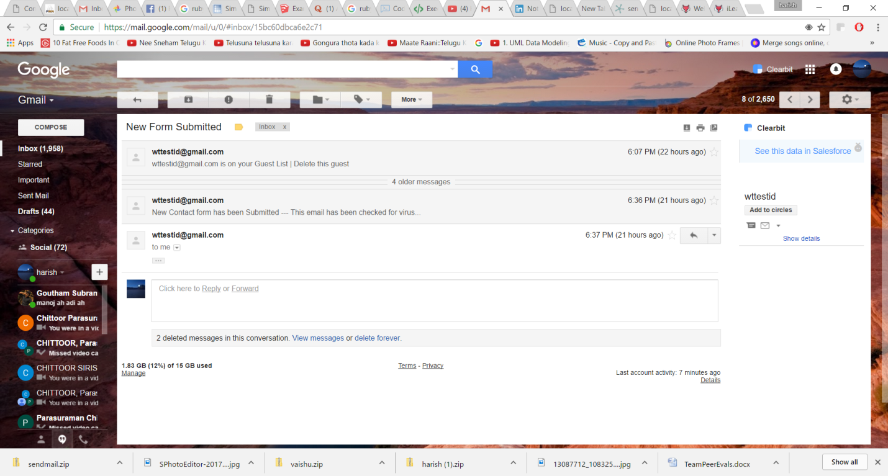

The new form submitted mail has been received as shown in the above screenshot