1.Papertrail

**Search Query :Microsoft-Windows-Security-Auditing**

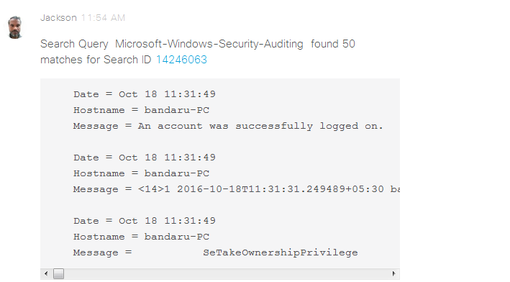

New message:**Search Query: Service_Control_Manager**

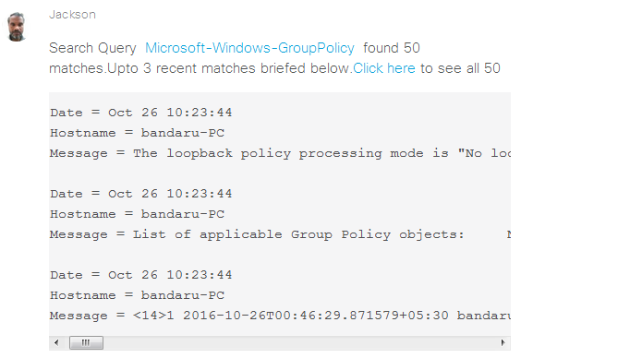

2.Docusign

**Send Document**

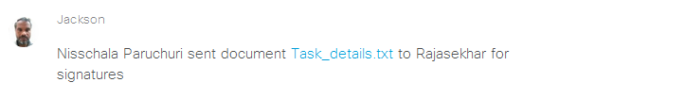

**Document Delivered**

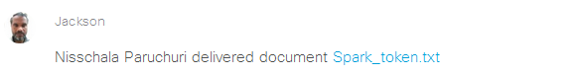

New message:

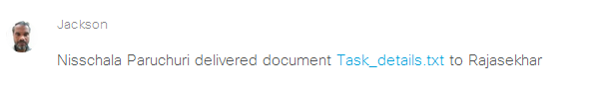

**Document Signed**

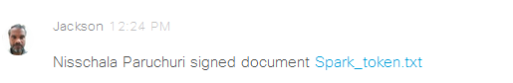  
**new message:**

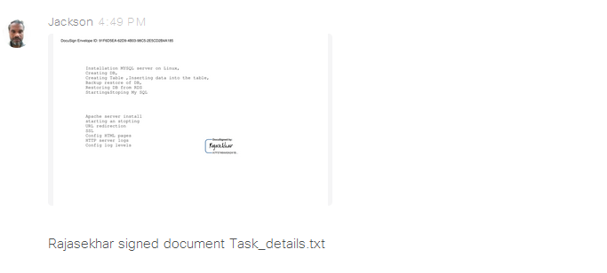

**Document voided**

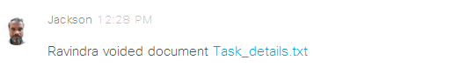

**Document Declined:**

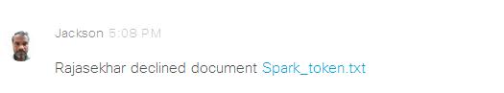

3.Asana

**Task Created:**

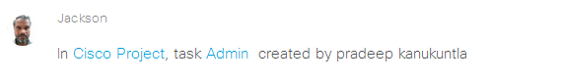

**Task Completed:**

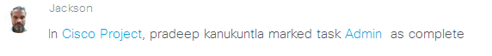

**Task Assigned:**

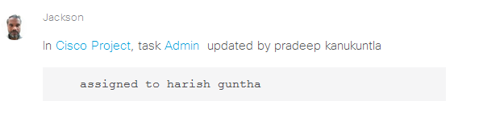

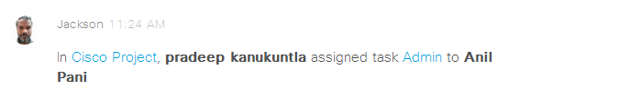

**Sub Task Added:**

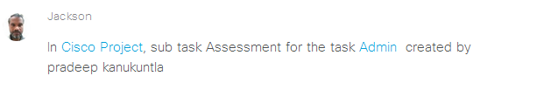

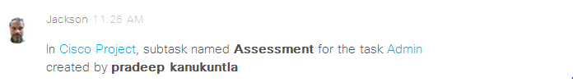

**Comment Added:**

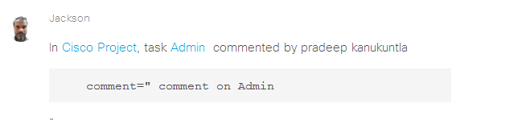

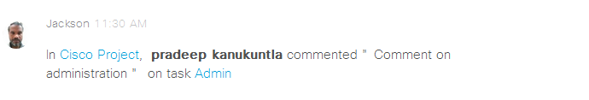

**Task Incomplete:**

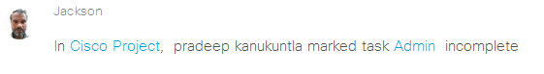

**Attachment Added:**

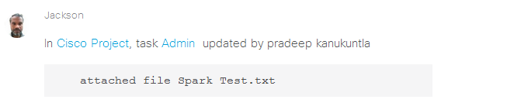

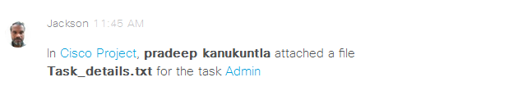

**Due Date Update:**

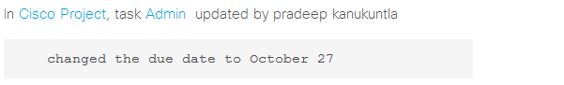

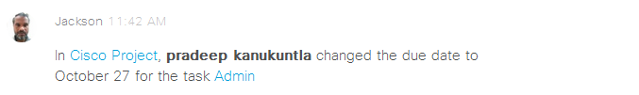

**Copy Task:**

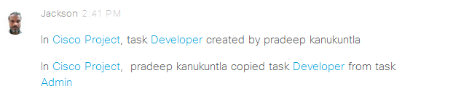

**Marked as Favorite:**

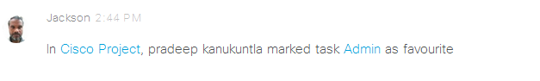

**Marked as Duplicate:**

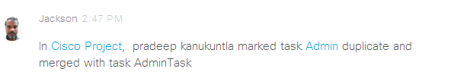

**4.User Voice**

**Ticket Created:**

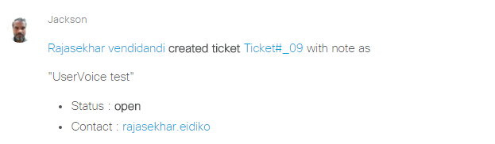

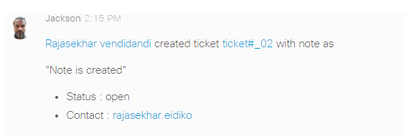

**Ticket Commented:**

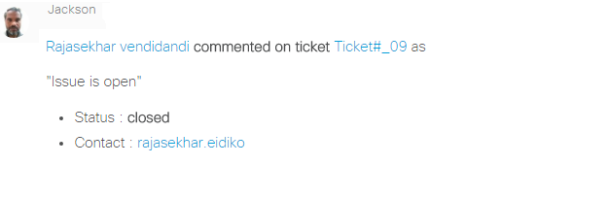

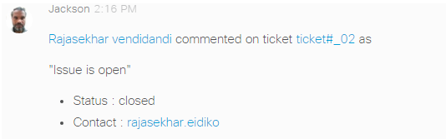

**Ticket Status Updated:**

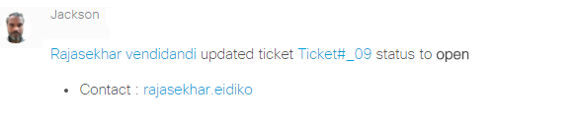

**Ticket Status Updated:**

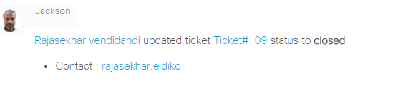

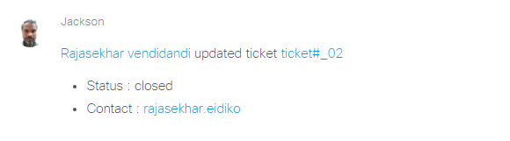

**Suggestion Created:**

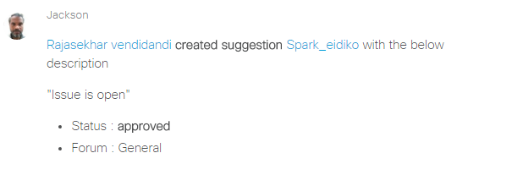

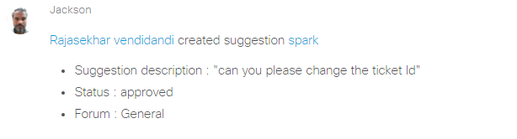

**Suggestion Votes Updated:**

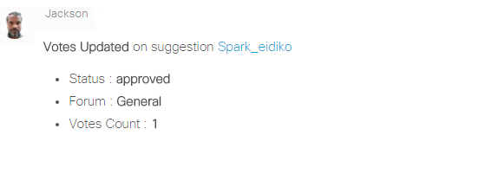

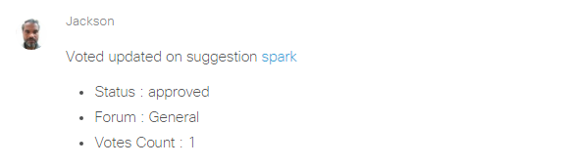

**New Kudo:**

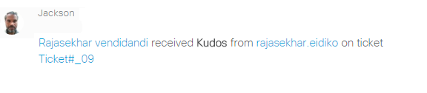

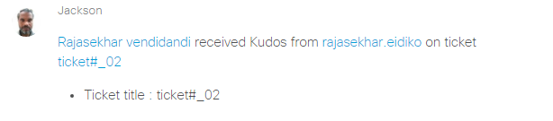

**Ticket Admin Reply:**

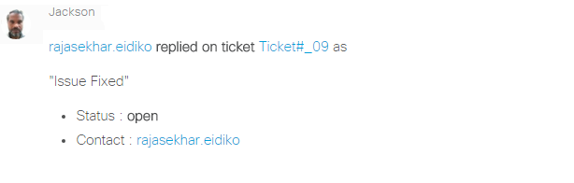

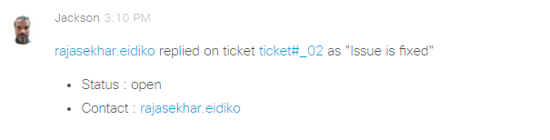

**Commented on suggestion:**

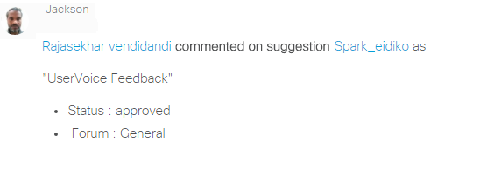

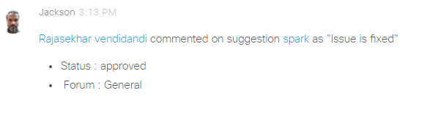 **Article Created:**

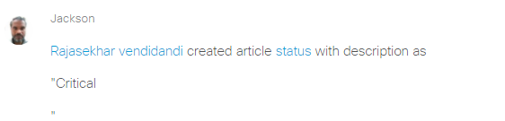

**User Feedback:**

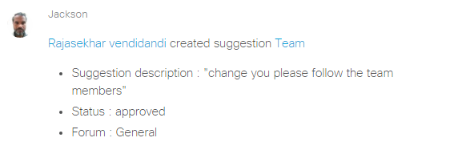

5.Wunderlist

**Task added to list:**

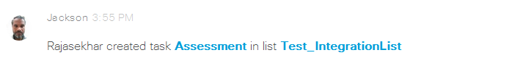

**Task completed:**

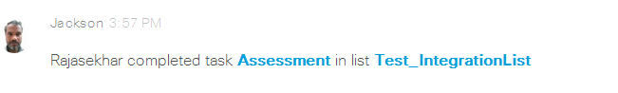

**Task modified:**

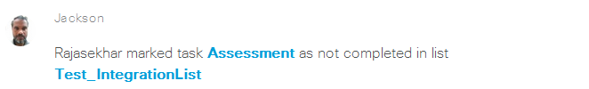

**Task assigned:**

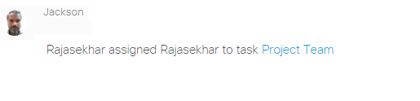

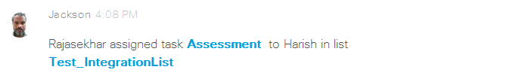

**Set Due date:**

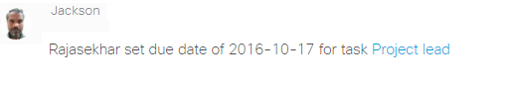

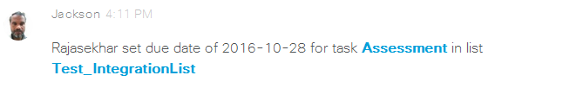

**Attached file :**

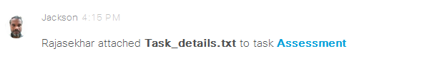

**Commented on Task:**

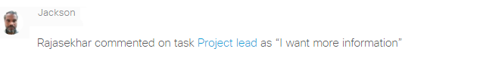

**Note added to task:**

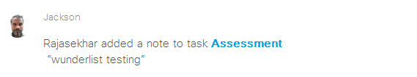

**Note changed:**

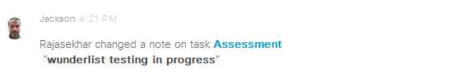

**Sub task added to task:**

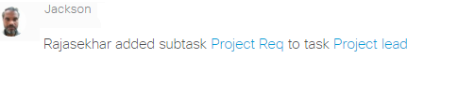

**Sub task completed:**

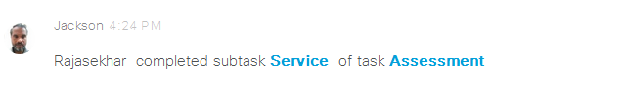

**Subtask modified:**

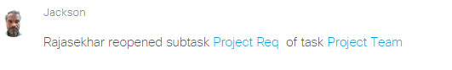

**Subtask deleted:**

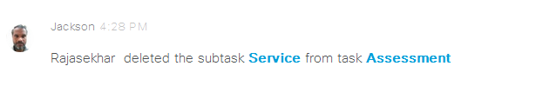

**Starred Task:**

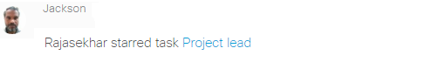

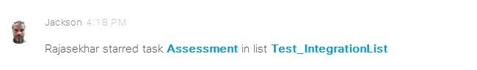

**Unstarred Task:**

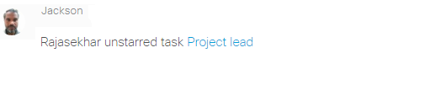

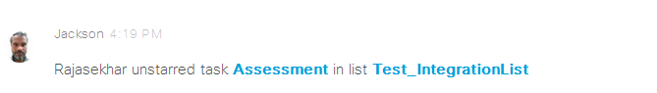

6.Stripe

**Customer Created:**

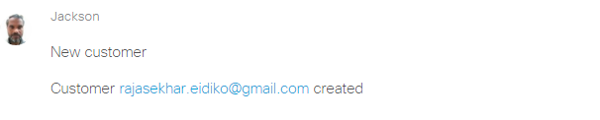

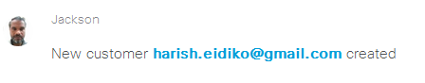

**Customer Updated:**

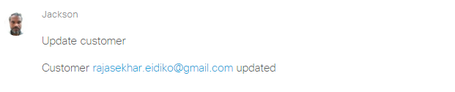

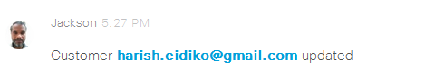

**Customer Deleted:**

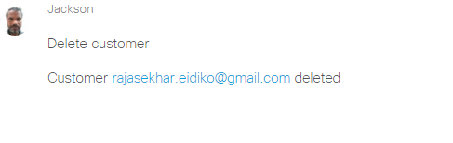

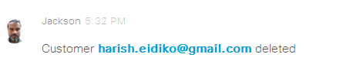

**Payment Succeeded:**

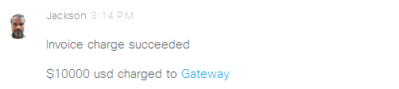

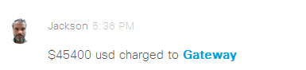

**Payment Refunded:**

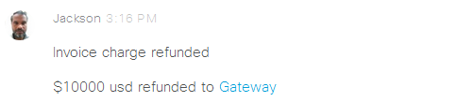

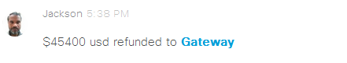

**Plan Created:**

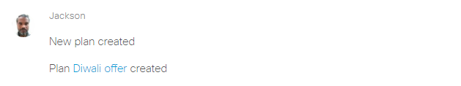

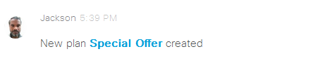

**Product Ordered:**

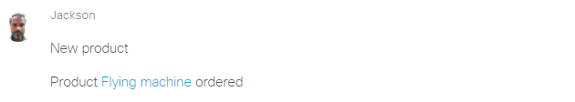

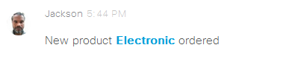

**Product Cancelled:**

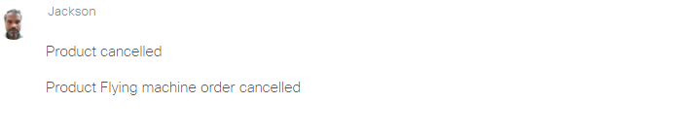

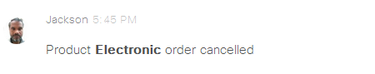

**Coupan Cretaed:**

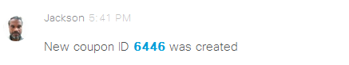

7.Onedrive

**Folder Created:**

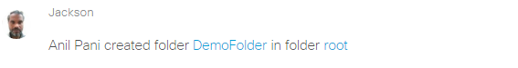

**File Created:**

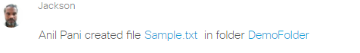

**Folder Updated:**

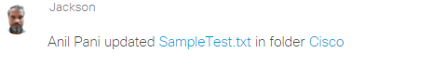

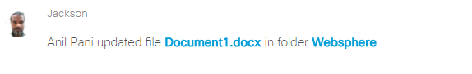

**File Copied:**

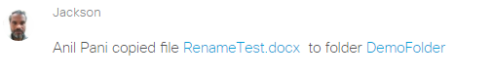

**File Commented:**

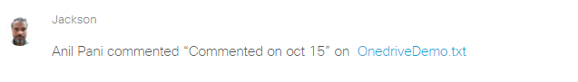

**Folder Deleted:**

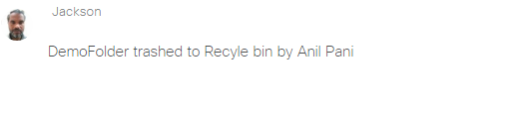

8.Basecamp

**Todo:**

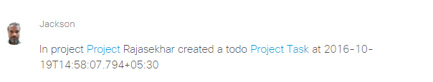

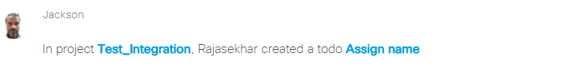

**Todo-list:**

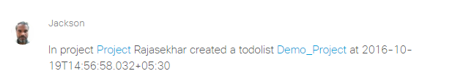

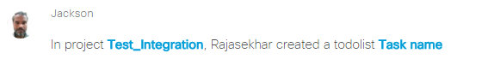

**Comment:**

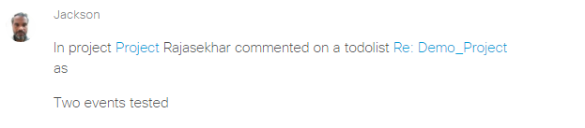

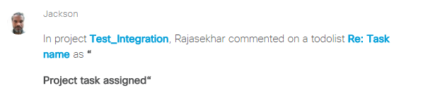

**Start a Doc:**

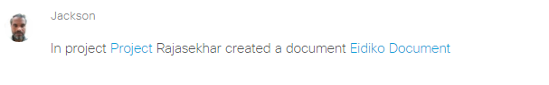

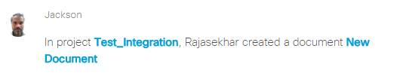

**Upload File:**

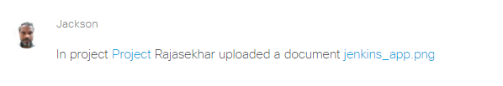

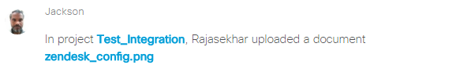

**Automatic check-ins:**

Question:

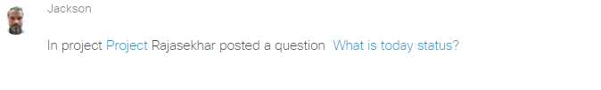

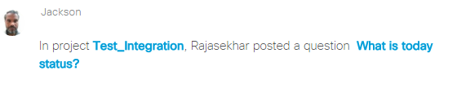

**Question Answer:**

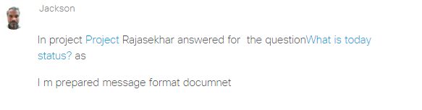

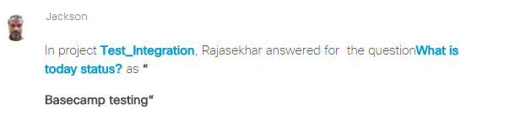

**Schedule**

Event created:

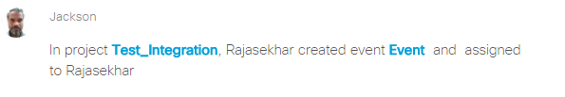

Comment:

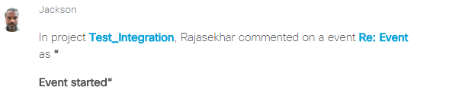

9.Twitter

**Post tweets sent from this account**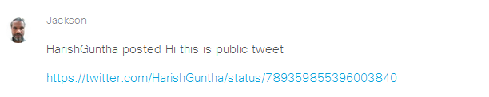

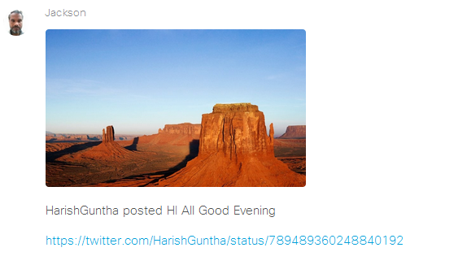

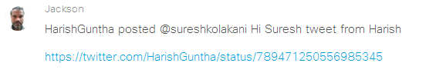

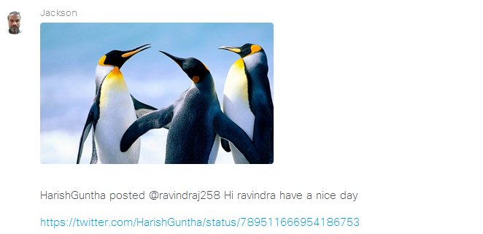

**Show retweets sent from this account** 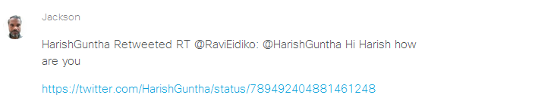

**Post tweets sent to this account**

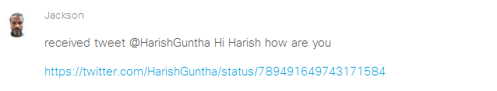

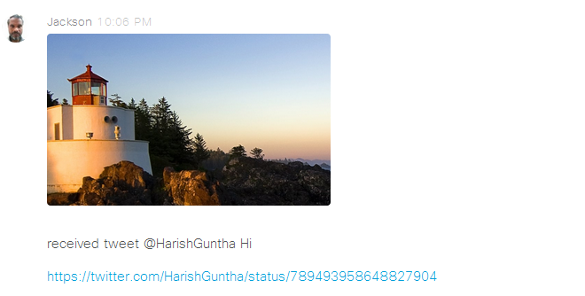

10.GoogleCalendar

**Event Created:**

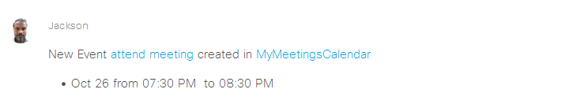

**Event updated:**

