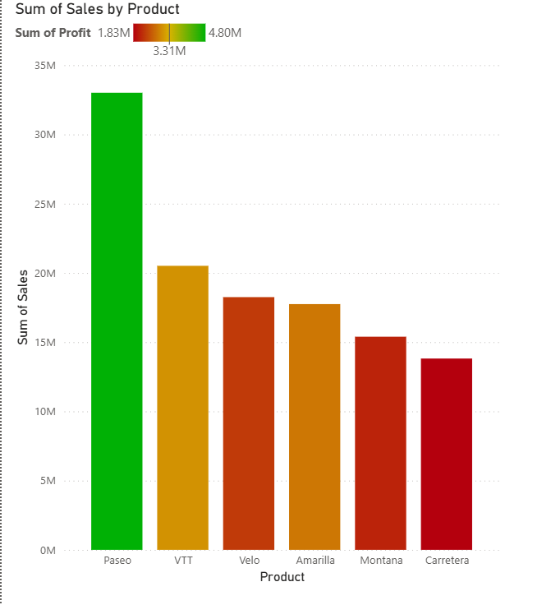

**Conditional Formatting**

**Steps:**

* **In Report View Tab**

1. Visualizations tab ->Build Visual
2. Click on **Stacked Column Chart**

* **Data Tab**

1. **Financials** -> Select Column name according to the given question

* **Build Visual**

1. X-axis -> Product
2. Y-axis -> Sum of Sales

* **Format Visual**

1. Format Visual ->Visual

* **Columns:**

Color -> Conditional Formatting

* **Color – Categories:**
* Format Style -> **Gradient**
* What field should we base this on? -> **Sum of Profit**
* Summarization -> **Sum**
* How should we format empty values? -> **Don’t Format**
* Minimum -> Lowest Value (red)
* Center -> Middle Value (Yellow)
* Maximum -> Highest Value (green)
* Click on: Add middle color, then press OK button.

**Conditional Formatting with Rules**

**Steps:**

* **In Report View Tab**

1. Visualizations tab ->Build Visual
2. Click on **Stacked Column Chart**

* **Data Tab**

1. **Financials** -> Select Column name according to the given question

* **Build Visual**

1. X-axis -> Product
2. Y-axis -> Sum of Sales

* **Format Visual**

1. Format Visual ->Visual

* **Columns:**

Color -> Conditional Formatting

* **Color – Categories:**
* Format Style -> **Rules**
* What field should we base this on? -> **Sum of Profit**
* Summarization -> **Sum**
* If Value >= **35000,** Number and <= **5000000** Number then color: **Violet**
* If Value >= **25000**, Number and <= **3500000** Number then color: **Orange**
* If Value >= **15000**, Number and <= **2500000** Number then color: **Pink**
* then press OK button.