## SCHOOL OF INFORMATION TECHNOLOGY AND ENGINEERING

***INFORMATION SECURITY ANALYSIS AND AUDIT***

**REVIEW 2**

**LIGHTWEIGHT CRYPOGRAPHY USING BLIND SIGNATURE AND AUTHENTICATION**

**TEAM MEMBERS:**

**18MIS0163- D HARISH**

**18MIS0193-A R HARIHARAN**

**18MIS0260-R SUDHARSHAN**

**SLOT : F2**

**CODE : CSE3501 FACULTY:Prof.CHANDRASEGAR.T**

**ARCHITECTURE:**

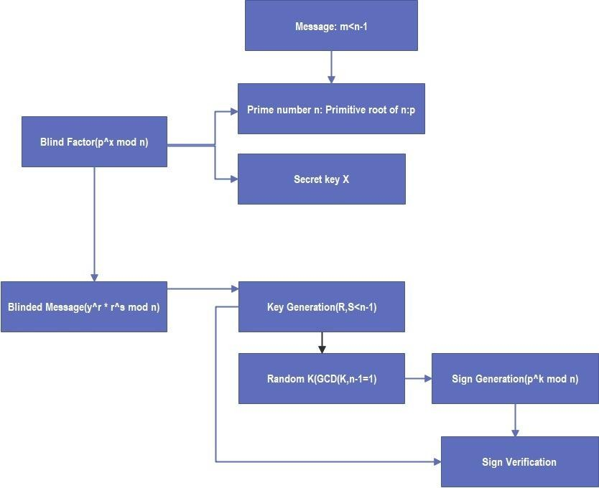

**ALGORITHM:**

* For each user, there is a key pair, which consists of a secret key x, and a public key y where,

P is primitive root of the prime number;

**BLIND FACTOR**: y = p^ x mod n.

* The public key y is published in a public file and known to everybody while the secret key x is kept secret.
* Let m, be a document to be signed, where: 0< m < n -1 and p is a prime.
* The public file consists of the public key y = p^ x mod n for each user.
* To sign a document, a user A uses the secret key X to compute a signature for, m so that any user can verify that this message has been signed by A, using the public key p together with n and p.

## KEY GENERATION:

* No one can forge a signature without knowing the secret xA.
* The signature for, m is a pair (r, s), where 0 < r, s c>n- 1, chosen such that

## BLINDED MESSAGE: BM = y^ r x r^ s mod n.

* The following three steps are done to compute the signature:
* Choose a random number k, uniformly distributed between 0 and n - 1, such that: can be written as gcd (k, n - 1) =1.

## SIGN GENERATION:

Compute SG = p^ k mod n,

## SIGN VERIFICATION:

SV=M^ x*sg x M1^k*s mod n

## NUMERICAL INSTANCE:

* + PRIME NUMBER n=19
  + MESSAGE=14
  + RANDOM X=13
  + R=2(0<r<n-1)
  + S=3(0<s<n-1)

## Primitive root of the prime number(n) 19= p (2)

**BLIND FACTOR:**

# y = p^ x mod n. y=2^13 mod 19 y=3

**Blinded Message:**

# BM = y^ r x r^ s mod n.

=3^2 x 2^3 mod 19

# = 15

gcd (k, n - 1) =1

**We find gcd(k,n-1)=1 We get 17 as k value.**

**Sign Generation:**

Compute SG = p^ k mod n,

=2^17 mod 19

=10

**Sign Verification:**

# SV1=M^ x*sg mod n =14^13*10 mod 19=17 Sv2= M1^k*s mod n=14^17*3 mod 19=12 Sv3= sv1*sv2 mod n

=17 x 12 mod 19

# =204 mod 19

=14

## We get the original message as the sign verification.

**CODING:**

import java.io.*; import java.util.*; import java.math.*;

public class Rev2

{

// Returns true if n is prime static boolean isPrime(int n)

{

// Corner cases if (n <= 1)

{

return false;

}

if (n <= 3)

{

return true;

}

// This is checked so that we can skip

// middle five numbers in below loop if (n % 2 == 0 || n % 3 == 0)

{

return false;

}

for (int i = 5; i * i <= n; i = i + 6)

{

if (n % i == 0 || n % (i + 2) == 0)

{

return false;

}

}

return true;

}

// Utility function to store prime factors of a number static void findPrimefactors(HashSet<Integer> s, int n)

{

// Print the number of 2s that divide n

while (n % 2 == 0)

{

s.add(2); n = n / 2;

}

// n must be odd at this point. So we can skip

// one element (Note i = i +2)

for (int i = 3; i <= Math.sqrt(n); i = i + 2)

{

// While i divides n, print i and divide n while (n % i == 0)

{

s.add(i); n = n / i;

}

}

// This condition is to handle the case when

// n is a prime number greater than 2 if (n > 2)

{

s.add(n);

}

}

// Function to find smallest primitive root of n static int findPrimitive(int n)

{

HashSet<Integer> s = new HashSet<Integer>();

// Check if n is prime or not if (isPrime(n) == false)

{

return -1;

}

// Find value of Euler Totient function of n

// Since n is a prime number, the value of Euler

// Totient function is n-1 as there are n-1

// relatively prime numbers. int phi = n - 1;

// Find prime factors of phi and store in a set findPrimefactors(s, phi);

// Check for every number from 2 to phi for (int r = 2; r <= phi; r++)

{

// Iterate through all prime factors of phi.

// and check if we found a power with value 1 boolean flag = false;

for (Integer a : s)

{

// Check if r^((phi)/primefactors) mod n

// is 1 or not

if (power(r, phi / (a), n) == 1)

{

flag = true; break;

}

}

// If there was no power with value 1. if (flag == false)

{

return r;

}

}

// If no primitive root found return -1;

}

static int calmodInv(int a, int b)

{

a = a % b;

for (int x = 1; x < b; x++) if ((a * x) % b ==1)

return x; return 1;

}

/* Iterative Function to calculate (x^y) in O(log y) */ static int power(int h1, int h2, int h3)

{

int res = 1; // Initialize result

h1 = h1 % h3; // Update x if it is more than or

// equal to p

if (h1 == 0)

return 0; // In case x is divisible by p;

while (h2 > 0)

{

// If y is odd, multiply x with result if ((h2 & 1) != 0)

res = (res * h1) % h3;

// y must be even now

h2 = h2 >> 1; // y = y/2 h1 = (h1 * h1) % h3;

}

return res;

}

public static void main(String[]args) { System.out.println(" ");

Scanner sc = new Scanner(System.in); System.out.println(" KEY GENERATION:"); System.out.println(" ");

System.out.println(" "); System.out.println(" Key Generation:");

System.out.println(" "); System.out.println(" ");

System.out.print("Enter the prime number:"); int n=sc.nextInt();

System.out.println("Smallest primitive root of " + n+ " is : " + findPrimitive(n));

int p=findPrimitive(n); System.out.print("Enter the Message :"); int sh=sc.nextInt();

System.out.println("Enter the random number X : "); int x=sc.nextInt();

System.out.println("Random Number is:"+x); int powerOfNumber = (int) Math.pow(p, x); int e=powerOfNumber % n;

System.out.println(" "); System.out.println("BLIND FACTOR :"+e);

System.out.println(" ");

System.out.println(" "); System.out.println(" ");

System.out.println("Random R between 0<r>P-1 : "); int r=sc.nextInt();

System.out.println("Random S between 0<s>P-1 : "); int s=sc.nextInt();

int power1=(int) Math.pow(e,r); int power2=(int) Math.pow(r,s); int bm=power1*power2 % n;

System.out.println(" "); System.out.println(" ");

System.out.print("BLINDED MESSAGE :"+bm); System.out.println(" ");

System.out.println(" "); System.out.println(" ");

int ok=n-1; System.out.println("P-1 :"+ok);

System.out.print("Enter the random k:"); int k=ok-1;

System.out.println("K MUST BE GCD (K,P-1 = 1)"); System.out.println("Random Number K is:"+k);

System.out.println(" ");

System.out.println(" "); int power3=(int) Math.pow(p,k);

int sg=power3 % n;

System.out.println("SIGN GENERATION :"+sg ); System.out.println(" ");

System.out.println(" "); int l1=power(sh,x*sg,n);

int l2=power(sh,k*s,n);

int l3=(l1*l2) % n; System.out.println(" ");

System.out.println(" ");

System.out.println("SIGN VERIFICATION :"+l3); System.out.println(" ");

System.out.println(" ");

}

}

## SAMPLE OUTPUT:

