Ex. No. 10 | WRITE A PHP PROGRAM USING SIMPLE GET FUNCTION
Date:

Aim:
To write a program in PHP for a simple GET function. Algorithm:
Step 1: Start
Step 2: Create a form using form tag.
Step 3: Get the form data using GET super global.
Step 4: Display the result.
Step 5: Stop the process
Program:
<html>
<body>
<form action="run.php" method=“GET">
Name: <input type="text" name="name"><br>
E-mail: <input type="text" name="email"><br>
<input type="submit">
</form>
</body>
</html>

Run.php:
<html>
<body>
Welcome <?php echo $_GET["name"]; ?><br>
Your email address is: <?php echo $_GET["email"]; ?>
</body>
</html>

Output:
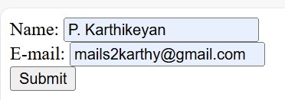


Particulars | Max Marks | Mark secured
Aim & Algorithm | 05
Program | 10
Execution and Output | 05
Viva & Record | 05
Total | 25

Result: Thus the above program is executed and output is verified successfully.

Ex. No. 10(L3) | Develop and demonstrate a PHP program to accept the Annual Income using the GET method. Using the POST method, calculate the Tax Amount and display the Annual Income, Tax Amount, and Net Income.
Date:

Aim:
Develop and demonstrate a PHP program to accept the Annual Income using the GET method. Using the POST method, calculate the Tax Amount and display the Annual Income, Tax Amount, and Net Income.
Algorithm:

Output:

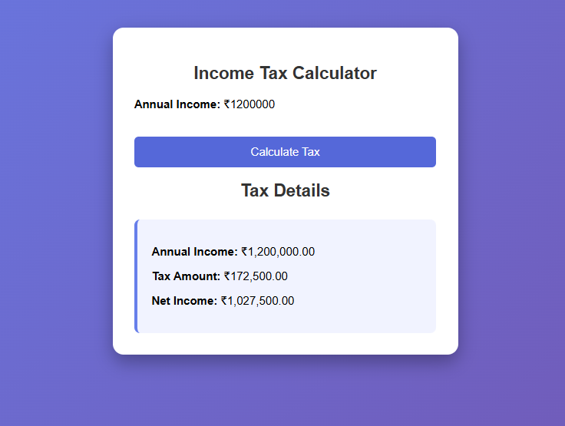

Particulars | Max Marks | Mark secured
Aim & Algorithm | 05
Program | 10
Execution and Output | 05
Viva & Record | 05
Total | 25

Result:

Ex. No. 11 | DESIGN A LOGIN FORM USING COOKIES, BOOTSTRAP, PHP, DATABASE.
Date:

Aim:
Design a login form using cookies, bootstrap, PHP, Database.

Algorithm:

Step 1: Start process. Step 2: Start a session.
Step 3: Assign session values using SESSION super global. Step 4: Display session value using echo.
Step 5: Stop the process .

Program:

Config.php:

<?php
$databaseHost = 'localhost';//or localhost
$databaseName = 'myproject'; // your db_name
$databaseUsername = 'root'; // root by default for localhost
$databasePassword = ''; // by defualt empty for localhost
$mysqli = mysqli_connect($databaseHost, $databaseUsername, $databasePassword,
$databaseName);
?>
Login.php:
<html>
<head>
<link href="https://cdn.jsdelivr.net/npm/bootstrap@5.1.3/dist/css/bootstrap.min.css" rel="stylesheet" integrity="sha384- 1BmE4kWBq78iYhFldvKuhfTAU6auU8tT94WrHftjDbrCEXSU1oBoqyl2QvZ6jIW3" crossorigin="anonymous">

</head>
<fieldset>
<div class="container" id="containers">
<legend>Login </legend>
<br>
<form action="loginprocess.php" method="POST"><br><br> Username:<input type="text" required="" name="uname"><br><br> Password:<input type="text" required="" name="upassword"><br><br>
<input type="checkbox" value="1" name="remember">keep me login:
<input type="submit" value="Login" name="sub">
<br>
<?php if(isset($_REQUEST["err"]))
$msg="Invalid username or Password";
?>
<p style="color:red;">
<?php if(isset($msg))
{
echo $msg;
}
?>
</p>
</form>
</div>
</fieldset>
</html>

Loginprocess.php:

<?php
$cser=mysqli_connect("localhost","root","","myproject") or die("connection failed:".mysqli_error());
if(isset($_REQUEST['sub']))
{
$a = $_REQUEST['uname'];
$b = $_REQUEST['upassword'];

$res = mysqli_query($cser,"select* from login where uname='$a'and upassword='$b'");
$result=mysqli_fetch_array($res); if($result)
{

if(isset($_REQUEST["remember"]) && $_REQUEST["remember"]==1) setcookie("login","1",time()+60);// second on page time
else
setcookie("login","1"); header("location:index.php");
}
else
{

header("location:login.php?err=1");
}
}

?>

Index.php:

<?php
if(!isset($_COOKIE["login"]))// $_COOKIE is a variable and login is a cookie name header("location:login.php");
?>
<h1>Hey ! welcome to main page .</h1>
<a href="page1.php"><h2>PAGE 1 </h2>
<a href="logout.php"><h2>Logout</h2>

Page1.php:
<?php if(!isset($_COOKIE["login"]))
header("location:login.php");
?>
<h1> Welcome to page 1 </h1>
<table>
<a href="page1.php"><h2>PAGE 1</h2>
<a href="logout.php"><h2>Logout</h2>

Logout.php:
<?php
setcookie("login","",time()-1);//for delete the cookie //destroy the cookie header("location:index.php")
?>

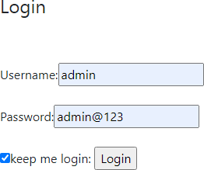
Output:





Particulars | Max Marks | Mark secured
Aim & Algorithm | 05
Program | 10
Execution and Output | 05
Viva & Record | 05
Total | 25

Result:
Thus the login form is designed and implemented.

Ex. No. 11(L3) | Develop and demonstrate a secure customer login system using Bootstrap, PHP, Cookies, and MySQL. The system should accept Email and Password, provide a Remember Me option, implement Session Handling, validate user credentials from the database, and include a Logout feature.
Date:

Aim:
To Develop and demonstrate a secure customer login system using Bootstrap, PHP, Cookies, and MySQL. The system should accept Email and Password, provide a Remember Me option, implement Session Handling, validate user credentials from the database, and include a Logout feature.

Algorithm:

Program:

Output:
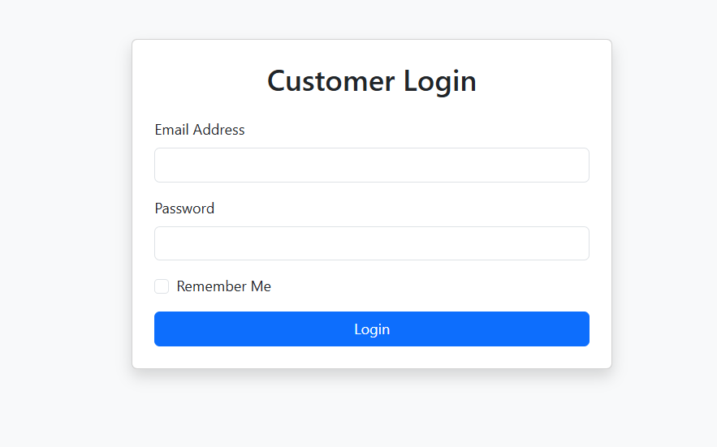

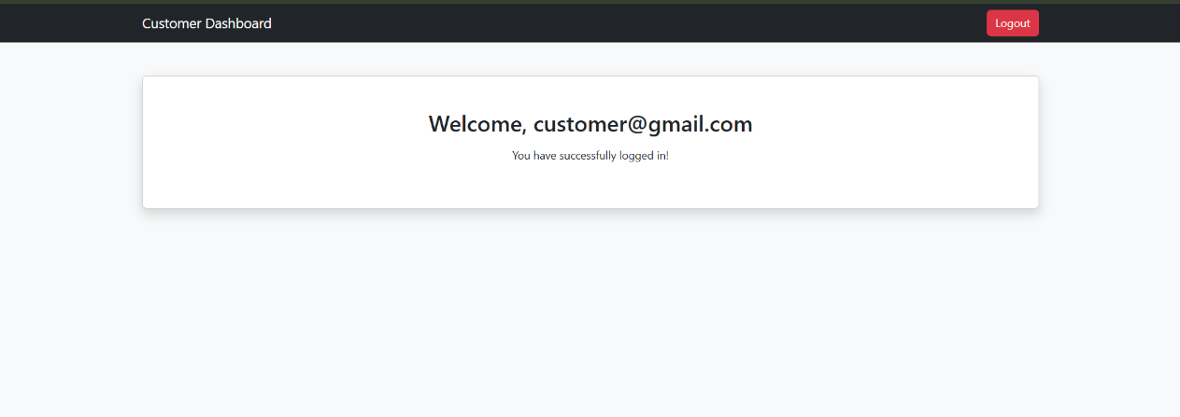

Particulars | Max Marks | Mark secured
Aim & Algorithm | 05
Program | 10
Execution and Output | 05
Viva & Record | 05
Total | 25

Result:

