Harish K S – Milestone Assessment 03 – iOS with SwiftUI && Core Java
Fitness Application
Project Name: Fitness
Core Data Model (.xcdatamodeld file)
Adding an entity called Workout with attributes:
- exerciseName: String
- duration: Double
- caloriesBurned: Double

PersistentController
import CoreData

struct PersistenceController {
static let shared = PersistenceController()
let container: NSPersistentContainer

init(inMemory: Bool = false) {
container = NSPersistentContainer(name: "Fitness")

if inMemory {
container.persistentStoreDescriptions.first?.url = URL(fileURLWithPath: "/dev/null")

}

container.loadPersistentStores {_ , error in
if let error = error as NSError? {
fatalError("Unresolved Error: \(error), \(error.userInfo)")
}
}
}

func saveContext() {
let context = container.viewContext
if context.hasChanges {
try? context.save()
}
}

}

FitnessApp
import SwiftUI

@main
struct FitnessApp: App {
let persistentController = PersistenceController.shared

var body: some Scene {
WindowGroup {
WorkoutListView()
.environment(\.managedObjectContext, persistentController.container.viewContext)
}
}
}

WorkoutListView
import SwiftUI

struct WorkoutListView: View {
@Environment(\.managedObjectContext) private var viewContext
@FetchRequest(
entity: Workout.entity(),
sortDescriptors: []
)private var workouts: FetchedResults<Workout>

@State private var showAddWorkoutView = false
@State private var editWorkout: Workout?

var body: some View {
NavigationView {
VStack {
List {
ForEach(workouts) { workout in
NavigationLink(destination: EditWorkoutView(workout: workout)) {
VStack(alignment: .leading, spacing: 5) {
Text(workout.exerciseName ?? "No title")
.font(.title2)
.padding(.vertical, 5)

Text("Calories Burned: \(workout.caloriesBurned, specifier: "%.2f") cal")
.font(.title3)
.padding(.vertical, 5)

Text("Duration: \(workout.duration, specifier: "%.2f") min")
.font(.title3)
.padding(.vertical, 5)
}
}
.buttonStyle(PlainButtonStyle())
.swipeActions {
Button(role: .destructive) {
deleteWorkout(workout)
} label: {
Label("Delete", systemImage: "trash")
}
}
}
}
}
.navigationTitle("Workouts List")
.toolbar {
ToolbarItem(placement: .navigationBarTrailing) {
Button(action: { showAddWorkoutView = true }) {
Image(systemName: "plus")
}
}
}
.sheet(isPresented: $showAddWorkoutView) {
AddWorkoutView()
}
}
}

private func deleteWorkout(_ workout : Workout) {
viewContext.delete(workout)

DispatchQueue.main.async {
do {
try viewContext.save()
} catch {
print("Error deleting workout: \(error.localizedDescription)")
}
}
}

}

struct WorkoutListView_Previews: PreviewProvider {
static var previews: some View {
WorkoutListView()
}
}

AddWorkoutView
import SwiftUI

struct AddWorkoutView: View {
@Environment(\.managedObjectContext) private var viewContext
@Environment(\.dismiss) private var dismiss

@State private var exerciseName = ""
@State private var caloriesBurned = ""
@State private var duration = ""

var body: some View {
NavigationView {
Form {
Section(header: Text("Exercise Details")) {
TextField("Enter Exercise", text: $exerciseName)
.textFieldStyle(RoundedBorderTextFieldStyle())

TextField("Enter Calories Burned", text: $caloriesBurned)
.textFieldStyle(RoundedBorderTextFieldStyle())

TextField("Enter Duration", text: $duration)
.textFieldStyle(RoundedBorderTextFieldStyle())
}
}
.navigationTitle("Add Exercise")
.navigationBarItems(
leading: Button("Cancel") { dismiss() },
trailing: Button("Save") {
addExercise()
dismiss()
}
.disabled(exerciseName.isEmpty || caloriesBurned.isEmpty || duration.isEmpty)
)
}
}

private func addExercise() {
let newExercise = Workout(context: viewContext)
newExercise.exerciseName = exerciseName
newExercise.caloriesBurned = Double(caloriesBurned) ?? 0.0
newExercise.duration = Double(duration) ?? 0.0

DispatchQueue.main.async {
do {
try viewContext.save()
} catch {
print("Error adding workout: \(error.localizedDescription)")
}
}
}
}

struct AddWorkoutView_Previews: PreviewProvider {
static var previews: some View {
AddWorkoutView()
}
}

EditWorkoutView
import SwiftUI

struct EditWorkoutView: View {
@Environment(\.managedObjectContext) private var viewContext
@Environment(\.dismiss) private var dismiss

@ObservedObject var workout: Workout

@State private var exerciseName = ""
@State private var caloriesBurned = ""
@State private var duration = ""

var body: some View {
NavigationView {
Form {
Section(header: Text("Exercise Details")) {
TextField("Enter Exercise", text: $exerciseName)
.textFieldStyle(RoundedBorderTextFieldStyle())

TextField("Enter Calories Burned", text: $caloriesBurned)
.textFieldStyle(RoundedBorderTextFieldStyle())

TextField("Enter Duration", text: $duration)
.textFieldStyle(RoundedBorderTextFieldStyle())
}
}
.navigationTitle("Edit Exercise")
.navigationBarItems(
leading: Button("Cancel") { dismiss() },
trailing: Button("Save") {
updateExercise()
dismiss()
}
.disabled(exerciseName.isEmpty || caloriesBurned.isEmpty || duration.isEmpty)
)
.onAppear {
exerciseName = workout.exerciseName ?? ""
caloriesBurned = String(format: "%.2f", workout.caloriesBurned)
duration = String(format: "%.2f", workout.duration)
}
}
}

private func updateExercise() {
workout.exerciseName = exerciseName
workout.caloriesBurned = Double(caloriesBurned) ?? 0.0
workout.duration = Double(duration) ?? 0.0

DispatchQueue.main.async {
do {
try viewContext.save()
} catch {
print("Error adding workout: \(error.localizedDescription)")
}
}
}
}

Output:
01_WorkoutListView
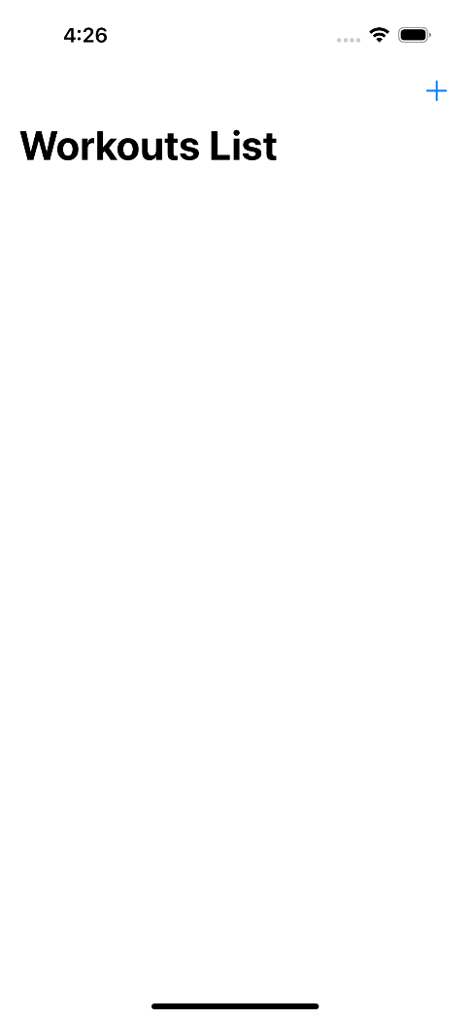

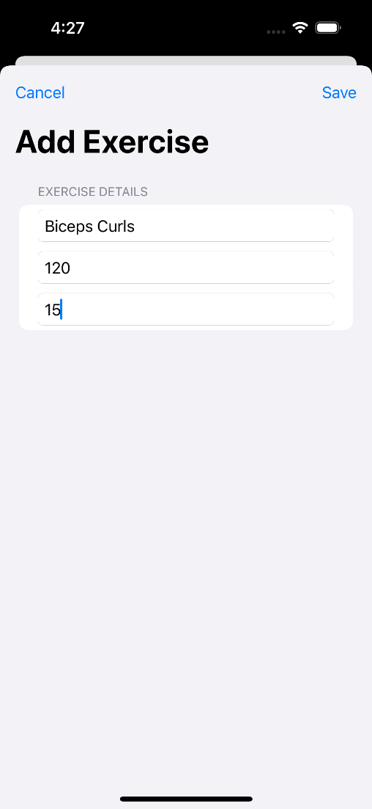
02_AddWorkoutView

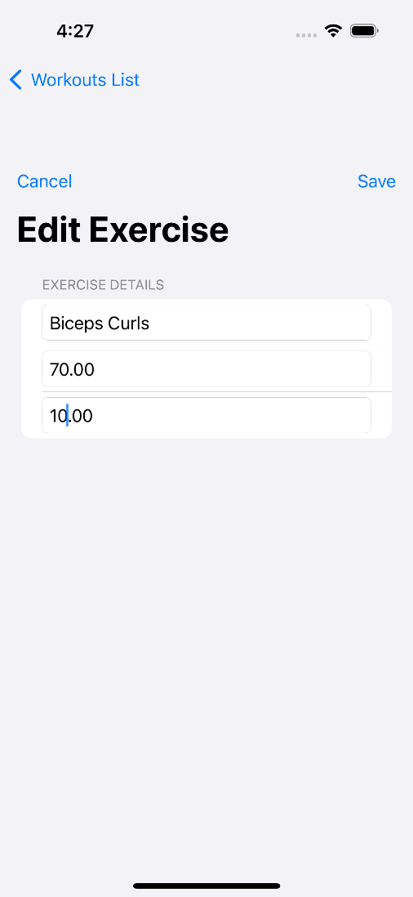
03_EditWorkoutView

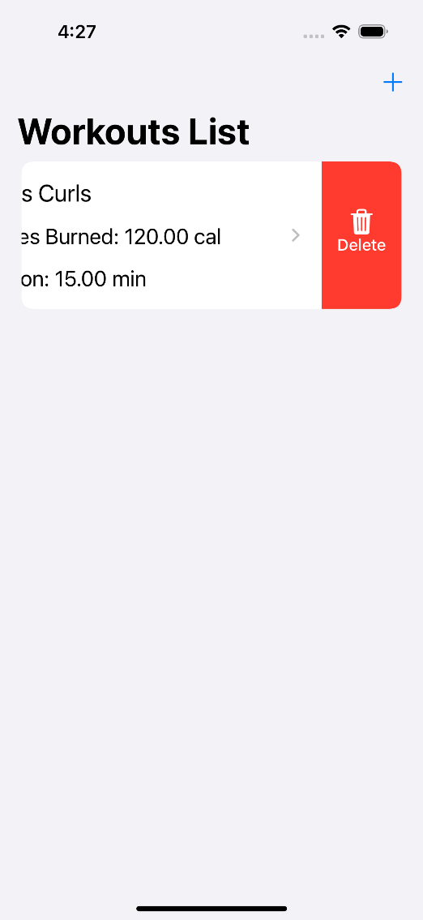
04_DeleteWorkout

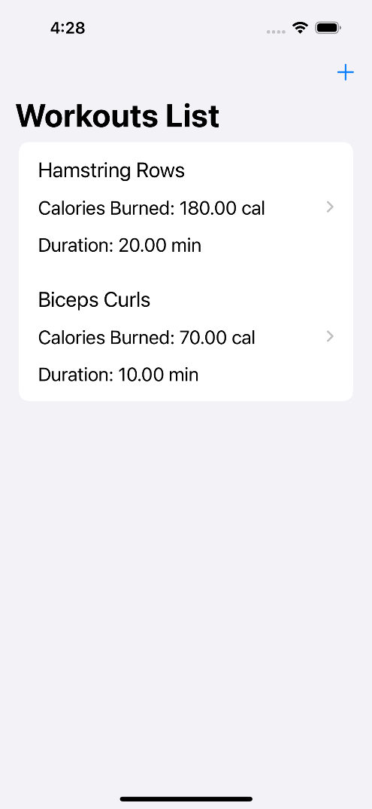
05_WorkoutListView

Core Java – Shooping Cart System
Package Structure:
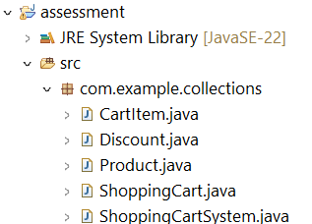
Product.java
package com.example.collections;

public class Product {
private int productId;
private String name;
private double price;
private String category;

public Product(int productId, String name, double price, String category) {
this.productId = productId;
this.name = name;
this.price = price;
this.category = category;
}

public int getProductId() {
return productId;
}

public String getName() {
return name;
}

public double getPrice() {
return price;
}

public String getCategory() {
return category;
}

@Override
public String toString() {
return "Product ID: " + productId + ", Name: " + name + ", Price: " + price + ", category: " + category;
}

}

CartItem.java
package com.example.collections;

public class CartItem {
private Product product;
private int quantity;

public CartItem(Product product, int quantity) {
this.product = product;
this.quantity = quantity;
}

public Product getProduct() {
return product;
}

public int getQuantity() {
return quantity;
}

public void setQuantity(int quantity) {
this.quantity = quantity;
}

}

Discount.java
package com.example.collections;

public class Discount {
private double discountPercentage;
private double cartValue;

public Discount(double discountPercentage, double cartValue) {
this.discountPercentage = discountPercentage;
this.cartValue = cartValue;
}

public double getDiscountPercentage() {
return discountPercentage;
}

public double getCartValue() {
return cartValue;
}

}

ShoppingCart.java
package com.example.collections;

import java.util.ArrayList;
import java.util.List;

public class ShoppingCart {
private List<CartItem> cartItems;
private Discount discount;

public ShoppingCart() {
this.cartItems = new ArrayList<>();
}

public void addProduct(Product product, int quantity) {
for(CartItem item : cartItems) {
if(item.getProduct().getProductId() == product.getProductId()) {
item.setQuantity(item.getQuantity() + quantity);
return;
}
}
cartItems.add(new CartItem(product, quantity));
}

public void removeProduct(int productId) {
cartItems.removeIf(item -> item.getProduct().getProductId() == productId);
}

public void updateProductQuantity(int productId, int quantity) {
for(CartItem item : cartItems) {
if(item.getProduct().getProductId() == productId) {
item.setQuantity(quantity);
return;
}
}
}

public void applyDiscount(Discount discount) {
this.discount = discount;
}

public double calculateTotal() {
double total = 0;
for(CartItem item : cartItems) {
total += item.getProduct().getPrice() * item.getQuantity();
}
if(discount != null && total >= discount.getCartValue()) {
total -= (total * discount.getDiscountPercentage() / 100);
}
return total;
}

public void displayProducts() {
System.out.println("Products in the cart:");
for(CartItem item : cartItems) {
System.out.println(item.getProduct() + ", Quantity: " + item.getQuantity());
}
}

}

ShoppingCartSystem.java
package com.example.collections;

public class ShoppingCartSystem {

public static void main(String[] args) {
Product product1 = new Product(1, "Television", 55000, "Electronics");
Product product2 = new Product(2, "IPhone-14Pro", 96000, "Electronics");
Product product3 = new Product(3, "HarryPotterBooks", 12500, "Books");

ShoppingCart cart = new ShoppingCart();
cart.addProduct(product1, 2);
cart.addProduct(product2, 2);
cart.addProduct(product3, 1);

cart.displayProducts();

System.out.println("\nTotal Value of Cart Items before Discount: " + cart.calculateTotal());

Discount discount = new Discount(10, 5000);
cart.applyDiscount(discount);

System.out.println("\n10 % discount for products above 5000");

System.out.println("\nTotal Value of Cart Items after Discount: " + cart.calculateTotal());
}

}

Output:
Products in the cart:
Product ID: 1, Name: Television, Price: 55000.0, category: Electronics, Quantity: 2
Product ID: 2, Name: IPhone-14Pro, Price: 96000.0, category: Electronics, Quantity: 2
Product ID: 3, Name: HarryPotterBooks, Price: 12500.0, category: Books, Quantity: 1

Total Value of Cart Items before Discount: 314500.0

10 % discount for products above 5000

Total Value of Cart Items after Discount: 283050.0

