Helper Document: Week-on-Week (WoW)

Week-on-Week (WoW) is a type of business metric that measures changes in a specific variable over a period of one week compared to the previous week. It is a common way of tracking business performance over time and is particularly useful for analyzing trends and identifying areas where improvements can be made. Here are the metrics for which we found the WoW change% in this video:

1. Revenue WoW change %: To get the revenue change percentage week over week.
2. Occupancy WoW change %: To get the occupancy change percentage week over week. 3
3. ADR WoW change %: To get the ADR (Average Daily rate) change percentage week over week.
4. RevPAR WoW change %: To get the RevPAR (Revenue Per Available Room) change percentage week over week.
5. Realisation WoW change %: To get the Realisation change percentage week over week.

DSRN WoW change %: To get the DSRN (Daily Sellable Room Nights) change percentage week over week.

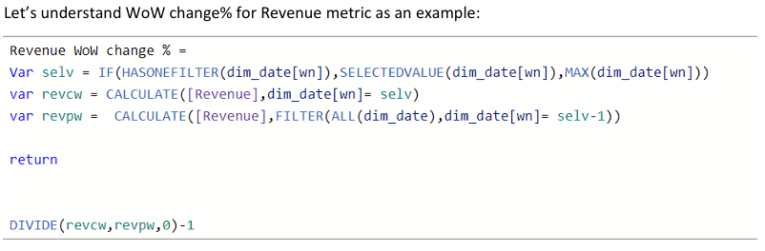

**Let’s break down this formula:**

Var selv = IF(HASONEFILTER(dim_date[wn]), SELECTEDVALUE(dim_date[wn]),MAX(dim_date[wn])) This line creates a variable named **selv**. It checks if there is only one filter applied to the **dim_date[wn]** column. If there is only one filter, it uses the selected value of that filter; otherwise, it uses the maximum value of the **dim_date[wn]** column.

var revcw = CALCULATE([Revenue],dim_date[wn]= selv)

This line creates a variable named **revcw**. It calculates the revenue by applying a filter on the **dim_date[wn]** column, where the value matches the one stored in the **selv** variable. The [Revenue] measure is used for this calculation.

DIVIDE (revcw, revpw,0)-1

This line calculates the percentage change in revenue WoW. It uses the DIVIDE function to divide the value of **revcw** (current week revenue) by the value of **revpw** (previous week revenue), with a specified default value of 0 in case the divisor is 0. The resulting quotient is then subtracted by 1 to calculate the percentage change.

The entire formula returns the week-over-week percentage change in revenue. This formula can be used as a calculated column or a measure in Power BI to display the WoW revenue change in a visual or table.