**Cookies  
(version 1.0)**

# *Introduction*

*A cookie is a****simple text file****that is created when you visit websites on the internet. Cookies allow a website to****store data regarding your activity****(only on that website) so that you can later retrieve it and get a more personalized experience.*

*Websites use cookies to keep track of your activity and your preferences.*

*Given that they keep recollecting data about users, they start creating a behavioral profile that tracks which websites you visit, what things are you interested in, and what are you buying online. This information can be later sold to other companies and used to show targeted ads according to your browsing habits.*

*This idea is very troubling for our privacy. It goes beyond the “improved experience” argument and it violates our right to be anonymous online.*

*Sure, technically these websites don’t know your name, they only use a****unique ID number****to build a profile with your data. Nevertheless, many people have shown their discomfort with these practices and the rejection against third-party cookies is constantly growing with more people trying to block and delete their cookies*

*A cookie is an amount of information that persists between a server-side and a client-side. A web browser stores this information at the time of browsing. A cookie contains the information as a string generally in the form of a name-value pair separated by semi-colons.*

*A cookie is a small piece of text sent to your browser by a website you visit. It helps the site remember information about your visit, which can make it easier to visit the site again and make the site more useful to you.*

*Computer cookies are small files, often including unique identifiers that web servers send to browsers. These cookies then can be sent back to the server each time your browser requests a new page. It's a way for a website to remember you, your preferences, and your habits online.*

*Accepting cookies will give you the best user experience on the website, while declining cookies could potentially interfere with your use of the site. For example, online shopping. Cookies enable the site to keep track of all of the items that you've placed in your cart while you continue to browse*

# *The Problem with Cookies:*

*Here’s the deal with third-party cookies: As their name suggests, they are stored in your computer by a different website from the one that you are actually visiting*

*This means that they are created if the website has****pop-up ads****or****any******embedded content****from another domain. This grants permission to that domain to create its own cookie on your computer. The problem arises when this domain is found in many different websites that you may encounter*

***Reference***

***1. medium links***

a. <https://medium.com/online-io-blockchain-technologies/everything-you-need-to-know-about-internet-cookies-2eb4aa85dd02>

b. <https://medium.com/from-the-scratch/cookies-visualized-everything-you-ever-need-to-know-about-web-cookies-c5f3b403dc65>

c .<https://medium.com/swlh/browser-cookies-101-241ef1ce3e7e>

***Youtube Videos Links***

a. how to get Cookies  
<https://www.youtube.com/watch?v=8tL5P-RtAH0&t=3s>

b. how to setup cookies and ask user permission   
<https://www.youtube.com/watch?v=-HgdzYCi2nI>

c. how to delete a cookies  
<https://www.youtube.com/watch?v=t3Dm3n2EvoY>

***Code/Implementation***   
  
1. Code github url  
<https://github.com/harishkumarforeverr/Cookies-in-React.js/tree/main>

in the above github repo u will find the files CookiesSetup.js, and CookiesSetup.scss

explore the code, where I wrote how to show cookies popup onces only and how to add and extract cookies

for more information please refer to these video : <https://www.youtube.com/watch?v=-HgdzYCi2nI>

2. we can check whether our cookies are stories or not in the cookies storage of the browsers  
as shown in the below photos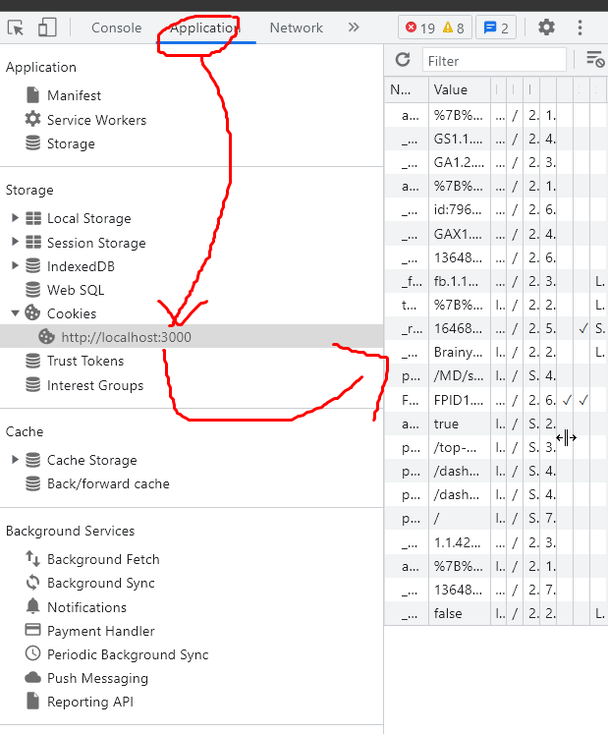

Added the cookies

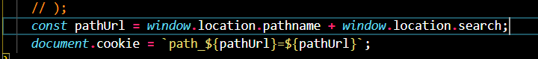

Here I added cookies for all the routes when user clicks or new page loads and stories them in the cookies storages as show in the above code

3. to extract the cookies from the cookies stories dynamically using javascript is show in the below photos ( don’t woory all the code is available in the github repo you can check)

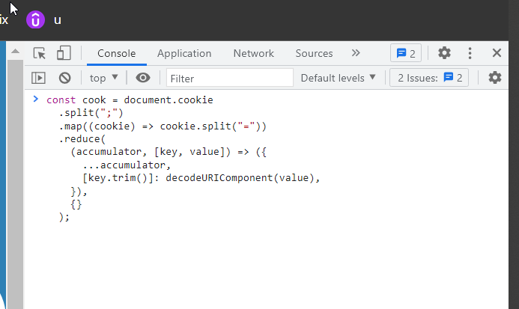

Output :

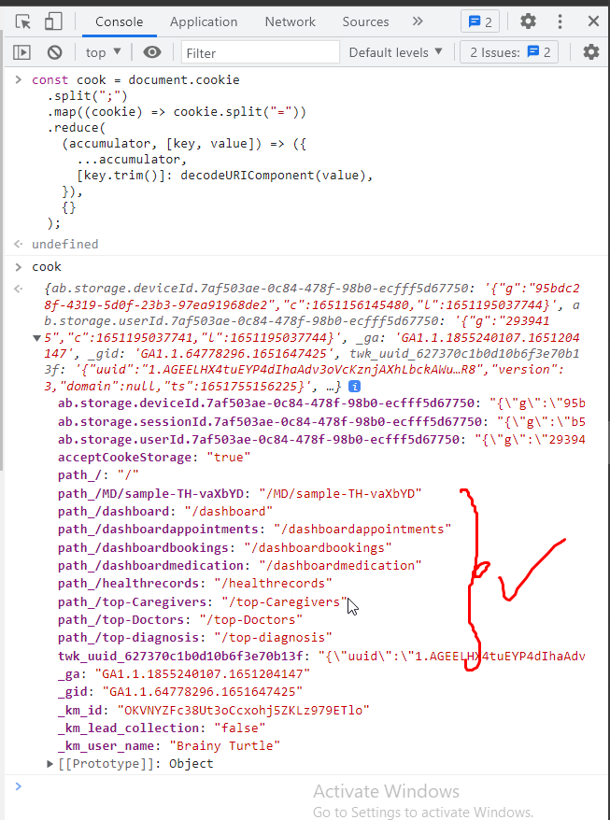

By these all these cookies are added to request header of post or get request from the browser

We can check it in our browser my opening the network tab in the header section as show in the photo  
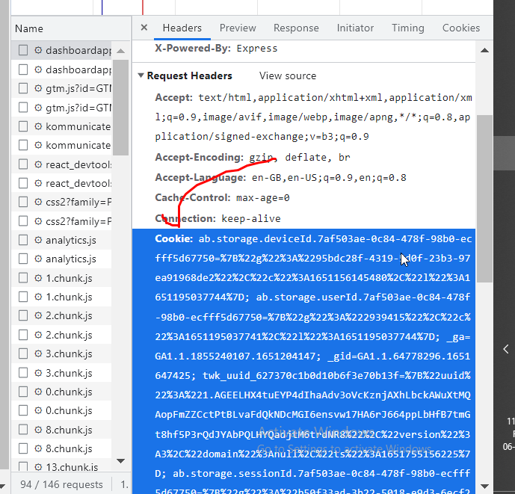

By these in the backend, we can collect these cookies and we can store them in our database and we can use these data what ever we like

OverAll Theme

1) 1st we ask the permission from the user whether is is willing to allow the website to accept the cookies, if user accepts, we continue to store the cookies

2) cookies are nothing but as we are programmer, we need to write manually cookies for each action like button click and page changes and etc... i.e all js events we collect and store in cookies

3) when we send the request to the domain(backend) then by default the cookies are added to request we need to store that cookies at backend ( which as all the infromation which we added on cookies)

4) we need to extract the cookies from the request Header

const cook **=** document**.**cookie

**.**split(";")

**.**map((cookie) => cookie**.**split("="))

**.**reduce(

(accumulator, [key, value]) => ({

**...**accumulator,

[key**.**trim()]: decodeURIComponent(value),

}),

{}

);

These above code will extract the cookies from the cookies storage in the browser, same logic also be implemented in backend also to extract the cookies from the response header

5) its overall same ga google analaitis but here we store in backend database anthi