**PYLO**

**Pylo Introduction**

Pylo connected health made easy and helps to achieving connected healthcare with secure and reliable cellular-connected patient devices, easy-to-use monitoring software, and a robust cloud API.

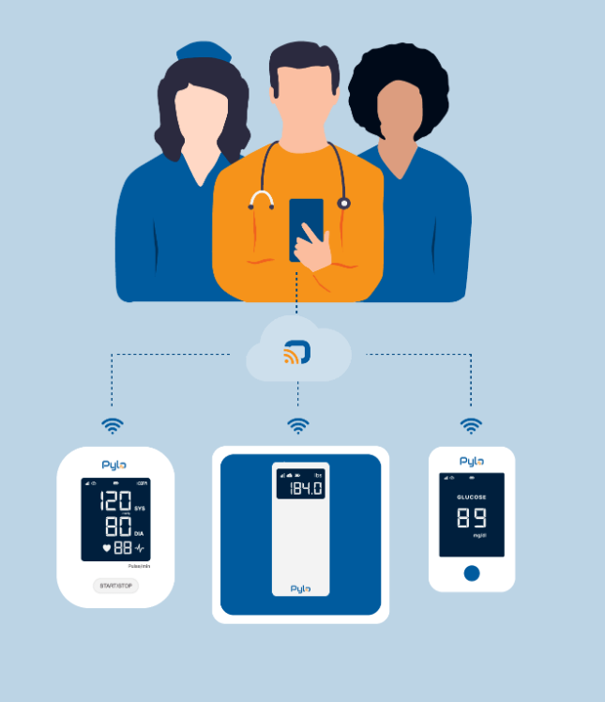

**Connecting Pylo**

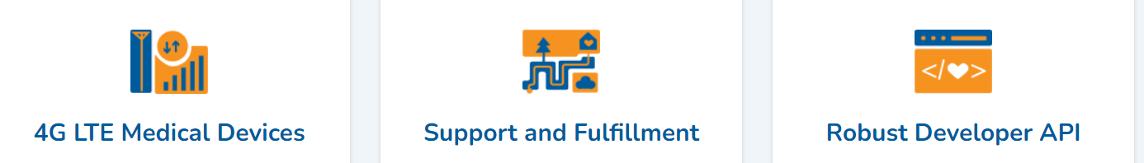

**4G LTE Medical Devices**

Cellular connectivity allows our devices to work out of the box without setup, pairing, or configuration.

**Support and Fulfillment**

Full-service option includes direct shipping to patients and providing initial training and support.

**Robust Developer API**

Comprehensive programming interface makes it easy to manage fulfillment and sends device readings to your EMR or other program in real time.

**We Deliver on Remote Patient Monitoring**



Pylo devices integrate seamlessly into medical practice workflow, allowing healthcare professionals to improve patient health outcomes and increase practice revenue while letting Pylo handle patient training and technical support.

**FOR HEALTH SYSTEMS**

There is extensive research showing strong benefits for remote monitoring by health systems. Pylo improves on the remote monitoring programs of the past to empower health systems to reduce readmission risk, improve disease management, and streamline care coordination without building a large training and logistics program.

**FOR INSURERS AND EMPLOYERS**

Telehealth technology is allowing insurance companies — including self-funded plans — to play an important role in the clinical management of their beneficiaries. Pylo allows insurers to own their own message with customized, branded patient device kits while letting Pylo handle the manufacturing, kitting, fulfillment, and connectivity.

**FOR PATIENTS AND CAREGIVERS**

Patients are increasingly expecting more telehealth options for convenience, continuity of care, and safety. Pylo increases patient engagement and care plan compliance while helping protect and monitor patient health and wellbeing.

**Pylo Secure**

**Secure and Compliant**

Our devices and API were not designed for consumers and then shoehorned into a medical setting. The Pylo team comes from a healthcare background, and our ecosystem was built from the ground up to exceed health security standards and regulations.

**Accurate and Reliable**

The Pylo ecosystem partners with the best device manufacturers and cloud computing services in the healthcare industry so that customers can rest assured that all patient measurements and other data is accurate, authenticated, and actionable.

**Contact Us**



**Contact Sales**

Our sales team is standing by to provide information about our devices and services as well as answer any questions you have about remote patient monitoring in general.

Email:sales@pylo.com

Phone/SMS: (818) 600-7161

**Contact Support**

If you need assistance with order tracking, patient kits, billing or other general topics, please contact our customer service team.

Customer Service: info@pylo.com

Phone/SMS:(818) 600-7162 (Option 1)

If you need assistance with our Pylo devices or API, please contact our technical support team.

Technical Support:support@pylo.com

Phone/SMS:(818) 600-7162 (Option 2)

**Pylo Devices**

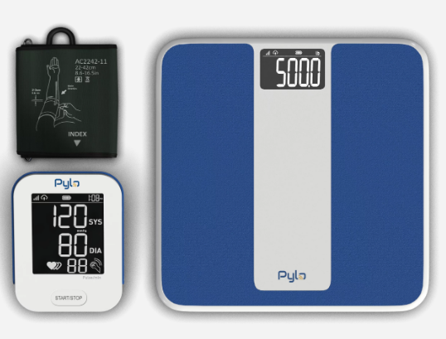

Blood Pressure Monitor (802-LTE)

Weight Scale Plus (300-LTE)

Weight Scale (200-LTE)

Pylo devices are the key to our connected health ecosystem. Each device has been designed to the latest industry standards of accuracy and security while minimizing the configuration and complexity for patients.

Our devices have one step to configure — just put the batteries in and go.

**Blood Pressure Monitor (802-LTE)**

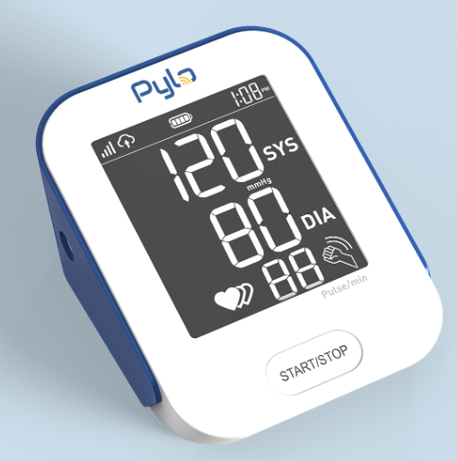

Millions of U.S. adults have high blood pressure, yet most do not have it under control. Research cited by the American Heart Association notes that remote cardiac monitoring can greatly reduce patient blood pressure compared to typical care and self-monitoring alone. The 802-LTE Blood Pressure Monitor makes remote blood pressure monitoring easy for patients, care providers, and developers.

**FEATURES:**

Clinically accurate systolic, diastolic, and heart rate readings

FDA 510(k) clearance

Direct LTE cellular connection

Irregular heartbeat detection

**Weight Scale Plus (300-LTE)**

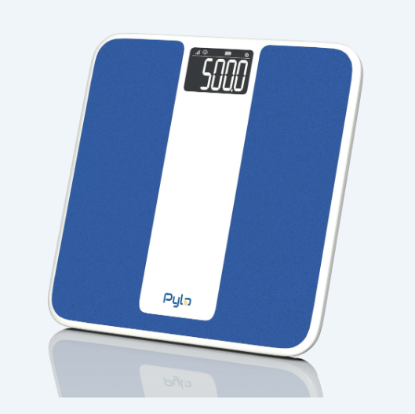

The 300-LTE is a clinically validated weight scale with a large form factor to minimize fall risk and supports patients up to 550 lbs.

**FEATURES:**

Weight readings accurate to 0.1 lbs.

FDA 510(k) clearance

Direct LTE cellular connection

Textured to decrease fall risk

**Weight Scale (200-LTE)**

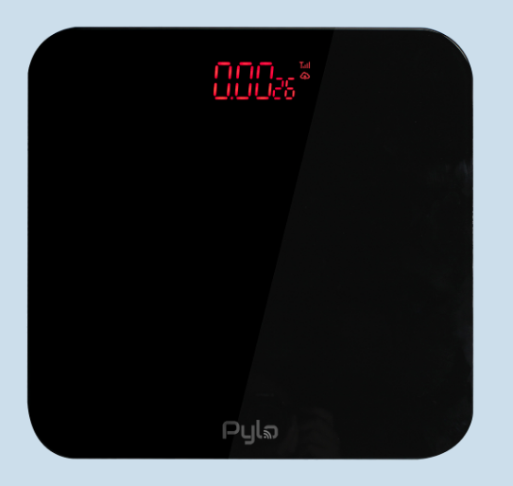

Coming soon in 2021

Pylo has also partnered with the best medical device creators to bring more functionality and device types to our platform.

Accurate, rapid deployment at any scale

**802-LTE Blood Pressure Monitor**

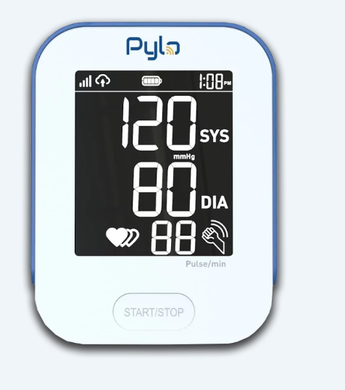

Blood Pressure, Connected

PY-802-LTE

Simple and accurate hypertension patient management, powered and secured by Pylo.

MEDICALLY ACCURATE

EASY TO USE

PRE-CONFIGURED

LTE CONNECTED

**802-LTE Blood Pressure Monitor**

With a single button to press, quick results, and automatic 4G wireless sync, the Pylo 802-LTE is the simplest way to manage patient blood pressure. Designed specifically for remote patient monitoring, the 802-LTE features enhanced accuracy and data security to provide real-time patient data that is actionable, secure, and authenticated.

**FEATURES AND SPECIFICATIONS**

Systolic, diastolic, and heart rate readings

Irregular heartbeat detection

Measurements synced via 4g network

Fda cleared and fcc certified

Comfortable universal cuff (22-42 cm)

Large backlit screen and long batterly life

**Why Remote Hypertension Monitoring?**

Millions of U.S. adults have high blood pressure, yet most do not have it under control. Since hypertension usually presents without symptoms, the only way to determine whether a patient has high blood pressure is to measure their blood pressure.

With ongoing remote monitoring of hypertension, cardiologists can make timely recommendations that better support heart-healthy living, such as changes to diet, exercise, and medication regimen.

Research cited by the American Heart Association notes that remote cardiac monitoring can greatly reduce patient blood pressure compared to typical care and self-monitoring alone.

**PY-300-LTE**

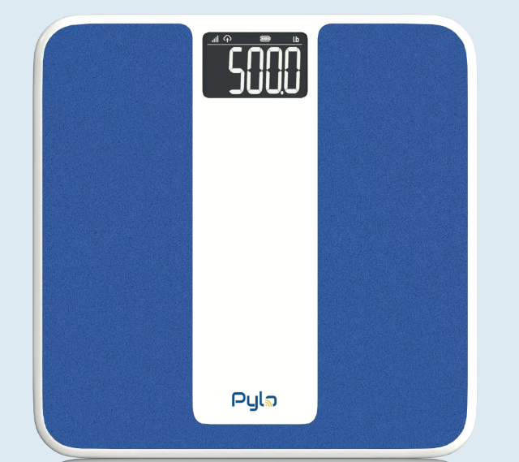

LTE Smart Scale Plus

PY-300-LTE

Clinically accurate management for weight and cardiovascular monitoring.

CLINICALLY VALIDATED

550-POUND CAPACITY

PRE-CONFIGURED

LTE CONNECTED

EASY TO USE

**Weight Scale Plus**

The 300-LTE brings clinically validated accuracy for finely tuned weight and heart failure monitoring. The 300-LTE has a large, textured standing and is accurate up to 550 pounds, allowing for easy use in a bariatric practice setting or when the fall risk of glass scales should be avoided.

Like all Pylo devices, the 300-LTE was designed specifically for remote patient monitoring. All patient data received is accurate, actionable, secure, and authenticated in real-time over the mobile network.

**FEATURES AND SPECIFICATIONS**

Weight measurements accurate to 0.1 lbs

Measurements synced via 4G network

Clinically validated, FDA cleared and FCC certified

Zero-configuration

Large backlit screen and long battery life

**Why Remote Weight Monitoring?**

The U.S. obesity problem gets a lot of attention, but it may be even worse than you realize. More than 42% of the American population was considered obese in 2017–2018 — a figure that is up from about 31% in 1999–2000. At the same time, the link between obesity and cardiovascular disease has never been clearer. Many cardiology practices now include weight management in their patient’s care plan to lower cholesterol, hypertension, and the risk of a cardiac event.

Ongoing monitoring of a patient's obesity can help ensure lifestyle changes intended to stabilize or reduce weight are proving successful and assess whether more aggressive measures, such as prescribing weight-loss medications or performing surgical procedures, are warranted.

A sudden or steady gain in daily weight (e.g., 2 to 3 pounds in 24 hours or 5 pounds over a couple of weeks) can indicate that the body is retaining fluid — a symptom of heart failure. In fact, patients can gain up to 10 pounds of "extra" weight from fluid before feeling bad or experiencing swelling.

With remote patient monitoring, cardiologists are alerted of such cardiac decompensation, allowing a fast response that can help reduce the condition and likelihood of hospitalization or critical care. Daily weight monitoring is frequently cited as one of the cornerstones for effective congestive heart failure (CHF) management.

**Pylo 200-LTE**

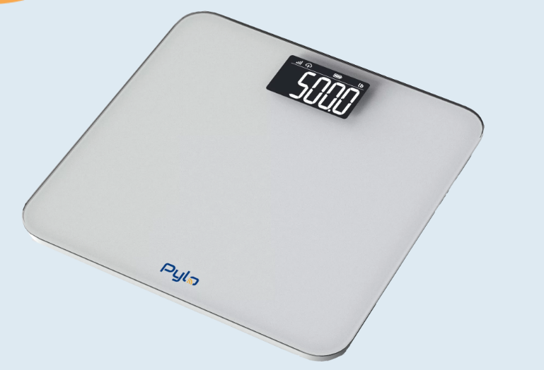

LTE Weight Scale

PY-200-LTE

Simple and accurate weight patient management powered and secured by Pylo.

COMING IN Q4 OF 2022

MEDICALLY ACCURATE

EASY TO USE

PRE-CONFIGURED

LTE CONNECTED

**Weight Scale Plus**

The Pylo 200-LTE is our smaller and economical LTE weight scale. It is perfect for rapidly expanding medical weight loss, hypertension or other remote monitoring programs.

Be sure to check back here for more information!

**Custom Patient Kits, Delivered.**

Pylo empowers our partner organizations with custom patient kits and managed fulfillment services to provide technology and personalized tools directly to your patient population.

**About the kits**

**Customized Design**

Kits customized to meet the needs of your patients. Our kits include our connected devices and all the tools needed to maximize patient buy-in, ongoing engagement, and compliance.

**Connected Devices**

Each patient kit includes one or more of our Pylo LTE connected devices pre-configured to send remote monitoring measurements back to your organization when used.

**Fulfillment Services**

Logistics surrounding patient kits can be complicated, but Pylo makes it easy. Kits can be delivered to your organization or directly to patients with the click of a button.

**How it Works**

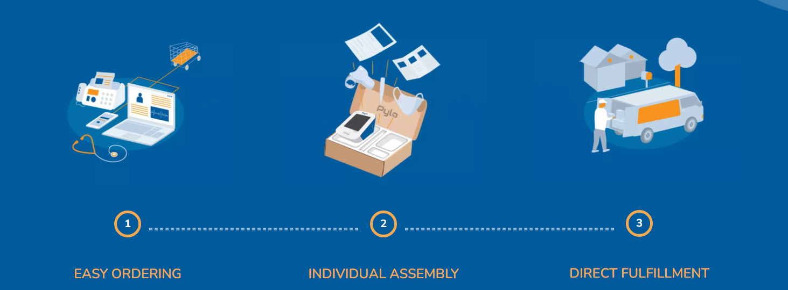

**EASY ORDERING**

Seamless ordering via the Pylo store, our API, or your EMR.

**INDIVIDUAL ASSEMBLY**

Tailor each kit with patient-specific care plans, educational materials, and instructions.

**DIRECT FULFILLMENT**

We ship to your organization or directly to patients and handle technical support and returns, as needed.

**HIPAA Compliant Fulfillment**

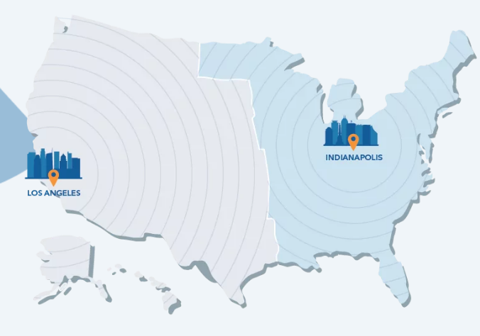

Not all fulfillment centers are created equal - especially when it comes to shipping to patients. We could not find a third-party fulfillment center that knew HIPAA like we did, so we built two of our own. This way, you can rest assured that your patient data is safe and covered under your business associate agreement with Pylo.

**Knowledge Base**

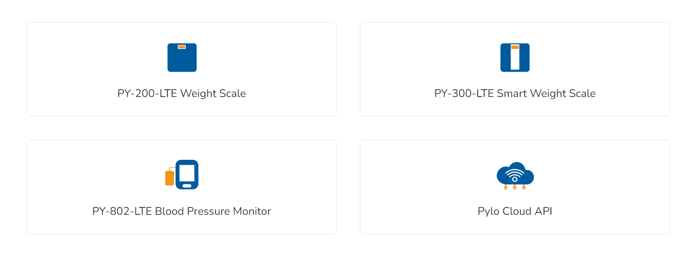

**PY-200-LTE Weight Scale :**

**PY-300-LTE Smart Weight Scale :**

**PY-802-LTE Blood Pressure Monitor**

Quick-Start Guide

LTE Blood Pressure Monitor(PYLO 802-LTE)

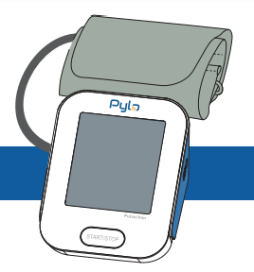

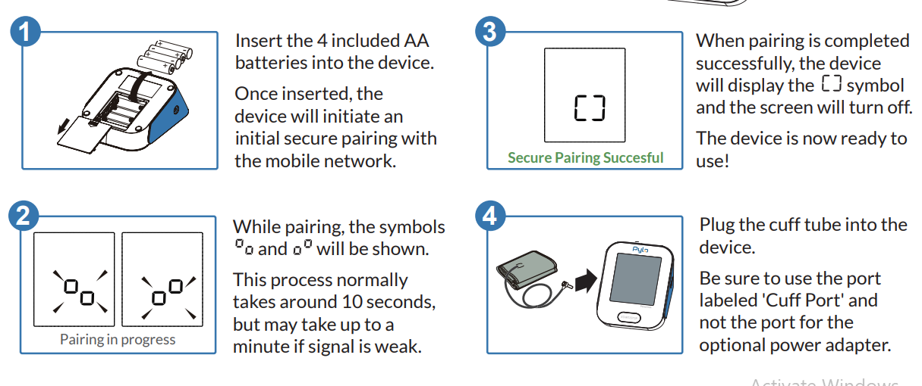

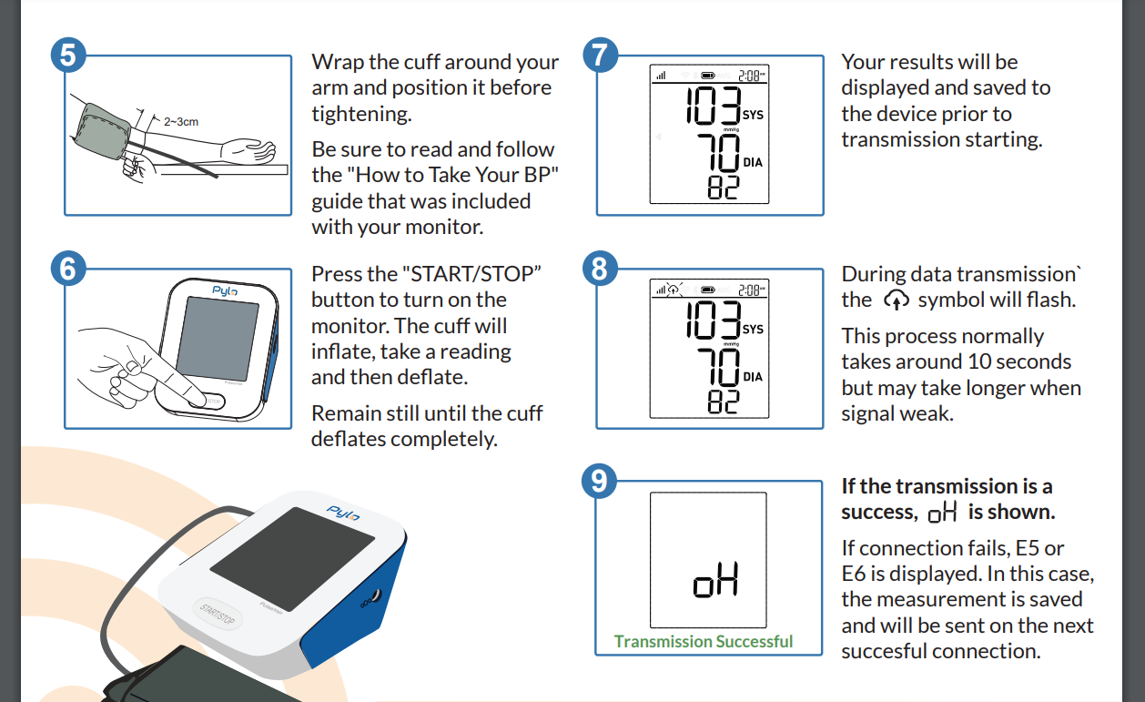

**LTE Blood Pressure Monitor PY-802-LTE**

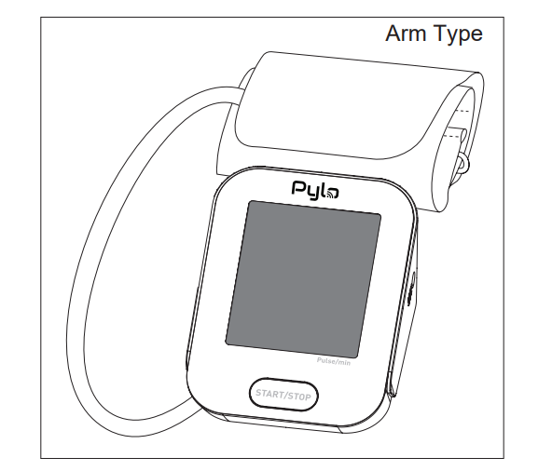



**Pylo API Developer Portal**

The gateway to your remote patient monitoring ecosystem.

To use any of our APIs you must have a developer account. If you are a current Pylo customer and need an account, contact us at api@pylo.com. A developer account provides an API Key for accessing our APIs, a playground for testing our APIs, and API usage metrics. With an account, you can sign in using the buttons on the top right.

Once an account is created, you need to connect your key to the APIs you want to access. To do this, navigate to APIs and find the API you want and click subscribe. Your API Key is now subscribed to the API and you can make calls to its methods. You can also set up your webhook endpoints and which notification events you want to subscribe to.

Depending on the API configuration, subscribing to one API may subscribe you to several APIs. These APIs may have related functionality or share a pricing plan. Requests against any of them will be counted together in your usage.

You can use the “Try it out!” feature to get examples of the request and response shapes of our APIs. This makes an API call to the backend service using your API Key and provides a sample curl request with all necessary input parameters and the real response.

If you need your API Key for any reason, you can always find it on your dashboard after logging in.

**Monitor your usage**

As you scale up your usage of the APIs, you can monitor your usage towards any limits on your dashboard. If you see that you are coming up on a limit, be sure to let us know so we can increase your quotas!

**API**

Our Connected Health API

Whether you are looking for easy access to patient readings or a comprehensive device management platform, the Pylo API is the easiest way to integrate cellular (LTE) remote patient monitoring into any health application or management system.

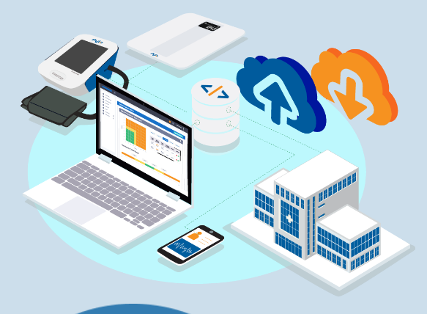

Management for our RPM Ecosystem

**RESTful**

Enables easy connectivity with a wide realm of remote devices using a standardized JSON format and an intuitive developer portal.

**Reliable at Scale**

Serverless architecture via AWS provides consistent reliability, infinite scalability, and industry-leading security.

**Serious Security**

The Pylo API was built specifically for healthcare. Its fully HIPAA-compliant workflow and architecture follows the latest common security framework.

**Powerful Management For Remote Care**

**EVENT NOTIFICATION WEBHOOKS**

Real-time webhook notifications push patient measurements, device changes, and shipping updates directly to your chosen endpoints.

**QUERYABLE REST API**

Intuitive HTTPS can be used to query patient measurements, manage devices, and order patient kits.

**INTUITIVE DEVELOPER PORTAL**

A well-documented developer portal with quick guides for common use cases gets your RPM program up and running in days, not weeks.

**WANT TO TAKE A LOOK UNDER THE HOOD?**

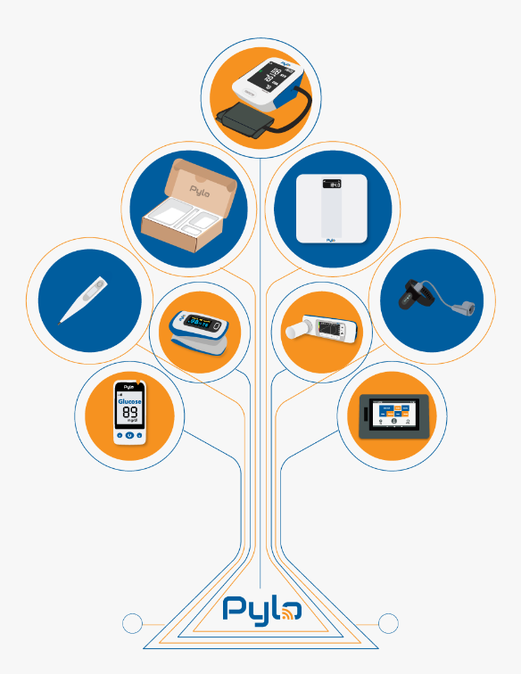

**Introduction**

Welcome! On this page you can learn how to use the Pylo API and webhooks.

Here is a summary of the services we offer:

**Devices Service**: API service where you can get information about devices currently possessed by your company.

**Readings Service**: API service where you can get device measurement readings.

**Fulfillment Service**: API service where you can place orders and get order status.

**Webhooks**: Webhooks enable you to subscribe your application to our system so that it can be notified when new measurement readings have been received.

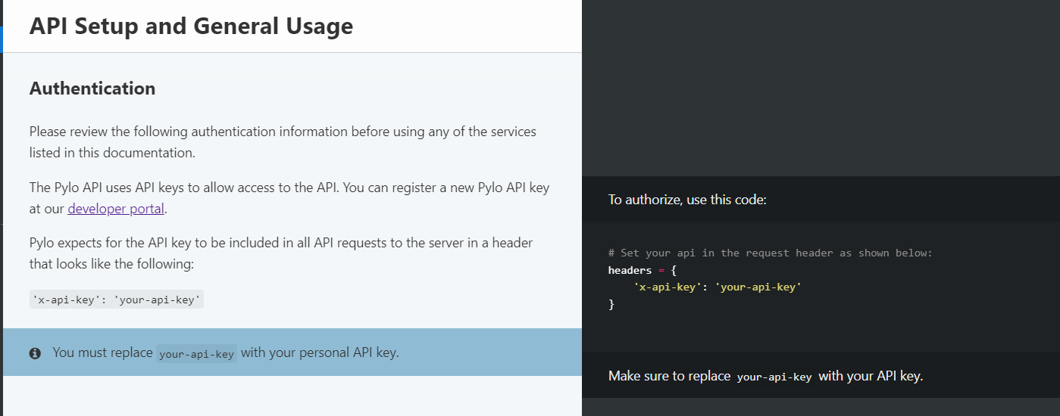

these is the api setup and how to send the request to the pylo port by setting the header as shown in the photo and for more information you can check out the pylo website

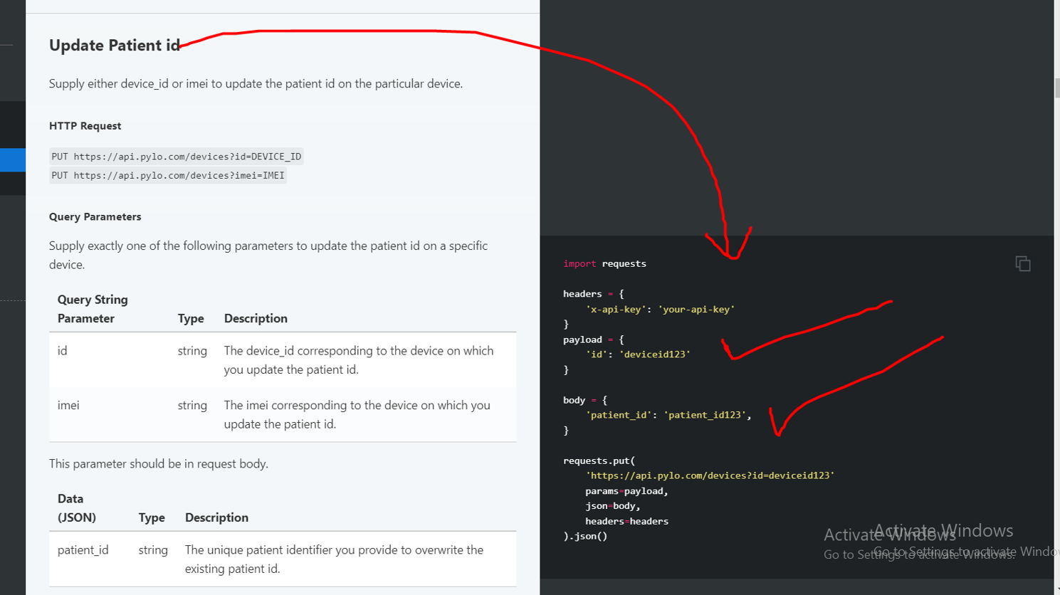

we can set and change the user id by sending a post request to the pylo website as shown in the photo and for more information you can check out the pylo website

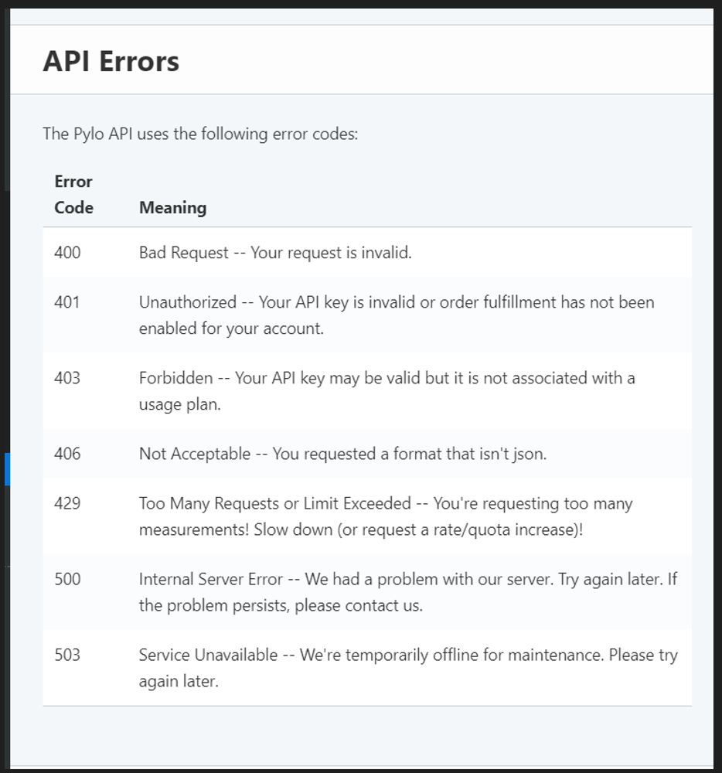

these is the status code of the pylo api, when we call there api , we get these status code from the pylo apis

**Webhooks**

**Overview**

Pylo webhooks can be used to notify applications when measurements are taken.

**Delivery Information**

Webhooks will be sent as POST requests.

Hooks will be sent immediately after a measurement is taken.

Failed deliveries are resent 15 minutes, 1 hour, 3 hours, 8 hours, and 24 hours after the initial attempt.

If all delivery attempts fail, an alert is generated for the Pylo team to follow up within 24 hours.