Worked Problems with Equations Pasted as Pictures

Fractions Inside Sentences
Fractions that sit inside a sentence were pasted from an equation editor as small pictures.
The mean of 18 equal parts of a total T is 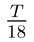.
Dividing both sides by 7 gives 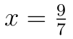.
The common denominator of 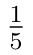 and 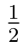 is their product when the numbers share no factor.
Multiplying 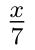 by 7 removes the denominator and leaves the single letter x.
To compare 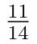 with 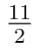, cross-multiply and compare the two products.
The average rate of change over the interval is 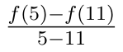.
Two pipes together fill 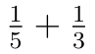 of the pool in one hour.

Determinants and Matrices
Arrays of numbers were pasted the same way, one picture for each display.
The determinant of a two by two matrix is the product of the diagonal entries minus the product of the others:
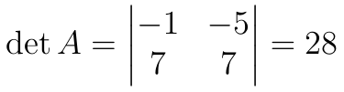 (2.1)
Expanding along the first row gives the determinant of a three by three matrix:
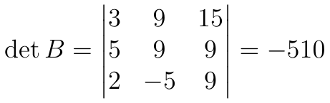
Scaling entries scales the terms of the determinant:
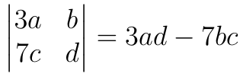
The characteristic condition below is a quadratic equation in x:
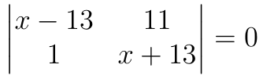 (2.2)
Cramer's rule writes each unknown as a ratio of determinants:
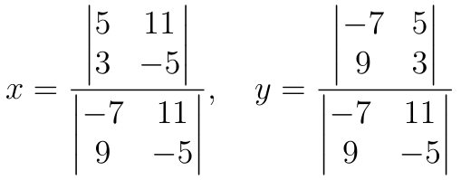
Vertical bars around an array also denote the determinant:
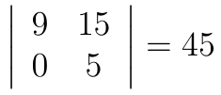
Transposing a matrix swaps its rows and columns:
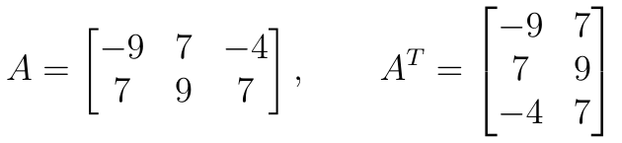
A matrix times a column vector gives another column vector:
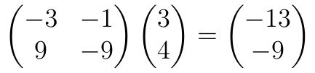 (2.3)
The inverse of a two by two matrix uses the determinant and swaps entries:
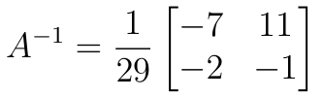
The augmented matrix of a system keeps the right-hand side beside the coefficients:
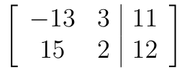
A three by three system gives an augmented matrix with one extra column:
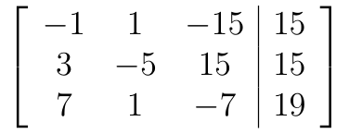 (2.4)
Row operations turn the left block into the identity and read off the solution:
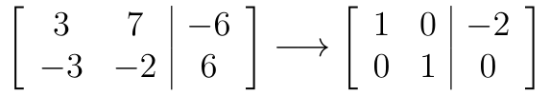

Systems and Cases
Braces and cases are pictures too, so the text layer holds none of their symbols.
Solve the system of equations by elimination:
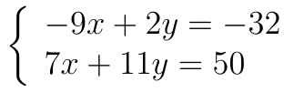
Find every pair of numbers that satisfies the system:
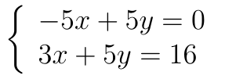 (3.1)
Use substitution to solve the following system:
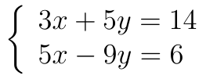
Determine the values of the unknowns in the system:
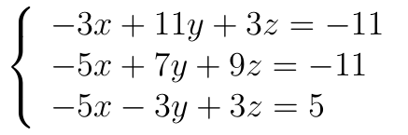
A function is defined in pieces:
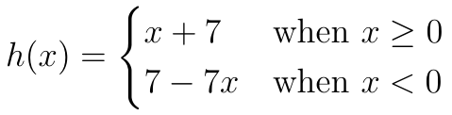
A function is given by cases:
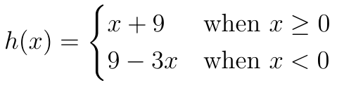
A function is defined in pieces:
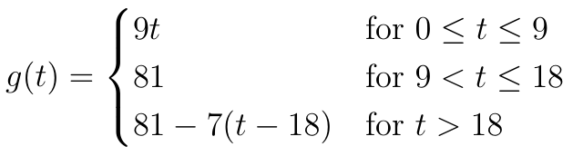 (3.2)
A function is given by cases:
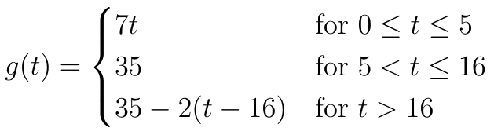

Derivations and Other Displays
The last group holds longer displays, some of them numbered at the right margin.
Isolating the unknown takes three short steps:
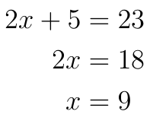 (4.1)
Completing the square solves the quadratic in four steps:
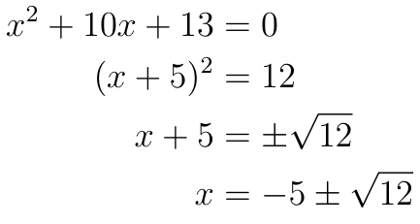
The power rule is applied term by term:
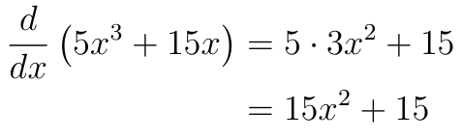
Matching bases turns an exponential equation into a linear one:
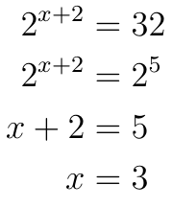
A further result is displayed below:
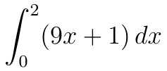
A further result is displayed below:
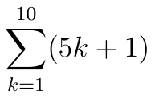
A further result is displayed below:
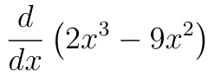
A further result is displayed below:
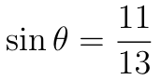

Summary of Results
Quantity | Value | Unit
Distance | 12 | m
Acceleration | 1.5 | m/s²
Density | 0.072 | g/cm³
Area | 44 | cm²

Handout Details
Return the sheet. Hand in the answers on Friday at the start of class. | Questions. Ask during office hours or write them on the board before the lecture.

