create database info;
use info;
create table person (driver_id varchar(10),
name varchar(20),
address varchar(30),
primary key(driver_id));

create table car(reg_num varchar(10),model
varchar(10),year int,primary key(reg_num));

create table accident(report_num int,accident_date
date,location varchar(20),primary key(report_num));

create table owns(driver_id varchar(10),reg_num
varchar(10),primary key(driver_id,reg_num),
foreign key(driver_id) references person(driver_id),
foreign key(reg_num) references car(reg_num));

create table participated(driver_id
varchar(10), reg_num varchar(10),
report_num int, damage_amount int,
primary key(driver_id,reg_num,report_num),
foreign key(driver_id) references person(driver_id),
foreign key(reg_num) references car(reg_num),
foreign key(report_num) references accident(report_num));

desc person;
select *from person;
select *from car;

select *from car;
insert into accident
values(11,'2003-01-01','Mysore Road');
insert into accident
values(12,'2004-02-02','Southend Circle');
insert into accident
values(13,'2003-01-21','Bulltemple Road');
insert into accident
values(14,'2008-02-17','Mysore Road');
insert into accident
values(15,'2005-03-04','Kanakpura Road');
commit;
select *from accident;
insert into owns values('A01','KA052250');
insert into owns values('A02','KA053408');
insert into owns values('A03','KA095477');
insert into owns values('A04','KA031181');
insert into owns values('A05','KA041702');
commit;
select *from owns;
insert into participated
values('A01','KA052250',11,10000);
insert into participated
values('A02','KA053408',12,50000);
insert into participated
values('A03','KA095477',13,25000);
insert into participated
values('A04','KA031181',14,3000);
insert into participated
values('A05','KA041702',15,5000);
commit;

TABLES

Accident Table

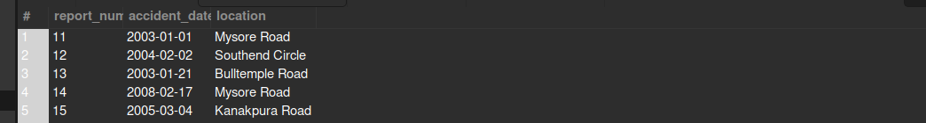

CAR Table
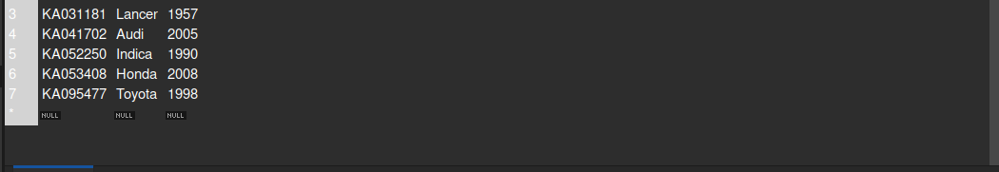

Owns Table

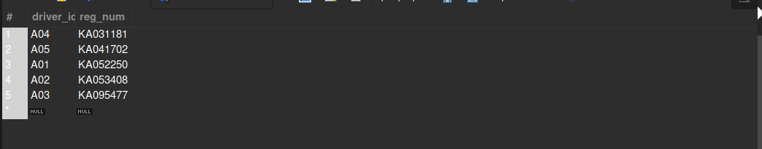
participated Table

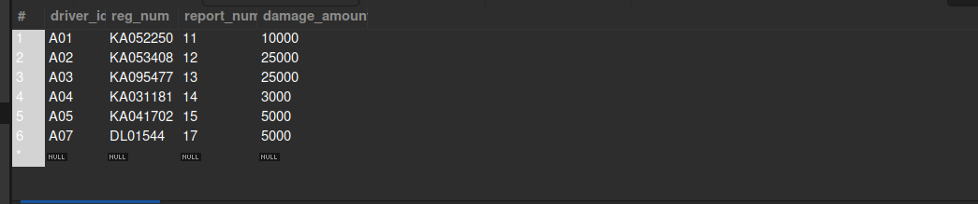

Person Table

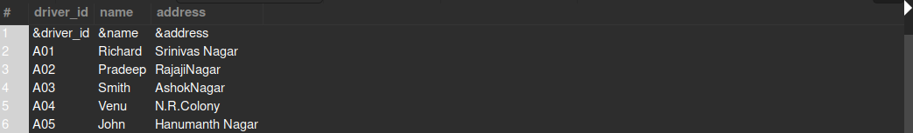

QUERIES

-- Update the damage amount to 25000 for the car with a specific reg-num(example 'KA053408')
-- for which the accident report number was 12.

update participated set damage_amount=25000 where report_num=12 and reg_num='KA053408';
select * from participated;
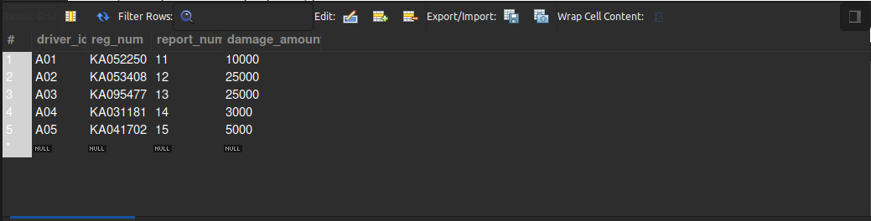

-- Add a new accident to the database.

insert into accident values(17,'2012-03-04','Lodhi Road');
insert into person values('A07','Shabaz','Nizzamudin');
insert into car values('DL01544','Dzire', 2009);
insert into participated values('A07','DL01544',17,5000);
select * from accident;

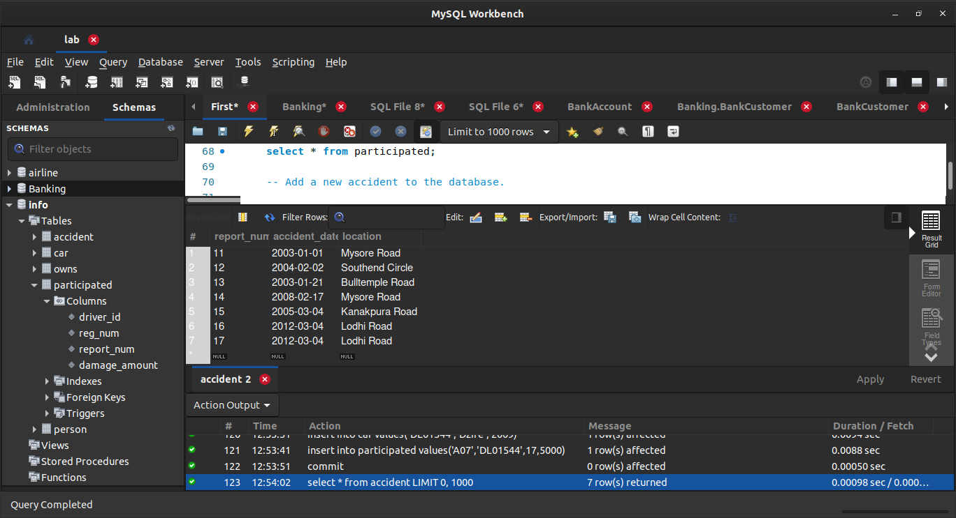

-- Find the total number of people who owned cars that involved in accidents in 2008.

select count(driver_id) from participated p,accident a where
a.accident_date like '2008%' and p.report_num=a.report_num;
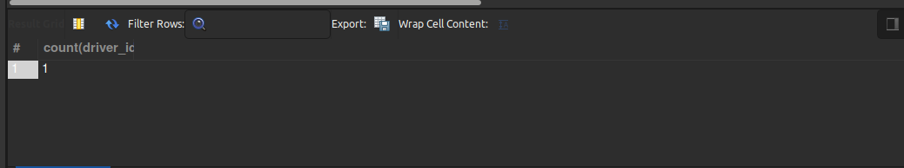

-- Find the number of accidents in which cars belonging to a specific model (example ‘Toyota’)were involved.

select count(*) from car c,participated p where c.reg_num=p.reg_num and c.model='Toyota';

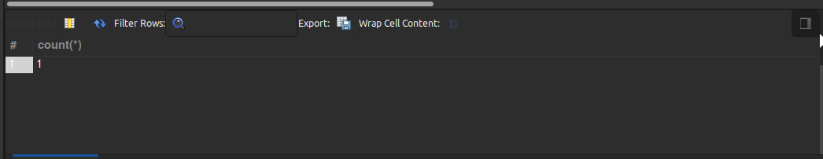

HARISH SINGH MEHRA

