Assignment | Reattempt_Skill Test 2
Skill Test - 2 Reattempt Container Orchestration
https://github.com/harishmsgit/Blue-green-Deployment/

Part 1: Local Deployment:
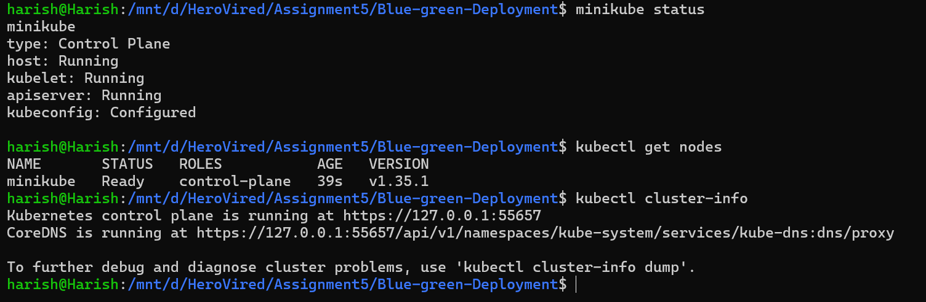

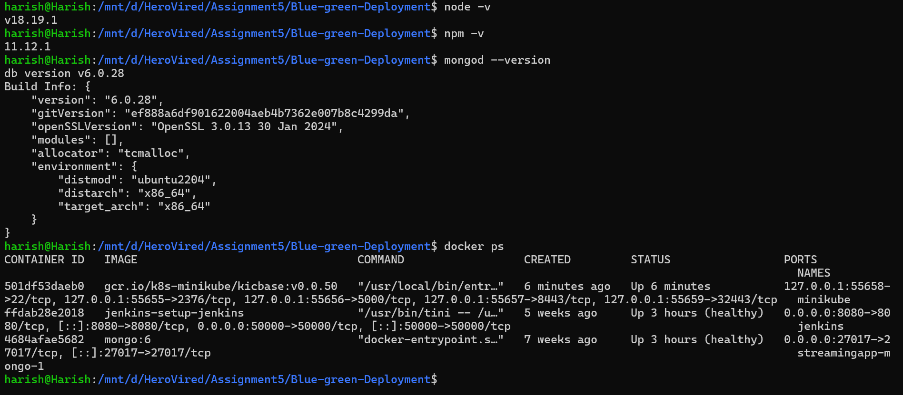

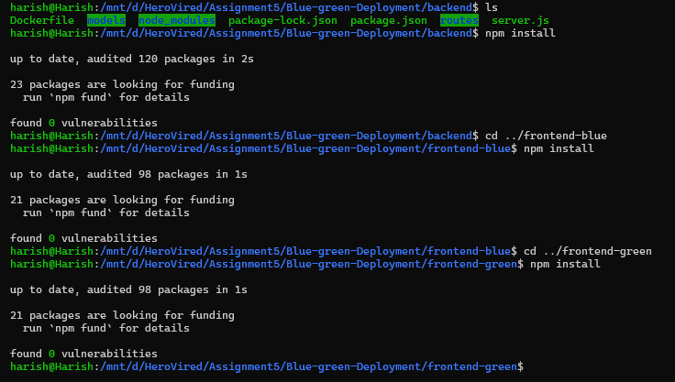
Part 2: Containerization:
docker compose down
docker compose up -d –build
docker compose up -d --build --force-recreate
docker-compose build backend
docker-compose build frontend-blue
docker-compose build frontend-green

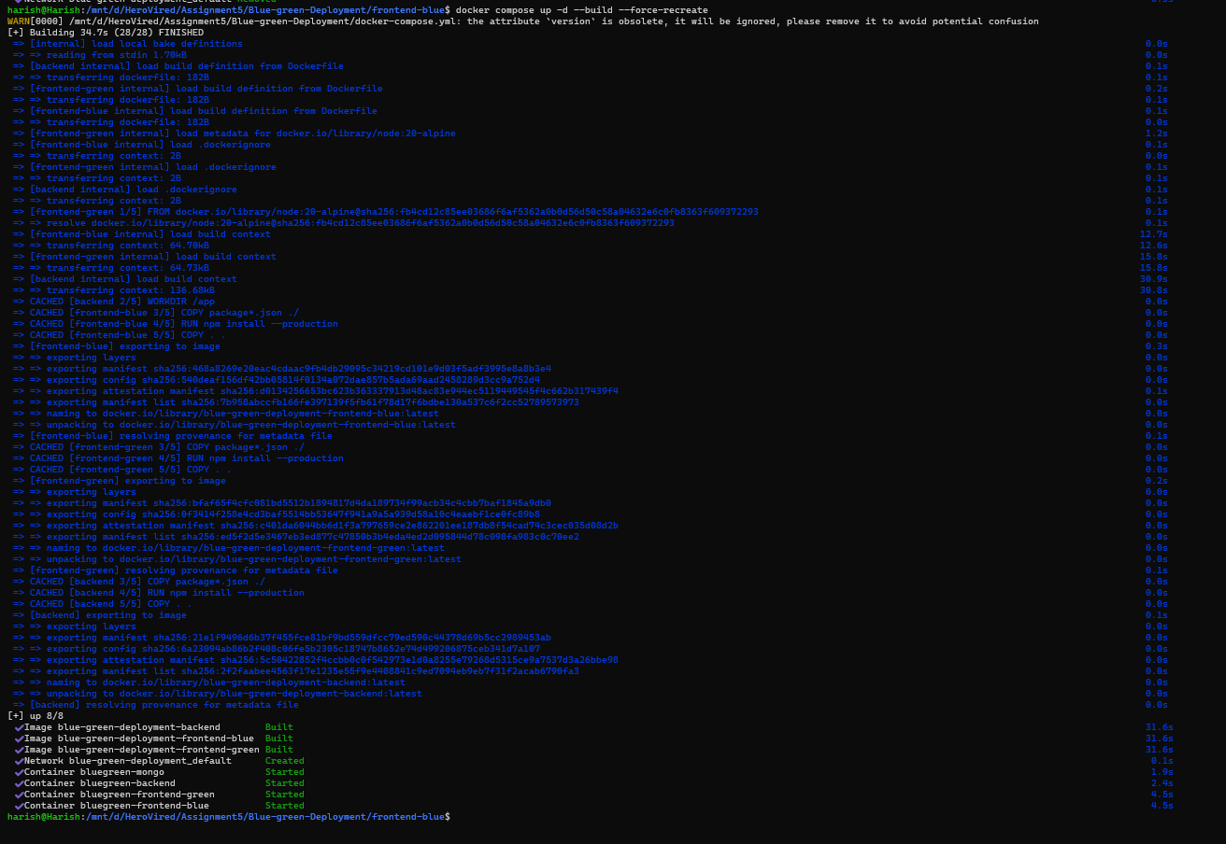

Start Application:
Access services:
- Frontend Blue → http://localhost:3001
- Frontend Green → http://localhost:3004
- Backend → http://localhost:3003/health
- MongoDB → mongosh --port 27018
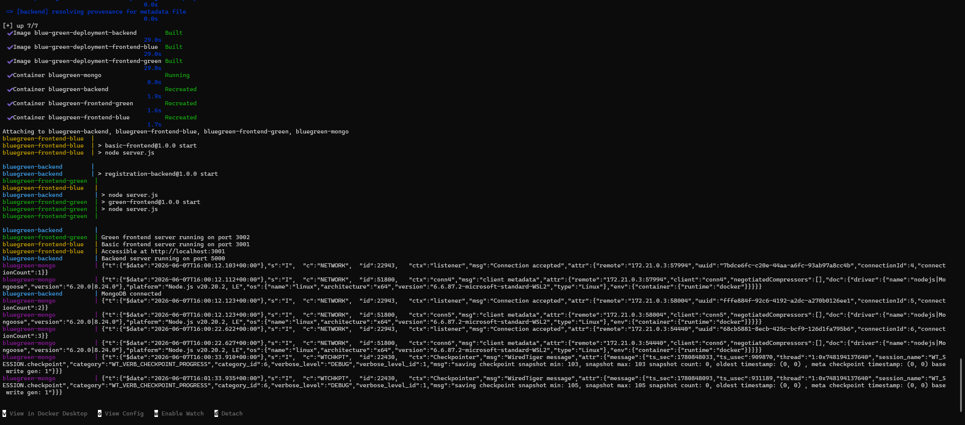

Backend:

UI:
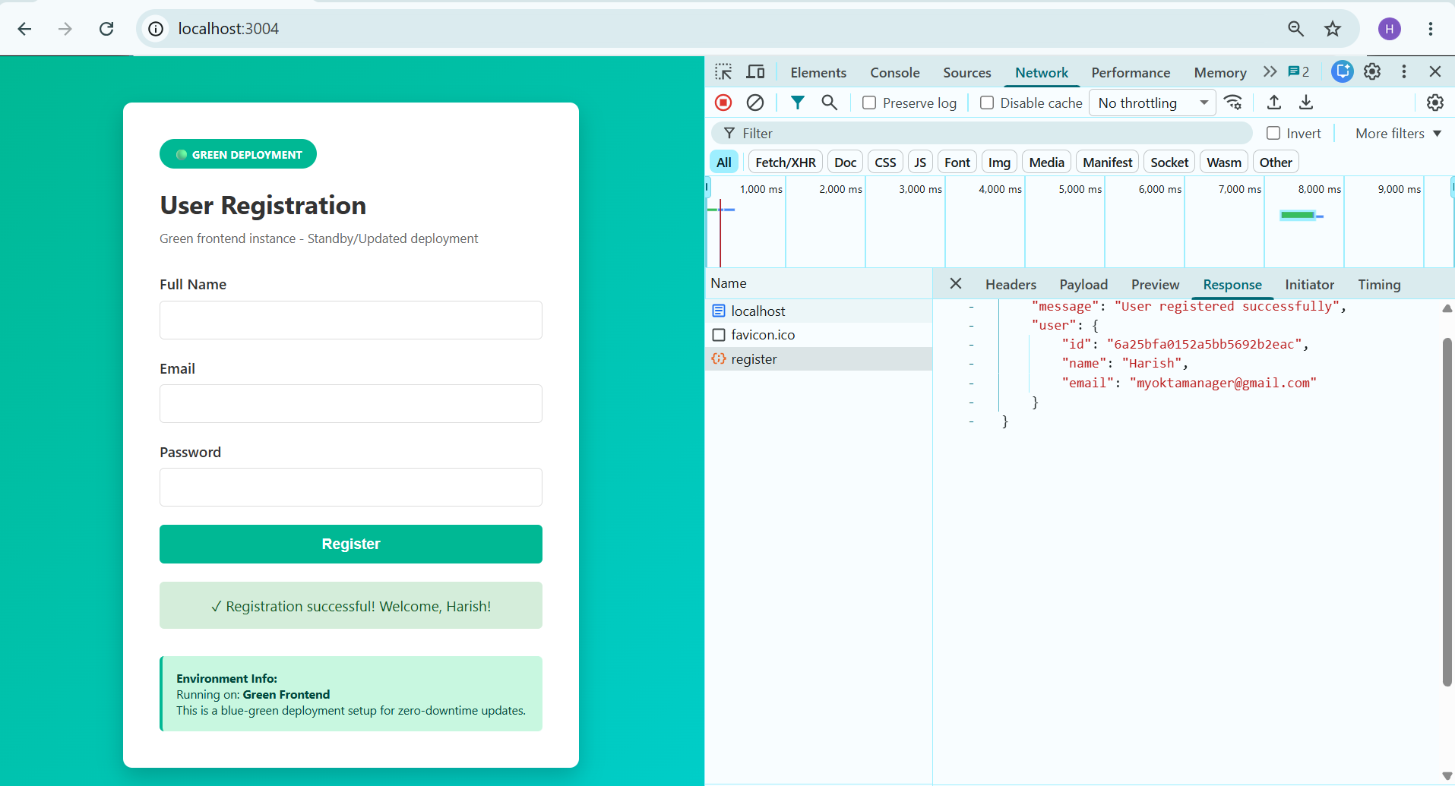

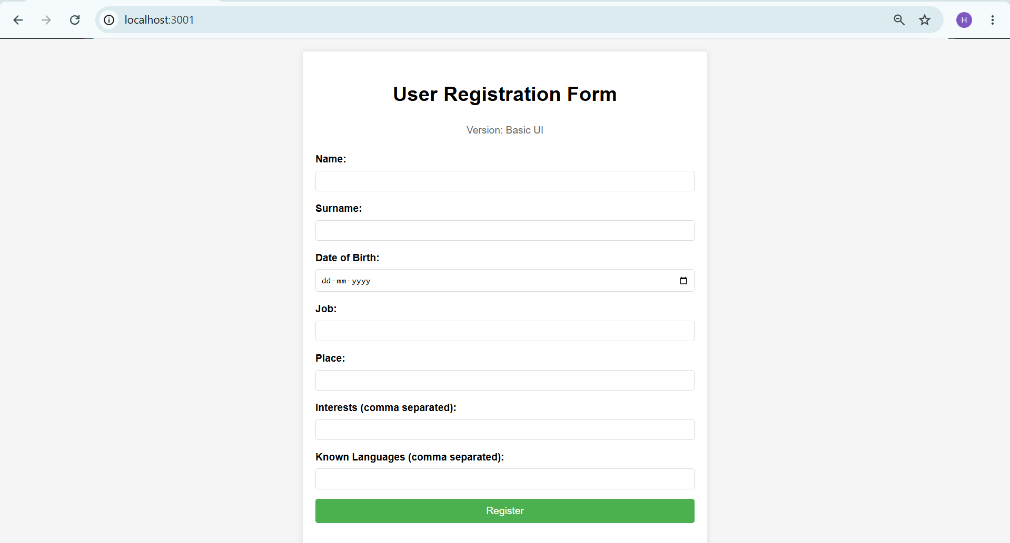

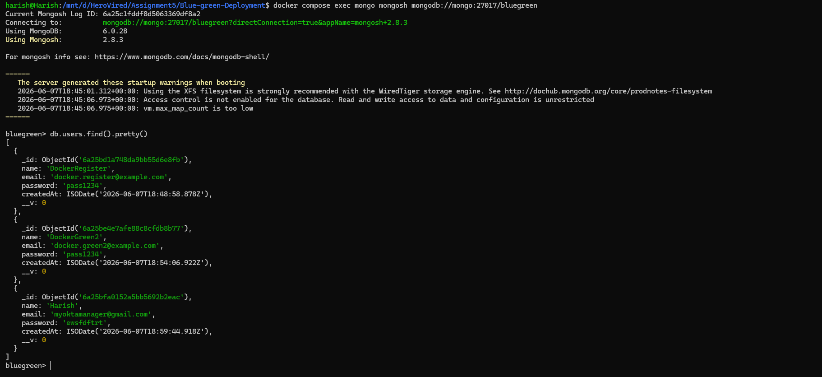

Part 3: Kubernetes Deployment
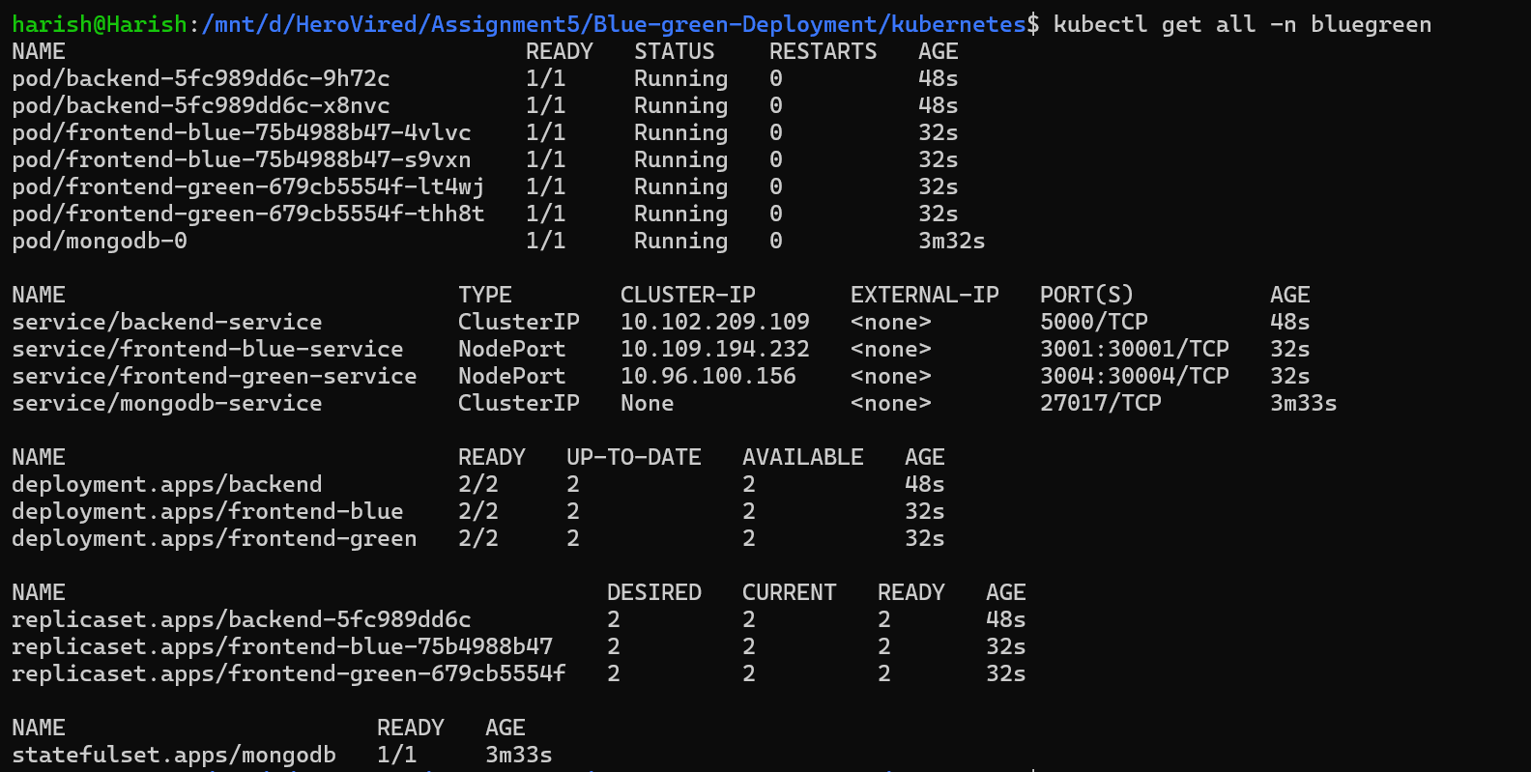

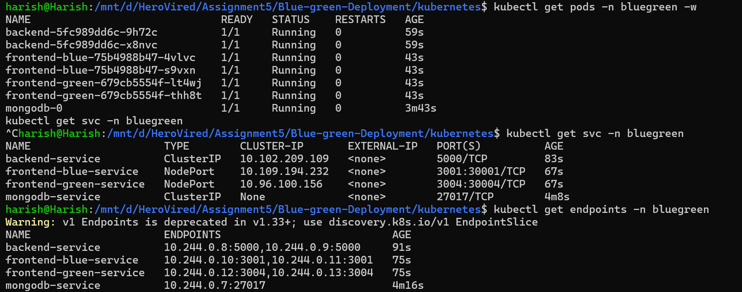

Part 4: Blue-Green Deployment Implementation
Blue-Green Deployment is a release strategy that **eliminates downtime and enables instant rollback** by running two identical production environments simultaneously. Only one receives traffic at any time. New versions deploy to the idle environment, get validated, then traffic switches instantly.
**In One Sentence:** Two production environments (Blue & Green), only one active at a time, switch with zero downtime.
## 📋 DEPLOYMENT CHECKLIST
### Before Switching to Green
- [ ] Green pods are 1/1 Ready
- [ ] Green /health endpoint responds
- [ ] All features tested in Green
- [ ] Load testing completed
- [ ] Security validation passed
- [ ] Database compatibility verified
- [ ] API response times acceptable
- [ ] Error rates are 0%
- [ ] Blue still stable (no unrelated issues)

### After Switching to Green

- [ ] Monitor error rates (next 1 hour)
- [ ] Monitor response times
- [ ] Check user feedback channels
- [ ] Verify database performance
- [ ] Confirm no data corruption
- [ ] After 6+ hours, declare stable
- [ ] After 24 hours, can retire Blue

### Before Retiring Old Version

- [ ] Green has run stable for 24+ hours
- [ ] Zero issues reported
- [ ] Rollback no longer needed
- [ ] Then: kubectl delete deployment frontend-blue

