# **Disparity Map Estimation Using SAD and SSD**

**Institute for Parallel and Distributed Systems, IPVS, University of Stuttgart**

Harish Neerthadi Gowdru: 3507225, st172064@stud.uni-stuttgart.de

Adarsh Palyam Satish: 3574740, st180155@stud.uni-stuttgart.de

Hithesh Chandra Chandrashekaraiah: 3506857, st172677@stud.uni-stuttgart.de

Course Instructor: Gasim Mammadov, M.Sc. (gasim.mammadov@cis.iti.uni-stuttgart.de)

1. **Project Overview**

Finding the pixels in the several perspectives that belong to the same 3D point in the scene is known as disparity estimation. Block matching algorithm is used to estimate the disparity map using sum of absolute difference (SAD) and sum of square differences (SSD) methodology. Image dimensions are hardcoded (countX, coutnY) as calculating the disparity map estimation was not successful with the dimensions of images calculated during readImagePGM call. Window size of 17 was chosen after examining the output of the algorithm with multiple window sizes and considering low noise factor. Disparity Max is set to 70 to get the ideal grey scaled disparity map considering the values in the range 0-255.

Implementation is available in the following GITHUB repo: [link](https://github.com/harishngowdru/GPU_LAB_UniStuttgart_SS2022)

1. **Results**

Input Image:

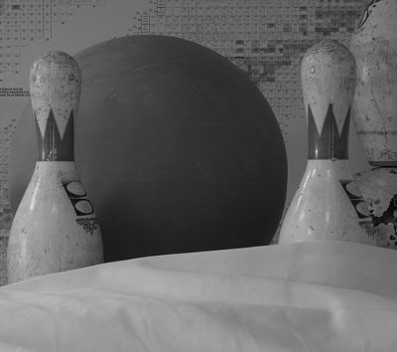 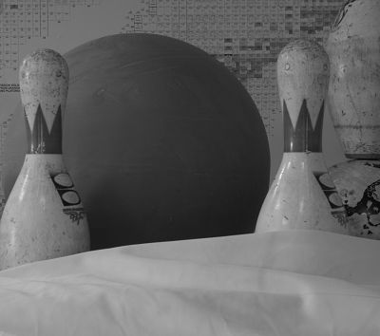

Left Image Right Image

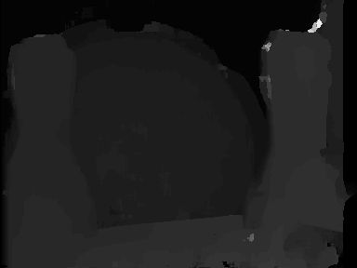 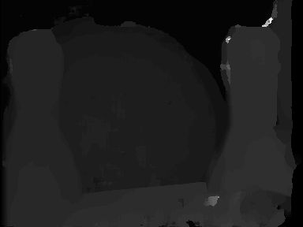

Disparity Map SAD Output GPU Disparity Map SSD Output GPU

 

Disparity Map SAD Output CPU Disparity Map SSD Output CPU

Performance results on NVIDIA and AMD

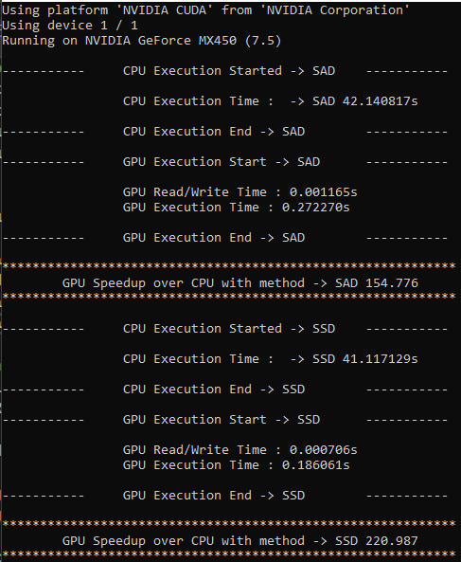 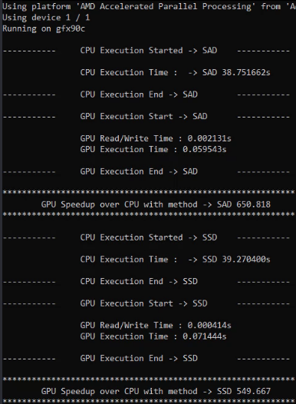

Performance on NVIDIA Performance on AMD

Dedicated AMD GPU has outperformed the basic NVIDIA GPU.

In both GPU’s, CPU performance is very low it doesn’t have parallel processing.

1. **Work Breakdown of Team Members**

Tasks achieved from the team

* Task 1: Understanding the problem and literature research
* Task 2: Deciding and implementing logic for CPU SSD/SAD
* Task 3: Deciding and implementing logic for GPU SAD/SSD
* Task 4: Analysing the output and writing the report
* Task 5: Regular Debug sessions
* Task 6: Analysing the performance on AMD GPU

Team worked collectively to achieve the results. Tasks were divided amongst the team and regular debug sessions were scheduled to discuss the issues and find fixes.

Task 1 was done together to understand the problem and possible ways of solving the problem. Task 2 to 5 was looked together and then divided between the team members for implementation. Contribution towards report were done based on the tasks assigned. Finally, team members had regular sync sessions to decide on the progress and resolve errors.

|  |  |
| --- | --- |
| Team member | Task Number |
| Harish Neerthadi Gowdru | 1,5,2 |
| Adarsh Palyam Satish | 1,5,3,6 |
| Hithesh Chandra Chandrashekaraiah | 1,5,4 |

1. **References**

[1] Hwang, Jae Jeong & Wu, Hong Ren. (2011). Stereo Image Quality Assessment Using Visual Attention and Distortion Predictors.TIIS. 5. 1613 1631.

[2] <https://en.wikipedia.org/wiki/Sum_of_absolute_differences>

[3] <http://mccormickml.com/2014/01/10/stereo-vision-tutorial-part-i/>

[4] Gasim Mammodov, sobel filter and Opencl, High Performance Programming with Graphic Cards Lab Course

[5] Hamzah, Rostam Affendi, S. Fakhar Abd Ghani, A. Fauzan Kadmin, M. Saad Hamid, S. Salam, and T. M. Faisal T. Wook. 2017. “Disparity Map Estimation Uses Block Matching Algorithm and Bilateral Filter.” IEEE Xplore. October 1, 2017. https://doi.org/10.1109/ICITSI.2017.8267934.

[6] <https://vision.middlebury.edu/stereo/data/scenes2003>

[7] R. A. Hamzah, S. F. A. Ghani, A. F. Kadmin, M. S. Hamid, S. Salam and T. M. F. T. Wook, "Disparity map estimation uses block matching algorithm and bilateral filter," 2017 International Conference on Information Technology Systems and Innovation (ICITSI), 2017, pp. 151-154, doi: 10.1109/ICITSI.2017.8267934.

[8] Lakshmi, Nithya. 2017. “IMPLEMENTATION of SAD ALGORITHM for MOTION ESTIMATION.” http://ijariie.com/AdminUploadPdf/IMPLEMENTATION_OF_SAD_ALGORITHM_FOR_MOTION_ESTIMATION_ijariie4555.pdf.