Application gateway – Load Balancer

Azure Application Gateway gives you application-level routing and load balancing services that let you build a scalable and highly-available web front end in Azure. You control the size of the gateway and scale your deployment based on your needs.

1. Create a dedicated subnet in virtual machine for configuring App Gateway
2. Create a new application gateway load balancer with the following steps

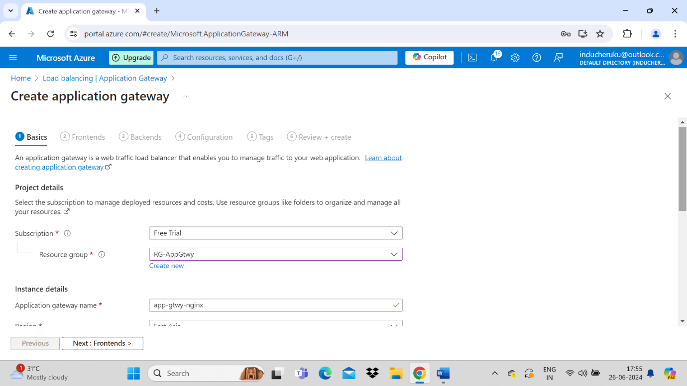

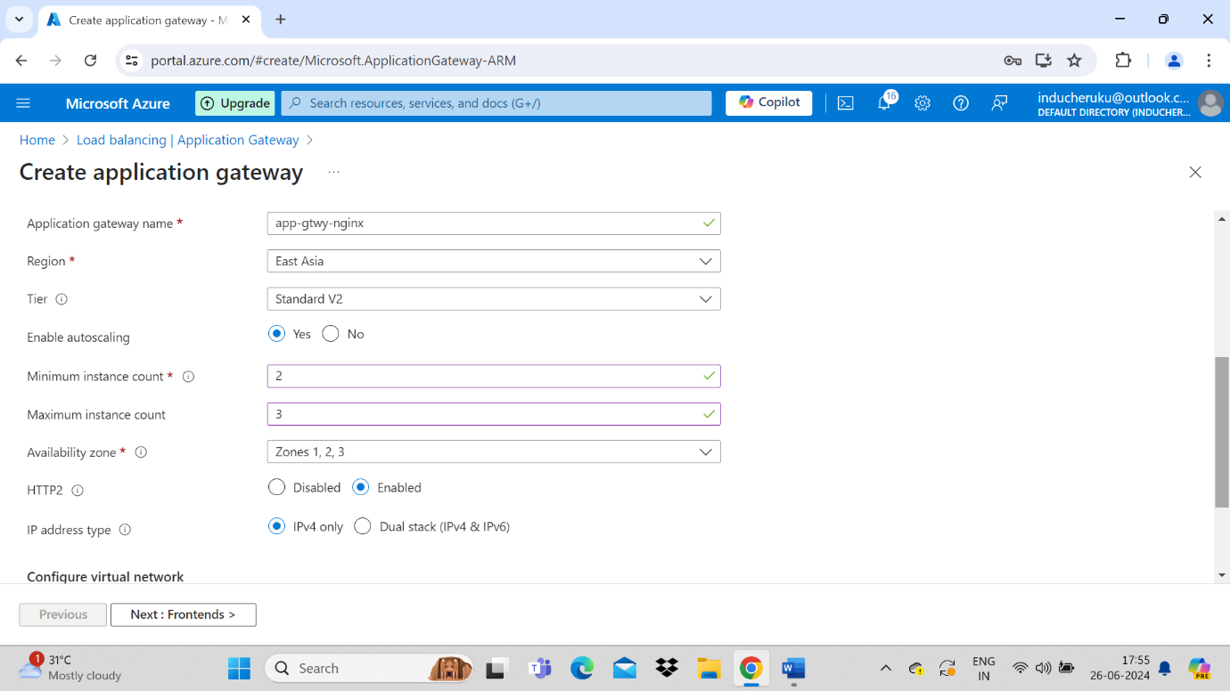

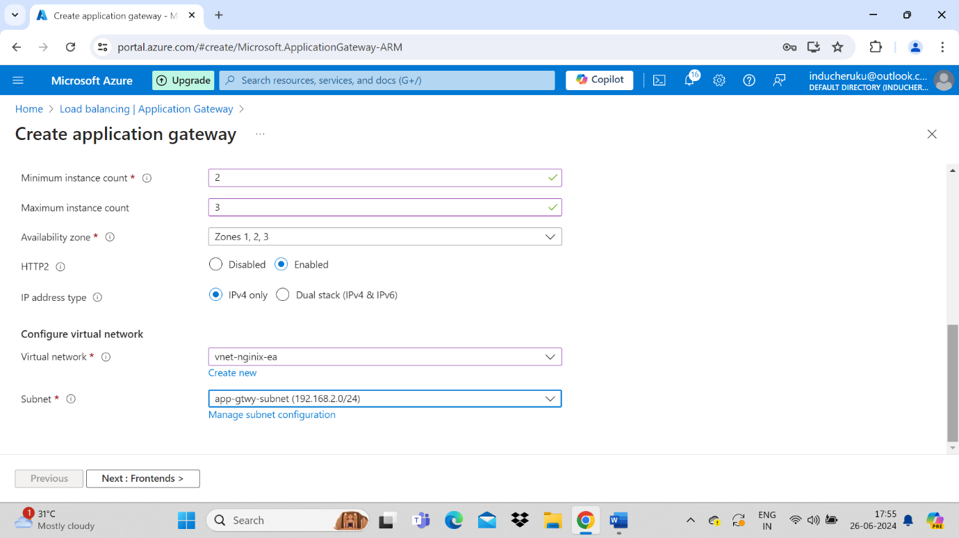

Next tab – Frontend – in this tab we will create a new public ip for our application network gtwy

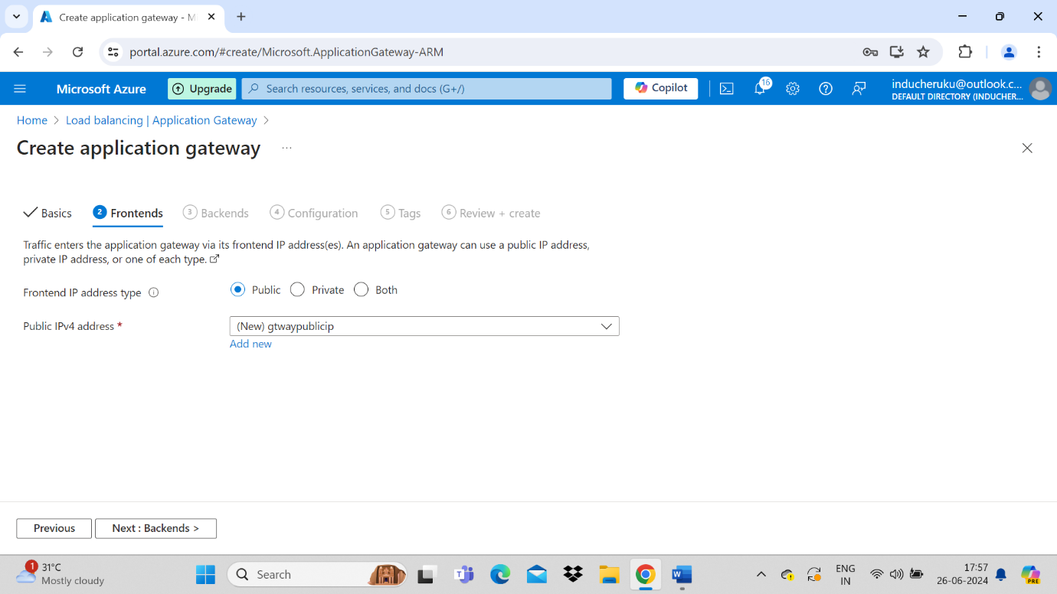

Next tab – Back end pool – we need to select virtual machines in this step more than one VM

Here we can give Multiple virtual machines in same vnet or multiple vnet or any public ip address also. Below example I am giving vm’s from two different vnets for better real time tasks

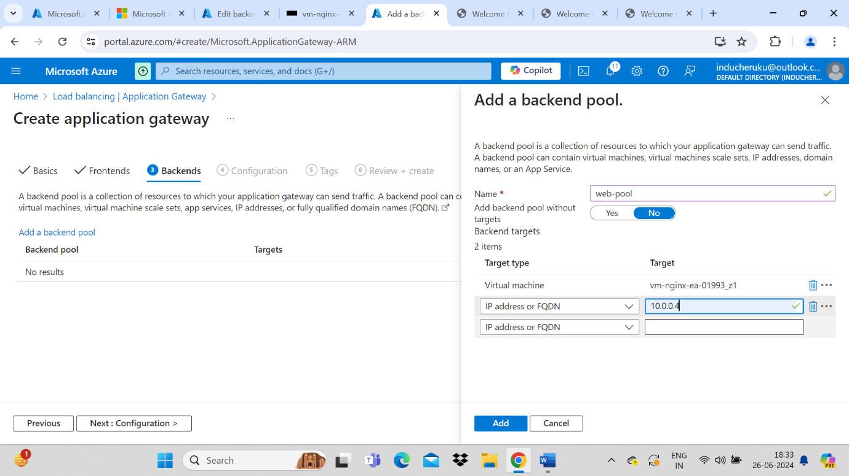

Virtual machine is selected from Vnet-01, IP address VM is selected from Vnet-02

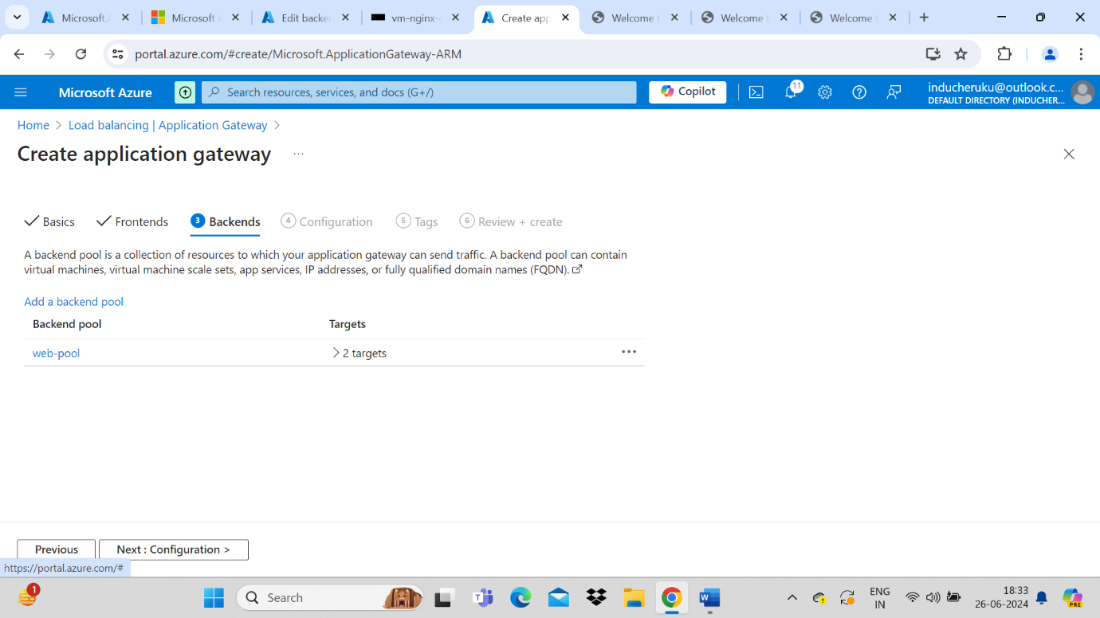

Next tab – Configuration, here we will create a new route rule

Create routing rules that link your frontend(s) and backend(s). You can also add more backend pools, add a second frontend IP configuration if you haven’t already, or edit previous configurations.

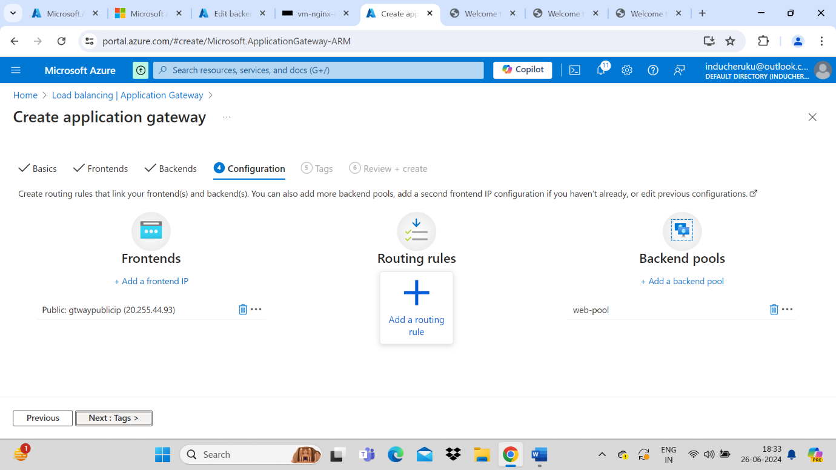

Add listener details – The end user will connect on this port 80 or 443 http or https

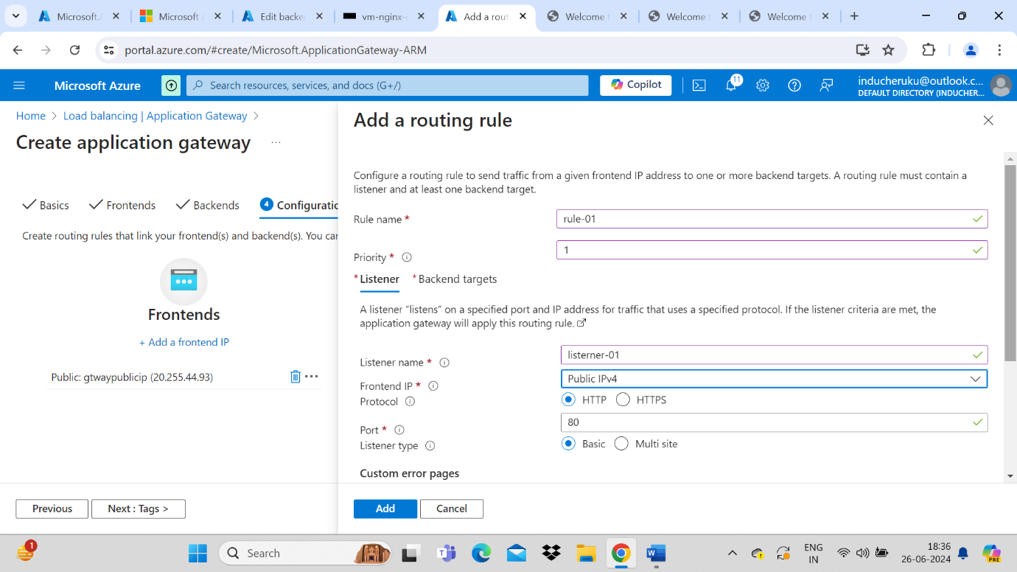

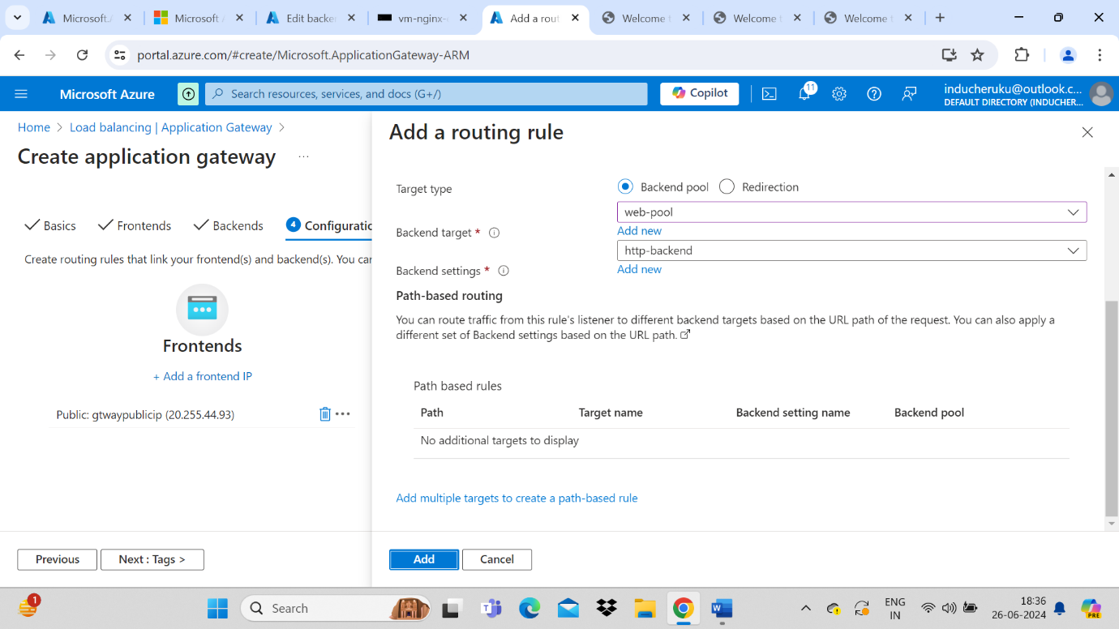

Now create a new backend=settings formerly know as http rule



