Virtual Network Gateway:

Azure VPN Gateway connects your on-premises networks to Azure through Site-to-Site VPNs in a similar way that you set up and connect to a remote branch office. The connectivity is secure and uses the industry-standard protocols Internet Protocol Security (IPsec) and Internet Key Exchange (IKE).

1. First create a Vnet-01 with gateway subnet

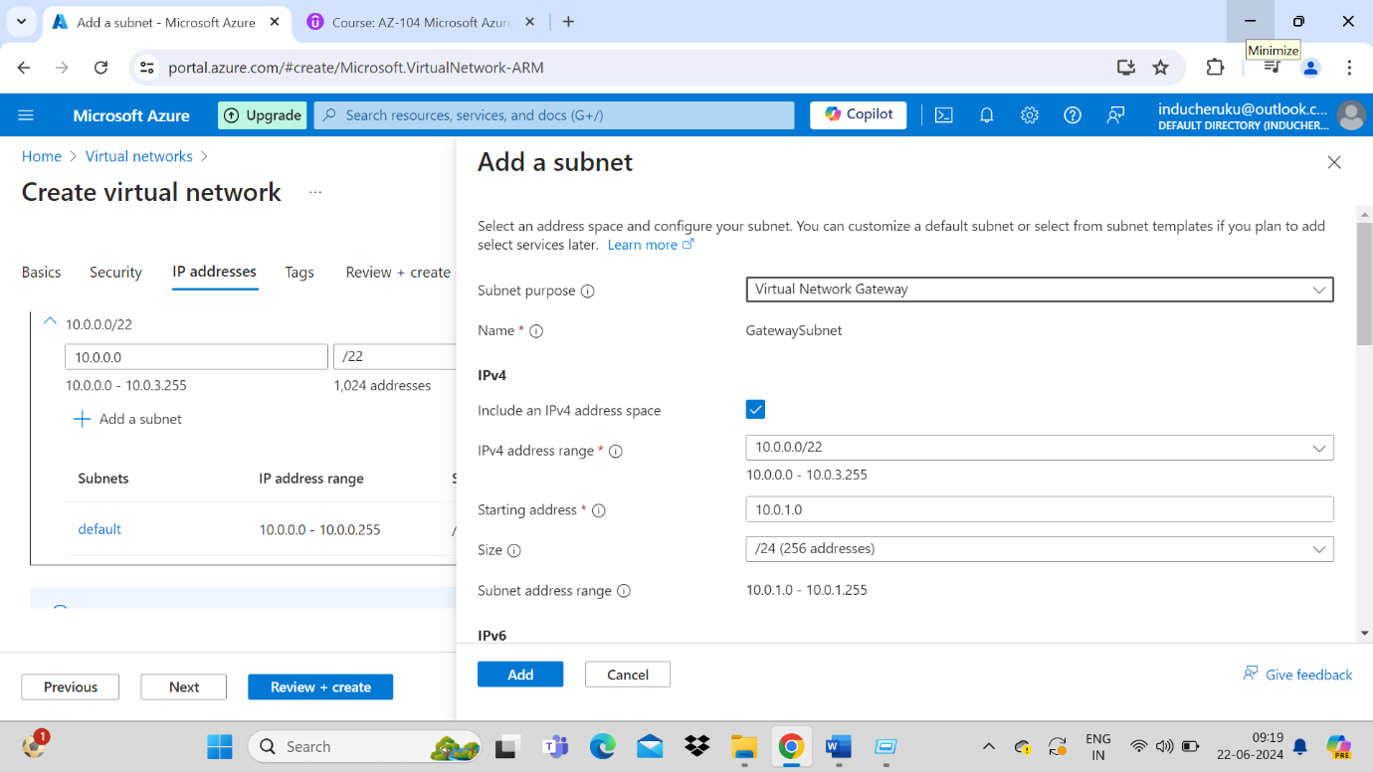

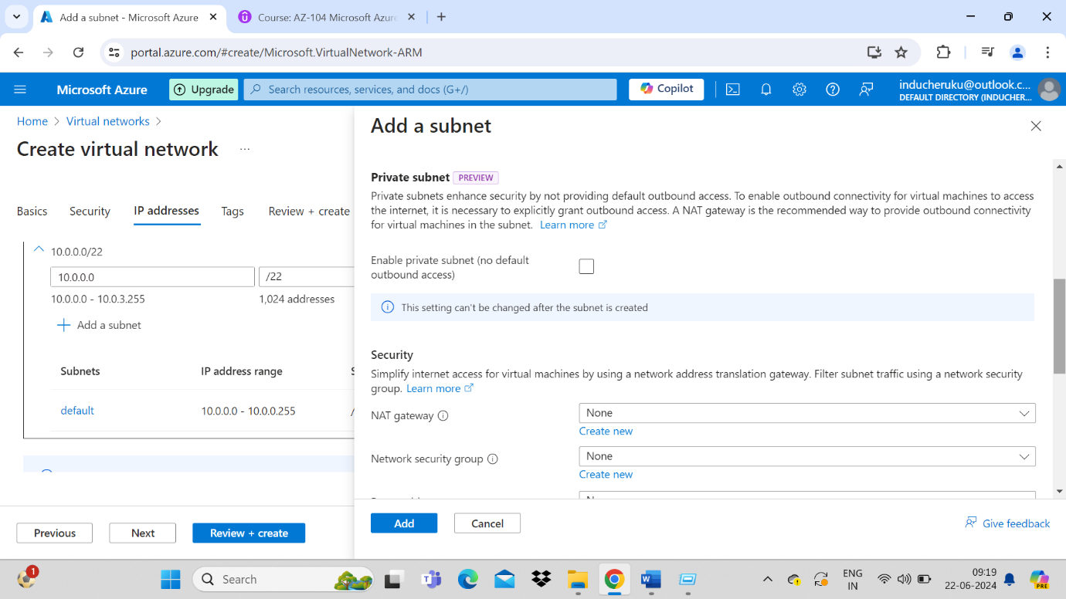

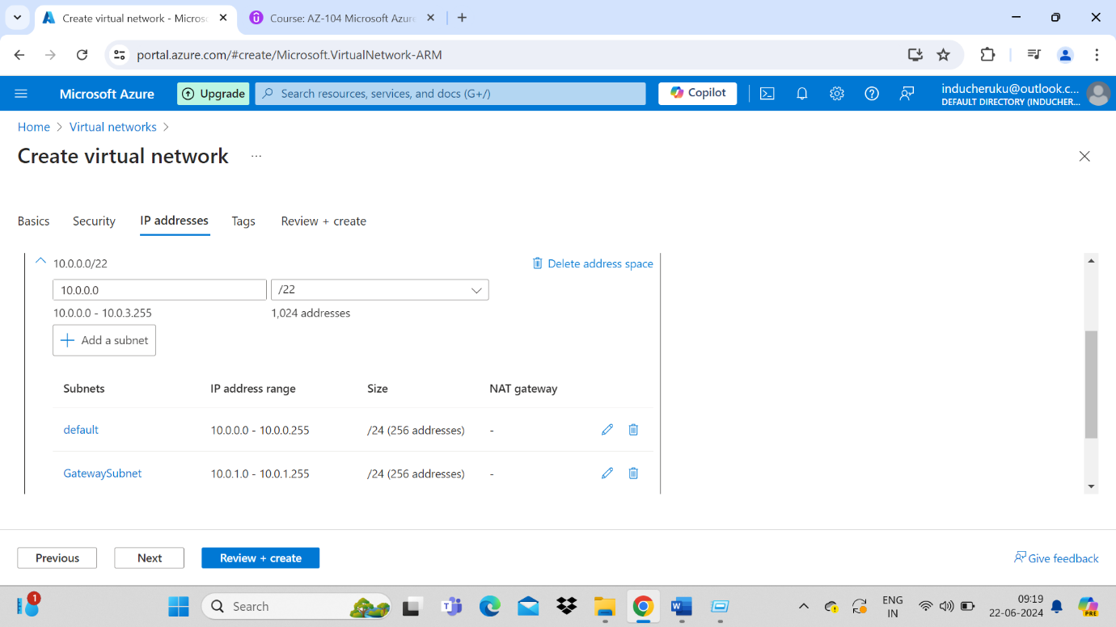

Review and create Vnet-01

1. Repeat the same for Vnet-02 and create second gateway subnet

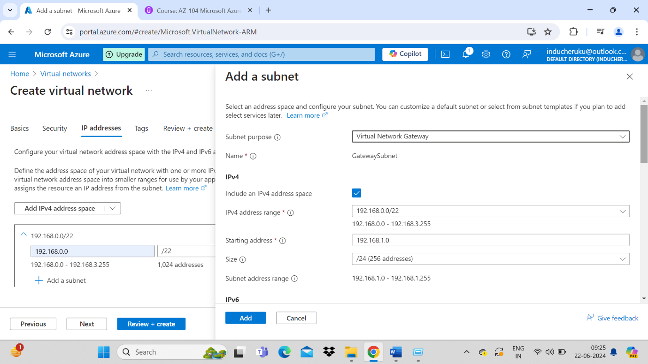

1. Now search for Virtual network gateway services in azure portal
2. Create a new virtual network gateway

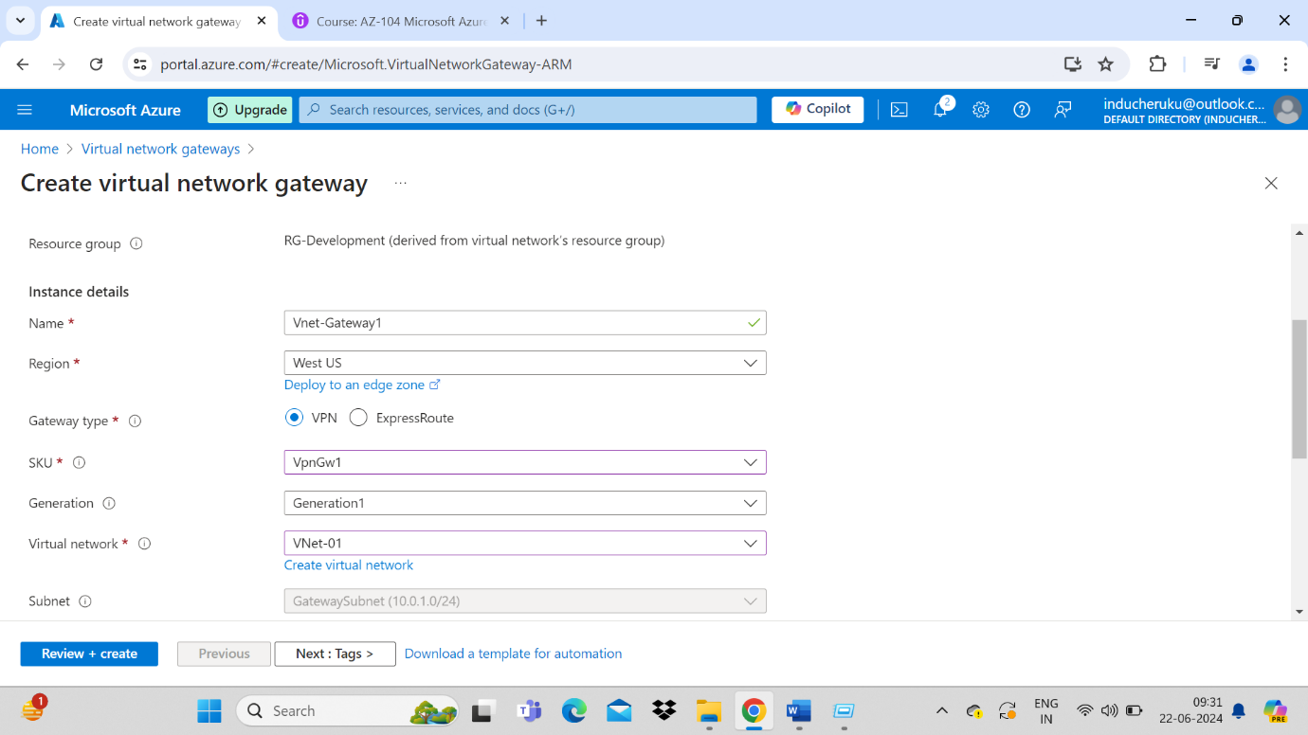

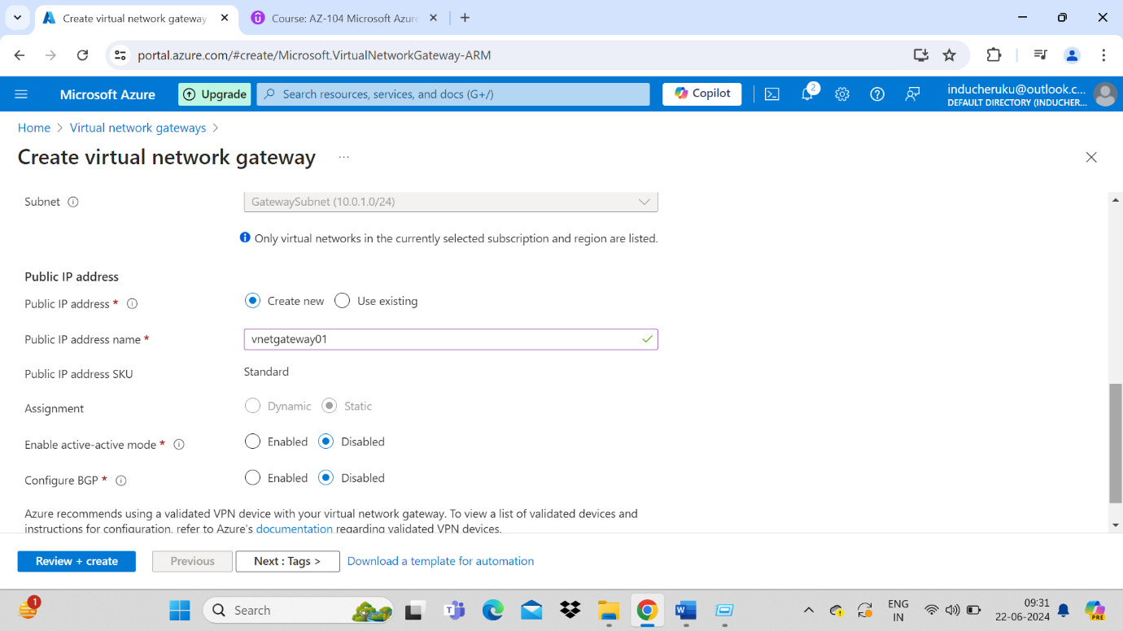

Click review + create

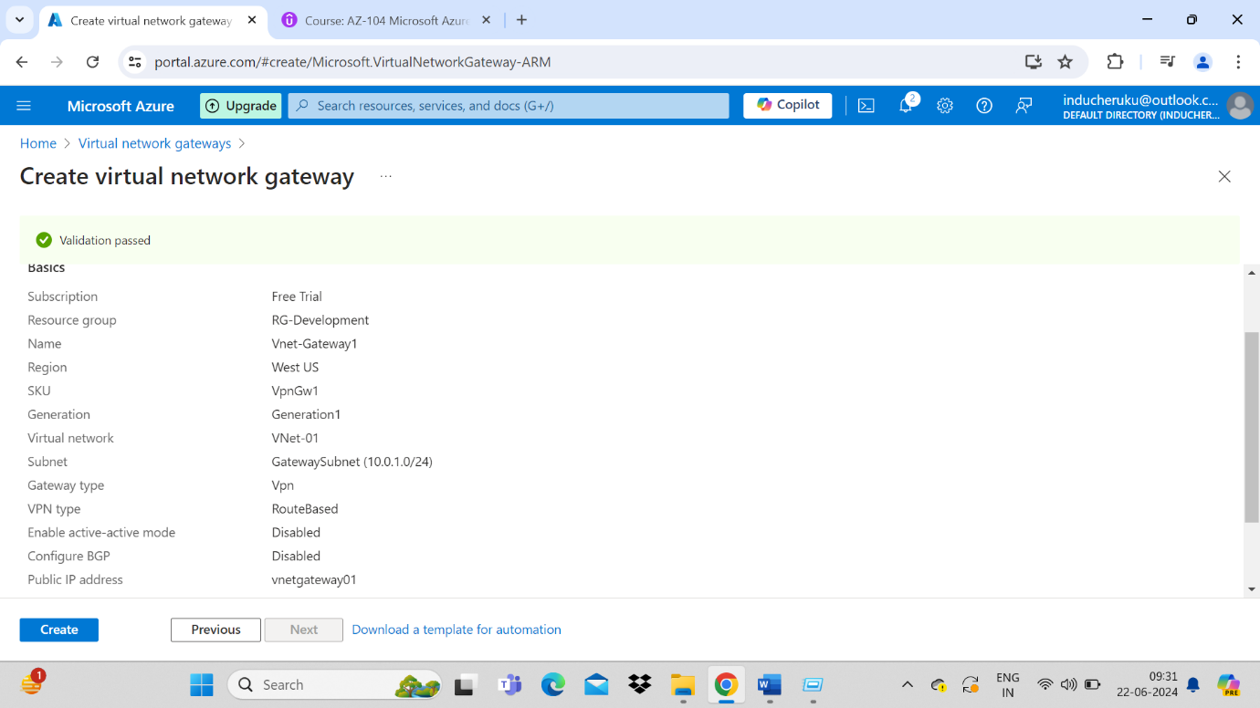

1. Now create second virtual network gateway for Vnet-02 just like above

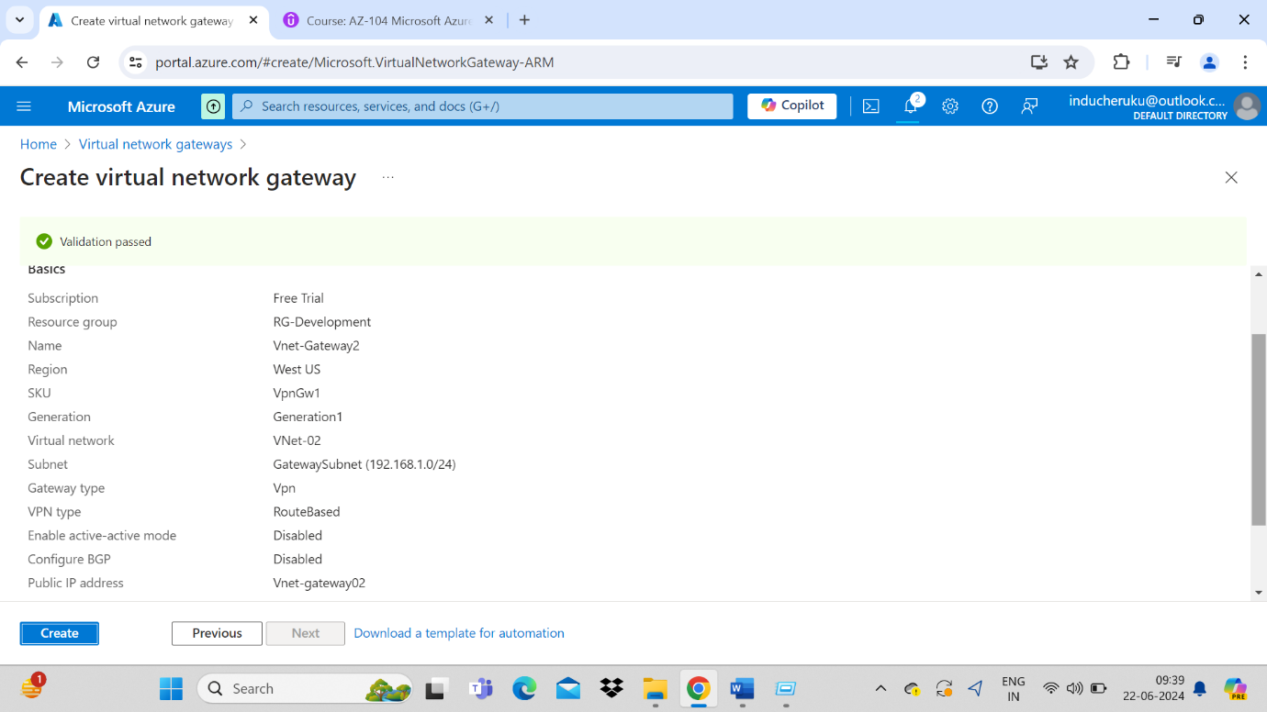

1. Adding a gateway connections
2. Go to VNet-Gateway01 - > Settings -> Connections - > Click add for new connection

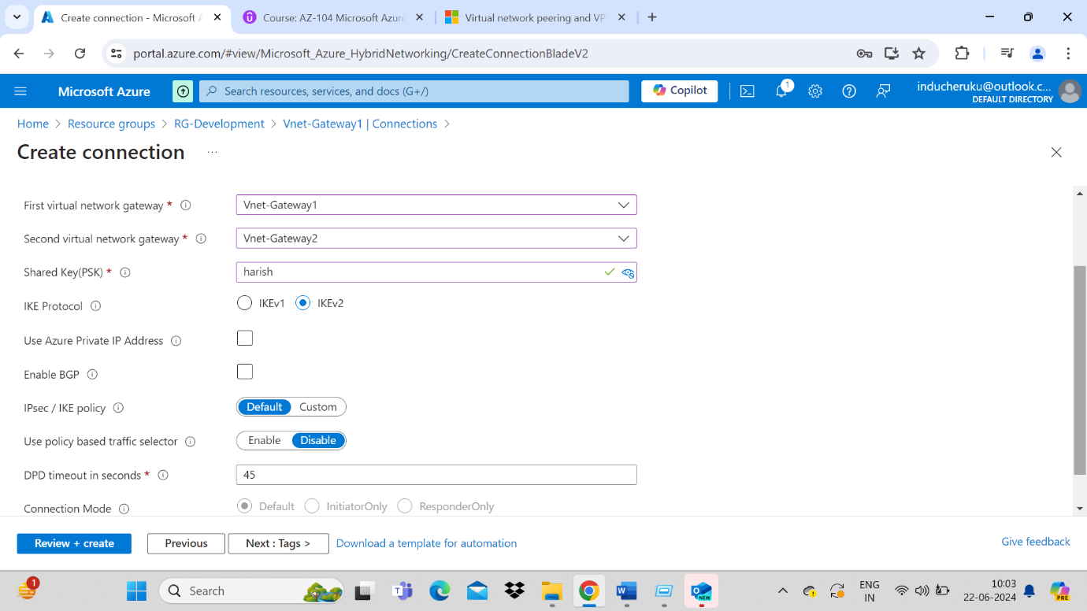

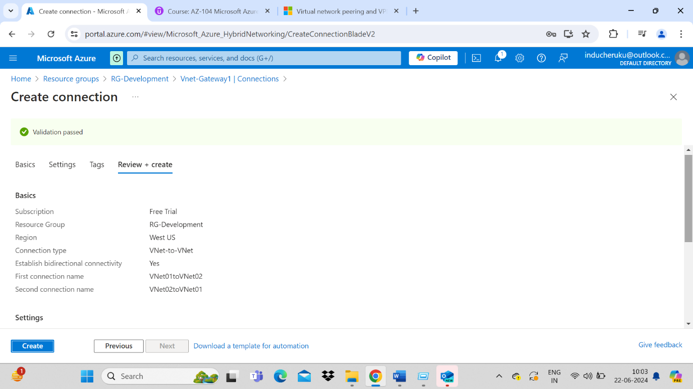

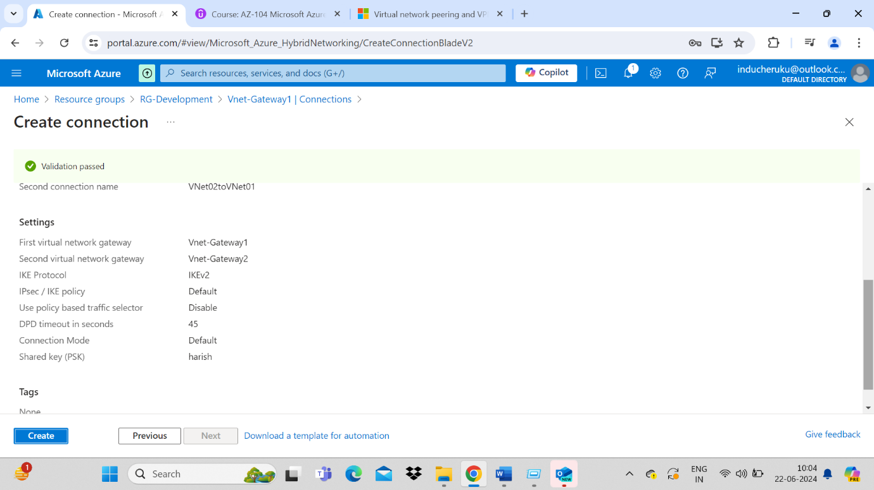

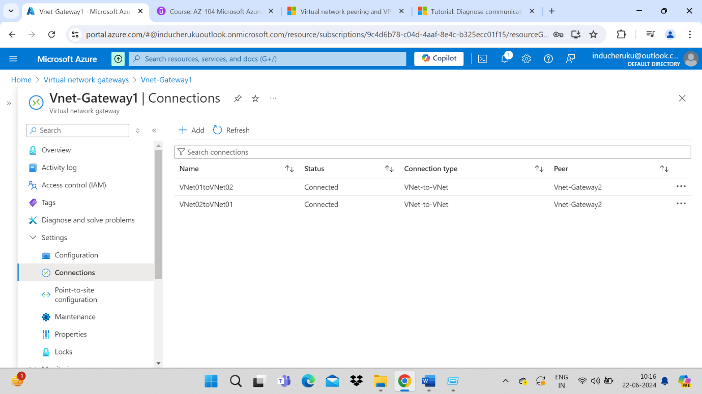

Trouble shooting Connections:

If any connections issues like NOT CONNECTED or UNKNOWN. We need to go to Help section and RESET the connection.

For Trouble shooting go to VPN trouble shoot in Help section

