**Lab 06 Create and Deploy pod Definitions**

**Step 1 : Check for the nodes**

#i-> kubectl get nodes

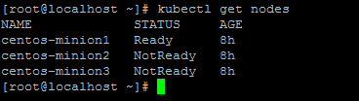

**Step 2 :Create a Builds Directory**

# mkdir Builds



**Step 3 :Change the directory & List the files**

# cd Builds

# ll

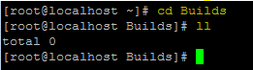

**Step 4 : Create a nginx file**

# vim nginx.yaml

apiVersion: v1

kind: Pod

metadata:

name: nginx

spec:

containers:

- name: nginx

image: nginx:1.7.9

ports:

- containerPort: 80

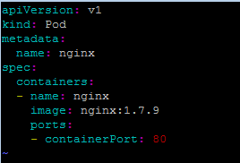

**Step 5 :Check for the pods(Currently no pods available)**

# kubectl get pods



**Step 6 : Create a pod (nginx.yaml)**

# kubectl create -f ./nginx.yaml



**step 6.a : Login to container**

kubectl exec -it nginx /bin/bash

ip a

exit

**step 6.b : copy a file**

touch anil.txt

kubectl cp anil.txt nginx:/tmp/

kubectl exec -it nginx ls –l /tmp

ls /tmp



exit

**Step 7 :List the pods**

# kubectl get pods

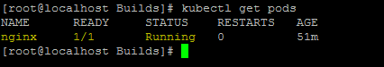

**Validate where your container is running**

kubectl describe pods nginx

**Step 8 :List all the running container on the node**

# docker ps | grep nginx

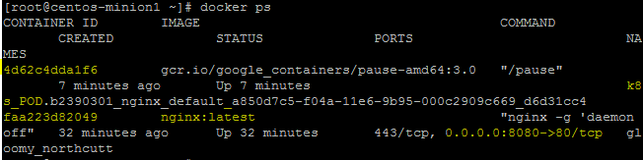

**Step 9 :List all the pods**

# kubectl get pods

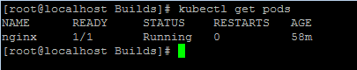

**Failure tests**

# docker ps

# docker rm <continerid>

# docker ps

# service docker stop

**Step 11 :Delete the nginx pod**

# kubectl delete pod nginx

