Q1:

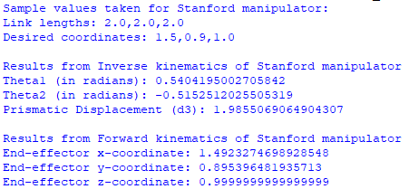

Q2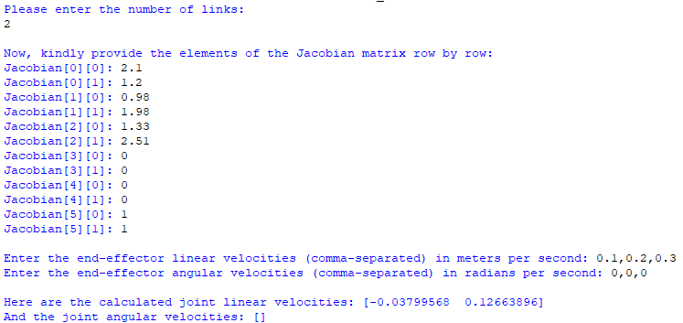

Q3,Q4: Reading task

Q5: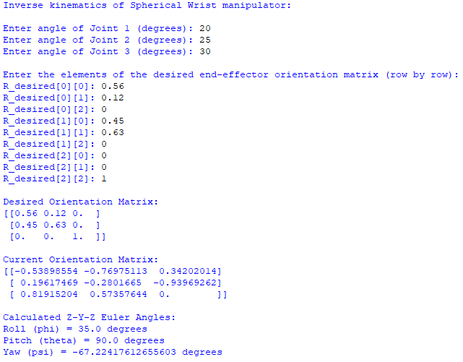

Q6(a):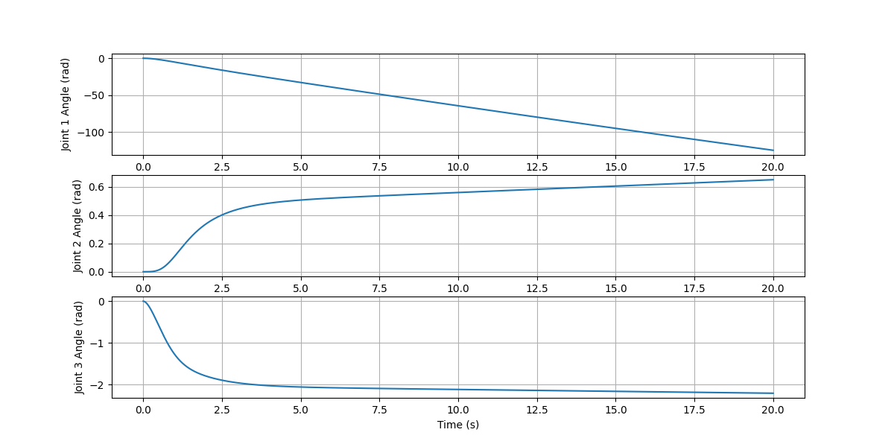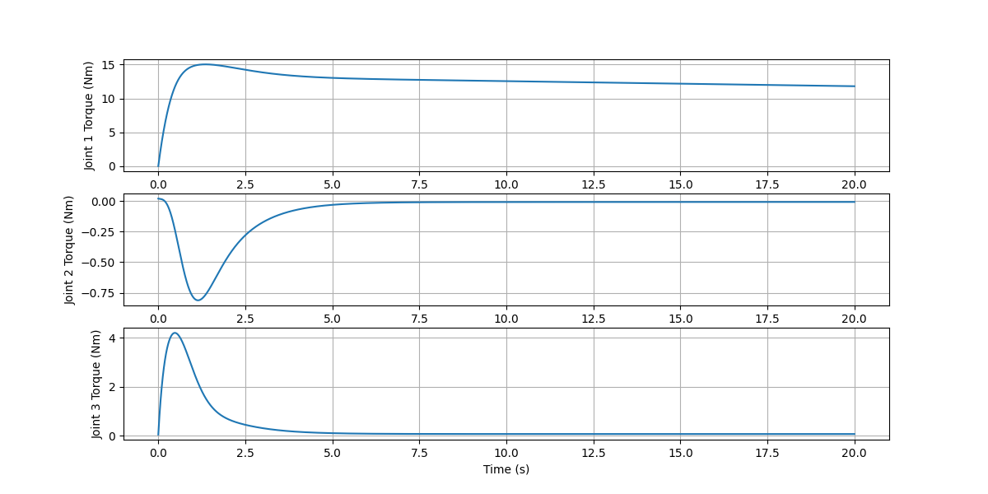

Q6(b):

Simple PD Control

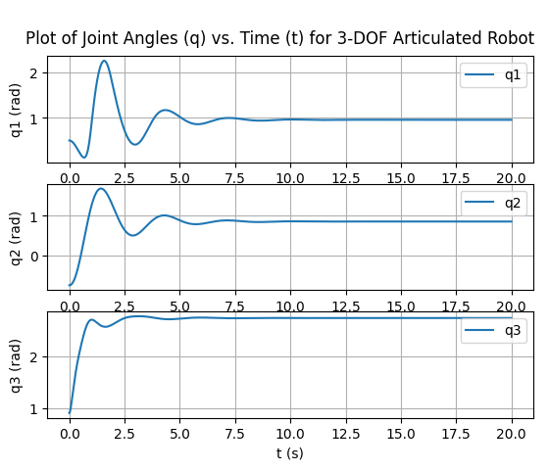

PD Control with gravity compensation

PD Control with feed – forward term

PD Control with Computed Torque Control

