**SQL Lesson 1: SELECT queries 101**

1. SELECT title FROM movies;
2. SELECT director FROM movies;
3. SELECT title,director FROM movies;
4. SELECT title,year FROM movies;
5. SELECT * FROM movies;

**Result:**

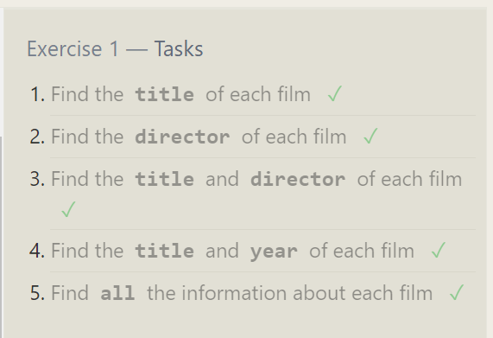

**SQL Lesson 2: Queries with constraints (Pt. 1)**

1. SELECT * FROM movies where id=6;
2. SELECT * FROM movies where year<=2010 and year>=2000;
3. SELECT * FROM movies where year not between 2000 and 2010
4. SELECT title,year FROM movies where id<6

Result:

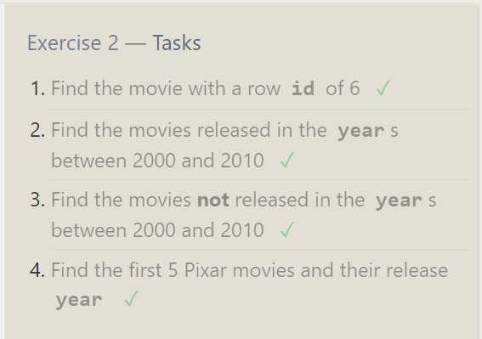

**SQL Lesson 3: Queries with constraints (Pt. 2)**

1. SELECT * FROM movies where title like 'Toy Story%';
2. SELECT * FROM movies where director like 'John Lasseter';
3. SELECT * FROM movies where director not like 'John Lasseter';
4. SELECT * FROM movies where title like 'WALL%';

Result:

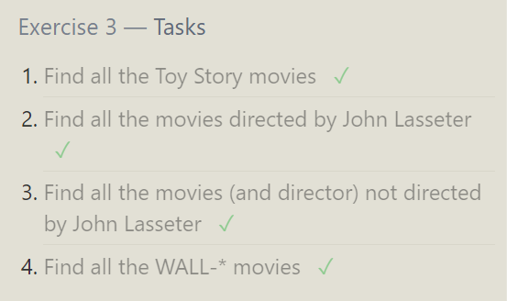

**SQL Lesson 4: Filtering and sorting Query results**

1. SELECT DISTINCT director FROM movies order by director Asc;
2. SELECT * FROM movies order by year desc limit 4;
3. SELECT * FROM movies order by title asc limit 5;
4. SELECT * FROM movies order by title asc limit 5 offset 5;

**Result:**

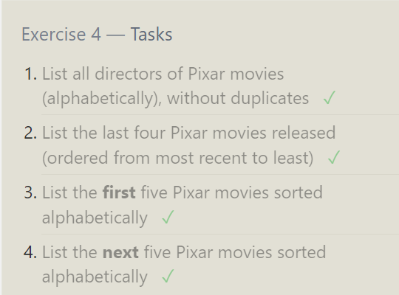

**SQL Review: Simple SELECT Queries**

1. SELECT City,population FROM north_american_cities where Country like 'Canada';
2. SELECT * FROM north_american_cities where Country like 'United States' order by latitude desc
3. SELECT city FROM north_american_cities order by longitude asc limit 6
4. SELECT * FROM north_american_cities where Country like "Mexico" order by population desc limit 2
5. SELECT * FROM north_american_cities where Country like "United States" order by population desc limit 2 offset 2

Result:

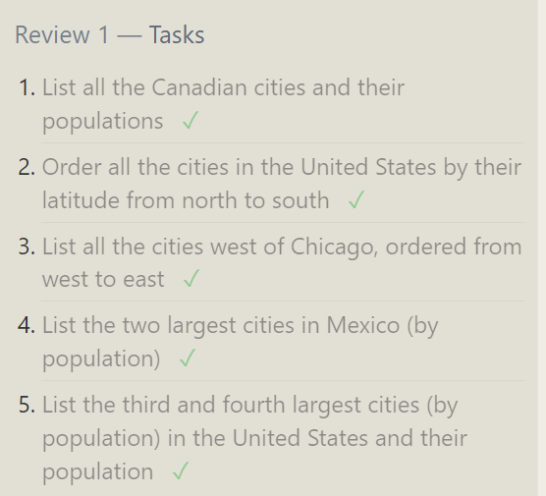

**SQL Lesson 6: Multi-table queries with JOINs**

1. SELECT * FROM movies inner join boxoffice on movies.id=boxoffice.movie_id;
2. SELECT * FROM movies inner join boxoffice on movies.id=boxoffice.movie_id

where International_sales>domestic_Sales;

1. SELECT * FROM movies inner join boxoffice on movies.id=boxoffice.movie_id

order by rating desc;

**Result:**

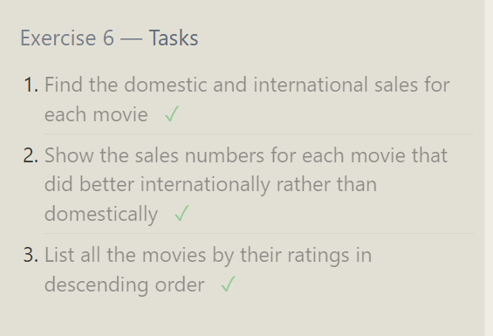

**SQL Lesson 7: OUTER JOINs**

1. SELECT DISTINCT Building_name FROM buildings INNER JOIN Employees

on employees.building=buildings.building_name;

1. SELECT * FROM buildings;
2. SELECT distinct Role,building_name FROM buildings LEFT JOIN employees on Employees.building=buildings.building_name

**Result:**

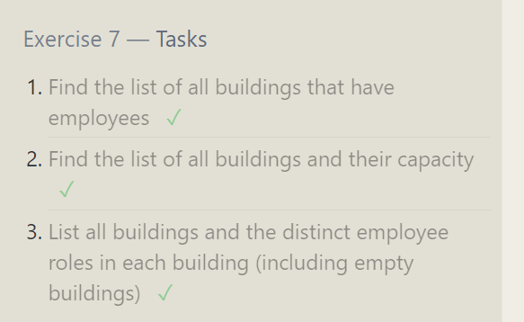

**SQL Lesson 8: A short note on NULLs**

1. SELECT Name, Role FROM Employees WHERE Building IS NULL;
2. SELECT Building_name FROM Buildings WHERE Building_name NOT IN (SELECT DISTINCT Building FROM Employees WHERE Building IS NOT NULL);

Result:

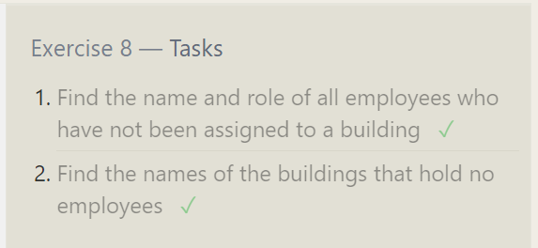

**SQL Lesson 9: Queries with expressions**

1. **SELECT m.Id,m.Title,m.Director, (b.Domestic_sales + b.International_sales) / 1000000 AS combined_sales_millions FROM Movies m JOIN Boxoffice b ON m.Id = b.Movie_id;**

**2. SELECT m.Id, m.Title, m.Director, m.Year, m.Length_minutes, b.Rating * 10 AS rating_percent FROM Movies m JOIN Boxoffice b ON m.Id = b.Movie_id;**

1. **SELECT Id, Title, Director, Year, Length_minutes FROM Movies WHERE Year % 2 = 0;**

**Result:**

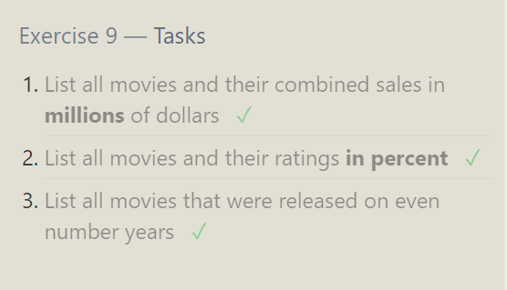

**SQL Lesson 10: Queries with aggregates (Pt. 1)**

1. SELECT MAX(Years_employed) AS longest_time FROM Employees;
2. SELECT Role, AVG(Years_employed) AS avg_years_employed FROM Employees

GROUP BY Role;

1. SELECT Building, SUM(Years_employed) AS total_years_worked FROM Employees GROUP BY Building;

Result:

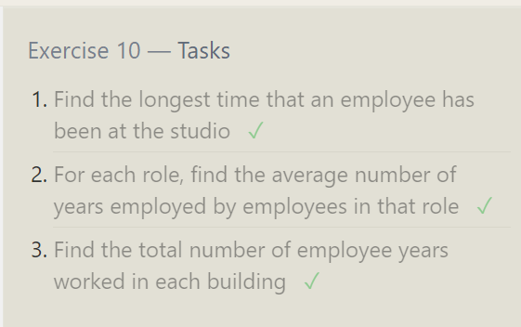

**SQL Lesson 11: Queries with aggregates (Pt. 2)**

1. SELECT COUNT(*) AS num_artists FROM Employees WHERE Role = 'Artist';
2. SELECT Role, COUNT(*) AS num_employees FROM Employees GROUP BY Role;
3. SELECT SUM(Years_employed) AS total_years_employed FROM Employees WHERE Role = 'Engineer';

Result:

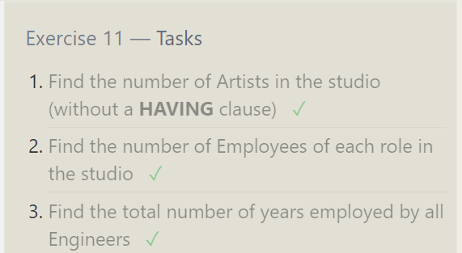

**SQL Lesson 12: Order of execution of a Query**

1. SELECT Director, COUNT(*) AS NumMoviesDirected FROM Movies

GROUP BY Director;

1. SELECT m.Director, SUM(b.Domestic_sales + b.International_sales) AS TotalSales FROM Movies m JOIN Boxoffice b ON m.Id=b.Movie_id

GROUP BY m.Director;

**Result:**

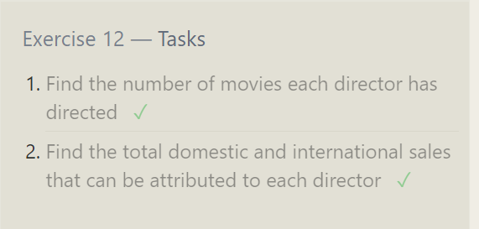

**SQL Lesson 13: Inserting rows**

1. Insert into movies values (4,'Toy Story 4','John Lasseter',2020,99)
2. insert into boxoffice values (4,8.7,34000000,27000000)

Result:

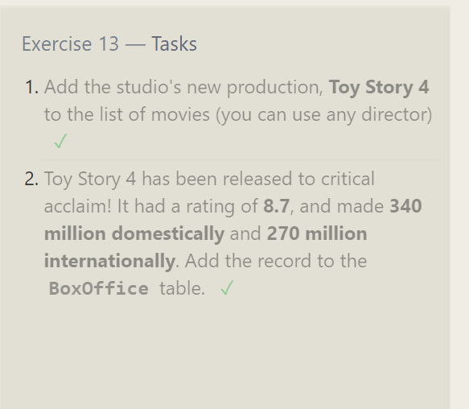

**SQL Lesson 14: Updating rows**

1. Update movies set Director='John Lasseter' where id=2
2. update movies set year='1999' where id=3
3. Update movies set title='Toy Story 3',Director='Lee Unkrich' where id=11

Result:

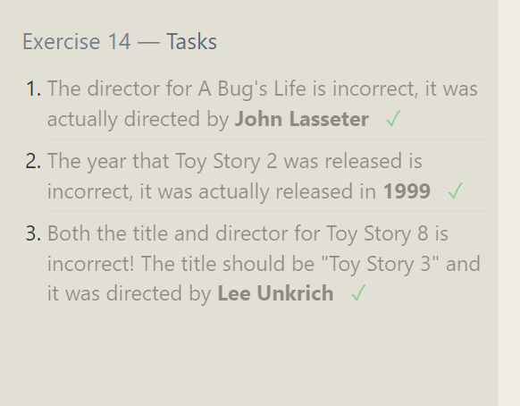

**SQL Lesson 15: Deleting rows**

1. delete from movies where year<2005
2. delete from movies where director='Andrew Stanton'

Result:

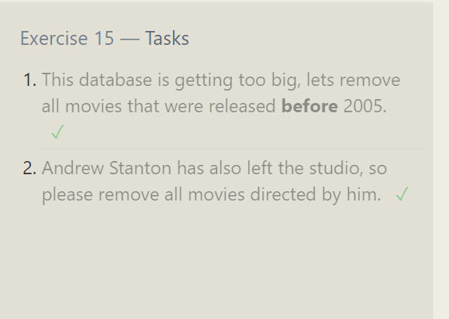

**SQL Lesson 16: Creating tables**

1. create table Database (

Name varchar(255),

Version float,

Download_count int

);

Result:

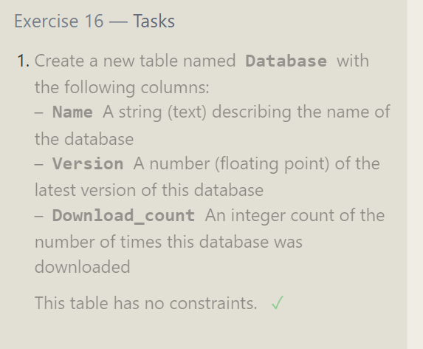

**SQL Lesson 17: Altering tables**

1. Alter table movies Add Aspect_ratio float
2. Alter table movies Add Language varchar(255) not null default 'English'

Result:

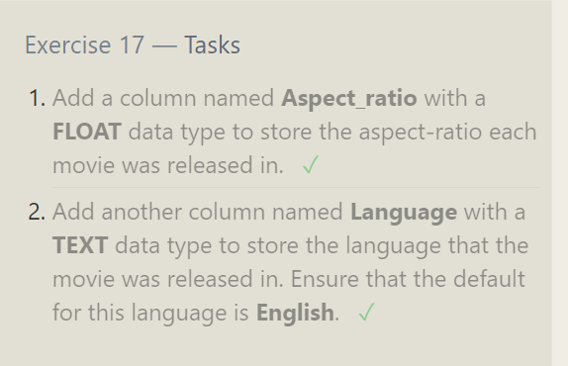

**SQL Lesson 18: Dropping tables**

1. Drop table movies;
2. Drop table boxoffice;

Result:

