# Design Document Specification

**For**

**Autism Spectrum Analyser (ASA)**

**Version 1.0**

**Prepared by:**

**ANUVIND MP – AM.EN.U4AIE22010**

**R S HARISH KUMAR – AM.EN.U4AIE22042**

**GIRISH S – AM.EN.U4AIE22044**

**AMRITA VISHWA VIDYAPEETHAM  
20 May, 2025**

# Use Case Diagram

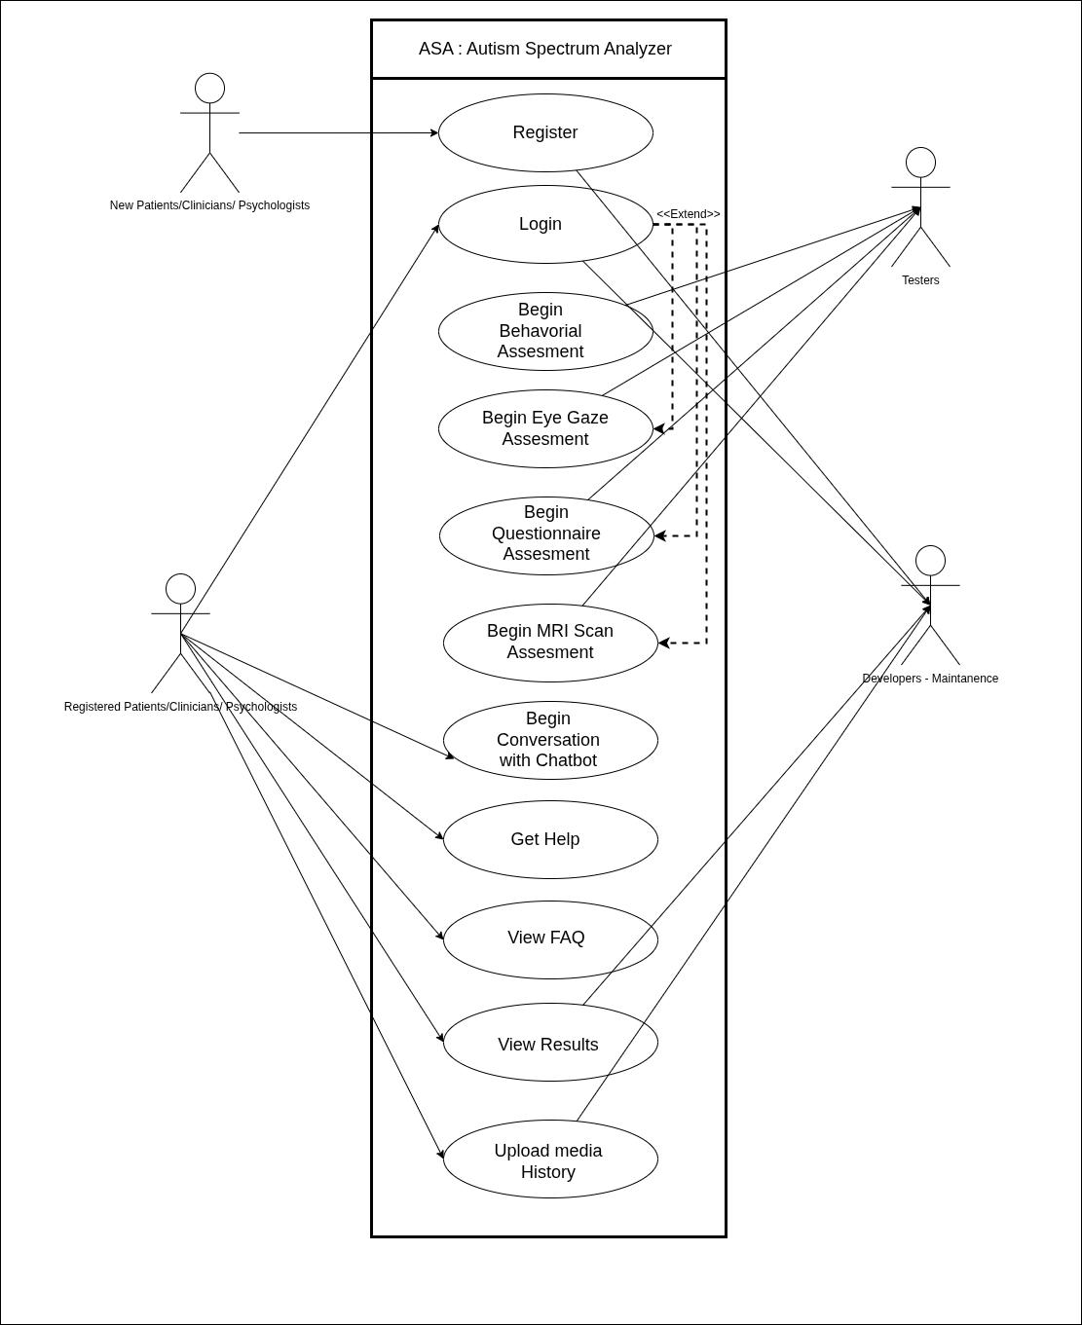

# Activity Diagram

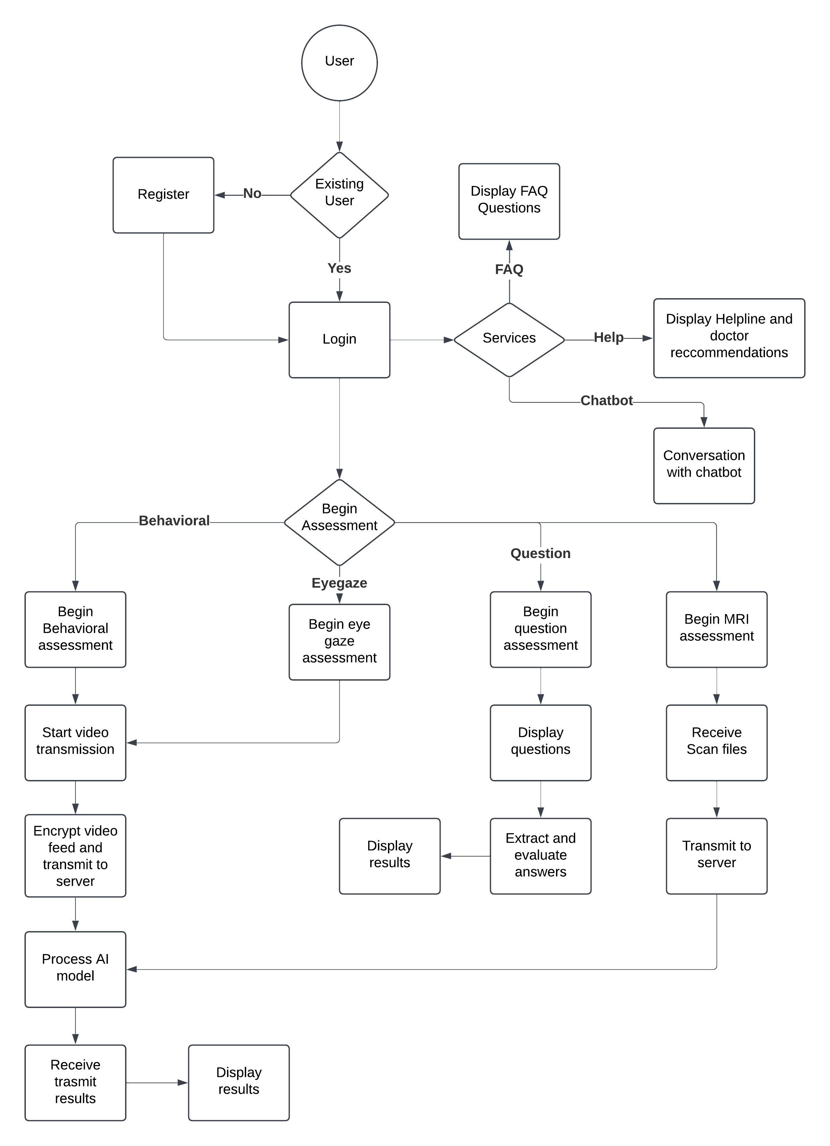

**Data Flow Diagram (DFD)**

**Level 0 :**



**Level 1 :**



**Level 2 :**

