1. Install node from node server from : <https://nodejs.org/en/>

**Follow the steps application to create one application on server**

1. Make a folder and run below command.

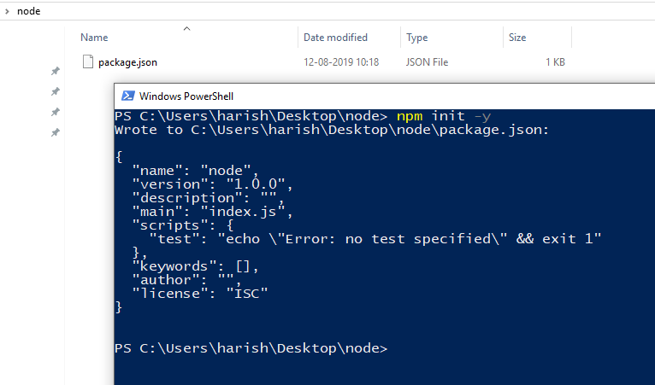

1. Now you need to install other packages so if you have package mentioned in your package.json file then you just need to run below command.

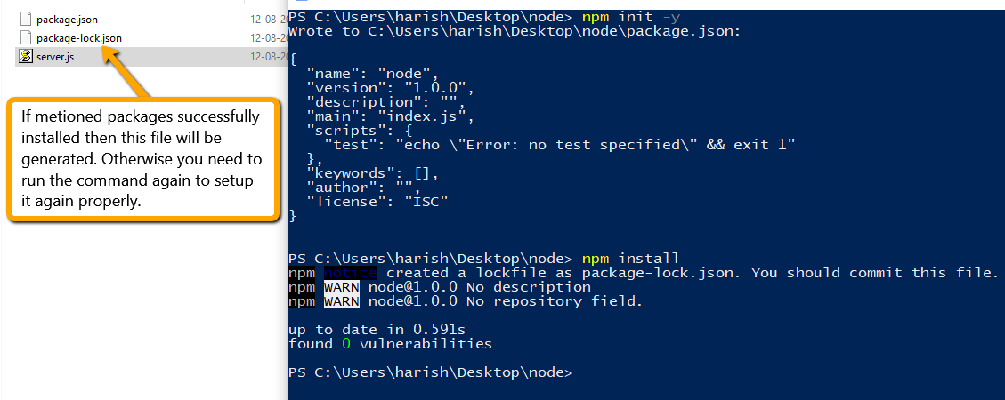

If you want to install specific package then you need to run below command.

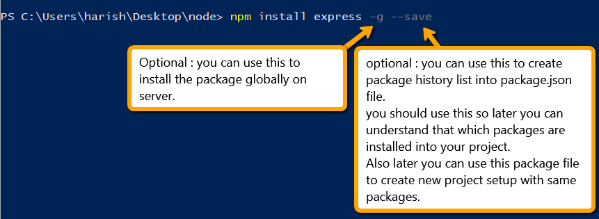

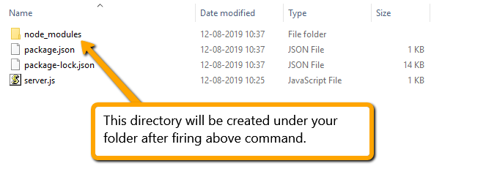

1. Now you need to write code to start your server into server.js file in your folder.



Run the server.js from your command



Test into browser that server started or not.

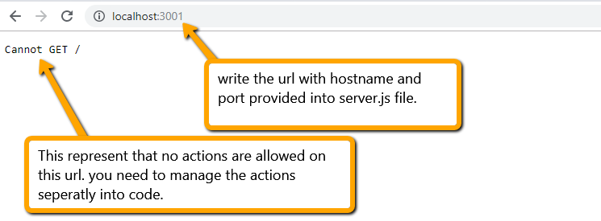

1. Now we will allow some action into code and test it on server.

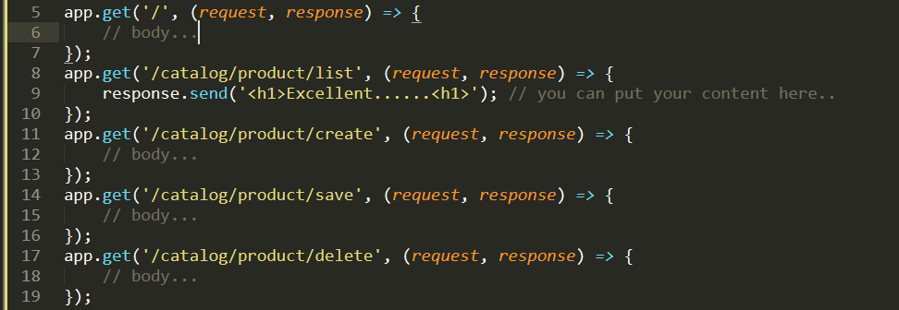

You need to restart the server again if you change any code into your application.

(Note : Use CTRL + C command to terminate any process in terminal if already running)



You can see the output into your browser.

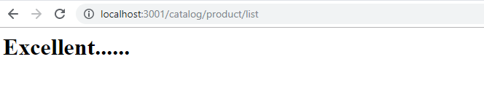

1. Access the parameters from allowed actions. Write below code into your application.

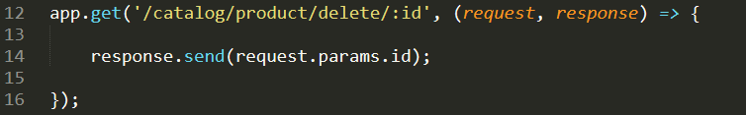

Restart the server again and run below url into browser to see the output.

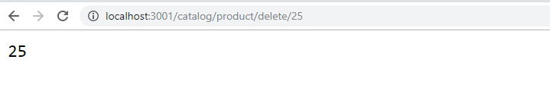

1. About how we manage the folder structure of application.

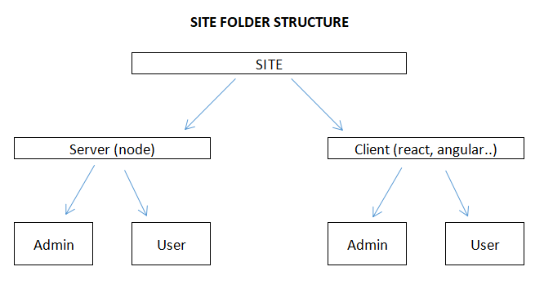

1. Install MySQL and sync - MySQL packages.

