WEEK 2 INTERNSHIP REPORT
Hands-on Practice in Mechanical CAD
Name | Harish S
Internship | Mechanical CAD Intern
Week | 2
Software | PTC Creo Parametric
Task | L-Bracket 3D Modelling

1. Objective
The objective of this task was to gain practical experience in mechanical CAD modelling using PTC Creo Parametric. The exercise focused on creating a simple mechanical component by applying sketching, extrusion, hole creation, and rounding features.

2. Exercise Description
For this exercise, I created a three-dimensional L-shaped mounting bracket. The component consists of a horizontal base and a vertical plate connected together. Mounting holes were created in both sections to demonstrate the use of material-removal features.

3. Software and Tools Used
The software used for this exercise was PTC Creo Parametric. The main tools and features used were Sketch, Extrude, Dimension, Remove Material, and Round. These tools helped me create and modify the required mechanical geometry.

4. Modelling Procedure
- Opened PTC Creo Parametric and created a new part document.
- Selected a suitable reference plane and created a two-dimensional L-shaped sketch.
- Used the extrusion feature to convert the sketch into a solid model.
- Created a mounting hole in the horizontal base and another hole in the vertical plate using sketching and material-removal operations.
- Applied a rounding feature to a suitable edge to improve the edge finish.
- Inspected the completed model in isometric view and saved the Creo part file.

5. Final Model
The completed model represents an L-shaped mounting bracket with a horizontal base, vertical plate, mounting holes, and a rounded edge.
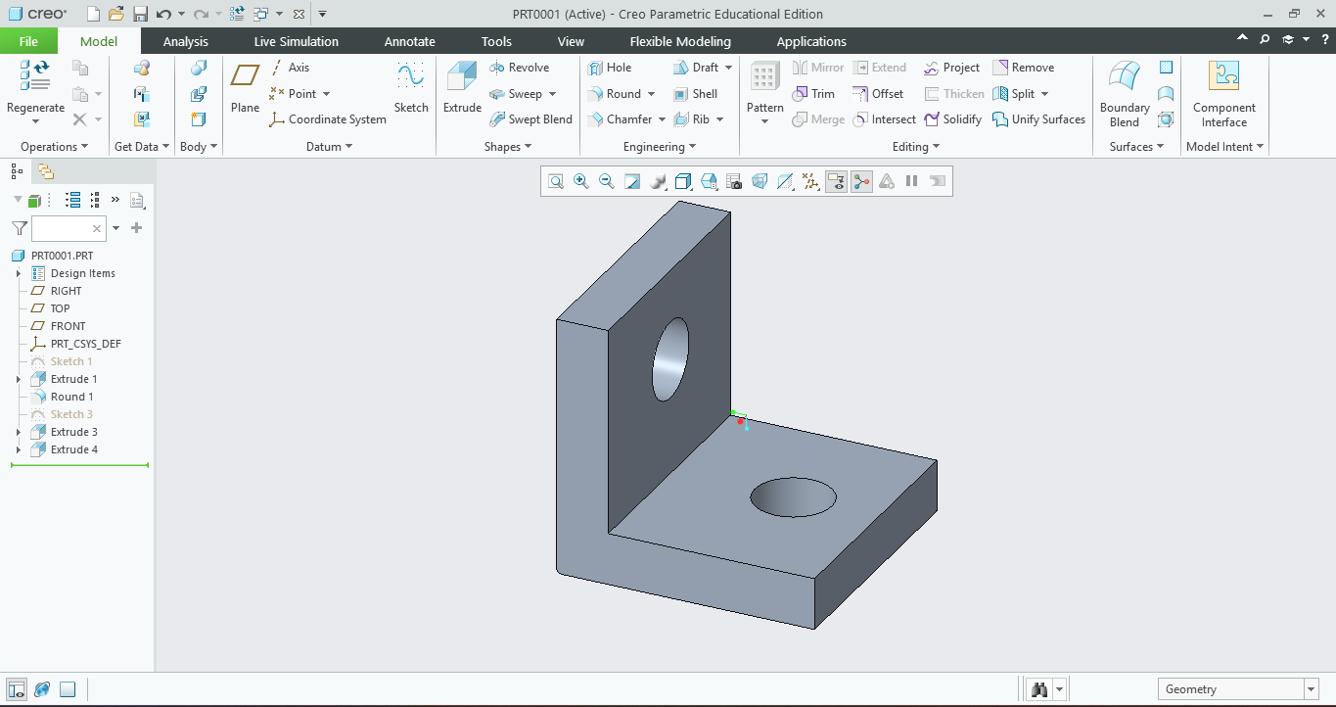
Figure 1: L-bracket model created in PTC Creo Parametric.

6. Learning Outcomes
Through this exercise, I gained practical experience in creating a three-dimensional mechanical component using PTC Creo Parametric. I improved my understanding of sketching, extrusion, hole creation, and edge-rounding operations. I also learned the importance of checking the model geometry and saving the CAD file correctly.

7. Conclusion
The Week 2 hands-on exercise helped me apply basic mechanical CAD concepts in a practical modelling task. The completed L-bracket improved my familiarity with Creo Parametric and provided experience in preparing a CAD model and documenting the modelling procedure.

