WEEK 1 INTERNSHIP REPORT
Foundations of Mechanical CAD Intern
Intern Name | Harish S
Internship | Mechanical CAD Intern
Week / Dates | Week 1 | 11-Aug-2026 to 17-Aug-2026
Software | PTC Creo Parametric – Education Edition

1. Introduction
This report describes my Week 1 activity for the Mechanical CAD Intern task. The focus was to become familiar with the PTC Creo Parametric environment and begin practising foundational 3D modelling operations. Computer-Aided Design (CAD) is used in mechanical engineering to create, modify, inspect, and communicate component geometry before manufacturing.

2. Objectives
- Understand the purpose and basic applications of Mechanical CAD.
- Explore the Creo Parametric interface and model tree.
- Recognize default datum planes and the coordinate system.
- Begin creating a 3D part using feature-based modelling tools.

3. CAD Fundamentals
Parametric CAD modelling commonly begins with a sketch on a selected datum plane. Dimensions and geometric constraints define the sketch, and modelling features are then used to create or modify solid geometry. Common operations include Extrude, Revolve, Cut, Fillet, and Chamfer. The model tree records the feature sequence, making the design easier to review and edit. The model should be inspected and saved with a clear file name.

4. Work Completed in Creo
I opened PTC Creo Parametric Education Edition and explored the Model ribbon, graphics area, model tree, datum planes, and coordinate system. I then worked on a part that contains the features named Extrude 1, Extrude 2, and Profile Rib 1 in the model tree. The displayed model has solid geometry with raised and recessed areas. This practice helped me become familiar with feature-based modelling and viewing a part in the 3D workspace.
The screenshot documents a modelling state with multiple features. This report does not assume specific dimensions or design functions that are not visible in the evidence.

5. Screenshot Evidence – 3D Model
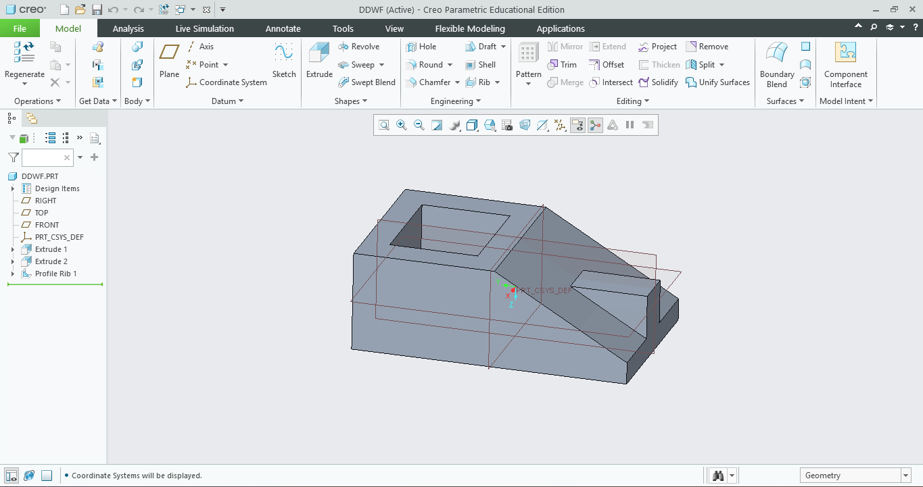
Figure 1. Creo Parametric part showing solid geometry and the model-tree features Extrude 1, Extrude 2, and Profile Rib 1.

6. Initial Workspace Evidence
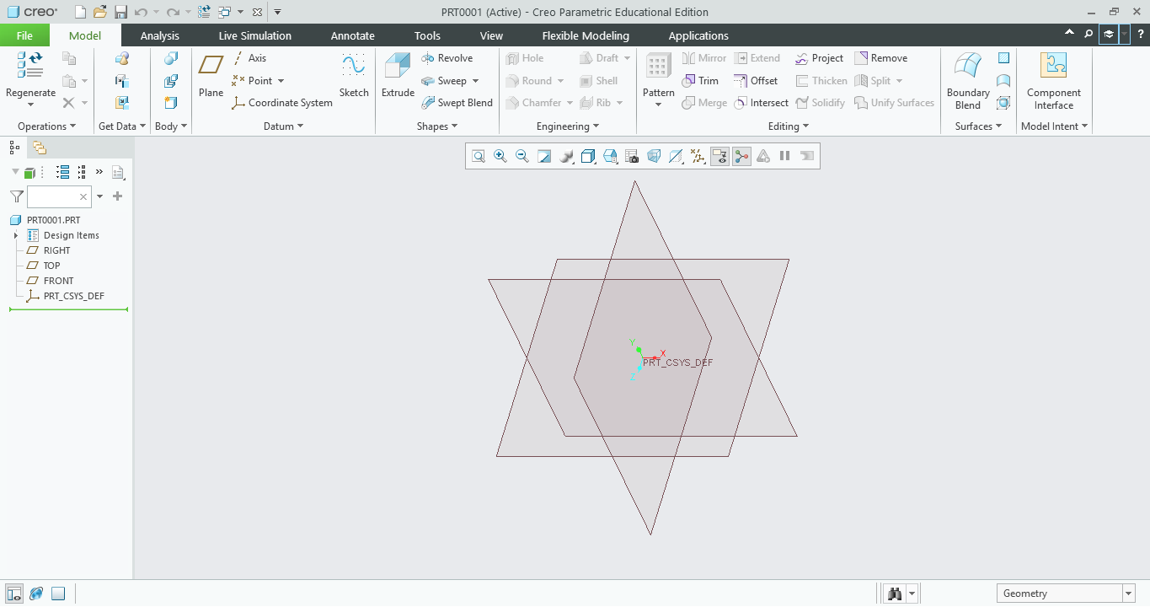
Figure 2. Initial Creo part workspace showing default datum references.

7. Skills and Learning Outcomes
This activity provided practice in navigating the Creo workspace, reading the model tree, recognizing datum references, and creating a part with multiple features. It reinforced the workflow of building geometry feature by feature and checking the result in the graphics area.

8. Conclusion and Next Steps
Week 1 introduced the Creo environment and provided initial hands-on experience with 3D feature modelling. In the next task, I will continue practising sketches, dimensions, constraints, and feature operations, then save and document the model with clear evidence.

9. Submission Checklist
- Week 1 report prepared.
- Creo modelling screenshot included as evidence.
- Report reviewed to ensure it reflects the visible work.
- GitHub repository URL added to the internship portal as required.

